Making Effective Relays:
With 25 Possibilities

Sourced from www.canadago4sport.com

Mostly written by ChatGPT

Compiled by John Byl JOHNBYL50@gmail.com

Feel encouraged to share this resource

Introductory Remarks
I developed over 1200 games, videoed many of them, presented them at hundreds of workshops, and compiled them into www.canadago4sport.com, YouTube, and Pinterest, and shared them each Tuesday and Thursday on Instagram, TikTok, and X.
Recently, I found myself wondering how AI could help uncover insights from much of the information above. Curious, I decided to see what ChatGPT could do with relay games. What follows is my first attempt at using ChatGPT to analyze data from www.canadago4sport.com
I do not think the final product is perfect, but it provides you, the reader, with some key principles in leading purposeful and engaging relays and provides you with 25 sample games that are in a relay format or can be modified to be a relay.
Thanks for taking your time to read through this document. If you have suggestions for ways I can more effectively mine my website I eagerly look forward to your thoughts
Sincerely

Dr. John Byl
JOHNBYL50@gmail.com

Table of Contents
- Design
  - 4--Well designed Relays
  - 6--Additional design guidelines
  - 8--A simple design formula
- Samples
  - 9--Moving
    - Egg and Spoon
    - Burrowing
    - Newspaper run
    - Step through race
  - 24--Bean Bag Relays and Challenges
    - Tic Tac Toe No Grid
    - Hidden treasurer
    - Flip bean bags into hoop
  - 34—Smaller Ball Relays
    - Team Planks Caterpillar
    - Basketball robin’s nest
    - Double dribble
    - Tunnel roll
  - 57—Larger Ball Relays
    - Pass
    - Crab walk
    - Circle
  - 70--Cross Curricular
    - Quick count
    - Word
    - Puzzle with blindfold
  - 80--Hula Hoop
    - Lift hula hoop over and jump back in
    - Roll to claim hoops
    - Flip Frenzy into hoop
  - 89--Agility Ladders
    - Every rung run
    - Alternate in and out sideways run
    - Two foot jump every rung
    - Ladder in and out run while throwing a ball
    - Ladder ball bounce each rung
  - 104--1200+ Activities Plus Tuesday and Thursday Posts
Well-designed physically active relays
do more than determine a winner
They maximize movement, engagement, learning, and enjoyment while minimizing waiting time and elimination. The following principles are widely used in quality physical education and long-term physical activity programming.
Principle | Why It Matters | Practical Application
Keep Everyone Moving | Maximizes moderate-to-vigorous physical activity (MVPA). | Minimize waiting in lines. Give waiting players an active task (jumping jacks, balancing, dribbling).
Emphasize Skill Development | Reinforces movement competence while students are active. | Build relays around running, hopping, throwing, catching, balancing, rolling, jumping, or striking.
Success for All | Builds confidence and motivation. | Adjust distance, equipment, or challenge so every participant can experience success.
Progressive Challenge | Keeps activities engaging and appropriately difficult. | Begin with simple tasks, then add speed, accuracy, decision-making, or obstacles.
Cooperation Before Competition | Encourages teamwork and positive relationships. | Include team challenges where success depends on helping teammates rather than simply winning.
Purposeful Competition | Competition can motivate without discouraging. | Celebrate effort, teamwork, improvement, and fair play—not only first place.
Minimal Elimination | Maximizes participation. | Avoid "out" games. Instead, use penalties such as completing a movement task before rejoining play.
Simple Rules | Players spend more time moving than listening. | Explain the game in under one minute and demonstrate key actions.
High Repetition | Skill improves through frequent practice. | Design relays so every participant repeats the movement many times.
Decision-Making | Develops tactical thinking. | Include choices such as selecting pathways, targets, or strategies.
Appropriate Intensity | Supports cardiovascular fitness. | Alternate bursts of activity with brief recovery or active waiting tasks.
Safety First | Prevents collisions and injuries. | Clearly define pathways, turning points, spacing, and equipment use.
Inclusive Design | Ensures everyone participates meaningfully. | Offer equipment choices, modified distances, adapted movements, and flexible roles.
Efficient Organization | Reduces transition time. | Prepare equipment before class and use consistent team formations.
Fun and Meaningful Themes | Increases motivation and engagement. | Add stories, missions, seasonal themes, or cooperative challenges.

Additional Design Guidelines
1. Maximize Active Learning Time
Aim for at least 70–80% of lesson time spent moving. Keep explanations brief and avoid long lines.
2. Focus on One or Two Learning Outcomes
Each relay should have a clear purpose, such as:
- improving sprinting technique,
- developing throwing accuracy,
- practicing teamwork,
- reinforcing math or literacy concepts,
- enhancing agility or balance.
3. Balance Physical and Cognitive Challenge
The best relays often combine movement with thinking, such as:
- solving a problem,
- remembering a sequence,
- making tactical decisions,
- communicating with teammates.
4. Vary Movement Patterns
Over a series of lessons, include:
- locomotor skills (run, hop, skip, gallop),
- stability skills (balance, twisting, landing),
- manipulative skills (throw, catch, strike, dribble),
- fitness components (strength, endurance, agility, flexibility).
5. Design for Positive Teamwork
Encourage teammates to:
- communicate clearly,
- celebrate effort,
- solve problems together,
- rotate roles,
- support everyone.
6. Differentiate the Challenge
Provide options by changing:
- distance,
- equipment size,
- target size,
- speed,
- movement pattern,
- number of repetitions.
7. Encourage Reflection
After each relay, ask questions such as:
- What strategy helped your team succeed?
- How did communication affect performance?
- What movement skill improved today?
- What would you do differently next round?

A Simple Design Formula
A practical framework for creating effective relays is:
Movement Skill + Challenge + Teamwork + Decision-Making + Continuous Activity = Great Relay
For example:
- Movement Skill: Dribbling
- Challenge: Navigate obstacles
- Teamwork: Pass to the next player
- Decision-Making: Choose the quickest route
- Continuous Activity: Waiting teammates perform balance tasks
This formula creates relays that are physically active, engaging, and educational.
The "MOVE" Checklist
Before using or creating a relay, consider whether it meets these four criteria:
- M – Maximize movement: Everyone is active most of the time.
- O – Offer success: The challenge is achievable and adaptable for all participants.
- V – Vary skills: The activity develops meaningful movement and thinking skills.
- E – Engage everyone: The relay promotes teamwork, inclusion, enjoyment, and positive participation.
Using these principles helps ensure that relays support physical literacy, fitness, skill development, and social learning while keeping participants active and motivated.

Moving Relays

Egg and Spoon Relay
Video
- https://youtu.be/sOxO4epqO98?si=O-GePMhPTyNvenYO
Skill Focus
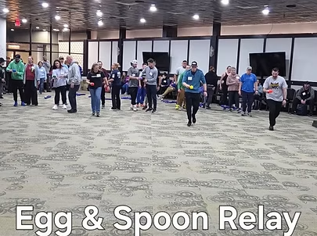
Fundamental Movement Skills
- Locomotor:
  - Running
Additional Skills
- Balance
- Coordination
- Concentration
- Body control
Grade Level
- Recommended Grades: K–8
- Adjust obstacle difficulty based on age and ability.
Equipment
- One egg and spoon set per game.
Equipment example:
- Crack'N Splat Egg and Spoon Set
Group Size
- Teams of approximately 3 players
Setup
- Divide students into teams.
- Teams line up behind a starting line.
- Create an obstacle course that each runner must complete while carrying the egg on the spoon.
Objective
For teams to successfully complete an obstacle course while carrying an egg on a spoon without dropping it.
Instructions
- The first player from each team holds the egg on the spoon.
- On the signal to begin, the player runs through the obstacle course and returns to their team.
- The player passes the spoon and egg to the next teammate.
- The next player completes the course.
- Continue until all players have completed the relay.
- If the egg falls, the player:
  - Stops,
  - Reassembles the egg if needed,
  - Places it back on the spoon,
  - Continues from where they stopped.
- For an added challenge, require players who drop the egg to restart the course.
Teaching Points
- Keep eyes focused ahead rather than only on the egg.
- Use small, controlled steps when changing directions.
- Keep the spoon level.
- Maintain good posture and balance.
- Encourage patience and control rather than rushing.

Modifications
Make it easier
- Remove obstacles.
- Allow students to hold the egg with two hands.
- Use larger or lighter objects instead of eggs.
Make it harder
- Add more obstacles.
- Increase running distance.
- Require specific movements such as hopping or side-shuffling.
Inclusion Ideas
- Allow students to move at their own pace.
- Use larger objects that are easier to balance.
- Provide alternate equipment such as foam eggs.
- Allow students to complete the course with a partner.
Safety Notes
- Space teams apart to avoid collisions.
- Ensure obstacle courses have safe pathways.
- Remind students to walk carefully near others.
- Avoid slippery surfaces.
Curriculum Outcomes
Physical Literacy
- Develop balance, coordination, and movement confidence.
Movement Skills
- Apply running and balance skills in a dynamic environment.
Personal and Social Responsibility
- Demonstrate patience, encouragement, and teamwork.

Health and Fitness
- Develop agility, coordination, and endurance.
Variations
- Use different objects instead of eggs.
- Add a memory challenge where students remember a sequence of movements.
- Create themed obstacle courses.

Burrowing
Video
- https://youtu.be/Hd94I-pGjFA?si=n9X9MkaFS9tHtWbl
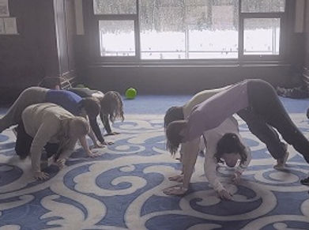
Skill Focus
Fundamental Movement Skills
- Locomotor:
  - Crawling
- Non-Locomotor:
  - Push-up position
  - Balance
Additional Skills
- Coordination
- Flexibility
- Cooperation
- Body awareness
Grade Level
- Recommended Grades: 2–8
Equipment
- One ball per group
Equipment example:
- Ball Equipment Collection
Group Size
- Teams of 3–5 players

Setup
- Teams lie down beside each other at a starting line.
- One player stands behind the line of players.
- The leader identifies how many times the team must complete the challenge.
- Players lying down prepare to create a bridge using a high plank/push-up position.
Objective
For players to move under their teammates as quickly as possible a set number of times.
Instructions
- On the signal to begin, players lying down move into a high bridge position.
- The standing player crawls underneath the bridge created by teammates.
- Once the player passes through, they extend the bridge by moving into position at the end of the line.
- The next player crawls underneath the team’s bridge.
- Continue until all players have crawled underneath the bridge the required number of times.
- Teams attempt to complete the challenge as quickly as possible.
Teaching Points
- Keep the body strong and stable while holding the bridge position.
- Move carefully and safely under teammates.
- Communicate when entering and exiting the tunnel.
- Maintain awareness of personal space.
- Work together to create a continuous flow.
Modifications
Make it easier
- Reduce the number of players.
- Allow players to hold a modified bridge position.
- Reduce the number of repetitions.

Make it harder
- Add more players to teams.
- Increase the number of repetitions.
- Add a ball that must travel through the tunnel.
Inclusion Ideas
- Allow students to crawl, slide, or use another safe movement method.
- Provide alternate bridge positions.
- Pair students strategically for support.
- Allow students to take leadership roles.
Safety Notes
- Ensure players maintain stable bridge positions.
- Remind crawlers to move slowly and carefully.
- Use adequate spacing between groups.
Curriculum Outcomes
Physical Literacy
- Develop movement confidence through challenging activities.
Movement Skills
- Demonstrate crawling, balance, and stability skills.
Personal and Social Responsibility
- Practice trust, communication, and teamwork.
Health and Fitness
- Develop strength, flexibility, and body control.
Variations
- Add more players to increase the challenge.
- Add a ball that must be carried through the tunnel.
  - Video: https://youtu.be/oVuwx-rANLE?si=Ul1DpIapdEELpQIz
- Create a timed team challenge.
Newspaper Run
Video
- https://youtu.be/991t6mm3LTk?si=KYRcjtIN8VPWFV8u
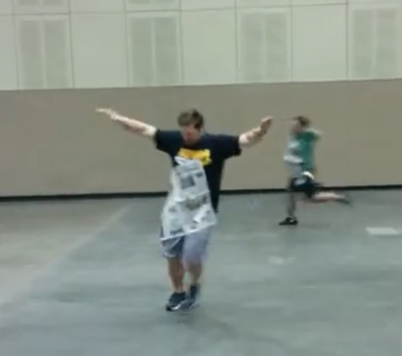
Skill Focus
Fundamental Movement Skills
- Locomotor:
  - Running
Additional Skills
- Speed
- Body control
- Problem-solving
- Coordination
Grade Level
- Recommended Grades: K–8
Equipment
- One sheet of newspaper per player
Group Size
- Individual activity, 3 to a team, or large group
Setup
- Players spread throughout the playing area.
- Each player holds one sheet of newspaper.
- Ensure enough space for everyone to move safely.
Objective
To run fast enough to keep a newspaper sheet attached to the front of the body without using hands.

Instructions
- On the leader’s signal, players place the newspaper against the front of their body.
- Players begin running to a designated spot, turn around, run back to their team, and gives the newspaper to the next player who runs...
- Students adjust their speed and movement to keep the newspaper from falling.
- Continue until players can successfully maintain control while running and complete the challenge a set number of times.
Teaching Points
- Find the correct speed needed to keep the paper in place.
- Run with good posture.
- Keep eyes up while moving.
- Use quick, controlled steps.
- Experiment with different speeds and body positions.
Modifications
Make it easier
- Allow students to walk or jog.
- Use larger pieces of paper.
- Reduce the movement area.
Make it harder
- Increase speed.
- Add changes of direction.
- Add stopping and starting challenges.
- Use smaller pieces of paper.

Inclusion Ideas
- Allow students to choose their movement speed.
- Provide different paper sizes or lightweight materials.
- Create partner challenges where students encourage each other.
- Allow wheelchair users or students with mobility differences to participate with adapted movement challenges.
Safety Notes
- Ensure students have enough space.
- Remind students to look where they are going.
- Avoid sudden changes of direction near others.
- Remove loose equipment from the playing area.
Curriculum Outcomes
Physical Literacy
- Develop confidence and creativity in movement.
Movement Skills
- Apply running technique and body control.
Personal and Social Responsibility
- Participate safely and respectfully.
Health and Fitness
- Develop speed, endurance, and movement awareness.
Variations
- Use different materials such as tissue paper, scarves, or foam sheets.
- Create races between groups.
- Challenge students to change directions while keeping the paper in place.
- Add music and have students move to different tempos.

Step Through Race
Video:
- https://youtu.be/SBiQG9djiwo?si=4pvUfG3z--WSHBTx
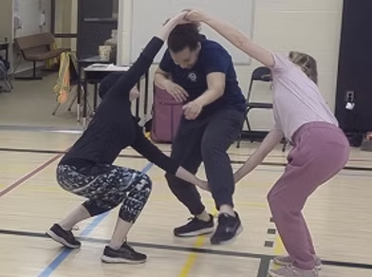
Skill Focus
- Cooperation
- Agility
- Body awareness
- Coordination
Additional Skills
- Communication
- Balance
- Spatial awareness
- Problem-solving
- Teamwork
Grade Level
- Grades K–6 (can be adapted for older students)
Equipment
- No equipment required
- Optional: Cones to designate activity areas
Group Size
- Groups of 3 players
Setup
- Divide players into groups of three.
- Each group stands together in an open space.
- Two players hold hands to create a large opening while the third player stands beside them.
- Ensure there is enough space between groups to move safely.
Objective
For groups of three to work together by taking turns stepping through a pair of joined hands as many times as possible within a set time or number of repetitions.
Instructions
- Two players hold hands to form an opening.
- The third player carefully steps through the opening created by the joined hands without letting the hands separate.
- Once through, players switch roles so another player becomes the one stepping through.
- Continue until each player has completed a turn.
- Repeat the sequence for a set number of rounds or within a designated time limit.
- The first group to complete the required number of rotations with good teamwork and safe movement wins.
Teaching Points
- Hold hands securely without pulling.
- Step carefully through the opening using controlled movements.
- Communicate before moving.
- Bend knees when stepping through lower openings.
- Work together rather than rushing.
- Encourage every teammate.
Modifications
- Allow players to raise or lower their joined hands depending on the size of the player stepping through.
- Replace stepping with crawling or ducking.
- Remove the competitive element and focus on completing the challenge together.
- Use a time challenge instead of a race.

Make It Easier
- Increase the size of the opening by extending arms.
- Allow players to release hands if necessary.
- Slow the pace.
- Provide demonstrations before beginning.
Make It Harder
- Require players to step through without touching the joined hands.
- Add multiple rounds.
- Perform the activity in silence using only non-verbal communication.
- Add movement between each turn (e.g., jog to a cone before switching roles).
- Time each group and challenge them to improve their score.
Inclusion Ideas
- Pair students thoughtfully to support success.
- Allow players with limited mobility to participate by directing teammates or adapting the movement.
- Increase the size of the opening as needed.
- Encourage teammates to adjust their positioning for different abilities.
- Remove competitive scoring if appropriate and celebrate successful teamwork.
Safety Notes
- Maintain enough space between groups.
- Hold hands gently—do not pull or twist.
- Move slowly when stepping through.
- Watch for balance and avoid pushing.
- Wear appropriate footwear and participate on a safe, non-slip surface.

Curriculum Outcomes
Students will:
- Develop locomotor movement skills.
- Demonstrate cooperative behaviours during physical activity.
- Apply communication and teamwork strategies.
- Improve body control and spatial awareness.
- Participate safely and respectfully in group challenges.
Physical Literacy
- Confidence in movement
- Competence with body control
- Motivation to participate
- Positive interaction with others
- Enjoyment through cooperative play
Movement Skills
Locomotor
- Step
- Walk
- Duck
- Crawl (optional)
Stability
- Balance
- Body control
- Bending
- Twisting

Personal and Social Responsibility
- Encourage teammates.
- Communicate respectfully.
- Take turns fairly.
- Demonstrate cooperation.
- Show perseverance.
- Include everyone.
Health and Fitness
- Coordination
- Agility
- Flexibility
- Dynamic balance
- Muscular endurance through repeated movement
- Social-emotional wellbeing through teamwork
Variations
- Timed Challenge: Count how many complete rotations each group can finish in one minute.
- Non-Stop Relay: Continue switching roles until the teacher signals stop.
- Travel Version: After each turn, the group jogs to another cone before continuing.
- Direction Change: Alternate stepping through from different sides each round.
- Silent Challenge: Groups complete the activity without speaking, using only gestures and eye contact.
- Cooperative Goal: Rather than racing, challenge the entire class to complete a combined total number of successful rotations.

Bean Bag Relays & Challenges

Tic Tac Toe — No Grid Relay
Video
- https://youtu.be/BqGmNFt9EO4?si=VuZVOAUrtlG7af5M
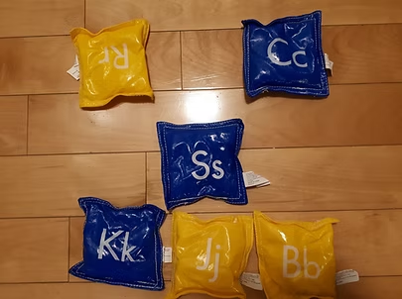
Skill Focus
Fundamental Movement Skills
- Locomotor:
  - Running
Additional Skills
- Strategy and problem-solving
- Cooperation
- Speed and agility
- Decision-making
Grade Level
- Recommended Grades: 1–8
Equipment
- Two sets of three playing objects per team:
  - Bean bags
  - Half cones
  - Foam squares
  - Other objects in two different colours
- One starting marker (line, spot, or bean bag)
Equipment example:
- Bean Bags

Group Size
- Teams of 3 players
- Two teams compete against each other
Setup
- Pair two teams together.
- Give each team three playing objects of the same colour.
- Place a starting marker 5–15 paces away from the playing area.
- Players line up behind the starting line, each holding one playing object.
- The playing area is an imaginary 3 × 3 grid.
Objective
To be the first team to get three markers in a row.
Instructions
- Teams decide who goes first using rock-paper-scissors.
- On the signal to begin, the first player from each team runs to the playing area and places their object.
- The first player returns while the next player runs forward.
- Players continue taking turns placing their markers.
- The first team to create three markers in a row earns a point.
- If neither team has three in a row after all markers are placed:
  - The first team moves one of their own markers to a new location.
  - The second team then moves one of their own markers.
- Continue until one team creates three in a row.

Teaching Points
- Think ahead before placing your marker.
- Balance speed with strategy.
- Communicate with teammates.
- Observe opponents’ moves.
- Encourage positive teamwork.
Modifications
Make it easier
- Reduce the distance between the starting line and grid.
- Use a smaller playing area.
- Allow teams more time to discuss strategy.
Make it harder
- Increase running distance.
- Add more markers.
- Require a movement challenge before placing a marker.
Inclusion Ideas
- Allow walking, jogging, or running.
- Assign roles such as strategist, encourager, or runner.
- Use larger objects that are easier to carry.
- Provide visual examples of possible moves.
Safety Notes
- Create separate running lanes.
- Remind students to look ahead while running.
- Avoid collisions near the grid.
- Keep equipment organized.

Curriculum Outcomes
Physical Literacy
- Develop movement confidence and decision-making.
Movement Skills
- Apply running skills in a game environment.
Personal and Social Responsibility
- Demonstrate teamwork and respectful competition.
Health and Fitness
- Participate actively while developing speed and agility.
Variations
Exercise Line Challenge
- Players waiting in line complete an assigned exercise each time a runner goes:
  - Five jumping jacks
  - Three push-ups
  - Two burpees
Dribbling Relay
- Players dribble a ball while carrying a playing object to the grid.
- After placing the object, they pass the ball back to the next teammate.
Questions for Understanding
- What strategies help your team win?
- How can communication improve team success?

Hidden Treasurer
Video
- https://youtu.be/KzI7UafEtrw?si=FA2dnSdfj56nhv79
Skill Focus
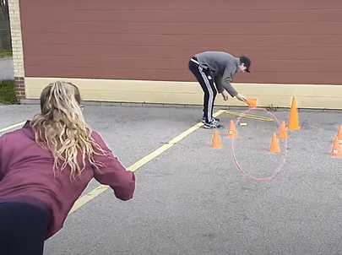
Fundamental Movement Skills
- Manipulative:
  - Sending
  - Rolling
Additional Skills
- Accuracy
- Strategy
- Observation
- Teamwork
Grade Level
- Recommended Grades: 1–8
Equipment
- 9 or 16 cones
- 4–9 bean bags
- 2 hula hoops
Equipment examples:
- Hula Hoops
Group Size
- Teams of 2–5 players

Setup
- Arrange cones in a grid pattern.
- Hide bean bags underneath selected cones.
- Place rolling spots 8–12 paces away from the grid.
- Teams line up behind their rolling spot.
- Each team receives a hoop.
Objective
To collect the most hidden bean bags.
Instructions
- The first player from each team rolls their hula hoop toward the cone grid.
- If the hoop lands around a cone, the player checks underneath.
- If a bean bag is found, the player returns it to their team for one point.
- The player returns the hoop to the next teammate.
- Continue until all hidden bean bags are collected.
- The team with the most bean bags wins.
Teaching Points
- Use controlled force when rolling the hoop.
- Aim carefully before releasing.
- Watch where bean bags are found.
- Communicate discoveries with teammates.
- Support teammates positively.
Modifications
Make it easier
- Reduce the distance.
- Use fewer cones.
- Make the grid smaller.

Make it harder
- Increase the number of cones.
- Increase rolling distance.
- Allow teams to remember locations without writing them down.
Inclusion Ideas
- Allow different rolling distances.
- Use larger hoops.
- Provide partner support.
- Assign memory or communication roles.
Safety Notes
- Avoid throwing hoops.
- Collect equipment carefully.
Curriculum Outcomes
Physical Literacy
- Develop object-control skills and confidence.
Movement Skills
- Demonstrate rolling accuracy and control.
Personal and Social Responsibility
- Communicate and support teammates.
Health and Fitness
- Encourage active participation and movement.
Variations
- Increase the number of hidden bean bags.
- Use different objects instead of bean bags.
Questions for Understanding
- What techniques help the hoop land around a cone?
- How can teammates help remember locations?
Flip Beanbag into Hoop
Video
- https://youtu.be/4KcJ6y7BHCg?si=5-ljK8e40c71HZuK
Skill Focus
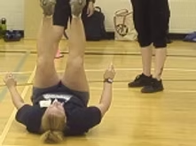
Fundamental Movement Skills
- Non-Locomotor:
  - Sit-up movement
  - Core control
Additional Skills
- Coordination
- Accuracy
- Upper and lower body control
Grade Level
- Recommended Grades: 2–8
Equipment
- One hula hoop per pair
- One bean bag per pair
Equipment example:
- Bean Bags Collection
Group Size
- Partners
Setup
- Partners stand behind a starting line.
- Each pair has one hoop and one bean bag.
- Players have enough space to safely complete sit-up movements.

Objective
To move a hoop down the floor by successfully tossing a bean bag into it from a sit-up position.
Instructions
- On the signal, each pair tosses their hoop forward a reasonable distance.
- The first player lies down in a sit-up position.
- The player places the bean bag between their feet.
- The player attempts to toss the bean bag into the hoop.
- When successful, the player moves the hoop forward and repeats.
- Continue until the challenge is completed.
Teaching Points
- Use controlled movements.
- Engage core muscles during the sit-up.
- Focus on accuracy rather than force.
- Adjust body position based on success.
- Encourage partners.
Modifications
Make it easier
- Move the hoop closer.
- Allow students to hold and toss the bean bag.
- Use larger hoops.
Make it harder
- Increase distance.
- Use smaller targets.
- Add a time challenge.

Inclusion Ideas
- Allow students to choose a comfortable position.
- Provide alternative throwing methods.
- Use larger targets.
- Work with a partner for support.
Safety Notes
- Provide enough space between pairs.
- Ensure students do not throw bean bags toward others.
- Remind students to control sit-up movements.
Curriculum Outcomes
Physical Literacy
- Develop confidence in body control and coordination.
Movement Skills
- Apply object-control skills with accuracy.
Personal and Social Responsibility
- Cooperate with partners.
Health and Fitness
- Develop core strength and control.
Variations
- Hold the bean bag in hands and toss from a sit-up position.
- Use different throwing challenges.
Questions for Understanding
- What helps you successfully land the bean bag in the hoop?
- How can you adjust your technique after an unsuccessful attempt?

Smaller Ball Relays

Team Planks Caterpillar Relay
Video
- https://youtu.be/SIvkXQcH1ww?si=Jbm4ws-vckz2-JN8
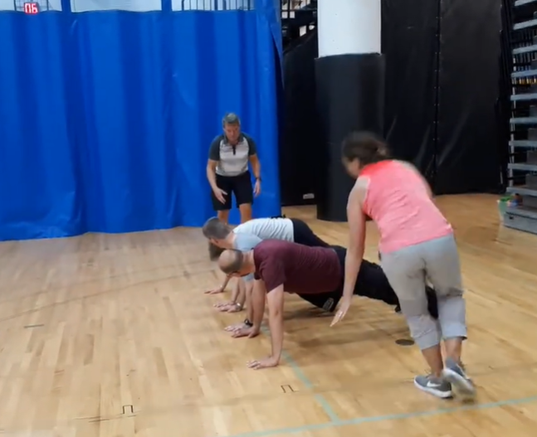
Skill Focus
Fundamental Movement Skills
- Locomotor:
  - Running
- Non-Locomotor:
  - Balance
  - Core stability
Additional Skills
- Cooperation
- Coordination
- Communication
- Strength and endurance
Grade Level
- Recommended Grades: 3–8
- Adjust the physical demands based on student age and ability.
Equipment
- One foam ball per team of 5–7 players
Equipment example:
- Foam Balls
Group Size
- Teams of 5–7 players

Setup
- Teams line up behind a starting line.
- One player begins holding the ball at the start line.
- Three players move into a push-up position to create a tunnel.
- One player stands at the end of the line ready to retrieve the ball.
- Players leave enough space between teams to safely complete the activity.
Objective
Be the first team to complete a set number of repetitions of the challenge.
Instructions
- On the signal to begin, the first player rolls the ball underneath the players holding the push-up position.
- After rolling the ball, the player moves into a push-up position beside the player in front of them, extending the caterpillar line.
- The player at the end of the line retrieves the ball.
- The player with the ball runs back to the beginning of the line.
- The player rolls the ball underneath the players and then joins the caterpillar line.
- Continue the pattern until the original starting player has received and held the ball for the fifth time.
- The first team to complete the required number of repetitions wins.
Teaching Points
- Maintain a strong plank/push-up position:
  - Hands under shoulders.
  - Body in a straight line.
  - Engage core muscles.
- Communicate with teammates before moving.
- Roll the ball accurately through the tunnel.
- Move quickly while maintaining control.
- Work together to create a smooth rhythm.
Modifications
Make it easier
- Reduce the number of repetitions.
- Allow players to use knees instead of toes during the push-up position.
- Use a larger foam ball.
Make it harder
- Increase team size.
- Increase the number of repetitions.
- Add movement challenges between turns.
- Require players to maintain plank position longer.
Inclusion Ideas
- Allow students to choose a plank position that works for them.
- Assign different roles such as roller, communicator, or encourager.
- Use larger balls that are easier to control.
- Allow students to move at a comfortable pace.
Safety Notes
- Ensure students maintain enough space between teams.
- Teach proper plank technique to avoid strain.
- Avoid collapsing onto teammates.
- Ensure players move carefully when entering and leaving plank positions.
Curriculum Outcomes
Physical Literacy
- Develop confidence in a variety of movement patterns.
Movement Skills
- Demonstrate locomotor and non-locomotor skills using control and coordination.
Personal and Social Responsibility
- Demonstrate cooperation and teamwork.
Health and Fitness
- Develop muscular endurance, balance, and active participation.
Variations
Wave Push-Up
- When the ball rolls past a player, that player completes one push-up, creating a wave pattern.
Leap Over Challenge
- Instead of running around the team, the player with the ball leaps over each teammate one at a time.
- Video: https://youtu.be/OCwk507Hb6g?si=1FhgpEGRbtPJd9hD
Questions for Understanding
- What strategies help your team complete the challenge faster?
- How does communication affect your team’s success?

Pass Circle Relay
Video
- https://youtu.be/6cBENVd2Y98?si=TWumfkjIWUbU6jHN
Skill Focus
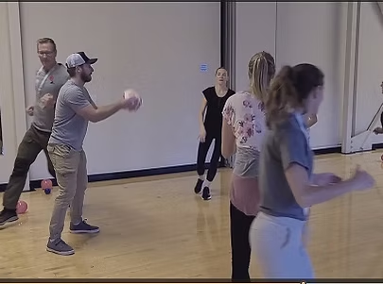
Fundamental Movement Skills
- Locomotor:
  - Running
Additional Skills
- Speed and agility
- Spatial awareness
- Teamwork and communication
Grade Level
- Recommended Grades: K–8
- Can be adapted for younger students with shorter distances or larger spaces.
Equipment
- One ball per group
Group Size
- Teams of 5–7 players
Setup
- Players form a circle with a diameter of at least 8 paces.
- Each team creates its own circle.
- Players stand evenly spaced around the circle.
- One player holds a ball
Objective
To complete the circle running relay as quickly as possible.

Instructions
- Player #1 begins by tossing the ball to another player and then running completely around the outside of the circle.
- The player that receives the ball passes the ball to another player and then runs completely around the outside of the circle.
- Play continues till all players have completed a set number of passes and circle runs.
- Teams can be timed to improve their personal best or compete against other groups to see which team finishes first.
Teaching Points
- Run with eyes up and be aware of other players.
- Accelerate quickly when beginning the relay.
- Maintain a controlled pace to avoid collisions.
- Encourage teammates by communicating and cheering.
- Use proper running technique:
  - Pump arms forward and backward.
  - Stay balanced while changing direction.
  - Run with quick, light steps.
Modifications
Make it easier
- Increase the size of the circle.
- Allow players to walk or jog.
- Reduce the number of players in each group.
Make it harder
- Decrease the circle size.
- Require players to weave between teammates.
- Add a skill challenge before tagging the next player.

Inclusion Ideas
- Allow students to choose walking, jogging, or running speeds.
- Provide a partner runner for students who need additional support.
- Use visual or verbal cues for students who benefit from predictable routines.
- Create roles such as runner, timer, or encourager so all students contribute.
Safety Notes
- Ensure enough space between players.
- Remind runners to look ahead and avoid cutting too closely around teammates.
- Use a non-slip surface.
- Avoid pushing or blocking other runners.
Curriculum Outcomes
Physical Literacy
- Develop confidence and competence in running, throwing, and catching movements.
Movement Skills
- Demonstrate locomotor skills using appropriate technique.
Personal and Social Responsibility
- Work cooperatively and encourage teammates.
Health and Fitness
- Improve cardiovascular endurance and speed.
Variations
Circle Weave
- Players weave in and out between teammates instead of running around the outside of the circle.

Basketball Robin's Nest
Video
- https://youtu.be/0p446FpzfFs?si=kmyiORq3YMw8Dgdc
Skill Focus
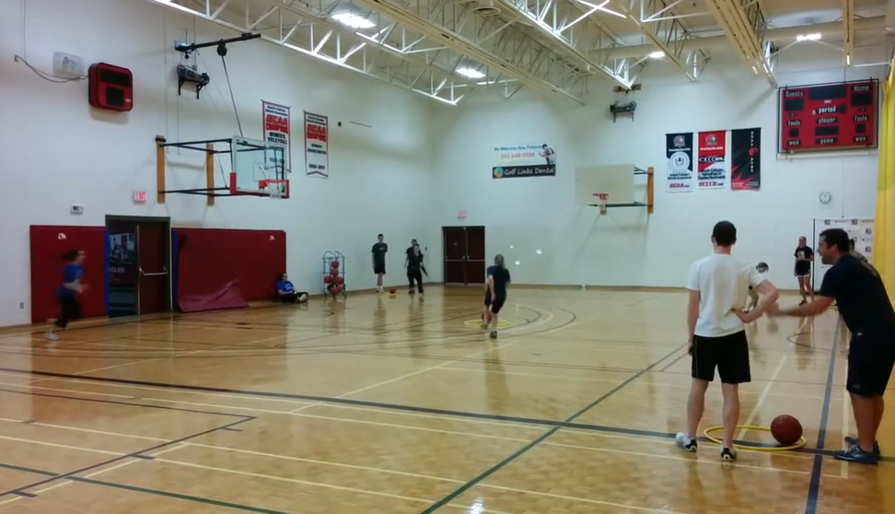
- Basketball dribbling
- Ball control
- Team strategy
- Agility
Additional Skills
- Running
- Decision-making
- Spatial awareness
- Communication
- Cooperation
- Offensive strategy
Grade Level
- Grades 2–8 (adapt distance, number of basketballs, and rules to suit learners)
Equipment
For four teams of three players:
- 4–5 basketballs
- 5 hula hoops
- Optional: Cones to mark boundaries
Group Size
- 12 players (4 teams of 3)
- Can be adapted for larger or smaller groups by adjusting the number of teams and equipment.

Setup
- Place four hula hoops in a large square, approximately 10–15 paces apart.
- Position one hula hoop in the centre of the square.
- Place all basketballs inside the centre hoop.
- Each team stands behind one outside hoop, which serves as their team's "nest."
- Ensure there is adequate space between hoops for safe movement.
Objective
To be the first team to collect three basketballs in their team's hoop by dribbling balls from the centre or stealing them from other teams once the centre supply is empty.
Instructions
- On the teacher's signal, the first player from each team runs to the centre hoop.
- The player picks up one basketball and dribbles it back to their team's hoop.
- Once the basketball is placed inside the team's hoop, the next teammate begins their turn.
- Players continue taking turns retrieving basketballs from the centre.
- When all basketballs have been removed from the centre hoop, players may steal one basketball at a time from another team's hoop.
- Players must always dribble the basketball while travelling back to their own hoop.
- The first team to have three basketballs in their hoop at the same time wins.
Teaching Points
- Keep eyes up while dribbling.
- Dribble with fingertips rather than slapping the ball.
- Keep the ball at waist height or lower.
- Control speed while changing direction.
- Place the ball securely inside the hoop before the next teammate begins.
- Communicate with teammates about which hoops to target.
- Encourage teamwork and positive sportsmanship.

Modifications
- Allow players to carry the basketball instead of dribbling.
- Require only two basketballs to win.
- Increase or decrease the distance between hoops.
- Limit stealing until every team has collected one basketball.
- Play cooperatively by challenging the class to move all basketballs within a set time.
Make It Easier
- Reduce the distance to the centre hoop.
- Use playground balls or larger basketballs.
- Allow players to stop and restart their dribble if they lose control.
- Remove the stealing rule.
- Provide extra basketballs so more are available in the centre.
Make It Harder
- Require players to use their non-dominant hand.
- Add cones players must dribble around before returning.
- Require crossover or change-of-direction dribbles.
- Increase the number of basketballs needed to win.
- Allow only one steal from the same team before choosing another target.
- Introduce a time limit for each turn.
Inclusion Ideas
- Adjust dribbling distance based on ability.
- Use lighter or smaller basketballs.
- Allow players to carry or bounce the ball at their own pace.
- Pair students with supportive teammates.
- Give students with limited mobility leadership roles such as directing team strategy or keeping score, or adapt movement expectations to individual needs.
- Celebrate teamwork and effort rather than only winning.
Safety Notes
- Keep heads up while moving to avoid collisions.
- Maintain adequate space between teams.
- No physical contact or blocking other players.
- Only one basketball may be carried or dribbled at a time.
- Return basketballs under control to prevent rolling hazards.
- Ensure the playing surface is free of obstacles.
Curriculum Outcomes
Students will:
- Demonstrate control while dribbling a basketball.
- Apply movement skills in dynamic game situations.
- Develop offensive strategies and decision-making.
- Work cooperatively to achieve a team objective.
- Demonstrate fair play and safe participation.
Physical Literacy
- Develop confidence with basketball skills.
- Improve competence in object control.
- Build motivation through active participation.
- Apply movement skills in game situations.
- Foster enjoyment of teamwork and physical activity.
Movement Skills
Locomotor
- Run
- Jog
- Change direction

Manipulative
- Dribble
- Control
- Retrieve
- Place
Stability
- Balance
- Stop
- Pivot
- Body control
Personal and Social Responsibility
- Take turns responsibly.
- Communicate effectively.
- Encourage teammates.
- Demonstrate honesty and fair play.
- Respect opponents and equipment.
- Cooperate to achieve a common goal.
Health and Fitness
- Cardiovascular endurance
- Agility
- Coordination
- Speed
- Muscular endurance
- Reaction time

Variations
- No Stealing: Teams may only collect basketballs from the centre.
- Non-Dominant Hand Challenge: Players dribble using only their non-dominant hand.
- Obstacle Course: Add cones that players must weave through before returning.
- Fitness Relay: Before retrieving a basketball, players complete a movement task (e.g., five jumping jacks or three squats).
- Passing Version: Instead of dribbling all the way back, teammates pass the basketball to one another before placing it in the hoop.

Double Dribble
Video
- https://youtu.be/UU-yzyf7bZc?si=N-q4lQx6V6-hrMWw
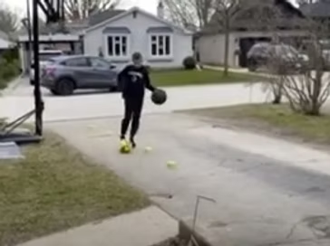
Skill Focus
- Simultaneous ball control
- Hand-eye and foot-eye coordination
- Dribbling
- Concentration
Additional Skills
- Multitasking
- Agility
- Balance
- Spatial awareness
- Coordination
- Focus
Grade Level
- Grades 4–12 (can be adapted for younger or older students by modifying equipment and distances)
Equipment
For each group of two:
- 1 basketball
- 1 soccer ball
- 4 cones or pylons
Group Size
- 3-4 players per team.
- Multiple pairs can participate simultaneously using separate courses.

Setup
- Place four cones in a straight line, approximately 2–4 steps apart.
- One player stands behind the first cone holding a basketball.
- Position a soccer ball at the player's feet.
- The second player waits beside the course and prepares for the next turn.
- Ensure there is enough space between courses to prevent collisions.
Objective
To complete the cone course as quickly as possible while simultaneously dribbling a basketball with the hands and controlling a soccer ball with the feet.
Instructions
- On the teacher's signal, the player begins dribbling the basketball while moving the soccer ball with their feet.
- The player weaves around each cone while maintaining control of both balls.
- After reaching the final cone, the player returns through the course to the starting point.
- Stop the timer when both balls return behind the starting cone.
- The partner completes the course after the first player finishes.
- Compare times or challenge players to improve their own personal best.
Teaching Points
- Keep your eyes up as much as possible.
- Use fingertips to control the basketball.
- Use gentle touches with the inside or outside of the foot to control the soccer ball.
- Move at a controlled speed before increasing pace.
- Stay close to both balls.
- Focus on smooth, consistent movement rather than rushing.
- Recover calmly if one ball gets away.

Modifications
- Complete only half the course.
- Dribble only one ball at a time.
- Walk instead of running.
- Increase the distance between cones.
- Allow players to stop and regain control before continuing.
Make It Easier
- Use larger playground balls.
- Reduce the number of cones.
- Increase spacing between cones.
- Carry the basketball while dribbling only the soccer ball.
- Remove the weaving requirement and travel in a straight line.
Make It Harder
- Use the non-dominant hand and non-dominant foot.
- Add more cones or tighter turns.
- Introduce a timed challenge.
- Require continuous movement without stopping.
- Add changes of direction or figure-eight patterns.
- Include additional movement tasks (e.g., pivot at each cone).
Inclusion Ideas
- Adjust cone spacing and course length to suit individual abilities.
- Use lighter, softer, or larger balls as needed.
- Allow students to complete one dribbling task at a time before progressing to both.
- Pair students for encouragement and feedback.
- Focus on personal improvement rather than competition.
- Adapt movement expectations to support students with diverse physical abilities.

Safety Notes
- Maintain adequate spacing between courses.
- Keep heads up to avoid collisions.
- Control both balls at all times.
- Ensure the playing surface is flat and free of hazards.
- Retrieve loose balls safely before continuing.
- Wear appropriate athletic footwear.
Curriculum Outcomes
Students will:
- Demonstrate control of objects using both hands and feet.
- Develop coordination while performing multiple movement tasks simultaneously.
- Apply focus and concentration during physical activity.
- Improve agility and movement efficiency.
- Demonstrate perseverance when learning challenging skills.
Physical Literacy
- Develop confidence through challenging movement experiences.
- Improve competence with multiple object-control skills.
- Build motivation by tracking personal progress.
- Enhance coordination and movement efficiency.
- Foster resilience through practice and persistence.
Movement Skills
Locomotor
- Run
- Walk
- Change direction

Manipulative
- Basketball dribble
- Soccer dribble
- Bounce
- Control
Stability
- Balance
- Pivot
- Body control
- Weight transfer
Personal and Social Responsibility
- Demonstrate perseverance.
- Encourage partners.
- Respect equipment and personal space.
- Celebrate improvement.
- Practice patience while waiting for a turn.
- Display honesty when recording times.
Health and Fitness
- Cardiovascular endurance
- Coordination
- Agility
- Dynamic balance
- Reaction time
- Concentration and cognitive engagement

Variations
- Non-Dominant Challenge: Dribble the basketball with the non-dominant hand and the soccer ball with the non-dominant foot.
- Figure-Eight Course: Arrange cones in a figure-eight pattern instead of a straight line.
- Obstacle Course: Add additional cones, hoops, or agility ladders to increase the challenge.
- Partner Relay: Partners alternate completing the course, combining their times for a team score.
- Mirror Challenge: One player leads while the partner mirrors the same movements on a parallel course.
- Personal Best Challenge: Record individual times over several rounds and aim to improve each attempt.
- Cooperative Challenge: Instead of racing, pairs work together to complete the course without either ball leaving the designated pathway.

Tunnel Roll
Video
- https://youtu.be/sEfeXmmcIV0?si=Brn9wN0EYyrs_yr1
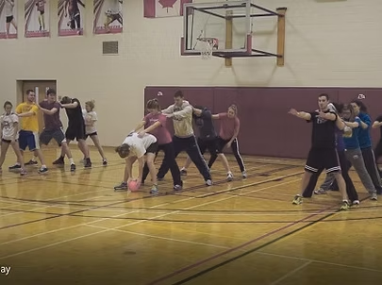
Skill Focus
Fundamental Movement Skills
- Manipulative (Send):
  - Rolling
Additional Skills
- Accuracy
- Teamwork
- Coordination
- Communication
Grade Level
- Recommended Grades: K–8
- Adjust team size and rolling distance to suit student ability.
Equipment
- One ball per team of 3–5 players
Equipment example:
- Ball Collection: https://www.gophersport.com/search-unbxd?q=ball
Group Size
- Teams of 3–5 players
Setup
- Teams stand in single-file lines facing the same direction.
- Players spread their feet shoulder-width apart to create a tunnel.
- Position teams near a wall or end line to prevent balls from rolling away.
- The player at the front of each line begins with the ball.

Objective
Be the first team to have every player roll the ball through the tunnel and return to the front a designated number of times.
Instructions
- On the teacher's signal, the first player rolls the ball between the legs of all teammates.
- The last player stops the ball.
- The last player runs to the front of the line with the ball.
- That player rolls the ball through the tunnel.
- Continue until the original front player returns to the front of the line.
- This counts as one complete rotation.
- Continue until the designated number of rotations has been completed.
- The first team to finish wins.
Teaching Points
- Roll the ball smoothly and accurately.
- Keep legs wide to create a clear tunnel.
- Stay alert and ready to receive the ball.
- Move quickly to the front while maintaining control.
- Communicate with teammates.
Modifications
Make it easier
- Reduce team size.
- Use a larger, slower-moving ball.
- Shorten the required number of rotations.

Make it harder
- Increase team size.
- Require non-dominant hand rolling.
- Increase the number of rotations.
- Add movement challenges before returning to the front.
Inclusion Ideas
- Allow walking instead of running.
- Use larger foam balls.
- Assign supportive roles such as scorekeeper or encourager.
- Adjust spacing between players.
Safety Notes
- Ensure players have stable footing.
- Leave adequate space between teams.
- Roll balls only along the floor.
- Encourage controlled movement when running to the front.
Curriculum Outcomes
Physical Literacy
- Develop confidence with object-control skills.
Movement Skills
- Demonstrate rolling accuracy and teamwork.
Personal and Social Responsibility
- Cooperate and communicate effectively.
Health and Fitness
- Participate in moderate to vigorous physical activity while developing coordination.

Variations
- Use different-sized balls.
- Change rolling distance.
- Add locomotor movements before joining the front of the line.
Questions for Understanding
- What helps ensure the ball rolls successfully through every player's legs?

Larger Ball Relays

Pass Relay
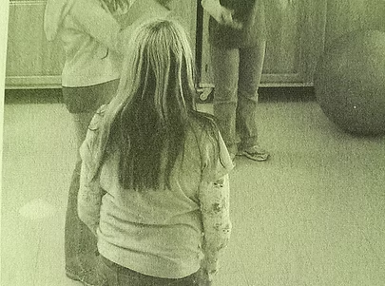
Skill Focus
Fundamental Movement Skills
- Manipulative (Send):
  - Throw
- Manipulative (Receive):
  - Catch
Additional Skills
- Hand-eye coordination
- Communication
- Teamwork
- Rhythm and timing
Grade Level
- Recommended Grades: 2–8
- Adapt passing distance and ball size to suit student ability.
Equipment
- One stability ball, Omnikin Six ball, or other ball per group of three players
Equipment example:
- Stability Ball: https://www.gophersport.com/fitness/stability-balls/ultrafit-stability-balls
Group Size
- Groups of 3 players

Setup
- Players stand in a straight line approximately 3–5 paces apart.
- One player at an end of the line begins with the ball.
Objective
Complete as many passing laps as possible within the designated time.
Instructions
- On the teacher's signal, the first player passes the ball to the middle player.
- The middle player passes the ball to the player at the opposite end.
- The player at the end passes the ball back to the middle player.
- The middle player returns the ball to the first player.
- One complete sequence counts as one lap.
- Continue passing until the teacher signals "Stop."
- Count the number of completed laps.
- Repeat and encourage teams to improve their score.
Teaching Points
- Step toward the target when passing.
- Watch the ball into the hands when catching.
- Use soft hands when receiving.
- Communicate by calling teammates' names.
- Maintain ready body position throughout the activity.
Modifications
Make it easier
- Move players closer together.
- Use a lighter or larger ball.
- Allow underhand passes only.

Make it harder
- Increase passing distance.
- Specify passing types (chest, bounce, overhead).
- Larger balls are more difficult than smaller balls.
Inclusion Ideas
- Adjust spacing for student ability.
- Allow seated passing if needed.
- Pair experienced students with beginners.
- Use larger or softer balls for students needing additional support.
Safety Notes
- Ensure adequate spacing between groups.
- Use soft balls.
- Encourage controlled throws.
- Remind players to stay alert while catching.
Curriculum Outcomes
Physical Literacy
- Develop confidence in throwing and catching.
Movement Skills
- Demonstrate manipulative skills with increasing accuracy.
Personal and Social Responsibility
- Communicate effectively and cooperate with teammates.
Health and Fitness
- Participate actively while improving coordination.

Variations
Round the Triangle Pass Relay
- Players form a triangle and pass continuously around the triangle for a set time.
- Challenge students to use different types of passes.
Challenge Option
- Use a Ballast™ Stability Ball for an added level of difficulty.

Crab Walk Relay
Skill Focus
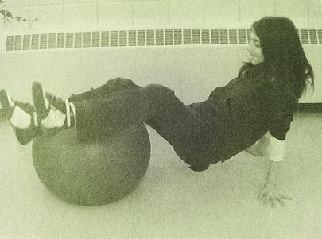
Fundamental Movement Skills
- Locomotor:
  - Crab walk
Additional Skills
- Balance
- Core strength
- Coordination
- Muscular endurance
Grade Level
- Recommended Grades: 3–12
- Reduce distances for younger students.
Equipment
- One stability ball or Omnikin Six ball per team of 3–4 players
- One cone per team
Equipment example:
- Stability Ball: https://www.gophersport.com/fitness/stability-balls/ultrafit-stability-balls
Group Size
- Teams of 3–4 players
Setup
- Establish a starting line.
- Position one cone approximately two paces away.
- Teams line up behind the starting line.
- The first player assumes the crab walk position with heels and calves resting on the stability ball.

Objective
Be the quickest team to complete the crab walk relay while maintaining control of the stability ball.
Instructions
- On the teacher's signal, the first player crab walks around the cone and back.
- Upon returning, the player touches the starting line with their hands.
- The player stands, places the ball under the next teammate's feet, and moves to the end of the line.
- The next player repeats the relay.
- Waiting teammates perform slow jumping jacks and encourage the active player.
- After all teammates have completed the relay, the team sits down.
- The first seated team wins.
Teaching Points
- Lift hips to maintain a strong crab position.
- Keep feet balanced on the ball.
- Move with controlled hand and foot movements.
- Maintain body control while turning around the cone.
- Encourage teammates throughout the relay.
Modifications
Make it easier
- Reduce the distance.
- Allow brief rest breaks.
- Use a smaller cone course.
Make it harder
- Increase the distance.
- Add additional cones.
- Introduce timed challenges.

Inclusion Ideas
- Allow alternative locomotor movements.
- Aid with ball positioning.
- Use partner support.
- Reduce the course length as needed.
Safety Notes
- Ensure adequate spacing between teams.
- Use non-slip surfaces.
- Encourage slow, controlled movement.
- Supervise turning around cones carefully.
Curriculum Outcomes
Physical Literacy
- Develop confidence in challenging movement tasks.
Movement Skills
- Demonstrate balance, coordination, and locomotor control.
Personal and Social Responsibility
- Encourage teammates and demonstrate perseverance.
Health and Fitness
- Develop upper-body strength, core stability, and muscular endurance.
Variations
Crab Walk Balance
- Players keep both feet on the floor while balancing the stability ball on their abdomen during the crab walk.
- Adjust the cone distance to match students' ability levels.

Circle
Skill Focus
- Rolling accuracy
- Ball control
- Teamwork
- Coordination
Additional Skills
- Running
- Spatial awareness
- Communication
- Cooperation
- Balance
- Timing
Grade Level
- Grades K–6 (can be adapted for older students by increasing speed or adding skill challenges)
Equipment
For each team:
- 1 stability ball or Omnikin Six ball per team
Optional:
- Cones to designate team spaces
Group Size
- Teams of 4–6 players

Setup
- Divide players into teams of four to six.
- Each team forms a tight circle with a stability ball placed in the centre.
- Number players consecutively (1, 2, 3, etc.) in a counterclockwise direction.
- Ensure there is enough space between teams for safe movement around the outside of the circle.
Objective
To be the first team to have every player successfully roll the stability ball around the outside of their team's circle twice (or the designated number of laps) while working together safely and cooperatively.
Instructions
- On the teacher's signal, Player 1 removes the stability ball from the centre.
- Player 1 rolls the ball on the floor around the outside of the team's circle in a counterclockwise direction while moving with it.
- Once Player 1 returns to their starting position, they place the ball back in the centre or hand it to Player 2.
- Player 2 repeats the activity.
- Continue until every player has completed the relay.
- After the final player finishes, the entire team lifts the ball together above their heads and celebrates by cheering, "We are the champions!"
- The first team to complete the relay safely and correctly wins.
Teaching Points
- Roll the ball with controlled force.
- Stay close to the ball while moving.
- Keep eyes forward to avoid collisions.
- Wait until the previous player has completely finished before beginning.
- Encourage teammates throughout the relay.
- Work together to celebrate the team's success.

Modifications
- Allow players to walk instead of run.
- Reduce the size of the team circle.
- Use a playground ball instead of a stability ball.
- Change the direction of travel each round.
- Complete one lap instead of two.
Make It Easier
- Walk while rolling the ball.
- Use a smaller circle.
- Use a lighter ball that is easier to control.
- Allow players to stop and reposition the ball if needed.
- Reduce the total number of laps.
Make It Harder
- Increase the number of laps around the circle.
- Require players to bounce the ball instead of rolling it.
- Roll using only one hand.
- Increase the size of the circle.
- Add obstacles players must navigate around while keeping control of the ball.
- Complete the relay using the non-dominant hand.
Inclusion Ideas
- Allow players to move at their own pace.
- Adjust the size or weight of the ball based on ability.
- Pair students for support if needed.
- Allow players using mobility aids to roll or guide the ball over a shorter distance.
- Celebrate teamwork, encouragement, and participation rather than only speed.

Safety Notes
- Ensure adequate space between teams.
- Always keep the ball on the floor.
- Watch for other players while moving around the circle.
- Avoid pushing or reaching across teammates.
- Lift the stability ball together using controlled movements.
- Play on a flat, non-slip surface.
Curriculum Outcomes
Students will:
- Demonstrate control while rolling a large ball.
- Apply movement skills during cooperative relays.
- Develop communication and teamwork strategies.
- Improve coordination and spatial awareness.
- Participate safely and respectfully during physical activity.
Physical Literacy
- Build confidence in object-control skills.
- Improve movement competence.
- Develop motivation through cooperative play.
- Increase enjoyment of active participation.
- Strengthen teamwork and communication skills.
Movement Skills
Locomotor
- Run
- Walk
- Change direction

Manipulative
- Roll
- Guide
- Control
- Bounce (variation)
Stability
- Balance
- Bend
- Reach
- Body control
Personal and Social Responsibility
- Encourage teammates.
- Take turns fairly.
- Demonstrate positive communication.
- Respect others and equipment.
- Cooperate to achieve a common goal.
- Celebrate everyone's contribution.
Health and Fitness
- Cardiovascular endurance
- Coordination
- Agility
- Dynamic balance
- Muscular endurance
- Reaction time

Variations
- Soccer Circle Relay: Players move the ball around the circle using only their feet.
- Bounce Circle Relay: Players continuously bounce the ball while travelling around the circle.
- Reverse Direction: Complete the relay clockwise instead of counterclockwise.
- Double Lap Challenge: Each player completes two full laps before passing the ball.
- Silent Relay: Teams complete the activity without speaking, using only gestures and eye contact.
- Cooperative Challenge: Rather than racing, challenge all teams to finish within a set time while encouraging one another.
- Obstacle Relay: Place cones around the outside of the circle for players to weave through while maintaining control of the ball.

Cross Curricular Relays

Quick Count Relay
Video
- https://youtu.be/DBOfDfF58xc?si=6pB2-eSq05mU8Tk4
Skill Focus
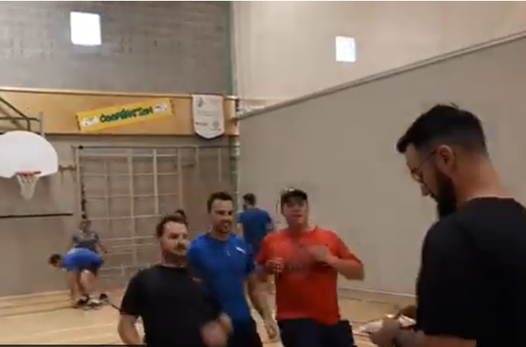
Fundamental Movement Skills
- Locomotor:
  - Running
Additional Skills
- Mental math
- Decision-making
- Communication
- Teamwork
Grade Level
- Recommended Grades: 2–12
- Adjust the mathematical operations to match students’ abilities.
Equipment
- One deck of playing cards
- Letter markers (e.g., Popsicle sticks, tongue depressors, rubber markers)
Group Size
- Teams of 3 players
Setup
- Teams stand behind a starting line.
- The teacher stands approximately 10 paces away with a deck of cards.
- Letter markers are placed beside the teacher.

Objective
Answer math problems faster than opposing teams to collect letters and be the first team to spell a designated word.
Instructions
- On the teacher's signal, the first player from each team runs to the teacher.
- The teacher reveals two playing cards.
- Players solve the required operation (addition, subtraction, multiplication, or another chosen operation).
- The first player to answer correctly earns one letter marker.
- The player returns the marker to the team.
- The next teammates repeat the process.
- Teams continue collecting letters until one team successfully spells the target word.
Teaching Points
- Think carefully before answering.
- Balance speed with accuracy.
- Encourage teammates.
- Use positive communication.
- Develop efficient strategies for spelling words.
Modifications
Make it easier
- Use addition only.
- Reduce running distance.
- Use shorter words.
Make it harder
- Include multiplication or division.
- Increase word length.
- Require complete sentences or multiple words.

Inclusion Ideas
- Differentiate mathematical operations.
- Pair students for collaborative problem-solving.
- Allow verbal support from teammates.
- Use picture or colour-coded letter markers.
Safety Notes
- Space teams adequately.
- Ensure runners look ahead.
- Encourage controlled movement.
- Keep equipment organized.
Curriculum Outcomes
Physical Literacy
- Combine movement with cognitive challenges.
Movement Skills
- Demonstrate running while transitioning safely.
Personal and Social Responsibility
- Communicate respectfully and encourage teammates.
Cross-Curricular Learning
- Apply mental mathematics and spelling skills in an active environment.
Variations
- Use multiplication, subtraction, or division challenges.
- Spell curriculum vocabulary words.
- Increase the number of required letters.

Word Relay
Video
- https://youtu.be/pA1QaTHpTIY?si=kDeJTQjixMSN5Bd1
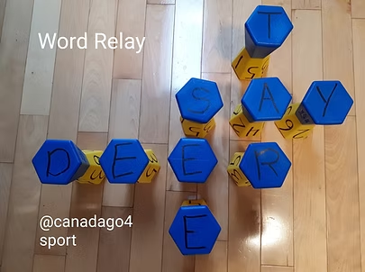
Skill Focus
Fundamental Movement Skills
- Locomotor:
  - Running
Additional Skills
- Literacy
- Problem-solving
- Communication
- Team strategy
Grade Level
- Recommended Grades: 3–8
Equipment
- Two sets of lettered ToppleTubes (48) or plastic cups
  - 4 x A
  - 1 X B
  - 1 C
  - 2 D
  - 6 E
  - 1 F
  - 1 G
  - 1 H
  - 4 I
  - 1 J 3 points
  - 1 K
  - 2 L
  - 1 M
  - 3 N
  - 4 O
  - 1 P
  - 1 Qu 5 points
  - 2 R
  - 2 S
  - 3 T
  - 1 U
  - 1 V 3 points
  - 1 W
  - 1 X 3 points
  - 1 Y
  - 2 Z 4 points
- Six poly spots
Equipment example:
- ToppleTubes: https://www.gophersport.com/pe/activities/action-toppletubes-game?item=10163
Group Size
- Four teams of 4 players
Setup
- Place all ToppleTubes or plastic cups letter-side down in the centre of the playing area.
- Position six poly spots around the outside.
- Teams line up behind a designated poly spot.
- Increase the distance from the centre to increase physical activity.

Objective
Score the most points by creating connected words using collected letters.
Instructions
- On the teacher's signal, the first player from each team runs to collect one ToppleTube.
- The player returns to the team.
- The next teammate repeats the process.
- Teams begin creating connected words as letters are collected.
- Once all letters have been collected, allow one minute for teams to organize as many connected words as possible.
- Teams total the point values of letters used in words.
- Subtract points for unused letters.
- The team with the highest score wins.
Teaching Points
- Work cooperatively to build words.
- Communicate ideas respectfully.
- Organize letters efficiently.
- Encourage every teammate to contribute.
- Consider both long and short words.
Modifications
Make it easier
- Use fewer letters.
- Create shorter words.
- Remove point values.
Make it harder
- Increase the number of letters.
- Require topic-specific vocabulary.
- Introduce bonus point letters.
Inclusion Ideas
- Pair stronger readers with developing readers.
- Use picture-supported vocabulary.
- Assign roles such as runner, word builder, or scorekeeper.
- Encourage every student to contribute ideas.
Safety Notes
- Ensure adequate spacing between teams.
- Keep running lanes clear.
- Collect letters safely without pushing.
- Return equipment carefully.
Curriculum Outcomes
Physical Literacy
- Integrate movement with literacy learning.
Movement Skills
- Demonstrate safe locomotor movement.
Personal and Social Responsibility
- Demonstrate teamwork, communication, and respect.
Cross-Curricular Learning
- Apply spelling, vocabulary, and word-building skills.
Variations
- Use plastic cups with letters instead of ToppleTubes.
- Limit the number of letters each team may hold before exchanging.
- Use science, mathematics, or social studies vocabulary.
Questions for Reflection
- How did your team decide which words to create?
- How did everyone contribute?
- How did it feel when your ideas were accepted or rejected?
Puzzle with Blindfold
Video
- https://youtu.be/CJLA-zqOojE?si=7Qq9JYij83S6SWTk
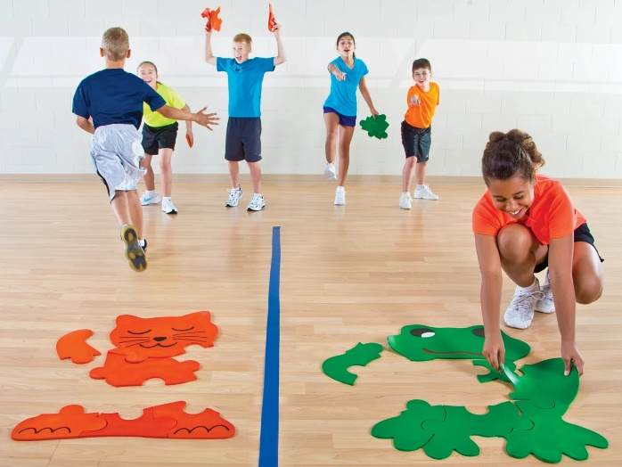
Skill Focus
Fundamental Movement Skills
- Locomotor:
  - Running
Additional Skills
- Communication
- Leadership
- Listening
- Problem-solving
- Trust
Grade Level
- Recommended Grades: 3–12
Equipment
- One 6–10 piece puzzle per team
- One blindfold per team
Equipment example:
- Team Relay Puzzles: https://www.gophersport.com/pe/activities/team-relay-puzzles
Group Size
- Teams of 4–6 players
Setup
- Establish a starting line.
- Place puzzle pieces approximately 10–20 paces away.
- One player sits at the start line wearing a blindfold.
- Remaining teammates prepare to retrieve puzzle pieces.
Objective
Be the first team to successfully complete the puzzle using clear communication and teamwork.
Instructions
- On the teacher's signal, one player at a time runs to collect a puzzle piece.
- The player returns the piece to the blindfolded teammate.
- Only the blindfolded player may touch the puzzle pieces.
- The remaining teammates guide the blindfolded player using verbal instructions only.
- Continue retrieving puzzle pieces until the puzzle is complete.
- The first team to correctly assemble the puzzle wins.
Teaching Points
- Speak clearly and calmly.
- Give one instruction at a time.
- Listen carefully before moving.
- Encourage teammates positively.
- Develop trust through effective communication.
Modifications
Make it easier
- Provide a picture of the completed puzzle.
- Use fewer puzzle pieces.
- Allow occasional visual checks.
Make it harder
- Increase puzzle complexity.
- Increase retrieval distance.
- Limit verbal communication to one speaker.

Inclusion Ideas
- Rotate the blindfold role.
- Use larger puzzle pieces.
- Pair students for communication support.
- Allow visual cues when appropriate.
Safety Notes
- Guide blindfolded players only while seated.
- Prevent unnecessary movement while blindfolded.
- Encourage respectful communication.
Curriculum Outcomes
Physical Literacy
- Develop confidence in cooperative movement activities.
Movement Skills
- Demonstrate safe running and retrieval skills.
Personal and Social Responsibility
- Practice leadership, trust, communication, and teamwork.
Cross-Curricular Learning
- Develop communication and collaborative problem-solving skills.
Variations
- Display a completed picture as a reference.
- Increase puzzle size or complexity.
- Assign one designated communicator for each team.
Questions for Reflection
- What communication strategies worked best?
- Why is clear communication important?
- How did encouragement affect team performance?
- How did each team member contribute to success?
Hula Hoop Relays

Lift Hula Hoop Over and Jump Back In
Video
- https://youtu.be/giNFlswYpmA?si=jc6pqVvODCjpoUtA
Skill Focus
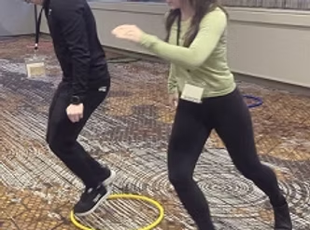
Fundamental Movement Skills
- Locomotor:
  - Jumping
  - Running
Additional Skills
- Coordination
- Timing
- Partner cooperation
- Communication
Grade Level
- Recommended Grades: K–6
Equipment
- One hula hoop per pair of players
Group Size
- Pairs
Setup
- Establish a starting line and a finish line approximately 10–15 paces away.
- Place one hula hoop at the starting line for each pair.
- One partner stands inside the hoop while the other stands directly behind it.

Objective
Work cooperatively to move the hula hoop from the start line to the finish line as quickly as possible.
Instructions
- On the teacher's signal, the player standing inside the hoop lifts it over their body and places it on the ground in front of them.
- The second player runs ahead, leaving enough space for the hoop to be placed between them.
- Once the hoop is on the ground, the second player jumps backward into the hoop.
- The second player lifts the hoop over themselves and places it farther down the course.
- Continue alternating roles until the pair reaches the finish line.
- The first pair to cross the finish line wins.
Teaching Points
- Communicate before moving.
- Place the hoop carefully to avoid stepping on it.
- Jump with two feet when possible.
- Maintain smooth rhythm between partners.
- Focus on cooperation rather than speed alone.
Modifications
Make it easier
- Shorten the course.
- Walk instead of run.
- Allow stepping into the hoop rather than jumping.
Make it harder
- Increase course length.
- Add obstacles.
- Require specific jumping patterns.

Inclusion Ideas
- Adjust movement speed.
- Use larger hoops.
- Pair students strategically.
- Allow alternative locomotor movements.
Safety Notes
- Keep adequate space between pairs.
- Avoid throwing or spinning hoops.
- Watch footing when jumping into hoops.
- Encourage controlled movement.
Curriculum Outcomes
Physical Literacy
- Develop confidence through cooperative movement challenges.
Movement Skills
- Demonstrate jumping, balance, and coordination.
Personal and Social Responsibility
- Work cooperatively and communicate effectively.
Health and Fitness
- Improve coordination, agility, and cardiovascular endurance.
Variations
- Complete the course backwards.
- Add balance challenges between hoop placements.
- Create relay races with multiple pairs.

Roll to Claim Hoops
Video
- https://youtu.be/3N7qPrJc5v4?si=GycMCoMg7mvVyI-X
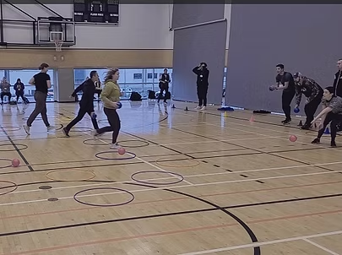
Skill Focus
Fundamental Movement Skills
- Manipulative (Send):
  - Rolling
Additional Skills
- Accuracy
- Strategy
- Teamwork
- Decision-making
Grade Level
- Recommended Grades: 2–8
Equipment
- Twelve hula hoops
- One set of Itty Balls (or other lightweight balls)
Equipment example:
- Itty Balls: https://gophersport.com/catalogsearch/result/?q=itty
Group Size
- Two or more teams
Setup
- Establish rolling lines at opposite sides of the playing area.
- Scatter hula hoops throughout the centre.
- Give each team an equal number of balls.
Objective
Collect the greatest number of hula hoops by accurately rolling balls into them.
Instructions
- On the teacher's signal, players roll balls toward the hula hoops.
- If a ball remains inside a hoop, that hoop is claimed and brought back to the team's side.
- Balls that miss may be retrieved and rolled again.
- Players may not interfere with rolling balls.
- Continue until all hoops have been claimed or time expires.
- The team with the most hoops wins.
Teaching Points
- Aim carefully before rolling.
- Roll with a smooth follow-through.
- Work together to decide which hoops to target.
- Retrieve equipment safely.
- Encourage teammates.
Modifications
Make it easier
- Move rolling lines closer.
- Use larger hoops.
- Use larger or softer balls.
Make it harder
- Increase rolling distance.
- Use smaller balls.
- Require non-dominant hand rolling.
Inclusion Ideas
- Adjust rolling distance.
- Use lightweight equipment.
- Allow seated rolling.
- Pair students for support.
Safety Notes
- Roll only along the floor.
- Maintain spacing between teams.
- Retrieve balls carefully.
- Avoid crossing rolling lanes.
Curriculum Outcomes
Physical Literacy
- Develop confidence in rolling accuracy.
Movement Skills
- Demonstrate controlled object manipulation.
Personal and Social Responsibility
- Cooperate with teammates and demonstrate sportsmanship.
Health and Fitness
- Improve coordination and active participation.
Variations
- Award bonus points for distant hoops.
- Introduce different rolling techniques.
- Create moving targets by having teammates reposition hoops.
Questions for Reflection
- What strategies helped your team collect hoops most efficiently?

Flip Frenzy (or other object that rolls) into Hoop
Video
- https://youtu.be/54iYYfRKiuc?si=WY3PFLrMpgE3mwfu
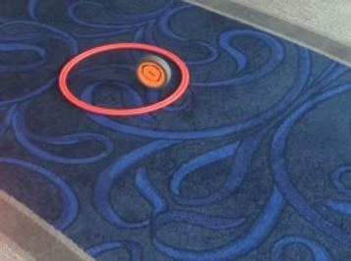
Skill Focus
Fundamental Movement Skills
- Manipulative (Send):
  - Rolling
Additional Skills
- Accuracy
- Strategy
- Partner communication
- Decision-making
Grade Level
- Recommended Grades: 3–8
Equipment
- One hula hoop per pair
- One cone per pair
- One Flip Frenzy puck (or roll of tape) per pair
Equipment example:
- Hula Hoops: https://www.gophersport.com/pe/hoops?tag=hoops
- Rolling objects like Flip Frenzy, rolls of tape, poly spots…
Group Size
- Pairs
Setup
- Establish a starting line.
- Each pair stands behind a cone.
- The first player holds both the hoop and puck.

Objective
Advance the hula hoop down the playing area by successfully rolling the puck into it.
Instructions
- On the teacher's signal, the first player slides the hula hoop forward.
- The player rolls the puck, attempting to have it stop inside the hoop.
- If successful, the pair moves the cone to the hoop's location.
- The hoop is then slid farther down the playing area.
- The second partner takes the next turn.
- If unsuccessful, the hoop remains in place and play continues from that location.
- Continue until time expires or a pair reaches the designated finish line.
Teaching Points
- Roll smoothly toward the centre of the hoop.
- Judge the distance before sliding the hoop.
- Balance risk and reward.
- Communicate with your partner.
- Focus on accuracy before distance.
Modifications
Make it easier
- Slide the hoop shorter distances.
- Use a larger hoop.
- Use a slower rolling object.
Make it harder
- Increase the distance between attempts.
- Use smaller hoops.
- Require consecutive successful rolls.

Inclusion Ideas
- Shorten distances.
- Allow underhand rolling.
- Use larger targets.
- Encourage collaborative decision-making.
Safety Notes
- Ensure sufficient spacing between pairs.
- Roll equipment only along the floor.
- Retrieve equipment carefully.
- Watch for moving hoops.
Curriculum Outcomes
Physical Literacy
- Develop confidence with rolling and aiming skills.
Movement Skills
- Demonstrate object-control skills with increasing accuracy.
Personal and Social Responsibility
- Cooperate with a partner and communicate effectively.
Health and Fitness
- Improve coordination and active participation.
Variations
- Use different rolling objects.
- Award bonus points for longer successful advances.
- Create obstacle courses between the hoop and starting line.
Questions for Reflection
- What rolling technique produced the greatest accuracy?
- Did taking larger risks lead to greater success or more missed opportunities?

Agility Ladder Relays
Almost any Ladder activity can be done in a relay version. Check out over 60 such challenges at: https://www.canadago4sport.com/agility-ladders

Every Rung Run
Video
- https://youtu.be/XTU33FF1vw4?si=KpEnlRW00FE9oA_f
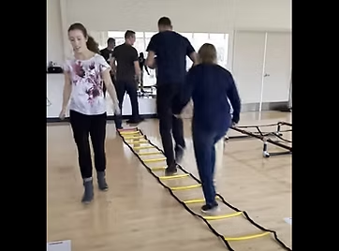
Skill Focus
Fundamental Movement Skills
- Locomotor:
  - Running
Additional Skills
- Foot speed
- Coordination
- Agility
- Balance
Grade Level
- Recommended Grades: K–8
Equipment
- One agility ladder
Equipment example:
- Agility Ladder: https://www.gophersport.com/search?q=ladder
Group Size
- Individual, pairs, or relay teams
Setup
- Place the agility ladder on a flat, non-slip surface.
- Players line up behind one end of the ladder.
Objective
Run through the ladder as quickly as possible while placing one foot in every rung.
Instructions
- Begin at one end of the ladder.
- Run through the ladder placing each foot inside every rung.
- Maintain quick, controlled footwork.
- Continue through to the end of the ladder.
- In relay format, return to tag the next teammate.
Teaching Points
- Stay on the balls of the feet.
- Pump the arms naturally.
- Keep eyes looking ahead.
- Maintain quick, light foot contacts.
- Focus on accuracy before speed.
Modifications
Make it easier
- Walk through the ladder.
- Slow the pace.
- Use fewer rungs.
Make it harder
- Increase speed.
- Time each attempt.
- Add a sprint after the ladder.

Inclusion Ideas
- Allow walking.
- Use wider ladder spacing.
- Provide partner encouragement.
- Adjust ladder length.
Safety Notes
- Ensure ladder lies flat.
- Allow only one player on the ladder.
- Wear appropriate footwear.
- Keep surrounding area clear.
Curriculum Outcomes
- Develop agility, coordination, and running mechanics.
- Improve cardiovascular fitness.
- Demonstrate controlled locomotor movement.
Variations
- Backward run.
- High knee run.
- Relay race between teams.

Alternate In and Out Sideways Run
Video
- https://youtu.be/VW9vzoQ8fVE?si=iswnhIesuRbp3IBs
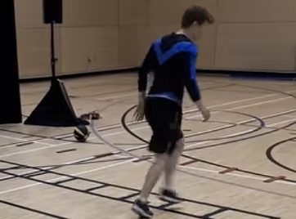
Skill Focus
Fundamental Movement Skills
- Locomotor:
  - Running
  - Side shuffling
Additional Skills
- Lateral agility
- Coordination
- Balance
Grade Level
- Recommended Grades: 2–12
Equipment
- One agility ladder
Equipment example:
- Agility Ladder: https://www.gophersport.com/search?q=ladder
Group Size
- Individual, pairs, or relay teams
Setup
- Position players beside one end of the ladder.
Objective
Move sideways through the ladder using the prescribed in-and-out foot pattern as quickly and accurately as possible.

Instructions
- Lead foot steps into the rung.
- Trail foot steps into the rung.
- Lead foot steps outside the ladder.
- Trail foot steps outside.
- Continue into the next rung.
- Complete the ladder.
- Repeat leading with the opposite foot.
Teaching Points
- Stay low with bent knees.
- Keep movements quick.
- Maintain balance.
- Lead with both feet equally.
- Stay light on the feet.
Modifications
Make it easier
- Walk the pattern.
- Practice one direction only.
Make it harder
- Increase speed.
- Carry a ball.
- Add reaction cues.
Inclusion Ideas
- Reduce ladder length.
- Slow movement speed.
- Provide demonstrations.
- Allow practice attempts.
Safety Notes
- Maintain spacing.
- Avoid crossing into neighbouring ladders.
- Watch foot placement carefully.
Curriculum Outcomes
- Develop lateral movement skills.
- Improve agility and coordination.
- Demonstrate movement control.
Variations
- Mirror partner.
- Relay competition.
- Perform while holding a beanbag.

Two-Foot Jump—Every Rung
Video
- https://youtu.be/f6D5cwuQXUM?si=MzdCV3GFmXqeO8E8
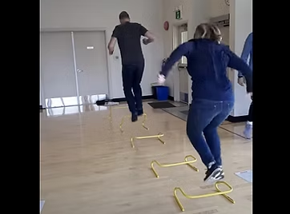
Skill Focus
Fundamental Movement Skills
- Locomotor:
  - Jumping
Additional Skills
- Power
- Balance
- Coordination
Grade Level
- Recommended Grades: K–8
Equipment
- One agility ladder
Equipment example:
- Agility Ladder: https://www.gophersport.com/search?q=ladder
Group Size
- Individual, pairs, or relay teams
Setup
- Players line up behind one end of the ladder.
Objective
Jump with both feet into every rung as quickly and accurately as possible.

Instructions
- Begin with both feet together.
- Jump into every rung.
- Land softly with bent knees.
- Continue through the ladder.
- Return to tag the next teammate if completing a relay.
Teaching Points
- Land softly.
- Bend knees on landing.
- Keep feet together.
- Swing arms for balance.
- Maintain rhythm.
Modifications
Make it easier
- Jump every second rung.
- Slow the pace.
Make it harder
- Increase speed.
- Add vertical jumps at the finish.
- Perform backward.
Inclusion Ideas
- Reduce ladder length.
- Allow stepping instead of jumping.
- Provide balance support if needed.

Safety Notes
- Land under control.
- Use non-slip surfaces.
- Keep ladder flat.
Curriculum Outcomes
- Develop jumping technique.
- Improve lower-body power.
- Build coordination and balance.
Variations
- Single-leg hops.
- Zigzag jumps.
- Timed relay races.

Ladder In and Out Run While Throwing a Ball
Video
- https://youtu.be/TjIdUfXxA4g?si=RgtLTIyE5pI3bz1C
Skill Focus
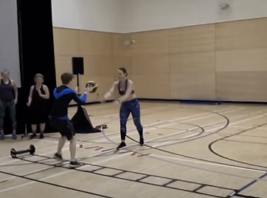
Fundamental Movement Skills
- Locomotor:
  - Running
- Manipulative (Send):
  - Throwing
- Manipulative (Receive):
  - Catching
Additional Skills
- Coordination
- Timing
- Communication
- Ball control
Grade Level
- Recommended Grades: 4–12
Equipment
- One agility ladder
- One large ball per pair
Equipment example:
- Agility Ladder: https://www.gophersport.com/search?q=ladder
Group Size
- Pairs

Setup
- One player stands beside the ladder.
- Partner stands opposite with the ball.
Objective
Complete the ladder footwork while successfully throwing and catching with a partner.
Instructions
- Player steps into the first rung.
- Partner throws the ball.
- Catch the ball.
- Throw it back.
- Move backward out of the rung.
- Continue into each successive rung.
- Reverse direction after completing the ladder.
Teaching Points
- Keep eyes on both the ladder and the ball.
- Communicate before passing.
- Use controlled footwork.
- Maintain balance while catching.
Modifications
Make it easier
- Slow movement.
- Reduce passing distance.
- Use a larger ball.
Make it harder
- Increase speed.
- Use one-handed passes.
- Alternate passing styles.
Inclusion Ideas
- Shorten the ladder.
- Allow bounce passes.
- Adjust partner distance.
Safety Notes
- Ensure passing lanes are clear.
- Only one pair per ladder.
- Retrieve balls safely.
Curriculum Outcomes
- Combine locomotor and manipulative skills.
- Improve coordination.
- Demonstrate teamwork.
Variations
- Soccer throw-ins.
- Chest passes.
- Bounce passes.

Ladder Ball-Bounce Each Rung from Plank Position
Video
- https://youtu.be/Tgn8hCxEi8U?si=IOA6EzGlYa7bHxPW
Skill Focus
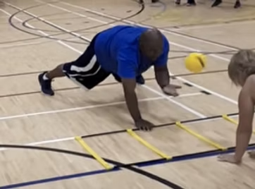
Fundamental Movement Skills
- Manipulative (Send):
  - Throwing
- Non-Locomotor:
  - Push-up position
Additional Skills
- Core stability
- Upper-body strength
- Coordination
- Balance
Grade Level
- Recommended Grades: 4–8
Equipment
- One agility ladder
- One ball per pair
Equipment example:
- Agility Ladder: https://www.gophersport.com/search?q=ladder
Group Size
- Pairs
Setup
- Players begin in a push-up position beside the ladder.
- Hands start inside the first rung.
- One player begins with the ball.
Objective
Move through the ladder while maintaining a push-up position and successfully passing the ball.
Instructions
- Begin in a push-up position.
- Move hands forward into the next rung.
- Pass the ball to your partner.
- Receive the return pass.
- Continue through every rung.
- Reverse direction using the opposite hand.
Teaching Points
- Maintain a strong plank position.
- Keep hips level.
- Move one rung at a time.
- Pass accurately.
- Work at a controlled pace.
Modifications
Make it easier
- Perform from knees.
- Use a larger ball.
- Reduce ladder length.
Make it harder
- Increase speed.
- Use one hand.
- Add push-ups between rungs.

Inclusion Ideas
- Modify plank position.
- Allow seated passing.
- Reduce number of rungs.
Safety Notes
- Use non-slip flooring.
- Keep hands directly under shoulders.
- Stop if wrists become uncomfortable.
- Maintain spacing between pairs.
Curriculum Outcomes
- Develop upper-body strength.
- Improve stability and coordination.
- Demonstrate manipulative skills while maintaining body control.
Variations
- Bounce pass each rung.
- Alternate hands.
- Complete as a timed relay.

1200+ Activities Plus Tuesday and Thursday Posts

Canadago4sport (as of August 1, 2026)
- Content:
  - Teaching Games for Understanding (Target, Net, Invasion, Striking)
  - Locomotor (Moving, Sending, Receiving, Retaining)
  - Specific Equipment (Ladders, Bosu Balls, Stability Balls, Parachutes)
  - Fun Activities (Combatives, RPS, Tag, Relays)
  - Thinking it Through Activities (Covid-19 safe, Active Numeracy, Mental Challenges, Leadership)
- Website (1100+ Game Documents—2/3rd linked to videos)
  - www.canadago4sport.com
- Tuesday and Thursday Posts
  - X.com (978+ Tweets)
    - Tuesday & Thursday posts
    - Follow at: twitter.com/canadago4sport
  - Instagram (750+ Posts)
    - Tuesday & Thursday posts
    - Follow at: www.instagram.com/canadago4sport/
  - TikTok (750+ Posts)
    - Tuesday & Thursday posts
    - Follow at: www.tiktok.com/@canadago4sport
- YouTube: (975+ videos)
  - Subscribe at: www.youtube.com/c/canadago4sport
- Pinterest: (28 boards, and 1.1k pins)
  - Follow at: www.pinterest.ca/canadago4sport/

