Copyright 2026 by John Byl
All rights reserved. Except for use in a review, the reproduction or utilization of this work in any form or by any electronic, mechanical, or other means, now or hereafter invented, including xerograph, photocopying, and recording, and in any information storage and retrieval system, is forbidden without the written permission of John Byl.
January 2027.
John Byl

212 Stonehenge Drive, Unit 50
Ancaster, Ontario
Canada, L9K 1N4

905 923-0938

JOHNBYL50@gmail.com

Acknowledgements
Many thanks are needed for the many people who helped make this book a reality. First and foremost, I am grateful for the miracle of life granted to me by Creator God and for the excellent medical care extended to me throughout these difficult years.
I am especially grateful for Grandma, who walked with me through the major traumas of my life. We are not the same people we were when we married, and some of those changes were intensified by these experiences. Through it all, Grandma loved me, stood by me, and walked alongside me through every challenge.
I remember vividly how each of my children came to my hospital bed during that first week when I collapsed from cancer. I cherish the many ways each of you has loved me, supported me, and cared for me in the ways you were able and whenever you had the opportunity.
Grandma and I are blessed with a rich and diverse community of extended family, friends, and professional colleagues. Each of you has encouraged, supported, and walked with us in different ways throughout my recovery. Your presence has meant more than I can adequately express.
Writing this manuscript was emotionally and, in many other ways, difficult. An initial 450-page draft was read and edited by Aunt Judith and Uncle Allan. Their challenging suggestion to delete half of the document was enormously helpful! I am also deeply grateful for the time and care they invested in editing those early pages.
A second, 225-page version was edited by our good friend Hugh Cook. His thoughtful editorial work helped make the manuscript much tighter and clearer.
Finally, our friends Gerri and Dirk Windhorst completed a detailed final edit. Their careful work, suggestions, and attention to detail helped make the words sing.
Any remaining mistakes are either because I failed to heed good editorial advice or because we simply missed them!
And to each of you, my grandchildren: your love for me encouraged me on the many days when writing this manuscript was difficult. Knowing that you might one day read these words gave me another reason to keep going.
Thank you all. I am deeply grateful for each of you.
Love you very much!
Grandpa

Table of Contents
- Row, Row, Row Your Boat 1
- A Cycling Storm 3
  - Forgiving the Storm Makers of Our Past 19
  - My Running Journey to Wellness 39
- A Cancer Storm: The First 2000 Days 45
  - Cancer Discovered 48
  - Surgery 61
  - Attacking the Cancer 95
  - Stability 151
  - How Do We Forgive When There is No One to Forgive? 193
  - Cancer: Walking Through My Healing Journey 196
- Afterword 207
  - What Do We Do if Your Heart Stops? 207
  - Still Able to Contribute to Our World 213
- References
  - Personal Bibliography 215
  - References 217

Radical Hope: Grab the Oars and Row On
To my much-loved grandchildren,
Debra Rienstra, retired English professor, once described radical hope by asking us to imagine being one of a crew of rowers in a racing scull. The rowers work together, pulling hard toward a goal they can imagine but cannot see. They sit facing backward, able to see where they have been but not where they are going. That image has resonated deeply with me throughout my life.
More than twenty-three years ago, I was struck by a pickup truck while riding my bicycle. I never saw it coming. The collision happened only two weeks after our first grandson, Zachary, was born. I had not yet met him. I came frighteningly close to never seeing him—or any of you.
I survived, but I have lived with permanent injuries ever since. Nearly two decades later, another unexpected storm arrived: cancer. Fortunately, skilled medical practitioners had the tools to repair the hole in my boat. The cancer treatments went well, and I’m currently stable. Grandma calls me “a walking miracle.”
Through both journeys, I have learned that life includes calm water, rough water, and sometimes storms. I have also learned that we rarely know what lies ahead.
When I look back, I see a wake filled with love and care: family and friends, doctors and nurses, phone calls, daily walks, laughter, helping others, and countless ordinary moments that have made life extraordinary.
I have sung Birtill’s song Outrageous Love which begins with the words, “There’s a lot of pain, but a lot more healing.” I wish I could say with certainty that this is always true. I have witnessed remarkable healing, but I have also seen suffering that ended in death. My own life has included both pain and healing. These experiences have left me with many questions about suffering and joy, faith and doubt, relationships, aging, death, hope, and, ultimately, what truly matters.
Over time, some of those reflections became things I wanted to share. I decided to put them into this very long letter to you, my much-loved grandchildren.
I don't write these thoughts because I have figured life out. Quite the opposite. I write because living through both deep pain and considerable healing has given me questions, and perhaps a few insights, that I would like to share with you. Some of what follows may be difficult, some may seem obvious, and some may simply reflect the way I have come to see life at this stage of my journey.
My hope for you is that you will live with radical hope. Hope does not mean believing that storms will never come. It means choosing to keep rowing when they do. You cannot see the whole journey from where you are sitting. Neither can I.
So, grab the oars.
Row with courage.
Row with compassion.
Row with perseverance.
Accept help when you need it and offer help when you can.
And when the future is hidden from view, trust that you do not have to see everything ahead to keep moving forward.
I’m alive, living well, grateful—and still rowing.
I hope you will be, too.

I love you!
Grandpa

A Cycling Storm

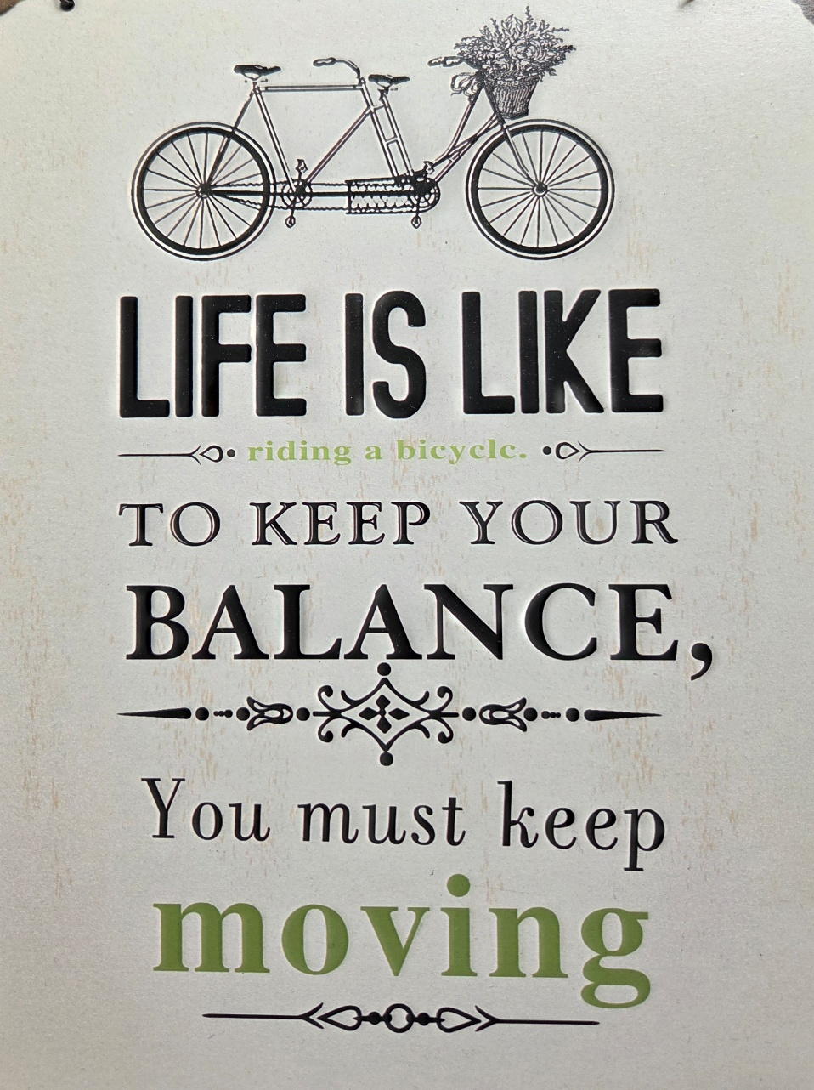

A Cycling Storm
Date: Monday, 30 June 17:34:07 -0400 (EDT)
From: Ryan and Hannah Braam
Subject: Family Prayer Request – Collision
Dear family,
I just got off the phone with my mom (Grandma) who asked me to pass on this message to all of you. Dad (Grandpa) was in a collision with his road bike this afternoon while returning home from a weekend of camping with friends. He had just left the campground and was hit by a drunk driver. He is doing okay and is responsive; however, from my understanding he does have a broken leg, many lacerations, and his ear needed to be repaired. He praised God that he survived this collision and we praise God that he seems to be responding so well thus far.
He will be held overnight in Tillsonburg Hospital and may then be taken to London or Hamilton for a CT scan of his brain as that cannot be done in Tillsonburg. If you like to reach him or Mom, you can call the hospital at xxx-xxx-xxxx (and the emergency extension where he is right now is xxx). He is listed there as Jan Bijl. In addition, good friends of the family are helping, and Mom may be staying with them tonight. Their number is xxx-xxx-xxxx or their cell number is xxx-xxx-xxxx.
Above all else, we request your prayers that he may have a safe and speedy recovery, and praise God with us that his life was spared.
Thank you.
Love,
Hannah

 | 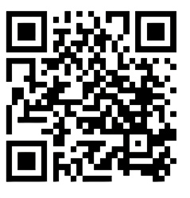  To view the television broadcast of the collision go to:  https://youtu.be/Kznj5oYR2x4?si=adqX0jRzggpx6PsQ

Victim Impact Statement (VIS)—Fourteen Months Post-Collision
As I prepared for the driver's court appearance, I wrote a Victim Impact Statement (VIS). Even though I wrote it seven months after the collision, the first court date did not take place until fourteen months after the crash.
The long delay was difficult. It was frustrating to watch the man I will call Rob—a name I have chosen for him and will explain later—appear in court repeatedly. After nearly a year of court appearances, he finally pleaded guilty.
Throughout that process I gradually came to understand that my role was limited. I was not there to influence the legal proceedings or the verdict. My role came at the very end, when I read my Victim Impact Statement as the judge considered Rob's sentence.
He was sentenced to nine months in jail, his driver's licence was suspended for ten years, and he was prohibited from entering any establishment that served alcohol for the same ten-year period.
Below is what I wrote and what I read in court in the presence of an unremorseful driver.
NOTE: The pictures and boxed text were not a part of the original VIS.

In connection with my being hit off my bike by a pickup truck driven by Rob on the 30th of June.
I love to bike. In the year immediately before the collision, I biked over 3,500 km. My plan on that beautiful Monday morning was to bike back to Hamilton after a delightful weekend of camping with friends (I had done that trip two times previously). I said goodbye to friends and kissed my wife goodbye. For safety reasons, I wore a helmet and a bright colored shirt. A few minutes later, after I had just left the campground, I was lying on the road, having been hit off my bike by a pickup truck driven by Rob. The impact on my being struck down was significant. My life was totally derailed.
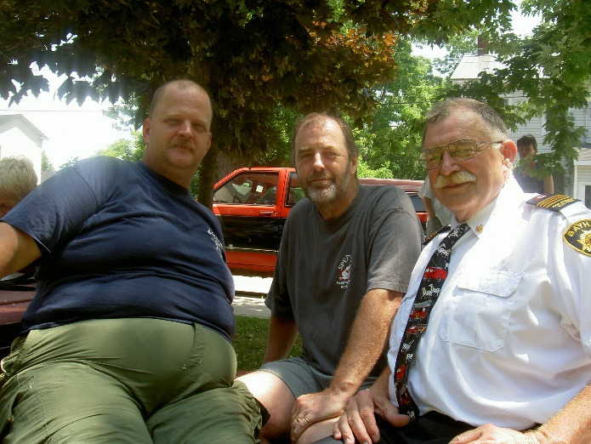
Two years later I had the opportunity to speak with a couple of volunteer firefighters that had attended to me after the collision and I thanked them for their work on me–they said they remembered it as if it was yesterday. At the end I spoke with the first firefighter to arrive at the crash site–he is also a cyclist and feared one of his children had got hit when he received the call that a cyclist was hit. The firefighters assumed I was dead, but thankfully I was still alive. I asked about the air ambulance that had turned back. They said the decision for the air ambulance to turn back was the pilot's who felt there was not a safe place to land the helicopter.

 | 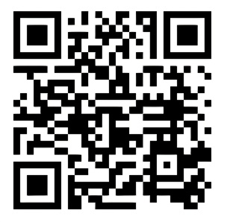  One of my experiences was that although God did not prevent the collision, God carried me through my recovery. One of my favourite groups sings about this in one of their songs. Watch for KING + COUNTRY - Shoulders (Official Music Video).  https://youtu.be/TfiYWaeAcRw?si=L7CfCi-gUkZc4nbe

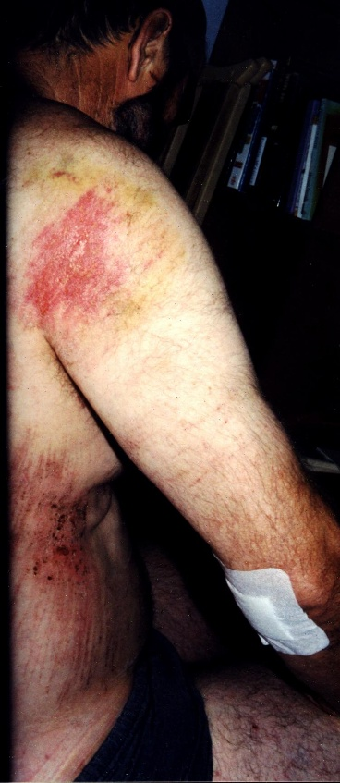
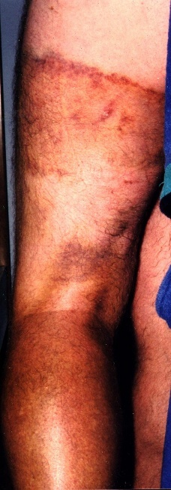
The front of the truck hit me on my left hamstrings which damaged the nerves. The nerves are still numb today. The bottom of the front of the truck hit me on the calf and broke my fibula in two places. Since my feet are clipped into my bike pedals, my leg could not move easily when struck from behind. In fact, the force of the blow on my left leg ripped my foot right out of my shoe. It was a massive blow. The other results were that my ankle and knee were also damaged. My ankle still gets jammed and has limited flexion. My knee suffered a partial tear of the anterior cruciate ligament. I feel the tightness of my ankle and the looseness of my knee every step I take. The combined effects of the damage to my leg were that I needed a wheelchair to move around for the first three weeks after being hit. I then used crutches till August 22 (almost eight weeks after being hit). On August 22 I made my first shuffle steps. I used a cane to help me get around for the next two weeks.
When Rob’s truck crashed into my leg, the force threw me off my bike and I landed on the road with my right shoulder. I suffered a second degree plus AC separation. Initially, I could not even raise my right arm to do anything. Over time and through physio, my shoulder has improved significantly, and we are hoping to avoid surgery on my shoulder. Not surprisingly, I also suffered some road abrasion on the right side of my body, and tore my right ear. The jolting of my body after being hit and then landing on the road also caused pain in my back and neck.
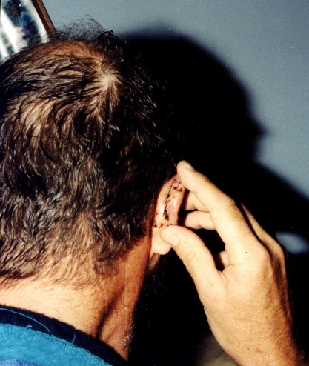
I hit the road with the right side of my helmet with such an impact that the helmet cracked and tore my ear which then needed stiches.
The helmet saved my life and absorbed the shock of my head hitting the road. I’m certain that I would not be able to be in court telling this story if I had not worn my helmet. Nevertheless, the trauma to my brain was significant. Though I’m told I was in and out of consciousness following my being hit off my bike, I have complete amnesia of what occurred. In fact, the first thing I remember is lying in an X-ray room in a hospital about two hours after being hit. I knew I was in a hospital but had no idea how I got there or what had happened. I knew from the pain in my body that something terrible had happened.
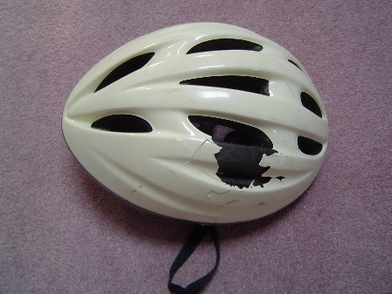
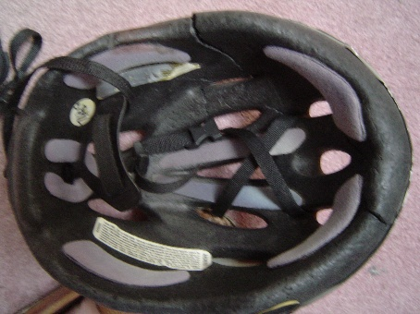

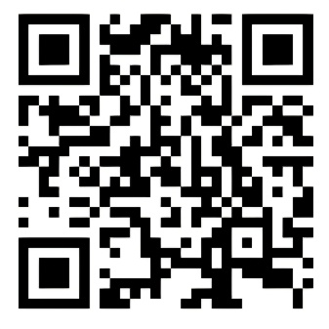

To view the television broadcast on my interview on helmet safety, two weeks post-collision, go to:

https://youtu.be/BQkU29J0eyI?si=i_2SJTA-8Lzp4aiY

As a result of the blow to my head, I experience three difficulties.
1. As a result of damage to the fourth and sixth cranial nerves and my brain stem, I suffered from “vertical diplopia” until mid-December. By December 16 the double vision had largely subsided, and my family physician gave me the green light to drive again. I was delighted to be able to drive again after not being able or permitted to drive for over 24 weeks, almost half a year. I do not have 100 % of my vision restored yet.
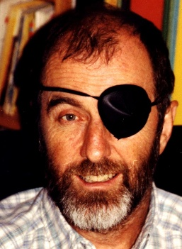
2. I also suffer from “postconcussional syndrome.” The internal head injuries mean I suffer the following symptoms: headache, dizziness, fatigue, irritability, “difficulty in concentration and performing mental tasks, impairment of memory, insomnia, and reduced tolerance to stress, and emotional excitement.” I’m a professor and writer. Due to the injuries, I have taken a pay cut and teach two out of three courses. As a writer I was on a roll: during the past six years I had written four books and coauthored or edited three books. I love to write, but since being hit I have also been unable to write anything substantial. I work about half-time.
3. I also suffer from “mixed anxiety and depressive disorder.” Although I tried to keep my spirits positive, being thankful to be alive (something I apparently often said during the first week in the hospital), I’m often discouraged. I have often been troubled as I rethought various aspects of the collision, dealt with a relentlessly antagonistic insurance company, and suffered the debilitating effects of my injuries.
Part of the often-daily challenge is to try forgiving Rob for the damage he did to me because of his intolerably wrong decisions to drink too much and to drive. I've tried to view him as a human, not just as a drunk driver (even though he had his license taken away a year earlier for impaired driving, and when he hit me, he had a blood alcohol level over double the legal limit at 10 in the morning). Yet I almost daily pray that he would be freed from the evil power of alcohol that is apparently damaging his retirement life and that almost took away my life. I pray that Rob will no longer let alcohol control his life in the way that it has, for the quality of Rob’s own life, and for the safety of other people. Forgiving is a difficult, ongoing process that I hope someday to fully complete.
I also serve as a volunteer in several organizations at a local to provincial level. Much of my contributions to these organizations has been curtailed on account of my injuries.
Activity is part of my profession and my lifestyle. I love to bike and did so whenever I could. I typically played squash three to four times a week, loving the activity and camaraderie with good friends. In the summer I golfed once a week with a few colleagues. These were times to relax and talk through issues as friends and colleagues. I have not been able to carry out any of these activities. I have been robbed of doing physical activities that I love to do, and of informally playing and talking with friends and colleagues.
Being hit also had a major effect on my family, especially on Grandma. She will never forget the police officer who approached her at the camp site, asked for her name, said that her husband had been in a collision, but that he would probably be okay. She will not forget how friends helped her and drove her too long a distance to the local hospital to be with me. She found me alive in the hospital but badly damaged. My eldest daughter, her husband, and our two-week-old grandson lived in Grand Rapids, Michigan, and immediately drove to Hamilton to be with me. They were thankful that our new and first grandson still had a grandfather. During the first few weeks of my recovery, I could not even get seated on a toilet by myself, and initially I could not even get into or out of bed by myself. Because of my broken leg and other pains, my wife and I could not sleep together for the first few weeks. My wife set up a mattress at the end of our bed for herself so she could help me during the night when I needed help. During that first month after I was hit, my wife cared for me 24 hours a day, 7 days a week. I was fortunate that my wife was not employed at the time because otherwise it would not have worked for us.
Once we got past the first month or so she still did all the household maintenance work, all the household duties, took care of all financial matters, and drove me everywhere. She probably spent two days a week caring for me in the autumn. When I was given the green light to drive again on December 16 her responsibilities for me were reduced by at least half, but she still devotes a day a week caring for me and doing things around the home that I’m unable to do. With the additional care required because of my injuries, her life has been severely challenged. Because of the physical injuries, and because mentally I’m easily overwhelmed by life on account of the brain injuries, it has been more difficult to easily enjoy physical intimacy, one way of celebrating the love my wife and I have for each other. My wife has been an awesome support to me, but it was at considerable price to her personal and our relational well-being. These have been a brutal seven months for her.
This statement summarizes some of what has happened during the first fourteen months following my being hit off my bike. The pains of the collision are with me every minute of the day. What the full impact for the future will be I do not know yet. How much will the physical and mental injuries heal and how much damage will I carry with me for the rest of my life? I don't know. But I do know I will never forget June 30.

I Thank God for Life: Cyclist Shares Story as RIDE Resumes—Seventeen Months Post-Collision
For the Christmas season the Hamilton Police asked me to be their “Poster Person” for that year’s RIDE Campaign. I agreed. I met with Paul Legall, from the Hamilton Spectator who wanted to write an article about my journey recovering from being hit by someone who drove a truck under the influence of alcohol. He wrote the following on November 27:
John Byl was knocked out when his head hit the road, and he has no memory of his near fatal encounter with the drunk driver.
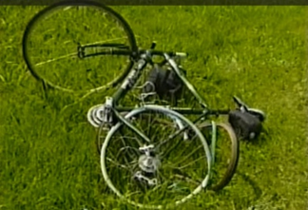
But the cracked white helmet and mangled rear wheel of his sleek Cannondale road bike tell an eloquent story in themselves.
There's also the residual pain and stiffness in his left leg which was broken, memory lapses, double vision and emotional problems he suffers as a result.
“I shouldn't be here,” the 51-year-old Redeemer College professor said yesterday as he displayed the helmet and bicycle to the media. “But I made it. I’m alive. I thank God for life. I ask that you cherish and enjoy life so much that you choose not to drink and drive.”
Byl became an instant poster boy for the Red Ribbon safe driving crusade by relating his story for the kickoff of the 2004 Reduce Impaired Driving Everywhere (RIDE) campaign.
The event has attracted 26 sponsors this year, including Crime Stoppers of Hamilton and the Hamilton chapter of Mothers Against Drunk Driving (MADD). During the RIDE season, MADD will be distributing red ribbons motorists can display to show their support for safe sober driving.
Last year, Hamilton police pulled over more than 131,000 in RIDE spot checks and have stopped about 70,000 so far this year. Up to October this year, there have been 92 alcohol related collisions which resulted in one death and injuries to three people.
Hamilton Police Chief Brian Mullan warned that officers will be even more vigilant during the Christmas blitz this year and expects they'll pull over more motorists than they did last year.
“One individual injured as a result of impaired driving is one collision too many,” Mullan told the media.
Introducing himself as a “survivor,” Byl had never set out to be a Red Ribbon poster boy on June 30, 2003, when he got on his bicycle and pedaled out of Port Burwell.
It was a glorious summer day with the sun shining as he was gliding down a quiet country road on his 130-kilometre trek to Hamilton.
He suddenly found himself lying in a hospital bed with no idea how he got there. He later learned a drunken Port Burwell man had struck him from behind with his car at 60 kilometres an hour and driven over his back wheel. Byl was knocked out of his cycling shoes by the impact before he landed headfirst onto the pavement, saved only by his white helmet. He was unconscious for two hours until he woke up in the hospital.
In September, the driver was sentenced to 9 months in jail for impaired driving causing bodily harm and ordered off the road for 10 years. According to court documents, he has a history of drunk driving and was known in Port Burwell as “slow driving drinking Rob.”
“What happened the night before I was hit, is that a retired man chose to split a 40 ouncer with a friend. That morning, he decided to drive. His blood alcohol was still 1.8 (more than double the legal limit) at the time of the collision,” Byl told reporters.
“One person's decision to drink and drive nearly took my life, nearly took away a husband, nearly took away a father, and nearly took away a grandfather (his first grandchild was born two weeks before the collision),” he said.
He told reporters he bears no ill feelings and has forgiven the driver. He said there are “no winners” in a collision like this because everybody feels only sadness, from the victim and his family to the driver.
“If you want a picture of sadness, drinking and driving is sadness,” he said.
John Byl, behind his mangled, MADD red-ribboned bike, thanks God for sparing his life after he was knocked unconscious by a drunk driver travelling 60 kilometres an hour.



To view the television broadcast of me speaking at the Hamilton RIDE kickoff, go to:

https://youtu.be/a-0z-fGZAVo

Notes on the affect on my life
when my husband and lover
was hit by a drunk driver—
34 months post-collision

Grandma Byl

I’ll never forget June 30, 2003, when a police officer came to my campsite and asked for me by name. I knew the news would not be good. I did not want her to talk. I anxiously expected news that one of our children was hurt. The news was not about them, but about Grandpa. He had just left for a great morning of biking. The police officer said she thought he would be okay but had been taken to the hospital in Tillsonburg. She said I should not drive to the hospital but have a friend take me. When I came to the hospital, I found he was alive but badly bruised. He had a broken leg, he could not lift his right arm or his head, he saw double of everything and appeared to be sleeping most of the time. Later that night I followed an ambulance which carried my husband to the Hamilton General Hospital. He stayed in the hospital for five days before he was released to my care at home.

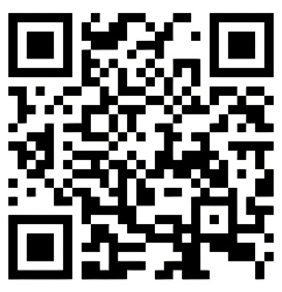
This song is a cry for hope that someone will listen and heal after he is prayed for in the waiting room for healing but ends up graveside. For people living in the light, reminds us broken people that we are still worth fighting for.

Watch “Casting Crowns - I'm Still Out Here (Official Lyric Video).”

https://youtu.be/0DVlla4_t5k?si=WbTQHvip1DYmXLKz

Grandpa has made some improvements in the last three years, but he is not nearly the man he used to be. I’m deeply saddened to watch a man I love, who was at the prime of his life with his teaching, writing, biking, living, loving, and on a positive giving roll but suddenly because one person chose to drink and drive, now often lies on the couch for endless hours watching TV and contributing little to the household or to others. He does not have energy because he gives what he has to the very limited hours of work he does. I need to do more work, and I need to do more work around a man who would love to do more but cannot get there.
Grandpa enjoys being with our children and grandchildren, but when they are all over, he will regularly retreat to our bedroom for awhile to have some quiet times. When the children have issues, he will try to help as he can but typically does not get emotionally involved–he has enough on his plate and has a hard time dealing with family difficulties (with any difficulties, he tries to avoid them all). So, the onus falls on me to be there for our children. I also love listening to music when I’m home. For Grandpa, the music quickly overwhelms his brain, so I listen to music only when he is not home.
Emotionally, Grandpa struggles. He so much wants a better world, and when he cannot contribute to that process, he gets frustrated. Grandpa is quickly angered and irritated with me. He has also experienced some extreme frustration in dealing with the insurance company about this collision. He has had some very dark days. Counseling and medications helped him through particularly dark times. I appreciated the medications because of what they were doing for Grandpa, but they also reduced his desire for me, and that pained him and me.
I lost a big part of Grandpa. We still love each other a lot but expressing that love through little touches became another item on a never-ending to-do checklist for Grandpa. I lost the husband I had before June 30, 2003. A marriage that was mostly fun and energizing has become hard work.
I have pushed through life during the past 34 months. They have been months of sadness. I was overwhelmed trying to keep everything going in our household. I have a hard time staying on top of things, completing tasks, and staying focussed. What I really need is to slow my life down and do less–but with less of Grandpa, there’s so much more I need to do. I also lost a passionate lover. I gained about 20 pounds during this time as I found some comfort in food and as I also biked less–we used to bike together regularly. With my inactive lifestyle, my physical fitness suffered. Grandpa frequently disturbs my sleep. Consequently, I have taken sleep medication on a regular basis for the past three years. I have been helped by going for psychological counseling (that I still go to). In March 2005 I had slipped into what is clinically termed as a “depressive episode.” I have experienced a grieving process–the price I pay for being a loving and faithful wife to a husband who has changed significantly because of the collision. The acquired brain injury has changed Grandpa’s life. He is not the same person he was before the collision.
I have not yet fully accepted the “new” Grandpa. It’s been a long and difficult journey. I need to move towards more acceptance of Grandpa’s losses and mine as this will lead to less frustration especially as it relates to our marital relationship. He tires quickly and gets disoriented when stressed and then shuts down. He lives with constant headaches, night and day; often, his head has a buzzing and spinning sensation. Consequently, he is more irritable and quicker to become upset. Before the collision, Grandpa was known for his flexibility; now he has become inflexible. When he is tired he may stutter and cannot multi-task as well. He needs to plan his day more carefully and is less spontaneous. He forgets things more easily and makes more mistakes. For example, when he writes, he makes more spelling mistakes and often misses words. He suffers from a profound sense of sadness. He lacks the ability to feel happy or excited about normal everyday events. When anything becomes too complicated, it quickly becomes too much for Grandpa to handle. Having to lessen the hours of teaching not only reduced our family’s income but also reduced his job satisfaction and sense of self-worth. Pain has significantly affected Grandpa’s daily life. There is probably not a minute that he is not aware of it. Pain is a constant and unfortunate part of who he is right now.
Rob chose to drink and drive and hit Grandpa; we did not choose to be in this mess. Grandpa’s life and mine were forever changed by Rob’s violent crime. I still pray for a miracle but am not hopeful–Grandpa resigned himself and tries to adjust to living as a new person. God did not intend for him to be this way, but he is. I will try to help make his days okay. He should probably not be alive, but he survived! As Grandpa finds a “new” self, I struggle with coming to grips with the idea that I have a new Grandpa, a new husband, because I still hope and pray that he improves beyond what he is today. When Grandpa was hit off his bike, I lost a big part of me.

Reflections on Different Parts of the Recovery Journey
When I arrived at the Tillsonburg Hospital about two hours after my collision, I was taken to be X-rayed. It was on the X-ray table that I first remember coming to. As I was lying on the table, I could not understand what had happened. I remembered that I had been biking, but now I was lying on a hospital bed. What had happened? How did I get here? Was this for real? I remember asking a nurse if this was for real. She said it was. I said, “Of course you would say it was for real because if it is for real you would say it is for real, and if it was a dream, you would say it was for real, otherwise the dream would be over.” I felt pains in my body, and I assumed I had somehow been hit while riding my bike, but I had no recollection of anything–other than that I was riding my bike and was now hurting in a hospital.
About six weeks post-collision, my parents came to visit me for my 50th birthday. I remember how proud I was that I could get around on crutches, and how proud I was as I waited beside the car at the airport for their arrival. I also remember how they both wept when they saw me. I was more broken than I thought.
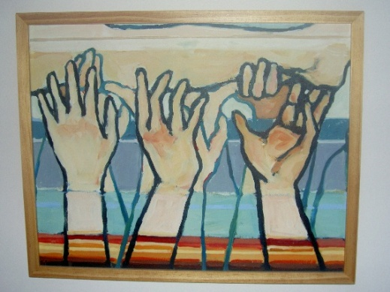
Throughout this experience, Grandma and I have felt incredible support from so many friends and family members. It is probably the first time in my life that I have felt so carried by prayer. On the Friday I came home from the hospital I had a vision during the day. Let me describe it. There was an altar, and I was lying in the smoke above (not on) the altar. What was holding me above the altar were hundreds of hands. A friend interpreted the vision. She thought it was an altar of prayer formed by the hands of many who carried me through. Thank you all for carrying me. This realization was so important to Grandma and me that we asked an artist to paint this dream. Brenda Ypma created a painting of my dream.


When I think of being carried so well by Grandma and so many others, I think of this song. The story of a young girl carrying her infant brother is first recorded in James Wells’ 1884 book, Parables of Jesus. When someone asked whether she was able, she replied, “He ain’t heavy; he’s my brother.” I think prayer through words and actions is a way of carrying each other. Watch “The Hollies 📀 He Ain't Heavy He's My Brother {Stereo} 1969."

https://youtu.be/Wtylya-hFTw?si=O3P9G1NPDgVEi2JE

People have often told me to be patient and then point to patience as being part of the fruit of the Spirit. They are right in that we need to often wait on the Lord. I was reading Lewis Smedes’ biography, in which he wrote these helpful words: “Impatience is one of hope’s life signs.” Later, he added, “Any hope, no matter how thin it gets, is better than no hope at all. To lose all hope is to die, inside. Still, even if having hope is one hundred % better than not having it, living by hope can get awfully wearying” (Smedes 2003). I find these to be hopeful and wise words.
Even a year after the collision, I still lacked the energy to do the things that mattered most to me. I constantly felt I was not loving Grandma enough, not spending enough time with my children, not writing enough, not exercising enough, not relaxing enough—in short, not doing anything well enough.
Before the collision, writing had been a central part of my life. During the previous decade I had completed my PhD, written five books, seen one translated into Chinese, published a second edition of another, co-authored two CIRA Ontario publications, and was in the middle of writing two more books. Now, finding the energy to write at all felt like a struggle.
The same was true of exercise. My goal was to be active for an hour each day, but many days I simply did not have the strength or motivation. Everything seemed to require more effort than it once had.
One obvious solution was to stop doing some things. But that frightened me. To me, letting go of any of these commitments felt like surrender. I did not want to give up on the life I loved, and I certainly did not want to give up on living.

Over Time, Healing Became Depressing
Emotionally I began to flatten. I did not experience many highs, but I did experience some significant lows. Though I never planned to take my life, there were many nights that I went to sleep and wished I would not wake up. Most of the time, if 10 is very enthused about life and a 0 is very discouraged, I was a flat 4. It was hard. Gaining weight was a result of less physical activity, depression, and medications. Thankfully, my community was a tremendous support, and eventually I was able to run and began significant healing.
Five months post-collision I went to my first of probably one hundred visits with a neuropsychologist. The visit was excellent and I began to have names and explanations for what I’m experiencing mentally. Grandma visited with me and began to understand what was going on as well. I did not have any evening meetings last week and that was also good for Grandma and me. Grandma also went for counselling. She was told at her first visit that most marriages do not survive the trauma we were experiencing. She answered back that when we were married, she had committed herself to me in health or in sickness. She and I were determined to make our marriage last.
I remember lots of days when I felt myself go into a dark place. I often stayed there for a few days. As I traveled to that dark place, I let Grandma know I was sinking and asked her not to join me. However, she loves me and often ended up going there with me. The dark place was not necessarily a bad place, and I could resonate with the Psalmist who wrote sadly that “Darkness is my closest friend” (Psalm 88:18). I never made any attempts to end my life in those times. I always felt God walking closely with me during those days. I always knew I would come back into a place of more light.

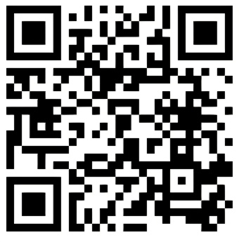
The singer feels unwell, unfixable, unstable, and is amazed that God still loves him like he is.

Watch "for KING + COUNTRY - Love Me Like I’m (Official Lyric Video)." https://youtu.be/H3lwmCDmSA8?si=Hss61IzmIlJ8Q3Yr

Twenty months post-collision my neuropsychologist said I was clinically depressed. It made sense as I think about it. I wake up early and am sad and irritable most of the day. My neuropsychologist said that 70% of people with brain injuries suffer from depression. Research is apparently not sure if this is due to chemical changes in the brain or is a result of post-collision adjustments to a different and lesser me. I saw my family doctor that week to get antidepression medication, and I have decided to drop some activities.
As I dealt with growing depression, pills were prescribed. Usually, it took a few weeks for them to take effect, and if I did not feel they were working, it took a few weeks to wean myself from them. I had no reluctance to take pills. I wanted to feel better than I was. I appreciated medical help based on medical knowledge. Pills have both positive and negative impacts, and each time I needed to find out what they were for me and then to weigh the options to determine if I should continue their use. However, we did not ever really arrive at a treatment that was satisfactory.

Forgiving
the Storm Makers of Our Past

Forgiving So You Can Thrive
When I was hit off my bicycle by Rob, I learned a lot about forgiveness, mostly through Lewis Smedes’ book The Art of Forgiving (1997). In the next fourteen reflections, I will use Smedes’ principles and my story to flesh out what I learned. If you have been wronged in any way, I hope these reflections will help you forgive and thrive. As someone once told me, “forgiving is one of the most selfish things a person can do.” This is a long section, but it was very important to my healing and, if you have been wronged, I hope it may assist you in your healing.
According to Smedes, when we forgive we go through three stages:
- Rediscovering the humanity of the person who hurt us;
- Surrendering our right to get even;
- Revising our feelings about the person we are forgiving.
Stage One: Rediscovering Rob’s humanity. When I was hit I had no recollection of anything of the collision until several hours later in the hospital. I never saw the man that hit me. I decided to go to court when he went there for one of his many hearings. I needed to put flesh and blood to this person I had never seen. I do not think he recognized me, and we did not speak together. I wanted to talk to him but was advised by legal counsel and others not to talk to him at this time. I referred to him as a drunk driver, but that reduces his identity to those words. He too is created in the image of Creator God even though his life was controlled by alcohol. He chose to drink too much, and he chose to drive, and he nearly killed me. He may drive drunk again. But he is human like me. I began to refer to him as someone who chose to drink and drive.
Stage Two: Surrendering my right to get even. There were days and moments when I wanted to get even with him, days when I hoped the courts would throw him in jail for a long time. I rarely thought of doing anything to him by myself; but that was more because of my own physical weakness after the collision than out of a pure heart. Mostly I realized Rob made some bad choices. Mostly I did not want vengeance, him being hurt for hurting me. But I also wanted him to be treated with justice, to pay a fair penalty for wronging me.
Stage Three: Revising my feelings toward Rob. I needed to forgive. About a month after the collision, I began to pray for him most mornings. I wanted him to live a better life, one in which he broke his dependence on alcohol.
If you are severely injured by a person, I hope you can:
- Rediscover the humanity of the person who hurt you;
- Surrender your right to get even;
- Revise your feelings about the person who injured you.

Let us try to make the world a flourishing place for all. Think of the song lyrics: “Tonight, we can be friends. Let's get down on our knees. The world won't have to end. Not tonight. Keep walkin'. We'll make it through. Try and make friends of my enemies.”

Watch “U2 - Happiness [Official Lyric Video].”
https://youtu.be/SA9Sle1Xn1E?si=k_RTE9hVmGxDMhCc

Who Can We Forgive?
Smedes states that there are four things we forgive:
- We forgive people, not institutions.
- We forgive people for what they do, not for who they are.
- We forgive people who wound us seriously.
- We forgive people for what they do to wrong us when they wound us.
One: In terms of who hit me, I blamed only Rob. However, there were times when I blamed institutions like the justice system or insurance companies. For example, I blamed the legal system when I heard, at the end of September, that Rob would have his license renewed. He was given an automatic 90-day suspension after the collision. On September 28 he was permitted to drive again. I was unable to drive till mid-December, and I saw the return of his license as giving him a license to kill. But the justice system is an institution. We can only forgive people in those institutions. So, I blamed and forgave those judges and lawmakers who permitted a person to be on the road again only 90 days after he had nearly killed me and after having incurred two impaired driving charges within one year.
Two: We forgive people for what they do, not for who they are. I forgave Rob for his choice to drink and drive, not for him as a whole person (there are probably things he does which are beautiful). I forgave the judges and lawmakers for their leniency on impaired driving, not for them as judges or lawmakers (there are probably things they do that they can be praised for doing well).
Three: We forgive people who wound us seriously. My collision was no small matter, a minor inconvenience in my life, an irritation. I received injuries that were serious, some of which—a head injury, a broken leg, a separated shoulder—will never fully heal. Rob changed my life forever.
Four: We forgive people for what they do to wrong us when they wound us. It is not enough to be wounded, but you need to be wronged to forgive. Rob had no right to drive while intoxicated, and he wronged me.
Many of us are hurt in our lives, but more often these injuries cause irritations, not wounds. If you are seriously wounded, I hope you will be able to forgive, especially if the injury was significant. Forgiving is challenging, but important for our well-being.
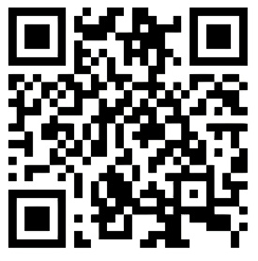
We often live with the lie that we have our life together when honestly we do not, and that everybody else’s life is perfect except ours when honestly it is not. The truth seems rarely to be told, but God is okay with who we are.

Watch "Matthew West - Truth Be Told (Lyric Video)."
https://youtu.be/8BaaoPMWaRc?si=4NWV8JbrJ0uuJg9K

Forgiveness Does Not Mean Reunion
A big part of me wanted to get to the point where I could drive to Rob’s house and shake his hand and talk kindly with him. Smedes states that this is not a necessary part of forgiveness. For Smedes, forgiveness is not about reunion or restoration but about what the forgiving person does inside; what forgiveness did for me.
I wanted to talk to Rob and hug him and say I’d forgiven him. Six weeks post-collision I thought, “We may try to go to court on the 12th if it works out for us–I need to see this person. What I would love to do is to hug him and say that I’m alive, now let’s get on with life and try to find healing for him and for me. But I probably will not do that since I’m treading in water that I’ve not swum in before.”
That day came and went. I recall that Grandma and I drove to St. Thomas with some nervousness. We wanted to put a face to the driver who nearly killed me. That day, the driver was to appear in court a second time for a preliminary hearing, the second of many hearings. We expected to be in the St. Thomas court waiting room from 9:00 in the morning till noon. We got there slightly before 9:00 and asked the court clerk if he knew if the person we were looking for was in. He said he was, that he was with a lady, and was wearing a baseball cap. The clerk meant to point him out to me but at that moment he was not in the waiting room. We took our seats, me hobbling on my crutches and with a patch over one eye. Shortly thereafter, walking slowly out of a courtroom, we saw the man and lady. I looked at him carefully enough to remember him, but not too carefully as to draw attention to me. I felt I needed to talk to him, but Grandma and my lawyer had earlier persuaded me that such an action was probably not wise. We sat across the waiting room glancing at him for a minute or two, then we walked out. Rob was 71 years old, a small white man with white very pale skin, wearing a hearing aid in his left ear. We looked in the courthouse parking lot to see if we could find the truck that hit me, but we could not locate it
Smedes makes the point that forgiving does not oblige us to go back. Reunion is sometimes impossible. Sometimes it is impractical to get together, but other times it is too painful, even though we may have forgiven the person. In my case, Rob lives an hour and a half away. I drove by his home each year for a decade when I went camping, but each time I drove by his house my emotions, memories, and nerves went awry. It would probably have been too much for me to meet with him. Turning forgiveness into an obligation for me to be “friends” with Rob might have robbed me of a chance to heal by forgiving him.
Learn to forgive, to heal yourself, and to be okay with maybe never seeing the perpetrator again, especially if such a meeting would prevent you from forgiving and flourishing.

Who Can Forgive?
Smedes suggests that the only people who can forgive are the ones who bear the wounds, the ones who have been wronged. He goes on to assert that sometimes we need others to push us towards forgiveness, which ultimately is for our own good.
I was injured, I was bearing wounds, and I needed to forgive the wrongs done to me. Grandma could not forgive Rob for the wrongs done to me, but she could forgive Rob for the wrongs he did to her, the emotional and other pains she suffered seeing me injured and helping me to get well, the difficulties she had in riding her bike again.
Smedes says we need to know we have been wronged. I knew I had been. It was a beautiful day. It was 10 o’clock in the morning Although I was wearing bright-coloured clothes and biking on the edge of the road. Rob chose to drink and drive and consequently hit me. I was wronged.
We need to have an inner push to forgive, Smedes says. Your parents may have told you to forgive a sibling, but really, we cannot be told to forgive. God gave me a remarkable peace during the first month following the collision that helped me to forgive. When two people emailed me about forgiving the driver, they both suggested it might be too difficult for me, and they offered to pray for him on my behalf. But I was ready and able to begin the process, and I began to pray for the strength to forgive.
Remember that you cannot be told to forgive, and you cannot forgive someone on behalf of someone. Others can encourage you to forgive, as I hope I’m encouraging and equipping you through these reflections. Know your wounds. Seek healing from your wounds. Enhance your healing through your acts of forgiveness.
How did I deal with this? Six weeks post-collision, I wrote:
We travelled to Port Burwell to retrace my cycle route from our campsite to the collision scene 2.97 km away. We went to our campsite and slowly went past our friend’s campsite where the police had come to speak with Grandma. We traced out our route and came to the spot on Plank Road (maximum speed 80 km) where my collision had occurred (as determined by my odometer, the New PL television video, and comments from the witnesses). On the way, I remembered the spot where I had waved at a provincial park worker, and the spot where I had seen the rail trail on my right just a hundred metres and a half-a-minute or so before the collision occurred. I realized that where the truck had impacted me there was no gravel on the side of the road instead there was a half-metre strip of rough pavement–a few feet further is where the gravel began. We took lots of pictures. When Rob’s truck hit my bike, I think I was knocked forward and sideways onto this narrow strip of asphalt–had I fallen the other way, I would have landed in front of his truck. God had protected me!

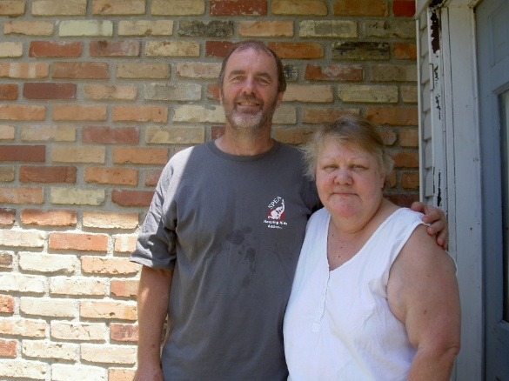
One year later, Grandma and I walked up to a house that overlooked the site of my collision. When the owners answered the door, I mentioned my name and that I was the cyclist who had been hit the previous year. They immediately welcomed us into their home. They offered Grandma and me lunch. After lunch, she offered us homemade rhubarb pie, a tart and coffee or tea. She was delighted to see me alive and went out of her way to show her gratitude. She mentioned that when she saw me last year lying there, she thought I was dead. When my leg moved once, she thought it was just the twitch of a dead person. But then at one point I spoke or moved my head, and she knew I was alive. They did not think I would survive and prayed for me last summer. They were happy to see me alive!

We then drove to Port Burwell. When we arrived there, we went to see the house of the driver. Oddly enough, it was for sale. It’s located a one-minute walk from the liquor store. We did not see the truck in the driveway either. I did want to see it, but it wasn’t there. We wondered if the police had impounded it as evidence, or if the lady was driving it, or if the man was driving it; I hoped the police had it.
Two months later I wrote: “I’m thankful for the amnesia I received because of the collision, not remembering anything till I was getting X-rayed in the Tillsonburg hospital two to three hours later. Yet I still wanted to know where I was thrown to the pavement, how the collision happened, and what the person looked like who had decided to drink in excess and then drive his vehicle. I’m thankful for protection, I’m thankful for my amnesia, but I’m also thankful that I can learn what I learned today.”

What Is Forgiving Not About?
You might have questions that make you resist forgiving. Smedes responds to six implied questions about what forgiving does not mean. I will list these responses and then add my own.
- Forgiving someone who did us wrong does not mean that we tolerate the wrong a person does. I forgive Rob for his bad choices, but this does not mean that I condone drinking and driving. I will speak against that more strongly than I ever have before.
- Forgiving does not mean that we want to forget what happened. Forgiving is not about forgetting. For myself, I’m thankful for my life. I’m also reminded each day of my injuries. June 30 was such a traumatic day in my life that I will remember it better than my birthday.
- Forgiving does not mean that we excuse the person who did it. Though I forgave Rob, I do not excuse him. Sure, he had a challenging life but choosing to medicate his problems with alcohol and then choosing to drive is inexcusable.
- Forgiving does not mean that we take the edge off the evil of what was done to us. Rob changed my life—for a time as I healed and for my lifetime as I dealt with the residual effects of the collision. It was and will always remain a horrible collision for me.
- Forgiving does not mean that we surrender our right to justice. In fact, I felt morally obliged to do my part to ensure that appropriate justice was meted out to Rob. I read a victim impact statement in court that states that although I have forgiven him, and that I suffered a lot from his decisions. I want anyone who hears about this case to shudder at the thought of drinking and driving.
- Forgiving does not mean that we invite someone who hurt us once to hurt us again. Next time I bike in that area, I will be even more careful about who is behind me, and I hope Rob is not able to drive again until he has had significant help dealing with alcohol.
I hope these descriptions of what forgiveness does not mean will help you forgive and to actively seek justice, to remember the injuries, to feel the resulting pain, and to learn to be safer.
Why Should We Forgive?
You might argue that because someone has made a criminal choice that negatively affects another person for the rest of their life, it is wrong to forgive people like Rob. Smedes provides six reasons why that argument is false. First, he defines what forgiving is by describing what it is not. We just covered that. Then he asserts the following five points, namely that forgiving is fair, honest, natural, suits us, and is all about the forgiver.
- It is fair to forgive. Not forgiving perpetuates unfairness. To throw a rock through a person’s window would be to invite that person to throw a rock through yours. Forgiving gives future fairness a chance.
- Forgiving is severe honesty. Forgiving is honest about what happened–that’s why it can be forgiven. Forgiving is honest about the responsibility of the person who committed the wrong–if I did not hold Rob responsible, there would be nothing to forgive. Forgiveness is honest about the accountability of the person who did it–I will not exact vengeance, but I hope for justice to occur. Forgiving is honest about the price of any reunion–the price is honest remorse and conversion. Forgiving is honest about the person who wounded us–a failed, weak, and guilty person who is the image of Creator God, not simply a drunk. Forgiving requires honesty with ourselves–I have also failed and I’m weak, guilty, and created in the image of God. Forgiving is honest about a future possibility of a new beginning.
- It is natural to forgive. It is human to be free for the future, unshackled by a past we cannot change. If it is human to create new paths out of old ruts, then forgiving is natural. If it is human to see beyond what was to what can be, then forgiving is natural. If it is human to want to heal our unfair pain and to make things fairer than they are, then forgiving is natural.
- Forgiveness suits us. We intuitively feel we ought to forgive. Forgiving is an “ought” of opportunity. Vengeance only makes the pain last longer and feel worse. We also ought to forgive because it suits us. A groom ought to be happy, a grieving person ought to cry, a happy person ought to smile, and a good person ought to forgive. It suits us to forgive. It is the only way we can heal ourselves from the hangover of a wounded past.
- Forgiveness is done for our own sake. Serious pain is always egocentric. Especially in the first two months following the collision, but also during the time afterwards, I was very much focussed on me. I think people got tired of hearing about the details of my collision. Egocentrism diminishes with forgiveness. Forgiving must heal our own pain before it can do any good for the person we forgive. God delights in restored relationship with us. If I want the best for the driver that hit me, then I need to forgive him for the pain he has caused me. Wishing the other person well is precisely what we do when we forgive. So, I pray for his recovery from alcohol so that he can be a more whole person and so that his actions will not hurt another (Smedes 1996).

I think we forgive because we are human. I hope you can forgive when you need to because forgiveness is fair, honest, natural, suits us, and is done so we can heal and thrive.

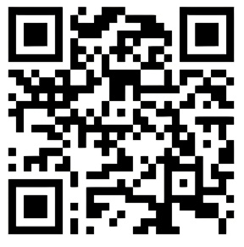
This song reminds us: “How do we save a life pointing fingers? How can we end the fight this way? When blame is the truth we're preaching and lies are what we're believing. No one ever wins when the goal is to settle the score.”

Watch “for KING + COUNTRY - Ceasefire - Music Video.”
https://youtu.be/vvfs2TUj-D4?si=07NTJhpQ1jDsWJea

.
Who Do We Forgive?
Obviously, we can only forgive the ones we blame. Smedes’ points out four fallacies that come into play followed by my reflections on these points.
- Some may ask, “Who are you to judge?” Though I must be humble in my blame, I have also made choices in my life, I’m a rational person, and I need to assign responsibility to Rob who wronged me.
- Some may ask, “Aren’t you partly to blame for the collision?” To that I flatly reply, “No!” I have a right to cycle on the edge of the road.
- Some may also say, “To understand all is to forgive all.” The fallacy goes as follows: When we understand why someone did it, we excuse them. When we excuse them, we do not blame them. When we do not blame them, we do not forgive them. Though the parole officer’s report helped me understand Rob’s background and why he chose to medicate his difficult life with alcohol, I still blame him for the choice he made to drink too much alcohol and then drive.
- Finally, there is the fatalist argument: I know I will die sooner or later, unless the Lord comes back, and I know Creator God has a plan for my life. Stuff happens, so there is no need to bother about collisions and the like. To die or to be injured by someone’s bad choice is not right. We do not blame animals for their actions because they are not children of God. To blame someone is to recognize that they are human.
One of my favourite Bible texts states that God came into this world that we might have abundant life (John 10:10). In my need to see Rob as a real person, Grandma drove me to the St. Thomas courthouse on August 12. In the waiting room of that courthouse was the first time I sat across from him for a few minutes. I needed to see that it was a real person I was praying for. I would have loved to talk with him at that time and at other times, but I was advised not to. It would have been the first opportunity I had to share my painful story with him, to blame him for what he did to me, and for me to say I was working on forgiving him.
I believe Creator God wishes all the world to flourish. If someone prevents others from flourishing, we have a right to name that, especially if we are the recipients of a significant injury. Although there are usually contributing factors to a person injuring us, they are people making choices and are responsible for their choices. When someone wounds you, assign blame where blame is due and remember that what Creator God wants is for all people to live a flourishing life.


I do not blame God for the collision. Psalm 40 reminds us to sing a new song about how God has walked with us through the healing journey. U2 put the words of Psalm 40 to words.

Watch U2 - “40” (Live From Red Rocks Amphitheatre, Colorado, USA / 1983 / Remastered 2021).

https://youtu.be/CMVghDg-ePc?si=u7h1uNfpPJ16O_Fv


“But when I think about what has the power to change the world, it could all be said with just one word: kindness. What if we lived with a heart of kindness? What if we loved like we've been loved? If that's all that we're remembered for, well, let that be enough.”

Watch “Steven Curtis Chapman - Kindness (with lyrics)(2022).” https://youtu.be/CM4ILF7BHTg?si=7lofid9KUmx-c9eJ

How Do We Know When Someone is to Blame, and Why We Should Forgive?
Smedes offers us three tests to determine if someone is to blame. When I thought about Rob injuring me, I knew:
- He drove after drinking too much alcohol.
- He meant to drink and drive.
- He initiated the action.
Many times, people will not say sorry, sometimes because they choose not to, and sometimes because our legal system makes that difficult to do. Smedes lists five reasons why people suggest we should not forgive someone, then immediately challenges those reasons.
- If a person who wrongs us does not repent, he doesn’t deserve to be forgiven–but forgiveness always flows out of grace.
- Forgiving someone who does not repent is just too hard to do–but it is the only way to heal our broken heart.
- To forgive an unrepentant person is not fair to ourselves–but to not do so is to prolong a bitterness that will shrivel our spirit.
- Forgiving an unrepentant person is dangerous if he feels no sorrow for what he did, he is likely to do it again–but forgivers are not sentimental fools.
- The Bible says we must repent before we can receive forgiveness–but that is when we are dealing with God and we have no right to expect forgiveness. But this passage is about one wanting to be forgiven, not about the one doing the forgiving—God wants reunion with integrity.
Even though a person made a terrible choice that caused us injury, let us be people who extend grace, allow forgiveness to heal our broken hearts, encourage our spirit to grow, to see the world for what it is, and to live right with Creator God.
Forgiving People Who Are Not Sorry.
Smedes offers six reasons to forgive people who never say they are sorry. The bottom line for all his arguments is that forgiveness is something we do for ourselves and does not involve the other person.
- Forgiving is something good we do for ourselves; we should not have to wait for permission from the person who did something bad to us. Except when I read my VIS in court, I had never spoken to the driver about anything to do with the collision, yet I have forgiven him repeatedly.
- When we forgive someone who does not say he is sorry, we are not issuing a welcome back to the relationship we had before; if he wants to come back, he must come in sorrow. In my case, I did not know Rob before, so he is not coming back into any relationship we had.
- To forgive requires nothing but a desire to be free of our resentment. I can only do my part, forgiving to be free from resentment.
- We cannot expect to be forgiven without sorrow for the wrong we did. We should not demand sorrow for the wrong someone did to us–that part is not up to us. I can do my part, which is to forgive, though a guilty plea on his part made forgiveness easier for me.
- Repentance does not earn the right to forgiveness; it only prepares us to receive the gift–if the driver had repented, that might have made it easier for me to forgive but would not have been essential to my forgiveness. However, he never repented to my knowledge.
- A wounded person should not put her future happiness into the hands of the person who made her miserable–I will choose life.
But what if he refused, was defensive, or blamed me for cycling? The parole officer suggested Rob showed no remorse for his criminal activity. What I needed to learn is that my forgiveness is my own act, and has nothing to do with whether or not he apologized, heard about my forgiveness, or decided to accept or reject my forgiveness. I’m forgiving, and I can carry on with my life as a whole person. Furthermore, Rob and I were not friends before, and I did not expect we would be friends in the future–though sometimes in my idealism I hoped that might work out. The main point is, I needed to forgive him for me. I had little to no control over what he wanted to do with my forgiveness.
This took some processing on my part. About two months post-collision, I wrote the following to some of my friends: “The driver who hit me has gone to a preliminary hearing three times and has still not decided if he will plead guilty or not, or if he plans to hire a lawyer. I of course wish he would just go to court, make his guilty plea, and allow everyone to move forward–but I guess courts don’t work as easily as I wish they did.”
A day later I journalled: “It is a day short of nine weeks after the collision. It is four in the morning, and I wake up from pains in my body. As I lie awake trying to get comfortable, my mind wonders how I need to move ahead, how quickly I and others talk about patience and how things are moving forward. Then I think of the person who hit me and I pray for peace and healing in his life, and I pray that we could get the court case out of the way–that we would say what all happened, deal with the consequences, and get on with our lives.”
Two months after the collision I wrote a letter to Rob which my lawyer suggested I not send yet. Nevertheless, it was good to write:
Dear Rob, As a fellow human being I need to let you know that I’m currently physically disabled in some ways, that I’m pained through a summer of healing and probably a lifetime of maintaining some disabilities, but I’m also deeply thankful to be alive. I need to let you know that the cost of alcohol is hundreds of times the cost of the bottles at the liquor store located just a few steps from your house. I also feel I need to let you know that freedom from alcohol’s grips in the loving hands of a power greater than us is freedom indeed. Rob, take responsibility for your life so that you (and I) can move forward. Make your plea in court and let’s get on with our lives. If you wish to respond to this letter, you can contact me at the address above.
At Rob’s sentencing hearing, over 14 months after the collision, I noted the following: During the proceedings a parole officer’s report was given to the judge to explain Rob’s heavy drinking. In it the details of a challenging life were outlined, including the death of Rob’s only natural child seven days after birth, the death of a brother, the death of his wife from cancer four years earlier, the death of friends, and growing up in an environment in which his father and brother both abused alcohol. Six months ago, he did indeed go through triple heart by-pass surgery, and he had been hospitalised on several occasions due to mini-strokes. “The loneliness, sadness, and depression have taken their toll on Rob over the years with alcohol being used to self medicate his psychosocial realms.” To the community he was known as “Slow driving drinking Bob.” “When drinking he would reportedly drive slow on the shoulder or take county roads with a ‘mickey’ (12-ounce bottle) by his side.” A year before hitting me, he had successfully concluded a remedial program for impaired drivers after being charged with drinking and driving at an earlier date. Furthermore, after hitting me, “of concern is that Rob expressed little regret for his actions, which could lead one to conclude that he could reoffend.” (Ontario Ministry of Community Safety and Correctional Services Client Identification No 1000469112). A thorough and sobering report on a sad life.
If someone is not remorseful about injuring you, wounding you and not apologizing, forgive so your life can flourish. If you are ever the cause of wounding someone, try find a way to apologize. Apologies will bring healing to both parties.
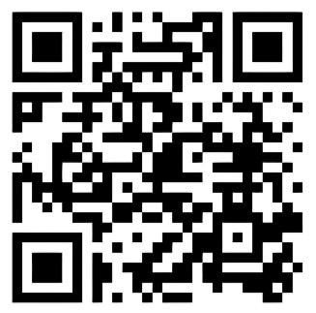
Though hoping none of us become a slave to alcohol, drugs, or other things. I had a friend who had an addiction to drugs and died from a fentanyl overdose while incarcerated. This song means a lot to me.

Watch “Zach Williams - No Longer Slaves (Live from Harding Prison).”

https://youtu.be/bDnA_coA168?si=5YG10fq-vao04ZrJ

How Do We Forgive?
I learned that forgiveness is as much an act as a process. It was a process involving many steps, beginning with rediscovering Rob’s humanity, surrendering my right to get even, and wanting Rob to experience a whole life, and a life safe for others, when he stops drinking alcohol. But there are more steps that helped me.
Smedes suggests that to forgive is to own our pain:
- We appropriate our pain. I know now that I was robbed, and I acknowledge I was robbed of a pain-free life. I acknowledge my pain. It still hurts now; I still experience the losses. The pain was and is so intense I’m sure I don’t want to experience it again–will I ride a bike again? I must. Most often I tried not to let one person’s bad choices negatively affect my whole life.
- We name our pain through prayer and other people’s voices. I feel I was robbed of health, of biking, of fully enjoying Grandma, of fully participating in the life of my children and grandson, of fully being able to carry out my work. I was robbed—and that is why I named the driver “Rob.”
- We evaluate our pain. For me the pain of this person drinking and driving and nearly taking my life was a significant pain.
- We recognize our pain. I know it is there, and for me, June 30, the anniversary of the collision, will likely never be forgotten.
Forgiveness takes time, and that’s okay. I was given the grace to quickly begin the process of forgiveness at the invitation of friends. Friends felt they needed to also pray for the driver; they knew I would probably have difficulty with that, and they offered to pray on my behalf. It took me about 15 months before I could truly say it was over, I’ve forgiven. It would have been good to have done it earlier. I just could not.
Take your time to forgive, but don’t take too long lest you become bitter. Know your pain. Name your pain. Evaluate your pain. Remember your pain. Forgive the pain-giver. Thrive again!

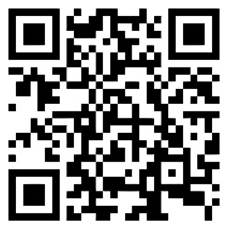
“We know what it's like to be hurt. We know what it's like to feel pain. But I think it's safe to say we're on to better days. Can you, can you relate? I don't know what it's like to be you. You don't know what it's like to be me. But by the grace of God, we'll see each other's heart. Can you, can you relate?”

Watch "for KING + COUNTRY - RELATE (R3HAB Remix)."
https://youtu.be/FhIosE9nEjI?si=Ei9dMwVwYn1EZwyz

When Is the Right Time to Forgive?
To understand if the time is right, Smedes suggests it may be helpful to consider the following questions.
- Learn—Try to understand what happened. Do you have all the facts? That took me months and was a process of more fully understanding my injuries. I never fully understood Rob until after his court case, 14 months after the collision.
- Evaluate—Was it an accident or done on purpose? In my case it was not an accident. It was precipitated by someone making a terrible choice of drinking too much and then choosing to drive–I began to refer to my being hit as a collision rather than an accident. My injuries were caused by a bad choice on someone’s part, even though he was not deliberately trying to injure me.
- Talk–ask for good advice from wise folks after you were damaged? Several skilled people gave me wise advice, but it took many months to apply it.
- Feel—Did you take time to understand what you feel? I needed to slow down occasionally to understand what I was feeling.
- Pray—Have you been honest to God with your feelings? I think it is related to my feelings, and it is hard for me to slow down and truly feel and be truly honest–though I’ve had my days.
Though we need to take our time to forgive, we shouldn’t wait too long. These roots of unforgiveness dig deeper into our very being the longer we hang on to them. The longer we wait the more entrenched these roots become. Bitterness begins to control us like a poison. We should try to understand why we were injured, seek wise advice, understand our feelings, and walk honestly with Creator God.


“Dream about what you could change, and live it out, before it's too late. The beauty of it is, we've just one life to live, and no one knows what happens next. If I love better, and you love better, our love will live on forever.”

Watch “for KING + COUNTRY - WHAT ARE WE WAITING FOR? [the single] Official Music Video.”
https://youtu.be/f3LAHvGG2PM?si=D5zlBCEOno-vP9XO

Not Putting Up with Intolerable Wrongs
We don’t have to put up with the wrong. Some things are intolerable in and of themselves no matter how many people put up with them. For me, drinking and driving are intolerably wrong.
Once I was more sensitized to the huge negative impact the collision had on my life, I frequently read about incidents in the newspaper of people driving while intoxicated. Others shared their stories of when they or someone they knew was hurt by someone who drank and drove. In Canada, two-to-three people are killed every day because of drinking and driving. Drinking and driving must stop. Grandma and I were blessed to attend an annual MADD Canada Conference where we heard not only about much pain caused by people drinking alcohol and driving, but also of much healing through medical care and forgiveness.
Intolerable things are forgivable—I can still forgive Rob for his poor choice. Forgiving an intolerable wrong does not make it tolerable—forgiving him does not mean I approve of what he did.
Ninety days after my collision, a television station ran a documentary on drinking and driving. I wrote the following note to them: I’m told that the person who hit me received an immediate 90-day suspension and will once again return to driving in a few days till he is convicted in court–but that can be at least half-a-year from now. It is a scary thought to think of this man being on the road again in a few days. I think one of the solutions to reducing collisions is significantly increasing the penalties for driving while impaired.
Three months after the collision a family member sent me a poem about “God’s grace to all people.” I responded by writing: Your poem is a helpful reminder that God is always there, especially during the difficult times. But as I forgive the person who hit me after he had drunk too much alcohol, I also feel morally obliged to make sure that the justice system gives him a stiff penalty for what he has done. Incidentally, as far as I know, the driver will be able to drive again this week Wednesday until he is officially convicted in court (that may not be until the spring—10 months from now). That is a scary thought—unless he has made some major life changes this past summer. I don’t want this driver driving again and hitting someone else so that his victim can experience the grace of God; I would rather they experience the grace of God through the joys of an abundant life he gives us. So yes, it is good for me to be reminded of God’s amazing grace during difficult times, but it is also a reminder for me that justice must be meted out to those who do wrong; or, at least, we cannot allow those who choose to do wrong find expression for their intent. I had begun to understand aspects of forgiveness and of justice.
Finally, forgiving an intolerable thing does not mean we intend to put up with it. I will do what I can, without losing focus on all the other neat things I feel Creator God is calling me to do, to try to minimize drinking and driving.
I think we make choices that help ourselves and the world around us to be a place of flourishing, and we also make choices that cause pain. We don’t need to put up with some people’s actions and choices that cause harm, but we ought to be wise and do our part to make the world a better place.


“Well, speak of the devil, he's no friend of mine. To turn from him is what we've got in mind, just a liar and a thief. We like to let him know where he can go. To hell with the devil.”

Watch “for KING + COUNTRY | To Hell With The Devil (RISE) feat. Lecrae & Stryper (Official Music Video).”

https://youtu.be/izdvVVVW8Ms?si=1M_Qffv7kx5oDwvn

How Often do We Forgive and How Do We Determine If We Have Forgiven?
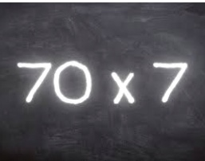
We need to forgive as often as we need to. Forgiving is not an obligation. It is an act of freeing ourselves to move on with life. It is not about the number of times we forgive, even though the Bible suggests 70 times 7.
What do we do when we are not sure we have forgiven? Smedes makes five suggestions:
- Be patient. Remember that forgiveness is usually a process.
- Expect relapses. I had to forgive him often. I caught myself feeling vengeful and needed to forgive again.
- Stay angry. I will always stay angry that someone could drink and drive and nearly kill me. It was not right, but I must be careful not to become an angry person.
- We don’t have to like the person that harmed us—but I will love enough to pray for him and wish him well.
- We all need a little help. God’s people and others were hugely supportive, holding my hand in the hospital, sending cards, emails, prayers, thoughts, and rebukes. I could not have forgiven on my own.
On October 3, fifteen months after the collision, while sitting in a dentist’s chair: “I think my unforgiveness was finally broken. This forgiveness does not mean I will not seek compensation and payment for injuries and expenses, but I will no longer be upset at Rob. So, I’m sad, and my head is sore, but my experience has been that sadness does turn to gladness I just need to push through. This is a big day!”
I know my forgiveness journey involved forgiving, relapsing, and forgiving many times. I needed to be patient with my feelings, to be okay with being upset with Rob. I invite you to stay angry with people who decide to drink alcohol and drive, to love all people, and to welcome help from others.


“Let me tell you a secret about a father’s love, daddies do not love their children now and then, it is a love without end.”

Watch “George Strait- A Love Without End, Amen.”
https://youtu.be/k2af10YlLoc?si=Urwe5Y_lh6dudlhE

Forgive, Remember. and Move On
Finally, forgive and remember the good parts of the bad past. I will not forget June 30. I will remember saying goodbye to friends in the park, kissing Grandma goodbye after I nearly forgot to, the beautiful sunshine, the warm air, the thrill of looking forward to 135 km of cycling, a Creator God who is not through with me yet, a God who each day gives me the gift of life.
We remember the past with truth. My collision really happened, and I have reconstructed most of it in my mind because I do not remember the actual event. We remember with a new respect for ourselves—"I’m alive.” We remember with sadness—"I’m broken.” We remember with no illusions. We are created to be dependent people, dependent on each other and dependent on Creator God.
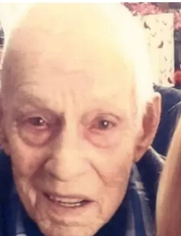
I needed to move on: however, I needed to forgive the one who injured me for my own sake and for my own healing. When I forgave, I rediscovered the humanity of the person who hurt me, I surrendered my right to get even, I revised my feelings about the person I was forgiving, and I was in control of the anger that would otherwise eat me alive. I took my time to genuinely forgive, and forgiveness helped me feel whole again. We often wondered if Rob was still alive. Recently we Googled his name and learned that he died April 13, 2019, at age 87.
Despite the pain of my injuries, the day I was injured was also full of beautiful things. The healing journey was filled with amazing people doing great things. Forgiveness allowed me to experience a flourishing life again, even with new limitations.

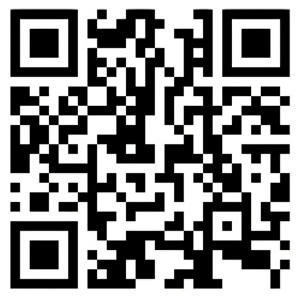
“Turn me tender again. Fold me into you. Turn me tender again, and mould me like new. When faith lost its promise, I stood there deep blue. Turn me tender, through a union with you.”

Watch “Turn Me Tender” (Martyn Joseph).

https://youtu.be/PIBx52eIyNg?si=Vwf-MSqovnoiMiUJ

My Running Journey to Wellness

Never limit where running can take you. I mean that geographically, spiritually, and of course, physically.
Bart Yasso

Four years after the cycling collision, I felt vulnerable, borderline sad, discouraged, and depressed. Even though life was so rich, there were days when I began to sink into darkness. The neuropsychologist diagnosed me as clinically depressed. One of the things I did that seemed to help me most was to eventually take up running. I had tried to get back into physical activity, but it never seemed to be sustainable.
Seven months post-collision, a physiotherapist recommended some aerobic equipment for home use. We were excited about getting it. I wanted to step forward. I wanted to run and walk and climb stairs normally. I wanted to get well again. Although the insurance company denied the equipment proposal, as they normally did, a second assessment proved it to be a healthy option for me and a cost-saving measure for the insurance company.
Then in December, four-and-a-half years after the collision, your Aunt Hannah wanted to do the 30 km Around the Bay Race in Hamilton. She asked who else wanted to join her. I wanted to and signed up, as did Uncle Matt, Aunt Charis, and Uncle Ryan. During the past few years we had attended some runs that Uncle Matt and Aunt Charis had entered. The enthusiasm at the start, during the run, and at the finish line (for the first-place winner to the last-place finisher) excited me each time, and so the opportunity to enter such a run myself was a no-brainer—except that I had never entered any run before, and now I was 12 kg (30 pounds) heavier than I was when I got hit. Neither Grandma nor I had ever entered any run before. We were both in our mid-fifties. I signed up for the run.
Now I needed to train. It was early December, and the run was the end of March. I had four months to train. I began by walking a 3 km block around our home, which took me about 40 minutes. I was proud of my accomplishment: my training had begun. The next day I did the same block but walked for two light-pole lengths and ran for two, then walked, then ran, till I was back home in about 30 minutes. I went out about four to five times a week, and each time increased the time I ran until I ran non-stop all the way around our 3 km block.
Next, I increased the distance to a 5 km block and then slowly to a 10 km block. A runner at our church gave me a training program from a local running store and encouraged me to run only three times a week to give my body time to heal (which is when the real growth takes place) and to avoid injuring my body–particularly my knees. I kept training and slowly decreasing the time it took for me to complete my distances. I was running 10 km at around 70 minutes. He also taught me the importance of proper running clothes and taking adequate nutrition and water with me on my longer runs.
The day before the Around the Bay Race, our whole family stayed at our home; we enjoyed a carbohydrate rich meal together, got a good night of sleep, and in the morning (after some nourishing oatmeal) were off to the race. Grandma was a support for us and cared for Zachary, Janae, and Daniel while their parents ran. It was totally exciting wearing a racing bib and being part of 5,000 other people milling about, warming up, stretching, and otherwise preparing for the run. I placed myself in the middle of the pack at the starting line. The horn went, and slowly we were off and running. Since I ran my 10-km training runs in 70 minutes I figured I would complete 30 km in 3:33:33–that gave me an extra three-and-a-half minutes for the longer distance :)
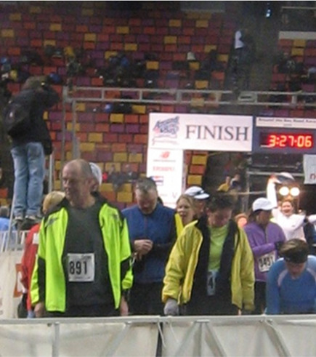
For the first 10 km I was slightly ahead of my pace as I was swept up by the tempo and excitement of running with so many other people. The next 10 km, I maintained that slightly quicker pace. The last 10 km, my pace slowed down. During the final 3 km, I needed to keep a constant dialogue going with my legs, which insisted I abandon the race. With the finish line in sight, and the supportive crowds along the sides of the race encouraging the runners with their words, clappers, pots, pans, drums, food, and smiles, I kept going despite the protestations from my legs. Finally, I turned the last corner and saw the finish line at centre ice inside the arena. Tears came to my eyes. I pushed through to the finish line. My time was 3:23:26. I had run faster than my 10 km training runs (though about two hours slower than the first-place runners). More importantly, I had done it.
I had accomplished more than running. I had taken control of my life again. I had stopped taking antidepressant medications. It worked for me to stop these medications, which is not a good idea for everyone. By race time, after four months of training (and maybe even eating a little more), I had lost the 9 kg (20 pounds) I had gained when I began taking the antidepressant medications. The leg I had broken still complained more (there was also a herniated muscle and an ankle that has 15 degrees less mobility), and I worked abbreviated days from before the collision, but I was becoming happy again. I began to see that the gift of amazing living was possible.
During the summer I continued to run 10 km two-to-three times per week and began cycling again. At the end of the summer the local newspaper ran a story about my recovery and the power of exercise in restoring a sense of amazing living. Grandma read that story. She looked at her own life. During this post-collision period of my life, she was an amazing support to me, driving me to places when I was unable to drive. Doing more things around the house. Taking on more responsibilities for our shared living and family care. And living with a spouse who was often depressed. My healing had overwhelmed her, and she also gained about 13 kg (30 pounds). At the beginning of the summer, we decided to get back to eating healthier, primarily eating fewer sweet foods and eating more complex carbohydrates and lots of lettuce and spinach salads.
After reading the article about me, Grandma said to herself, “If Grandpa can do it, so can I.” Now it was her turn to not sacrifice for others but to take care of herself, so she began going around the block, as I had done, by walking two light pole lengths and running two. She is a determined lady, and more quickly than I, she was running around the block and then doing the 5 km block. Once in awhile we enjoyed running together. Typically, I ran mid-afternoon when I came home from work early, and Grandma ran at noon hour when the temperature was the warmest. She then added time to the beginning or end of the day to make up for time missed from work, though she felt more alert and productive at work because of her running. We liked running in the winter months when it was too difficult to golf or bike or play tennis. We just needed to dress properly, and running worked great. If the weather was too cold or slippery, I used an elliptical machine in the basement instead. I watched television when I did that, otherwise I would not last more than a few minutes. Grandma would use a treadmill at work on the occasional poor-weather days. I also did some strength-training at home with the use of suspension straps hanging from the basement ceiling. Grandma used the weight room at work two times a week.
In early November there was a 5 km run and a half-marathon. Grandma entered the 5 km run (and raised over $2,000 for a charity to build schools in Haiti), and I entered the half-marathon. Grandma ran her 5 km run in 27:52, and I ran my half-marathon in 1:48–very fast times for us. Then we both signed up for a half-marathon at the end of February. This was Grandma’s farthest distance. It was a cool and windy day, and one-third of the course was slightly snow-covered. I completed my run in 1:56:38 and she completed her run shortly after me with a time of 2:10:17.
We both, as had Aunt Charis, signed up for the Around the Bay Race. Grandma and Aunt Charis had also agreed to each raise over $500 for a local hospital foundation. The race was about a month away. I was running about 50 km a week and Grandma was running about 40 km a week. I had lost another 9 kg (20 pounds) and was 5 kg (10 pounds) under my collision weight then and feeling great. Grandma had lost 14 kg (30 pounds) during the last eight months and felt great. We had each lost about four inches around our waists, and the research suggests that, for a long and healthy life, a thinner waist is beneficial. I found these longer training runs to be great times to reflect on my life and to be in prayer. Grandma often wore an iPod and listened to encouraging music.
Truth is, I still had pains in my leg, my brain was constantly fatigued, and I had constant low-level headaches that sometimes increase in intensity disabled me. With Grandma’s newfound energy she worked even harder. Once the Around the Bay Race was completed, we slowed our running down to around 20 km a week and interspersed that with some cycling, squash, tennis, or walks, takes about three hours (to get dressed, run, and then shower), and that is a lot of time. I had that kind of time, but Grandma did not. But we both know that healthy eating and exercise have made a huge difference in our lives. If you asked Grandma now how she is doing, she might give you a quick answer and say, “Fine,” but then correct herself and say, “No, I’m feeling fantastic!”
In 2014, at the finish of a half-marathon, I came across a runner friend lying on the pavement with paramedics unsuccessfully trying to revive his failed heart. This friend's sudden death took away my zest for running. He would not have wanted that. I stopped running. The joy of running was gone. In 2016, I did run Around the Bay with a friend, and I gave it one more try at a Road2Hope half-marathon six months later. Then I stopped running altogether.

Byl’s back to his “Amazing Life.” 61 Months Post-Collision
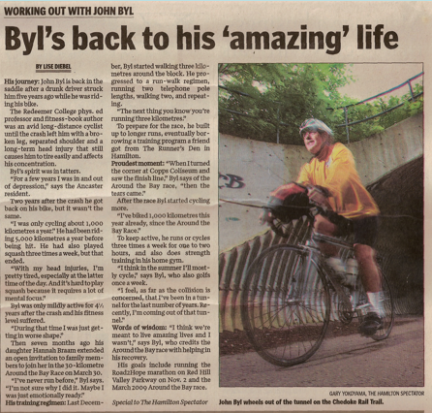
A little over five years after the collision and four months after the Around The Bay Race, Lise Diebel, from the Hamilton Spectator wanted to do a story on my collision recovery. For that article, we took a picture of me coming out of a tunnel along the Bruce Trail in Hamilton.

Sometimes in life it may feel as if we’ve fallen into a deep well or have wandered into a cave, and we don’t know how to get out of either. During my clinical depression, I was often in a very dark space, not unlike the darkness one might find deep in a well or cave, but fortunately, each time my experience was more like a tunnel than a well or a cave. Each time I knew there was light to be seen and to be reached.
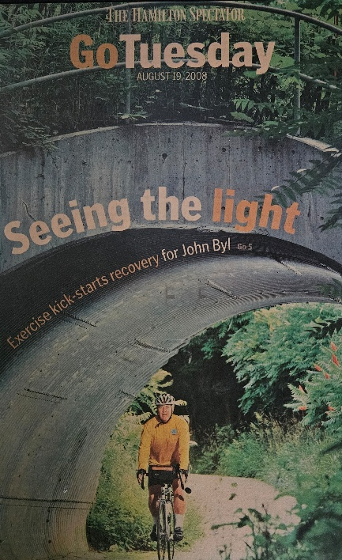
The picture taken for the Spectator article had me outside of the tunnel. At the time of the interview, that is how I felt. There were times before and after that article was published that I was deep inside a very long and dark tunnel, but there were other times when I was nearer the exit and saw considerably more light in my life.
In the dark periods of my depression, I always felt the comfort of knowing God was with me, and I always felt I could see some light and that I would be standing outside the tunnel again and feeling the warmth of sunshine around me.
In Genesis 3 we read that God came to walk with Adam and Eve, but they were afraid, felt naked, and wanted to hide. I hope you never feel afraid, or exposed, or wanting to hide from God. I also enjoy walking with you. I hope you never feel afraid, or exposed, or wanting to hide from me. I hope you can walk in a flourishing way with yourself, the world, with me, and with God.
After each formal race I usually took a few weeks off from intense running by shortening my running distance and increasing my running times. This gave my body a break. I usually signed up for the Around the Bay Race in the spring and for a marathon in the autumn. I found signing up for a race helped motivate my training.
Sleeping is critically important before and after races, during your training runs, and for life in general. There are several helpful hints to get a good night of sleep with a good balance of deep sleep (for muscle recovery) and REM sleep (for clear thinking). If possible, try establishing a consistent sleep schedule. If you like some evening snacks, focus on veggies. Caffeine and alcoholic drinks add stress to your sleep. If you have a Smartwatch that tracks stress, try a night of rest without any caffeine or alcohol and then try it with one of those drinks, and the results might astonish you. They astonished me. Try to have a calm mind prior to going to sleep. For me that means turning off my cell phone and not watching the news after 8 pm. Try to create a wonderful nest to sleep in with the right number of blankets, a good pillow, all lights off, and no sound (unless you prefer a noise machine to drown out extraneous noises that might wake you during the night).
As Grandma and I reflect on our lives, we often say some of the best years were when we were running. We loved the long runs as we got lost in our thoughts, took time to pray for each of you, greeted fellow runners and walkers, saw a lot, and felt great in our bodies. I know many of you are also great runners, so you know the joy that running can bring. Keep it up!

Living Through and Beyond This Collision
As I recovered from the collision, I walked through some of the darkest periods of my life and ran through some of the brightest periods in my life.
Prior to the collision, I was actively engaged in life and enjoyed great health. Following the collision, it took me two months before I could walk independently, a half-year before I could see one image, one year before my acquired brain injury healed sufficiently so I could write a small article, years before I could heal from clinical depression, and many more years suffering from various degrees of headaches 24/7. I was also angry at Rob for choosing to drink too much alcohol, choosing to drive, and disrupting the rest of my life. Many days I walked in a very dark place where I wished God would end my life.
I cannot whitewash any of the above, but I experienced incredible support from Grandma, loving family members, good friends, concerned colleagues, a caring lawyer, a capable neuropsychologist, a supportive worshipping community, and many more. Even during some of the darkest places, I always felt a calmness as I experienced the loving presence of Creator God. Smedes’ book on forgiveness was instrumental in helping me forgive Rob and to unchain me from his bad decision.
I knew of the importance of physical activity to physical and emotional well-being, but for a time I was too depressed to be physically active. About four-and-a-half years post-collision, I did not know if I had healed sufficiently, or if Aunt Hannah’s invitation to run the Around the Bay Race was forcing me to train, but I began to run, and that running changed my life for the good. I loved the long training runs where I could explore neighbourhoods, solve problems through the rhythm of left-and-right leg-and-arm movements, take a lot of time to hold you all up in prayer, and just be in the presence of God. These years of running were probably some of the best in my life.
One of the longest enduring challenges of the collision was that I kept having various degrees of headaches 24/7. Nine-and-a-half years after the collision, I took early retirement, in part because I was tired of fighting these headaches all the time. Also, retiring freed me from regular fixed commitments, and gave me space to spend more time with family and to pursue my lifelong passion of helping children develop their physical literacy, experience joy, and taste the goodness of Creator God.



To view a 13-minute talk I gave 15 years post-collision about recovering from my concussion, go to:

https://youtu.be/M3s57XNduF8

A Cancer Storm:
The First 2000 Days

Accept what is, let go of what was, and have faith in what will be.
Sonia Ricotti

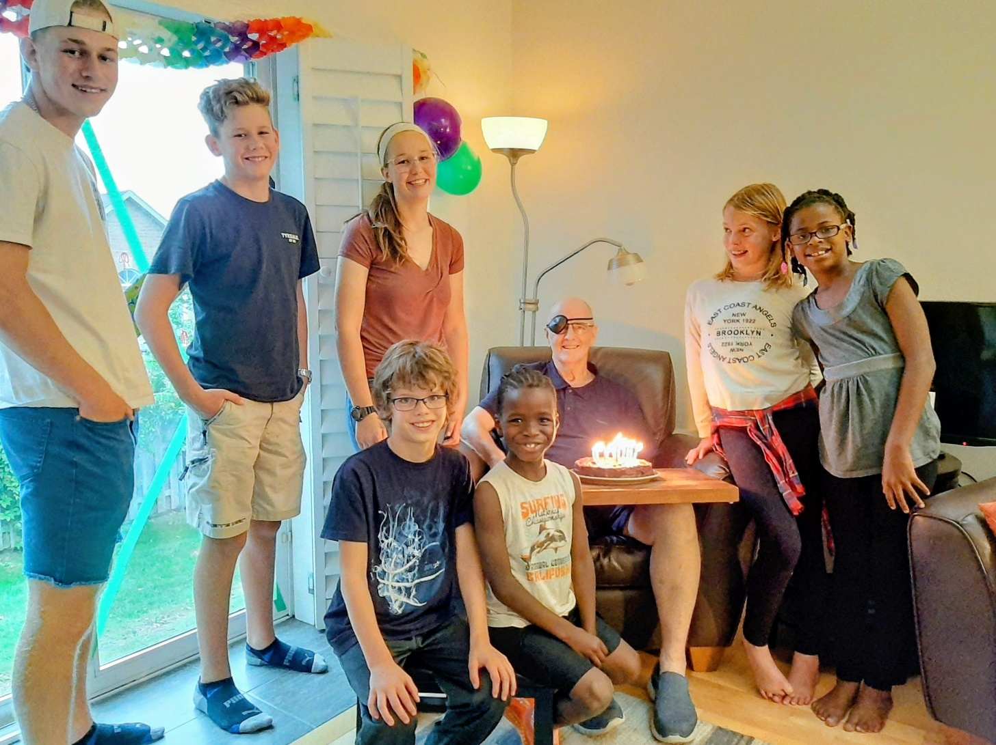
This was you around the time my cancer was diagnosed.

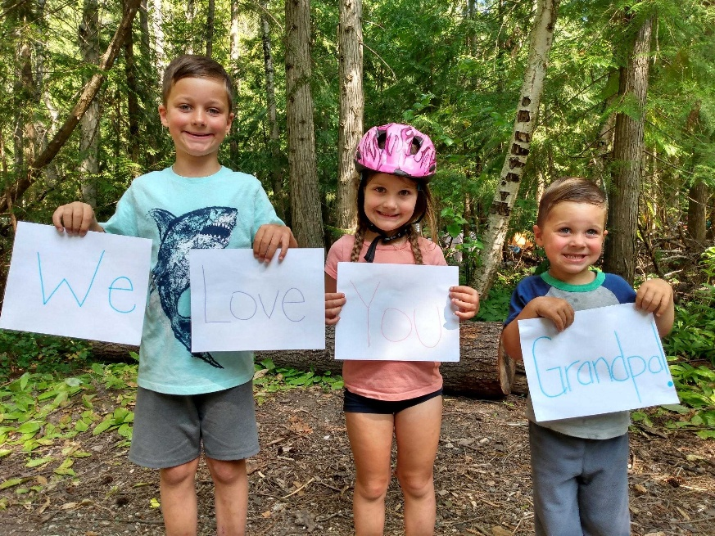
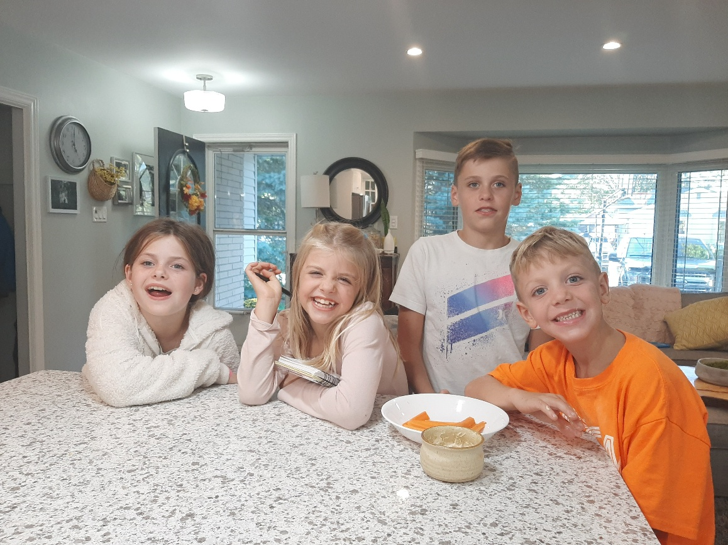
Cancer Discovered
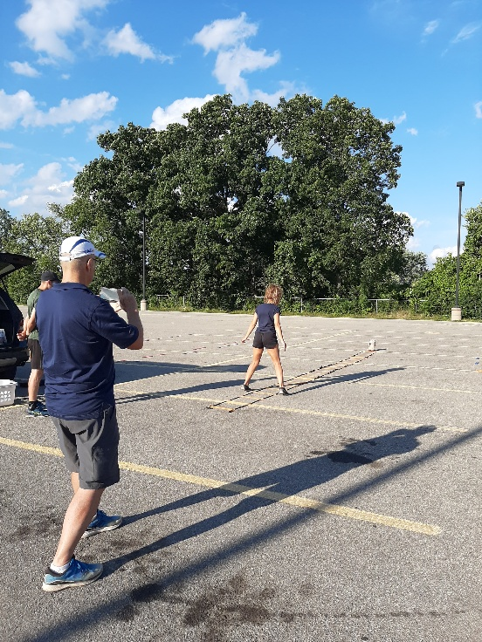
For a little over a month, I had not been feeling well. I was experiencing shortness of breath, exhaustion, and little appetite. My family doctor ordered some blood work, and the results showed I was losing blood, low hemoglobin, and abnormal kidney function. She ordered an endoscopy and colonoscopy.
On Wednesday, July 29, a couple days before completing either scope and while working on demonstrating a physical activity to a few students to help create videos, I lost consciousness and collapsed, hitting my head as I fell. This is the final picture I took as I fell.
I woke up in the ER at the Hamilton General Hospital. I could not figure out initially why I was in a hospital ER. The last thing I remember was filming two students demonstrating some games. On the heart rate image below, we can see my heart rate rising and then stopping when my watch was removed.
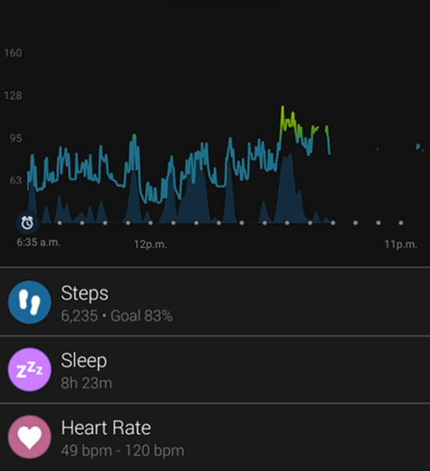
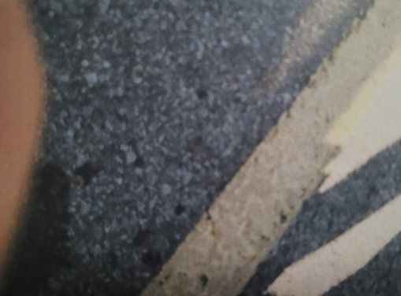
I did remember filming two students. Grandma was also there. As I lay on this hospital bed, I really wanted Grandma near as I longed for her love and for her explanation of why I was in the hospital—what had happened to me? Because of Covid restrictions I knew she was not allowed to see me in the ER.

I did not recall it at the time, as I moved in and out of consciousness, but the medical team took X-rays of my chest and spine, CT scans of my head and chest, and a carotid angiogram. Based on the scans, they determined that my difficulty in breathing was due to a large bilateral pulmonary embolism with extensive clot burden—and I was placed on oxygen for one week. They also installed a Foley catheter, and that was painful, though some nurses were better at it than others.
As I was moved to the Intensive Care Unit (ICU), I realized I had vertical diplopia. When I fell and hit my head on the asphalt, I had once again damaged my 4th and 6th cranial nerves, the same as 17 years earlier. On my left side of my sight, I saw two clear images.
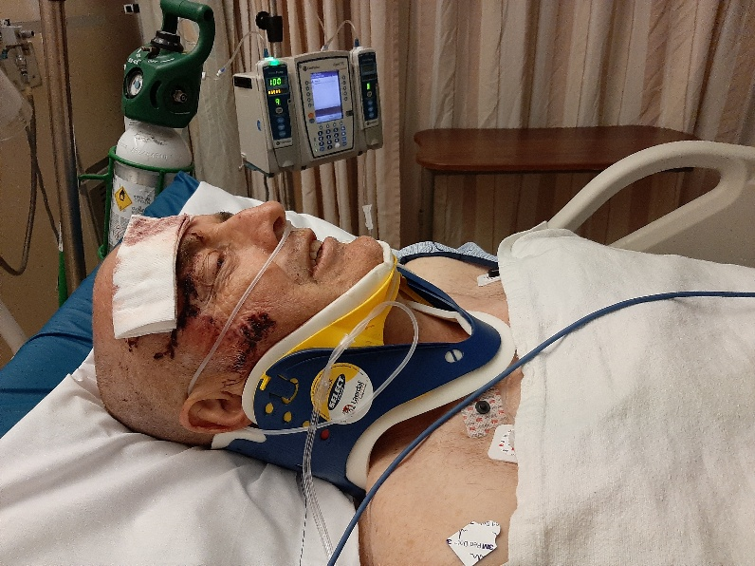
I had collapsed because my lungs were full of blood clots. The medical team wanted to give me blood thinners to dissolve the clots, but due to the fall, I had a small scattered subarachnoid hemorrhage, a brain bleed within the protective covering of my brain, so they could not give me blood thinners until the bleed had stopped.
Following all these tests and resting in the ICU, Grandma and Uncle Matt, who drove an hour to be with us, were finally permitted to see me. This event was traumatic for Grandma as she was the first responder, along with help from the students, until the ambulance arrived, about ten minutes after the students called 911. In hindsight, it was good that I continued to breathe. Actually the 911 operator should have first sent the fire department to give me oxygen, as they were only about 200 metres from the site of my collapse. Thankfully, Grandma kept me cool from the summer sun until the ambulance came and took me to the nearest trauma hospital.
During my second day in the hospital, I had an ultrasound on my legs, since blood clots typically originate in the legs. The results showed that there was no deep vein thrombosis (DVT), but the medical team decided, out of caution, to insert an Inferior Vena Cava filter (IVC). An IVC filter is a small, wiry device. I was taken to a surgical room where they inserted a filter into my IVC, the major vein that brings oxygen-poor blood from the lower body back to the heart. The heart then pumps the blood to the lungs to pick up oxygen. When the filter was placed in my IVC, the blood flowed past the filter. The hope was that if clots travelled from my legs to my lungs, the filter would prevent clots from traveling to my lungs or brain. `
Because of the clots in my lungs, my breathing had become more difficult, causing me to collapse. I hit my head as I fell, which caused a bleed near the brain for a short period. Grandma heard from a nurse who indicated that I was “lucky” that it was just my lungs that were so full of clots as the clots could have just as easily traveled to my brain and I would not have survived. Once the bleeding in the brain subsided, I began injecting 75% of a therapeutic level of blood thinners, and in five days, they increase the level to 100%.
Meanwhile, as the doctors were inserting the filter, they encountered a large thrombus (a type of large blood clot) protruding into the IVC, and as they viewed the CT scan, they noticed a shadow on my left kidney. A CT scan of my pelvis showed a tumor thrombus and a large renal cell carcinoma measuring at 7.0 x 7.6 x 8.7 cm that had taken over my left kidney. Not easy words for us to hear. At this point, the plan was to surgically remove the kidney. While I awaited surgery, I first needed to regain strength as I was very weak and tired. The oncologist met us a few days later to discuss this diagnosis in more detail.
While the cancer diagnosis came as a shock, it was also good to know what had been making me so unwell for the last number of weeks. We were all thankful for an excellent medical team that gave me outstanding care.
At this point, there was no obvious evidence of cancer spreading beyond the kidney. There were no concerning lymph nodes. There were a few very minute nodules in my lungs (which could represent metastatic disease), but the surgical oncologist needed to treat the primary tumour first.


Letting my 92-year-old Mom know that I have cancer.

View video at: https://youtu.be/NahJFNvP_ow

Showing Signs of Improvement While We Wait—Several Days Following Diagnosis
Journal Entry by Aunt Charis
Our family likes to say thank you to everyone for your outpouring of love, support and prayers. My parents both feel blessed by so many in their community and have been uplifted by your prayers. We are extremely grateful for the excellent medical care Dad continues to receive at the hospital; the staff have all shown such genuine kindness and professionalism. The staff have expressed their appreciation having him as a patient 😊.
Dad has shown many encouraging signs of improvement over the past 24 hours. Today he was able to stand up and walk up and down the hallway, and even managed to climb up and down 13 steps with the physiotherapist. He is gaining his strength back slowly but is still quite weak and tires easily.
His appetite seems to be improving. He is no longer receiving oxygen and is cord-free for the time being! We are so thankful that his cognition was not affected. He can express his eagerness in the next steps to healing, and is dreaming of the days to come and future opportunities in his life. We are thankful for his positive outlook!
Right now, we are eagerly anticipating our meeting with the oncologist to discuss how to move forward from here and decide on the next steps. Today, he was seen by the resident physician of internal medicine, as well as the neurologist. He is still experiencing double vision. His lungs still have numerous blood clots. His blood thinners have been switched from Heparin to a low dose of Fragmin, which will gradually be increased.
We continue to put our trust in the Lord, trusting Him to direct our steps and provide wisdom to the medical team.
Dad, you are so loved, seen, known, and prayed for! We will continue to walk this journey with you.
Prayer Points:
- Praise for gradual improvements in Dad’s strength,
- Healing for his double vision and that the numerous blood clots in his lungs, heart, and legs will dissolve,
- That we will have a meeting with the oncologist team soon,
- For continued peace and strength for Dad, and Mom as she supports him.
Isaiah 41:10 – “So do not fear, for I’m with you; do not be dismayed, for I’m your God. I will strengthen you and help you; I will uphold you with my righteous right hand.”

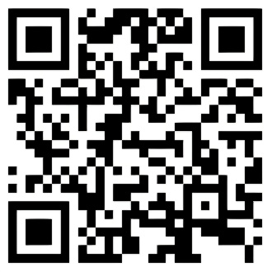
For years I posted on social media on Tuesdays and Thursdays. This post came from my hospital bed

View video at: https://youtu.be/2pviwoUEkHc?si=me0fkzaexboiSj8H

“It Is Better to Give Than to Receive”—Two Weeks Post Diagnosis
“It is better to give than to receive.” This is a statement I think we believe in. And we tried to give as we could. However, when there is a need, such as I have now, wow, it’s such a blessing to receive.
First, I arrived at a hospital unconscious. The medical team revived me, made me feel comfortable, washed me, fed me, and nursed me. Nurses, dietary folks, cleaners, doctors, and specialists were phenomenal in their care for me. Then there were these crazy blood clots, and a cancer growing on my left kidney. I had no power to deal with that, but I had to totally receive the work of well-trained people who could deal with these ailments. That made me feel good.
Second, numerous families, friends, colleagues, and people in many places offered me their positive energy, and their prayers, and they asked if there was anything that we needed. That generous outpouring of support was phenomenally helpful in the condition and need that I was in. To each one of you, I thank you so much for the support you offered to me and my family. There were times, even during these difficult days, that I was able to give to people. However, most of these days I was gratefully receiving. Perhaps it is neither better to give or receive, but to give when we are able and receive when we are in need.
I have experienced the heartfelt support of a lot of people. Thank you. I love you. Please give as you can to needy people around you and gratefully accept help when you are in need. Let us bless each other by choosing to enhance life for all!

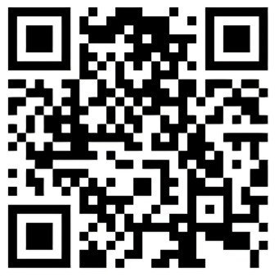
This song is a metaphor for the many people who provided unwavering support, comfort, and stability to Grandma and me as we navigated a difficult, chaotic, and emotional time.

Watch “Simon & Garfunkel - Bridge Over Troubled Water (Audio).”

https://youtu.be/4G-YQA_bsOU?si=FuJzOH33uG5czYZz

DISCHARGE SUMMARY—August 9

IDENTIFICATION: John Byl is a 66-year-old male admitted to the Internal Medicine Service for a fall secondary to exertional syncope.

PRIMARY DIAGNOSIS: Pulmonary embolism.

SECONDARY DIAGNOSES:
1. Query renal cell carcinoma.
2. Intracranial hemorrhage.

HOME MEDICATIONS:
1. Escitalopram 10 mg p.o. daily.
2. Amitriptyline 20 mg p.o. daily.

NEW MEDICATIONS STARTED IN HOSPITAL AND TO BE CONTINUED AT HOME:
Dalteparin 7500 units subcutaneous daily until August 12, for pulmonary embolism. On August 13, he will begin taking 10,000 units subcutaneous daily until September 12, 2020. He was taught how to self-administer subcutaneous Dalteparin and properly self administered for 3 days in the hospital.

COURSE IN HOSPITAL:
Four weeks prior to John’s presentation to the hospital, he began to develop shortness of breath. The day before admission, he collapsed during physical exercise. He was admitted to the ICU for treatment of bilateral pulmonary emboli and was found to have a small subarachnoid hemorrhage on CT head, which resolved on repeat scan on July 31. He was seen by Dr. Ekkehard Kasper, Neurosurgery, who recommended observation versus hemorrhage and cleared him for anticoagulation. He was started on heparin and went for an IVC filter insertion.
CT abdomen and pelvis without contrast was performed during his stay, which unfortunately revealed a large hypodensity in the cortex of the left kidney measuring 7 x 7.6 x 8.7 cm, most in keeping with a large renal cell carcinoma. Thrombus of the left renal vein and proximal IVC were in keeping with tumor thrombus.
During his stay, John had a Foley catheter placement which was complicated by extreme suprapubic pain, hematuria and clotting. He was seen by Dr. Laura Nguyen from Urology, who suggested prostatic urethral injury and recommended urethral irrigation. This resolved prior to discharge.
During his stay, Mr. Byl also noticed that he had developed binocular vertical diplopia, worse at distance, in keeping with his prior episode secondary to head injury in 2003, but he reported no other neurological deficits or headache and his neurological exam remained otherwise benign. He was seen by Dr. Devin Hall from Neurology, who suggested recrudescence of his old injury and management with only observation. His diplopia improved during his stay.
In summary, Mr. Byl is a 66-year-old male admitted for bilateral pulmonary embolism and intracranial hemorrhage, found to have a large mass in the left kidney, most in keeping with a renal cell carcinoma. We recommend the following:
1. Query renal cell carcinoma: Dr. Zareba from Urology at the Juravinski came to see him in hospital the day before his discharge. John will be called the week of his discharge to book follow up with Dr. Zareba.
2. Bilateral pulmonary embolism: John was seen by Thrombosis for discharge instructions. He will continue self-injecting Dalteparin 7500 units subcutaneously until August 12. On August 13, he will continue self-injecting 10,000 units subcutaneously for 1 month. Pulmonary embolism is most likely secondary to tumor thrombus from his presumed renal cell carcinoma.
3. Intracranial hemorrhage: John’s subarachnoid hemorrhage resolved during his admission.
He developed diplopia which improved during his stay. His consulting neurologist recommended considering a neuro-ophthalmologic outpatient referral to Dr. Rodriguez if his diplopia returns or worsens.
It was a pleasure being involved in the care of this patient.

A Hug for My Fellow Canadians—Two Weeks Post Diagnosis
I was in hospital for ten days. In a few weeks, I hope to be back for a few days to have my left cancerous kidney removed.
I was an immigrant settler to Canada 62 years ago. In the hospital, I had a roommate who had immigrated from the Middle East eight years ago. There were patients who needed a lot of medical help, and there were patients who seemed to have mental health challenges.
As I observed medical personnel, their interaction with all of us was always professional, fair, kind, patient, helpful, and generous. These are typical health professionals, but they are incredible front-line workers.
I’m very thankful I live in Canada. During the last couple weeks, I gave a lot of thought to my blood-clot-filled lungs and the orange-sized cancer engulfing my left kidney. I never gave a thought to the expense of all this—neither did any of my roommates. Why not? Because my fellow Canadians are footing the bill. Thank you! My taxes are used to help pay the bill for my fellow Canadians, and it is my pleasure to do so. Please accept a virtual group hug to my amazing 37 million fellow Canadians for the way we support each other.
My hospital stay is a reminder to appreciate being there for others and to gratefully receive communal help when needed.

Supportive Blessings—Three Weeks Post Diagnosis
When Grandma fearfully watched the person she most loves in the world collapse in front of her with a bloodied head, saying, “I can’t breathe,” this began a difficult period. A few years earlier, a friend had collapsed in front of her at the end of a half-marathon, and he had died.
For Grandma, what followed my hospitalization was a lot of support from family and friends, but also a total disruption to her daily routine. When I was in the hospital it meant most of her days were spent in the hospital and away from her regular routines. It meant that when she returned home, there were people to connect with. A huge part of her daytime was taken up with me. Then a short nighttime was further shortened by anxious thoughts after learning I had cancer.
My life has become more egocentric as I carefully walk around with my double vision, hoping to stay healthy for my scheduled cancer surgery on September 2.
Grandma’s life has become even more giving than it has been in the past as she cares for me and our household.
I’m blessed to have a lovingly supportive spouse in my life like Grandma. We are both blessed to have lovingly supportive family and friends, such as you, in our lives. Thank you all.
As you live your life, try not to live it alone. Be a good friend to a few people, support them, and welcome their support.

Blood Clotting—Nearly Three Weeks Post Diagnosis
Following my initial ten-day ICU hospital stay, I was happy to be home again. I was able to rest well in the comfort of our home. I was able to see people more easily, and I was able to enjoy one last day with Aunt Charis, who needed to fly back to her family in Vancouver.
A week later, while visiting some friends, I was not feeling well. Blood clots the size of mints flowed out when I urinated. I went back into the hospital. I wrote: “Yesterday I went back to the hospital because we felt there was too much blood and too many blood clots in my urine. Hospital staff took great care of me and ran a series of procedures. They currently plan to keep me in till Monday so I can see my oncologist then.” Friends appreciated the wisdom of going back to the hospital, but I did not really have a choice.
At the hospital they decided to clean my bladder with two catheters; one put saline fluid into the bladder, the other removed it, and they flushed my bladder with over 20 bags of saline fluid. Doctors attributed the clots to a “gross hematuria in the context of a known renal mass.” At the time, my left testicle had at least doubled in size. Doctors attributed that to the cancer that had overtaken my left kidney. Poor drainage of the left testicular vein can lead to pathological conditions such as testicular swelling.
During this hospital stay I received a CT scan, ultrasounds, and daily blood work. My blood pressure, heart rate, and oxygen levels were all very good each day. My hemoglobin numbers decreased by about 10% because I was losing blood. No blood clots were found in my legs! I had been able to do several 15-minute walks using a walker during my hospital stay. The size of the renal cell cancer had increased by about 10%. Aside from the blood clots and cancer, I felt healthy and apprehensively optimistic about the surgery. I remained in good spirits.

DISCHARGE DIAGNOSIS: Fragmin 10,000 units subcutaneous daily.—August 19
COURSE IN HOSPITAL:
This is a 66-year-old gentleman who was admitted to hospital with gross hematuria in the context of a known renal mass. He also has a medical history of bilateral PE as well as an IVC filter and is currently on dalteparin for this. He has planned surgery with Dr. Zareba on September 2. His hematuria resolved in hospital after holding his anticoagulation.
Thrombosis team was consulted in the hospital who restarted his anticoagulation. They plan to lower his dose from 10,000 units b.i.d. to 10,000 units daily up until the surgery. They have arranged for followup in their preoperative Thrombosis Clinic prior to surgery. He was discharged on August 19 when his hematuria resolved and he was feeling well.
FOLLOW UP:
The patient will be followed by Dr. Zareba. No follow up will be arranged with Dr. Fischer as this patient is already a patient of Dr. Zareba and has upcoming surgery planned.
Thrombosis will also follow up the patient in the Preoperative Clinic.

John Returns Home from the Juravinski Hospital!—Three Weeks Post Diagnosis
Journal Entry by Grandma
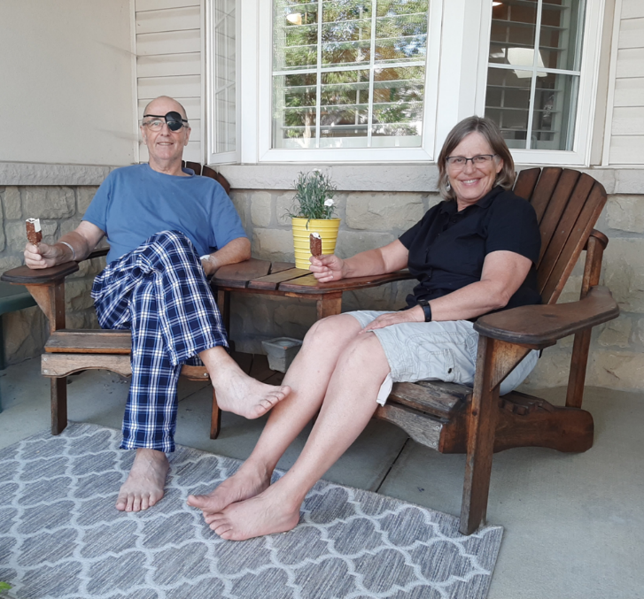
John said to me yesterday “that aside from the blood clots and cancer, he is healthy and apprehensively optimistic about the surgery.” He is currently in good spirits.
I give thanks to God for the peace I have experienced during these last three tumultuous weeks. The outpouring of love and support from so many people has been so amazing! We do feel carried by many people who are committed to praying, expressing encouragement, and sending positive energy for John and me. Thank you!
Several friends shared songs that have lifted our spirits and reminded us that we are not alone in this journey. The first song is called “The Solid Rock,” sung by a Virtual Choir (put together by a nurse from Cobourg, ON). It’s beautiful!
“Be still and know that I’m God” (Psalm 46:10).



To listen to “The Solid Rock” go to:

https://Youtu.be/nkIr6eHjqXI

SURGERY

Surgical Removal of the Cancer
The surgical oncologist liaised with the thrombosis team to balance the risk of doing the surgery too soon, while there was still a risk of blood clots propagating, against the risk of waiting too long and giving the cancer time to metastasize.
The surgical oncologist explained to us that the surgery would be technically challenging, with significant risk of complications, mainly because of the extension of the tumour into the vein. A vascular surgeon would also be involved in the surgery, as the tumour may have attached to the wall of the IVC. A major risk for me was that the blood clots could progress during surgery, and in the immediate period after, I needed to discontinue use of the blood thinners.
The surgical oncologist hoped to schedule this surgery as soon as possible, sometime within the next few weeks. In the meantime, the focus was on preparing for the surgery and waiting for clearance from the thrombosis team. The surgery would be scheduled based on this team’s recommendations.
Grandma and I wondered if I would survive the surgery, and I decided to write a brief note to each of you, letting you know that I loved you and the ways I thought you were special. We prepared some things for the possibility of me dying. My life-sustaining surgery was a time of complete surrender. It turns out the skilled surgical oncologist and his team spent six hours removing the kidney and the thrombosis. I survived due to this exceptional medical team. The love and care of that team is positively embedded in my mind.
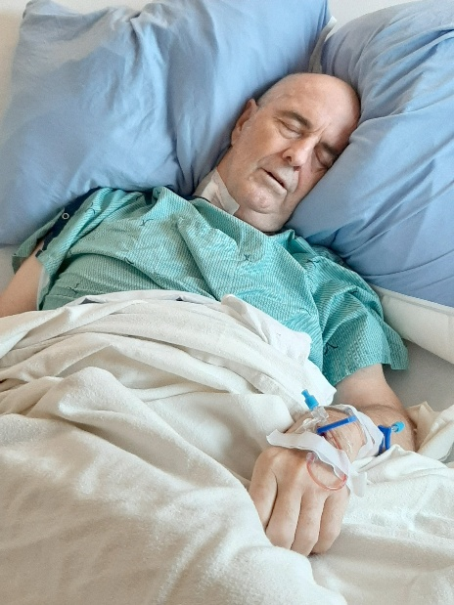
I knew I had renal cell carcinoma. Following the surgery, we were told that the surgery was a complicated one but had gone well. They also cut away a seemingly healthy part of the inferior vena cava for pathology to assess if cancer cells had spread. Pathology determined I had a unique and very aggressive high-grade cancer variant with rapid differentiation. They scheduled me for a follow-up body scan in three months, and the expectation was that the cancer might spread to the lungs and possibly the liver and bones. Treatment options would be considered as needed—difficult news for Grandma and me to process. For me, once I got over my initial sadness, the gift of each day and each relationship became even more valuable, but I did begin to make funeral preparations. A friend agreed to lead the service.
After the surgery I learned that three blood donors kept me alive. They gave of themselves. They volunteered to give 5 x 350 ml of blood. We gave them a pop and cookie. They are heroes. In my life, I’ve managed to give over 200 units of blood: the dance of giving and receiving.


We were blessed with the words of the song by Keith Duke · Geoffrey Nobes · Margaret Rizza · Kevin Mayhew Ltd. Watch “Come, Be With Me” reminding us to rest and be quiet in God’s presence.

https://youtu.be/mLy0qzcPXVo

Rejoicing in a Successful Surgery—September 2, One Month Post Diagnosis
Journal Entry by Aunt Hannah
The surgery was successful, and we are so thankful! An answer to the prayer of multitudes. Thank You, Jesus! We are so grateful to God and so thankful for an amazing medical team who carried out their roles in a caring, professional way.
The left kidney and 10 x 8.2 x 6 cm tumour and thrombus were successfully removed, and the thrombus was able to be successfully detached from the IVC (main vein). A few enlarged lymph nodes were also removed. Dad was stable throughout the surgery, and his body responded well.
He will remain in intensive care for the next week as he recovers from the surgery. The tumour will be sent for testing and in a few weeks, Dad will meet with the oncologist to learn results and plan going forward.
As a family, we are so grateful for the ways that many people have tangibly supported Dad and Grandma/Mom and each of us through the last number of weeks. You are all so appreciated!
We are relieved and overjoyed with these results. Everything went so smoothly; we are so grateful for the prayers of many. Thank you for carrying him through this surgery as he imagined! Thanks be to God!!
“Don’t be afraid, for I’m with you. Don’t be discouraged, for I’m your God.” Isaiah 41:10
“Finally, be strong in the Lord and in the strength of his might.” Ephesians 6:10


Letting my 92-year-old Mom know that the cancer surgery went well.

View video at: https://youtu.be/LDPKwub2PbQ

Discharge Summary—One Week Post-Surgery
Mr. Byl, who is 67 years old, was admitted for left nephrectomy and IVC thrombectomy. Procedure was done on September 2. The OR was complicated. The patient was transfused around 5 units as preop and postop of packed RBCs. Mr. Byl has a history of bilateral PE [pulmonary embolism] and DVT [Deep Vein Thrombosis] with IVC [inferior vena cava] filter. His course in the hospital was uncomplicated and he was followed by the Thrombosis team. Upon discharge, he was asymptomatic, passing bowel movement. He was vitally stable. Also, he will follow as an outpatient with Thrombo team for prescription of anticoagulation and IVC filter removal.

Carrying on Post-Surgery
It was still difficult for me to breathe. The pulmonary embolism made getting air through my lungs a challenge. Going up the stairs from the basement to the main floor required a few minutes’ break to recover. My heart rate was higher as my heart worked harder to get oxygen to fuel my resting body. I wondered:
- When can I exercise my body more freely?
- When can I walk as others can? I told myself to be patient. Perhaps the striving for breath can remind me to strive similarly for the sacred.
The double vision, which was a result of collapsing and hitting my head onto hard pavement remained unchanged. In a previous collision, in 2003, it took about six months till one day my sight was fully restored. Maybe it would take another few months till my eyesight was normal again?
I had about an hour or two of productive energy each day. I asked myself:
- How do I use the gift of those few hours?
- If you had two hours a day of productive energy, how would you use it?
- How will I spend more quality time with Grandma?
- Is there something I can do for my children, their spouses, and you?
- Do I write?
- Do I get myself more organized?
- What head things (I cannot do anything physical) need doing for our home?
- How do I divide those limited hours? These hours are increasing each week, so I expect I will be able to do more going forward.
When I asked myself what had changed for me because of all that I had experienced thus far, I thought of two things:
- One: My life had been placed on pause, and that pause or silence is something I hoped would continue as I moved forward. I wished to take more time to pause and appreciate silence in my life. A time to smell the roses, so to speak.
- Two: I looked forward to engaging more deeply in life again. To more deliberately and deeply, rather than more often, spend quality time with family, friends, conference attendees, online connections, the poor, and the needy.
I also did not want to get ahead of myself. I reminded myself: “Today is a gift to be unwrapped in places of silence, in places of deep connection with others, and in places of quiet healing. Yesterday was like that. I will try do something similar today.”

Love Heals—Two Weeks Post-Surgery
I woke up this morning recalling sitting on the edge of the operating table prior to surgery. The anesthetists had begun giving me drugs, and I said I wanted to lie down. They wanted me to stay seated. I fondly remember a comforting nurse standing before me, her hands firmly and assuredly holding my shoulders, speaking affirming words to me as the buzz of the pre-surgery operating room swirled around me. I remember thanking her for how she securely held me in place and prevented me from falling. I remember other health professionals who also cared, comforted, affirmed, held my hands, and gave me the important attention I needed to move towards healing. For my part, I needed to befriend my brokenness and accept the loving acts of healing provided by others.
Then I got my coffee this morning and read of the fires and smoke on the west coast of the USA and the hurricanes in the Caribbean nations and the Southern USA, and I wonder what we are doing to Planet Earth? I read of the killing of innocent people in Yemen, and I wondered how we are complicit as we ship arms to that part of the world; I wonder who the war criminals are? I read of leaders of countries, organizations, and companies who willfully lie or hide the truth, and I wonder why we support people like that? I read of 80 million people on earth who have fled their homes, 26 million who are refugees—of which 13 million are children 18 years old or younger, and I wonder why I’m concerned about the chipped paint on my dining room wall? I read how the number of hungry people in the world is rising, and I wonder how we can help. Lord, have mercy on us.
Then I sit back in my easy chair, hoping my healing will improve so I can enjoy and contribute more. I have befriended my woundedness and received a lot of love that helps me send this cancer away.
Then I dream of a world where children can grow up playful and healthy. I hope we can be like the nurse in the operating room, providing, in our own small and big ways, comfort, stability, care, and healing for parts of this very injured world. Maybe, I/we need to own our world’s woundedness more, in order that love can heal our planet.

Did I Win the Lottery?—Two Months Post Diagnosis
Yesterday I was thinking about today’s visit with the oncologist.
If I paid $5.00 for a lottery ticket, I might go online at a certain point and see if I had won a million dollars. I might even dream positive thoughts of what I might do with all those winnings.
An emergency room nurse shared with me this past August, that “cancer is a random evil.” My surgical oncologist said I have a 50% chance of coming out of surgery cancer-free. As the nurse said, it seems to be totally random whether I still have cancer or not. Going into my follow-up appointment this morning with my oncologist, I was not dreaming of life without cancer but how I would face life with various cancers. I tried not to think about it.
I wondered if I was part of the 50% that are cancer-free, but did that increase the odds for someone else to have cancer? I realized that if I was cancer-free, it was not because of my own doing; it’s a lottery, and I happened to win. The same is true the other way. If I have cancer, it’s not because of anything I have done, it is a lottery, and I lost. The above made me mindful of two things.
- Whatever life’s outcomes, I need to thoughtfully and thankfully unpack the gift of each day I have breath. If I do have cancer, may I have the strength and wisdom to deal with it, and still thoughtfully and thankfully unpack the gift of each day. I think a challenge in dying is to still reasonably choose living. Even though I believe there is a glorious place prepared for us after death, we were made to live on earth to care for and enjoy this planet and each other. I love this place where I get to love and be loved by Grandma, our children, their spouses, each of you, friends, and colleagues, and get to playfully and creatively try to make this earth a better place to live.
- May I similarly unpack the gift of each day and be mindful of the pain and suffering of those who lost life’s lottery.
We all make choices each day about the food we eat and the activity levels we engage in, and these choices help us to be more or less healthy. There is a randomness in life where some of us get cancer and others do not; some of us are born in financially well-to-do families, and others are born in poverty; some of us are born in places of abundant food, and others are born in places of famine; and some of us are trustworthy, and some are untrustworthy. May we be mindful that we live in a global family and celebrate the good things in life, and share, as we are able, with those in need. Maybe it’s not so much whether we win or lose, but how we play life’s game—playing the cards we are dealt. Thanks for how you each cared for me during the past two months of need.
What did I hear today? Good news and bad news.
I knew I had renal cell carcinoma. We were told that the surgery was more complicated than I anticipated but had gone well. The team also cut away a seemingly healthy part of the inferior vena cava, and pathology determined there were cancer cells there. Pathology determined I have a very aggressive high-grade cancer variant with rapid differentiation. I will get a follow-up body scan in three months, and the current expectation is that the cancer may spread to my lungs and possibly my liver and bones. Treatment options will be considered as needed. This is difficult news for Grandma and me to process. For me, once I get over my initial sadness, the gift of each day and each relationship has become even more valuable. Whatever cards you are dealt, use them for good.

Deep Sadness to Tempered Gladness—Nine Weeks Post Diagnosis
After hearing the difficult update this week concerning my cancer, there were a few days of sadness and lots of loving support from family and friends. Then, lots of time to think. Rumination developed into two thoughts that help me move from deep sadness to tempered gladness.
One, I thought about aspects of who I have been and am today. I came up with a sample list:
Blood donor, runner, playful game promoter, husband, colour-blind man, dad, writer, PhD, double-visioned person, colleague, brother, squash player, grandpa, workshop leader, cancer victim, Margaret Eaton School expert, friend, volunteer, child of God, uncle, golfer, retired professor, brain-injured person, teacher, brother-in-law, church member, and chocolate lover.
I need to remind myself not to be defined by one aspect in the middle of my life: “cancer victim.” All of us, including me, are more complex than that.
Two, I listened to some good advice from a good friend, Opa to Anna and Peter. He suffered a heart condition a few years ago that could have ended his life. He feels that each new day, month, and year is bonus. Before my surgery on September 2, Grandma and I talked about the low, but still real, risk that I might die during the surgery. Like my good friend, I did not die—nor did I die when I was hit off my bicycle by a truck. I can now say, “I only have a year, five years, or whatever time I have left” and be sad about that, or I can say, as my friend does, “each day, month, and year is bonus,” and be glad in it.
This week I was helped to understand that I’m a complex being who is defined by a lot more than one aspect of who I am, and that each day, month, or year is a rich gift to be used wisely and well. The fireplace is on, I have a warm coffee in my hand, my wife of 45 years is sitting across from me, and we are looking forward to visits with a few people today. :)
Know that you are defined not just by one aspect of who you are, but that you are a beautiful and richly complex and unique human, created in the image of Creator God, and loved.

“You Are Kind of Useless”—Eleven Weeks Post Diagnosis
We went to help our daughter move into a new home some years ago. I had just come out of a hospital with a broken leg, separated shoulder, double vision, a concussion, and some minor injuries resulting from being hit off my road bike by a truck. I was fortunate to come out alive. Even though we went to help, it was Grandma who was helping, and I sat out of the way in a quiet room. One person asked me why I was not helping. I explained why I could not. He replied, “You are kind of useless!” He was right, but I did not find the comment helpful. I love few things more than helping.
I’m retired now, but I’m still trying to help kids through their teachers and recreation providers by posting on social media and preparing virtual presentations. It is about all I can do at the present time. We hired some excellent people to build a backyard patio and deck. I feel useless though. I wish I could help. I move a couple of shovels of soil, and my lungs force me to sit down as I gasp for air. I want to pick up something that is a bit heavy, and I’m told not to; I wait and watch someone else do it. I can’t drive yet due to my double vision. I hear that voice saying, “You are kind of useless.” I often feel useless. It hurts a bit at times.
Maybe, like after my bike collision, my usefulness is in coping with my new limitations. I also enjoyed my first rounds of golf this past week. Mark Twain once said, “Golf is a good walk spoiled.” Not for me, I love the outdoors (especially the beautiful fall colours), I love the game, and I love important time spent with wonderful friends. They spoke appreciatively of my joining them this week. I teed up most of my golf balls, and my game was not terrible, despite a lack of depth perception. I could do something! I needed to take satisfaction in moving at least a few shovels full of dirt, making pancakes for lunch once, filling and emptying the dishwasher a few times, hitting a golf ball, and being a friend.
My 92-year-old mom is losing her memory. She cannot do much, but she knows who her children are and she effusively expresses her love for us. If that is all she does, that is amazing! Perhaps some time in the future (I hope many years in the future), due to the cancer in me, the only thing I might be able to do is to share my love for those near me. That will be good enough. Maybe I’m too absorbed by living as a “human doing” and need to do better at living as a “human being.”
Enjoy being a human being who also does good.

“I’m Choosing life” Is a Conscious Decision—Three Months Post Diagnosis
When I first went to the hospital at the end of July after collapsing on account of lack of air, the attending doctor asked me what they should do if my heart stopped. I said, “I’m choosing life, and please revive me, unless I’ve been dead for a while.” Before I collapsed, I never thought much about dying. Great Grandpa died at the age of 96, and Great Grandma died at the age of 97. If I did think about my death, I thought I might live a long life as did my parents—another 20 to 30 years.
Even though I have chosen life, fear of the cancer cells that invaded my body have begun to lurk in my subconscious. When I read a newspaper, my eyes are more quickly drawn to articles about celebrity deaths at the ages of 21, 44, 65, 75, 81, and 96. We all die. When I choose life, such as when I’m considering purchasing a season pass for golf next year, I realize I’m consciously choosing against dying next year. Death had not been part of my thinking before. Now it is. Death is now in my subconscious, showing its morbid head whenever possible. Thoughts of cancer cells possibly making me deadly sick in the future, and thoughts of dying sooner than later, is a burden I carry from time to time. But I’m also buoyed with people’s stories of cancer healed or in remission.
In church last Sunday, we sang the following words:
Come to me, O weary traveler,
come to me with your distress,
come to me you heavy burdened,
come to me and find your rest.

Do not fear, my yoke is easy,
do not fear, my burden’s light;
do not fear the path before you;
do not run from me in fright.

I’m comforted by a belief in a personal and loving God who walks with me. I do find rest in that belief. Nevertheless, there are times when life’s burden/yoke is not easy. It made me think how easily we say/sing words when we are well that may not totally connect with our reality when we are in pain or burdened.
When I previously thought of a yoke, it was two oxen yoked together as they walk and pull a heavy load. The Bible and the song, say that Jesus invites me into that kind of shared relationship. As I think through the yoke metaphor in my current situation, I think of a yoke as joining three oxen: God, me, and you. I hope you are not offended at me comparing you to an ox . You have discerningly loved me. Your prayers, your positive energy, your caring comments, your offers of assistance, your golfing with me, your friendly greetings, and your sharing bread with us, have been ways of you sharing my burden/yoke and helping me journey onward choosing life.
As I choose life, thank you for your willingness to pull along with me. You help me, especially when the soil is heavy and the plowing is difficult. I love to be yoked with you as well. Thank you!


To listen to “Come to Me, O Weary Traveler,” listen to Paul Tate’s version at:

https://www.youtube.com/watch?v=mCmlg2X1O9w&list=RDmCmlg2X1O9w&start_radio=1

The Best of Times, the Worst of Times: Love—Thirteen Weeks Post Diagnosis
This morning, I read and learned from Roman Catholic Sister Joan Chittister that those who “never lose hope that the values they learned in the best of times or the courage it takes to reclaim their world from the worst of times are worth the commitment of their lives” (2019). Even though Chittister’s focus is on social justice, her words are an encouragement for me to maintain my values and to live to fight my cancer. I want to prod myself “into seeing newly what it means to be fully alive, personally, nationally, and spiritually.” I want to love God and this world enough to be “a prophetic presence that our corner of the world becomes a better place because we have been there.”
I have chosen life, which is more than breathing, but Chittister has given us a challenge to live it well, to “seed new life, new hope, new dynamism, the very essence of a new world community.” Let us love enough to heal the sick, feed the poor, encourage children to play, unshackle the prisoners, and see the beauty around us.

Letter from Prison—Fifteen Weeks Post Diagnosis
A young friend wrote to me from his prison cell—probably during one of his many institutional lockdowns. I received his caring letter this past week and read and reread it. Several years ago, he, his girlfriend, and their daughter began attending a church I also attend. We became friends quickly. During the last three-and-a-half years, he has been mostly in and out of jail. He was scheduled to be released in four months. From his prison cell, he encouraged me with these words:
I will do my best to be there for you and your family. If I can be of any assistance for home repairs or maintenance…. I will be there for you my friend. Just a couple more months.
Hope, love, and patience are the best antidotes that get us through today so we can be open to the beauties of tomorrow… Johnny, I’m praying for you brother…. You are too strong to be beaten by this health issue. I have faith you will overcome.
A couple days ago, I heard he had been hospitalized from a fentanyl overdose. Today, I visited him. Machines are keeping his body alive so that he can give the gift of life to others through organ donation. Prisons are awful places for so many reasons. Our judicial system is flawed.
I will miss my friend. He taught me much about love, commitment, the challenges of post-traumatic stress, imprisonment to drugs, incarceration, and the desire to live well despite challenges. We failed in this young man’s life. I wish we could find a way in our country to provide a system of care that helps inmates leave their incarceration more able to live in this world and to flourish in it.
I’m not living in a prison cell. However, cancer has begun to imprison me. I hope I will not succumb to cancer. I hope I can continue to desire to live well and have that same desire for those of us imprisoned by stone walls, illegal drugs, a history of abuse, hunger, past trauma, loneliness, wealth, negative body image worries, and addictions. My friend is now free from his troubles.
Can we try creating a bit of heaven on earth? Can we try to help all people, especially the needy, to be set free to enjoy life and live it abundantly? My incarcerated friend wanted nothing less for me. He prayed that in the here and now I could be set free.

Finding Revolutionary Love When I’m So Egocentric—Sixteen Weeks Post Diagnosis
When we have cancer or other significant ailments I think we necessarily turn inward and become more egocentric. How do I balance responding to a world of significant and important needs given my personal significant and important needs? Is it even okay for me to ask people to care/pray for me in my need when there are so many more significant needs in the world?
My current need story is about cancer cells in my body. I know the cells are there, but I do not know what they are doing. I’m choosing life in this story, but I also know that we are all mortal. The cancer cells remind me, more often than before, that my life may well be shortened. Today is a new day where I’m gifted with life. Let me rejoice and be glad in it, and help make this world the best it can be.
How is this world doing? When I Googled “worst pains in the world,” answers that came up were shingles, slipped discs, and cluster headaches. All personal issues. But what about significant pains? I thought about Yemen where 80% of the population is in need of humanitarian assistance. In North America we have jobs creating war tools that inflict harm on Yemen’s citizens. In the Democratic Republic of Congo 30% of the people suffer from food insecurity, yet in Canada we waste 31 billion dollars-worth of food a year, and our southern neighbours waste 161 billion dollars. We could go on listing significant pains.
At one level, I feel paralyzed to speak into the darkness of this world and the tremendous hurt we inflict upon the earth and each other. I’m reminded of a childhood Sunday School song that reminds me and us to shine our light into this world, “You in your small corner and I in mine.”
How do I love myself enough, my enemies enough, and my neighbours enough to make for even small differences in my community?
Valerie Kaur is an activist and founder of the Revolutionary Love Project. I found this quote from her to be helpful: “Loving only ourselves is escapism; loving only our opponents is self-loathing; loving only others is ineffective. All three practices together make love revolutionary, and revolutionary love can only be practiced in community” (Kaur, 2020).
Perhaps it is with this revolutionary God that I find balance. It is good for me to love myself enough to ask others to support me in my need, like the triple-yoke I wrote about earlier, and to also love those who damage this good earth and its people. I’m uncertain how I do that with some people. Know that I live with you in a loving community that seeks for the betterment of this earth and all people in it as your love for me is an encouraging example to me. Thanks!
Prayer thought: Help us to love ourselves, love those we are pained by, and love others—especially those of us in need.
“Grandpa Is Not as Crazy as He Was Before.”—Seventeen Weeks Post Diagnosis
“Grandpa is not as crazy as before.” A perceptive comment from my then three-year-old grandson during a recent video call.
Probably without me being aware of it, my recent disposition has become more shaped by my sadness than by joyfulness. My apprehension of my cancer, current political leaders, and COVID restrictions, contribute to this sadness.
I asked myself what helps me be joyful, such as celebrating divine victories, and to be a bit crazy. Activities such as relaxing with Grandma while we’re engaged in meaningful and positive conversation, sharing my heart with my children and grandchildren, assisting a friend to get dentures, assisting a mother—who recently lost a son—by celebrating the good person he was, sharing life with my dear golfing friends, listening to the songs of nature, and sharing ideas to help kids be active and healthy—all are helpful.
I think my disposition is fed by what I experience. For me, cancer is real, political concerns are real, and COVID concerns are real. However, I cannot control my cancer, my life is not at stake, and if I heed the safety practices around COVID, I should remain safe. While I do think it is important to invest in meditative time, to feel a little of the pain of a loving and creative divinity. I need not feed what I cannot change by doing too much cancer research and watching too much television news; otherwise, all I’m feeding is my sadness.
It does feed my joy to spend time dining from a smorgasbord of positive relationships. It is nourishing to spend more time dining there. Joy is invigorated by meditative time on the love of God, encouraged by life with Grandma, aided by connections with my children, with each of you, helped by walking with people and their needs, deepened by shared life with good friends, blessed by listening to birds sing, enriched by helping kids enjoy play, and fulfilled by being a caring and crazy Grandpa. It is important to nurture meaningful joy.

Cared For and Choosing to Care—Eighteen Weeks Post Diagnosis
Tomorrow, I’m going to the hospital for a CT scan. During the last several weeks, this appointment had me think regularly and warmly about hospital care. After collapsing at the end of July, I spent almost three of the next six weeks in a hospital—mostly in Intensive Care. My last hospital procedure (removing an IVC filter) was two months ago. Next week I will meet with my surgical oncologist. Following that meeting, I wonder how much more care I will be receiving in a hospital and when the hospital will become a haven again.
Being cared for and feeling safe are the two feelings I most experience when I think of my hospital stays. The front-line workers there made me feel the way I did. Their regular check-ups, medicinal availability, reassuring words, skilled work, and genuine care made hospital stays a bit of a refuge, even though I did whatever I could in the hospital to be well enough to go home again. There is nothing like sleeping in my own bed.
It made me realize that it feels good when I’m cared for—especially when I’m vulnerable. Many of us will have time in our lives when we feel vulnerable. I pray that any time you feel that way, you will be comforted by the kind of care I have been given. I also hope I can be mindful of those with vulnerabilities and offer them my love. So many people have done that for me. Thanks!
All of the above made me consider a bigger picture. I believe our expanding universe was created by a relational Creator who has placed divine DNA in all of us, a Creator who cares for all and invites us to use our abilities and shared creativity to care for each other and for the universe we are a part of. God invites us to put skin in the game. Bigness becoming little, little becoming big. It is a taste of divinity when we are cared for and choose to care.

Living Today As If It Was a Final Day, But Knowing I Have More—Nineteen Weeks Post-Diagnosis
Today I met with my surgical oncologist to discuss last week’s CT scan. The results were very good. He said there were no changes anywhere except for a 1 cm nodule on my lungs. He thinks it may just be an infection related to the diminishing clots in my lungs. We will have another CT scan in six weeks, followed by an appointment with my medical oncologist. I do have an aggressive cancer variant, but thankfully it seems to be less active, for now :).
I’m very thankful. A beautiful way to go to Christmas celebrations!
This past week I was thinking: if we believe, based on regressive mathematical computations of an expanding universe, that the universe is 13.7 million years old, then don’t 10 or 20 years of life seem inconsequential? If we accept the Christian belief that we live forever, doesn’t that make 10 or 20 years on earth seem even more inconsequential? We all die on earth. Nearly two people in the world die every second. Cancer and kidney disease, both of which I have, are the number 2 and number 12 killers (Statistics Canada 2026).
However, I began to consider that if we were told we have only a few months or days to live on earth, how would that affect us and what we do? As I prepared to be told the results of my recent CT scan, I thought a lot about my final days. Three thoughts went through my mind:
One. I most love Grandma and the children of our love—and also their wonderful spouses. Further, I love you, our grandchildren, which came to our children as a gift of their love, either through the intimacy of their longing hearts for each other or their longing hearts for unique children an ocean away. Intensified by COVID-19, I long to be in the loving presence of Grandma, my children and their spouses, you, and others I dearly love. During these last days, I would do anything to be in the presence of my dear family and friends. I do not believe there is anything inconsequential about any of this. It is holy time.
Two. Martin Luther, an influential Christian who lived about 500 years ago, was planting a tree one day, and, as it has been recorded, was asked by someone, “If the Lord returned tomorrow, what would you do today?” He answered that he would plant the tree. His point was that the good things we do on earth are important. If this was my last day on earth, and I was able, I would go on social media and post one more fun, inclusive, physically active game to help leaders bless the well-being of children. I would try to play one more round of golf with friends whom I love; and, if time permitted, share a wonderful beer and delicious sweet potato fries with them. I would try to find one more joke to brighten the day for my friend who is in lockdown at his retirement home. I would love to spend time with my extended family. With thanks, I want to break bread and share wine with Grandma, and perhaps enjoy one last romantic evening. With Luther, I do not believe there is anything inconsequential about any of this. It is holy time.
Three. I would want to bless those who were with me today and receive their blessings. The last thing my father did, nine months ago, before he went to sleep one final time, was to reach out his open hands to receive the Lord’s blessing from a visitor. “The Lord bless you and keep you; the Lord make his face to shine upon you and be gracious to you; the Lord lift up his countenance upon you and give you peace.” Great Grandpa passed on six hours later. I want to wish this blessing on all people I know, and in turn receive this blessing from them. There is nothing inconsequential about any of this. It is holy time. As a Christian, I do believe that we live forever, and I look forward to a place of no more death, or pain, or tears, with children playing in the city streets in the loving presence of God.
Thinking about final days, especially with the good news I just received, it has also been helpful for me to consider how to spend less time today on what is not important, and more time on what is. What can I take with me when I die? Not wealth. Not memories. Nothing. What can I leave behind? Perhaps, with intentionality today, a life well-lived, having caressed a small part of this world with joyful, significant, holy, extravagant, and even reckless love. I hope you can do the same.

I was touched by Justin Bieber’s song, “Everything Hallelujah,” in which he invites the listeners to understand all the big and small things in life to be touched by God.

You can listen to this song at: https://youtu.be/GuOt7iANSO4?si=nUSDeIm4lKpFW2s9

I Tried—Five Months Post Diagnosis
My common phrase about life is, “I tried.” I think this phrase grew in me from what I perceived as a childhood of failures, a time in my life where I set a life pattern of trying to work harder so as not to fail. Recently, with my cancer realization, my default was to say, “I tried.” I sought medical assistance and was resigned to whatever outcome occurred.
At Grandma’s encouragement, I went past resignation and allowed myself to pray for healing—she prayed for a miracle. I could not pray for a miracle because I was not sure I felt life and God work that way, but maybe that reflects my resignation about life.
Today I heard a message about longing. It was a warmly encouraging message that changed me and gave me freedom to long for a world as it was intended. These words gave me emotional permission to be in a place where I can long for my eyes to see only one image instead of two, for my lungs to be free of clots so I can breathe more freely, and for the cancer to be gone.
I also long for a world of more peace, joy, play, human contact, and health. May our longing, our hearts, and our contributions help shape on earth as it is in heaven. Let us all long for a better world and at least say, “We tried!”

Do I Believe in Miracles?—Twenty-three Weeks Post Diagnosis
A dear friend, and Opa to Anna and Peter, sent me a thoughtful note considering the nature of miracles. His note made me think through four important questions: Who is God? Who are we? What is prayer? What are miracles? Let me try to briefly explain what I think and believe. My apologies that this is still a longer read. Some of you may find this explanation a bit too complicated but I needed to process the above questions and come with answers for myself. Maybe grab a tea or coffee before reading much further.
Who is God? Essentially, for me, God is an all-powerful and all-loving being who created and cares for the entire universe. I believe God created “laws” which govern what was created. Who are we? I believe that God created people in his image, not to reflect the image but to be it. In other words, God is significantly present in all we are as humans. All people are God’s children and are loved by God. God invites us to enjoy, care for, and love the world we are in and are a part of. Because people are the image of God, God encourages us to make our own choices as we engage in our lives. As we observe love displayed, we experience God.
I think that in the chaos of our lives we try to discover God’s laws to help us live. We often think, even subconsciously, about cause and effect. My friend wrote, that which comes “from careful observation, we believe to be in accord with the laws of the universe as we know it. A person steps off a cliff and the law of gravity will have an effect. But we ought not suppose for a moment that this fully describes the event. Why, for example, does the person step off the cliff? That is usually a much more complicated question which will lead us to a consideration of many factors.” Though we often live with a cause-and-effect way of thinking, the more we think about life, the more complicated it can seem. In that respect, God is also more than the box we tend to put God in. As I get older, I’m more drawn into the mystery of God. I recall that when I was younger, I knew exactly who God was, what God did, and why God did it. Now, I know God as a creator of the universe, and one who loves all that God made. How God does much of that is a mystery to me, and I’m okay with that.
I think we always need to temper our understanding and realize that our understanding of the world and causation is limited. I often remind myself of Bertrand Russell’s discussion in The Problems of Philosophy of a chicken that gets fed every day by a farmer. When the farmer comes out, the chicken looks forward to more food, but this time the farmer wrings the chicken’s neck and brings it home for supper. Russell says that all this goes to show is “that more refined views as to the uniformity of nature would have been useful to the chicken.” I believe that as humans we try to understand the order of the world to make living simpler and more predictable, but our understanding should be tempered by the realization that we may not always fully understand life’s complexities.
In my cause-and-effect way of thinking, I asked the question, “Where did my cancer come from?” From a simplistic view, I do not think there was anything I did that caused the cancer. Some people might blame an all-powerful God for giving cancer to me for some reason. Maybe there was something I did that negatively affected my health, or maybe the answer is more complex, and the cancer can be explained by factors within this world, such as the water I drink, or the manufacturing of food I consume. Furthermore, I do not believe an all-loving God inflicts ills on humans created in God’s image. I do not accept that argument. Maybe my cancer is best explained by a nurse who cared for me and said he thought the cancer comes from random evil in the world.
How do we get rid of my cancer? Some say through prayer. My friend wrote: “In the last year or two I have been informed regularly about the progress of two illnesses leading to death. In both cases, self-described ‘prayer warriors’ became involved. They ‘claimed’ physical healing would happen as a direct and certain consequence of their act of praying with confidence. Well, both persons died, and, as far as I know, their time of preparation for death was unduly limited, precisely because of those prayer warriors’ insistence that they knew the way prayer would work for physical healing.”
The above examples raise the question, what is prayer? Or, why pray? My experience is that your prayers, as well as your positive thoughts and energy have carried me. I have no explanation for how that works, but I’m acknowledging that I feel carried. I think prayer, which includes positive thoughts and energy with God, is time spent with a loving divinity sharing our yearning heart, our thoughts, our spoken words and our whole being. Another friend once told me that to pray for the sick is to go visit them. As I reflect on that, I know I felt carried by your visits in person, on the phone, with cards, being nourished by your meals. I was also carried by you carrying me before God. How does this work? I do not know. It is part of the mystery of life, and I’m okay with that. My good friend wrote: “We do not know what ramifications come from that prayer any more than we can predict the consequences of the flapping of the butterfly’s wings [some chaos theorists say that the flapping of butterfly’s wings in China can lead to a hurricane in the Caribbean]. It is not unreasonable, in my view, to posit that there are consequences we cannot fully predict that arise from the act of praying. Prayers can, I think, have multiple effects, certainly and obviously on the one who prays, but also, in usually untraceable ways, on the one prayed for.” I have also seen research that supports this conclusion. Please continue to hold me up with your prayers, thoughts, and energy.
As we commune with God with our thoughts and prayers and lay our thanks and needs before God, God certainly listens with love. Yet like the example of Great Grandpa and the two examples my friend listed, the prayers of many people are no guarantee of receiving what we ask for, even if it is a good thing by our standards.
Should we then pray for a miracle? That begs the question, What is a miracle? My good friend wrote the following which I found very helpful: “Perhaps a miracle is an event in that web for which we cannot fully trace the operations of cause and effect. This does not mean that the event is outside the laws of the universe which we claim God has established. We say that God’s hand and will is in the blessing but that is true of many and perhaps all things. The sun rises in the morning, and we do not call it a miracle. I think we do not call it a miracle because we (mainly) do understand the mechanisms by which it happens. But it is still a great wonder and a ‘sign’, the usual New Testament word for miracle. A sign is something, I would say, that shows the love and power of God rather than merely something the cause of which is mysterious or even inexplicable. In that sense, the daily rising of the sun is a sign or a miracle.”
Do I want to be cured from cancer? The short answer is, “Yes!” I love Grandma, our children, their spouses, all of you, my extended family, and friends who are reading this. I love living in this world. I deeply appreciate the multi-faceted support you have given me and our family. Can I, and can I ask you, to pray for a miracle? I have struggled with this question for the last half year. My experience with Great Grandpa’s visitors, and my friend’s story of prayer warriors who failed to help a friend face death, made me unsure of praying for a miracle. Some people when they encounter something like cancer or other disastrous news, ask, “Why me?” I have not asked that question. I think my answer to that question is, “Why not me?” Why am I so special that I should not get cancer or die from it? In that same spirit, why should God grant me a cure, when over 80,000 Canadians die each year from cancer? By the time it takes to drink a cup of tea or coffee, one Canadian dies from cancer, and one to three Canadians are diagnosed with cancer (the math shows that most Canadians with cancer do not die from it—and I’m one!).
The cancer in my kidney is no longer there. The doctors removed the whole kidney. I’m told there are microscopic cancer cells still in my body. The expectation, from the research on previous cancer patients, is that these cells will likely multiply. The doctors tell me that when they see these cells multiplying, metastasizing somewhere, they have ways to surgically or medically deal with this development. They are confident, but we all know that oncologists cannot save everyone. My feeling is that the cancer cells I have in my body will begin to multiply, and I feel medical professionals will be able to remove these cells.
To sum up, my good friend wrote: “I do think that what we call miracles remain within God’s laws, but we do not have the capacity fully to describe the operations of God’s law. I further believe that prayer can and does have effects, which, again, we cannot fully describe. These miracles, and many things that we neglect to call miracles (the skill of doctors, the care of nurses, the brilliance of researchers), are all ‘signs’ of God’s love. May you experience many such miracles!”
I believe my prayer, and if you are able, your prayer, can be for people in adversity, that adversity be relieved. I long for my cancer to be gone. It does not matter to me how I might be healed. I think I would be equally delighted and thankful if the cancer was removed through the cause-and-effect miraculous world of skilled surgical and/or medical oncologists, or through an unexplained miracle. At the same time, through the random evil of our present life, if the cancer does not go away, I pray for myself, my family, and for those who support me, that we manage the struggles, the pains, and the eventual death, remembering that a loving God invites each of us to help make life “on earth as it is in heaven.” Today is a gift; let us unwrap it well.
Finally, aa my good friend wrote: “I have doubtless gone on too long.”

Putting “My Cancer” in a Box—Six Months Post Diagnosis
If I were a soldier and being attacked by an enemy army, I would not call the attacking army “my army.” The opposing army is attacking me, possibly killing me. Similarly, one of my caring neighbours recently reminded me that the cancer attacking me is not “my cancer.” The cancer is opposing me, attacking me, possibly killing me. The cancer is not me, or mine.
My neighbour explained how she was once able to take her pain and place it in an imaginary box where she could view it as an object, not something that transcended her being. In due time, when her pain subsided, she was able to put an imaginary lid on the box. Later, when she felt mostly healed, she was able to toss this imaginary box into the trash. It was her way of dealing with pain by making it an object outside of herself and not allowing it to define her. Her pain eventually subsided—perhaps the power of a positive perspective, perhaps a natural healing, and perhaps a miracle.
Since I was diagnosed with cancer, I have been labeling the cancer as mine. My neighbour’s conversation helped me to not be defined by a vicious cancer that is attacking me, but to put it in a box. Putting the cancer in a box allows me to be me. As I discussed previously, I’m a victim of cancer, and I’m trying to survive this cancer’s onslaught. It’s helpful for me to defend myself against cancer. It is not helpful for me to define myself by an outside force that might be destroying me from the inside out. I’m not John Cancer. I’m John Byl. I should not get lost in an individualized and negative reality but instead nurture goodness and view the groanings of a cancerous creation as something we can fight and heal as a community. With the help of amazing medical practitioners, many supportive people, and God, I resist the cancerous attack against me! With cancer’s attack on me I have created a safe place, partly through CaringBridge, for you to enter my life and support me as you have. The cancer is not “my cancer” anymore, I’m putting it in a box. We’re fighting its intrusion into my life and the lives of others, and I hope we can eventually put a lid on this cancer, and cancer in general, and toss it in the trash. Thanks for joining me in this fight.
P.S. My good neighbour unfortunately died from cancer’s attack four-and-a-half years later.

Choose life’s Dance: Celebrating, Strengthening, and Loving—Twenty-eight Weeks Post Diagnosis
Whenever I experienced a significant change in life, I sometimes experienced significant loss, but I also found opportunity to learn more about a new me, learning anew how to dance though life. In the case of my collapsing from cancer’s attack on me six months ago, I experienced loss, and I learned about a new me living with precarity. Two recent CT scans showed that I have a few nodules in my lungs that have not grown during the last two months. I’m not sure why I was expecting bad news at last week’s surgical oncology appointment, but now I have opportunity to dance anew and be delighted with a more stable life. We all celebrated this positive news. I wish I could celebrate more and live normally again. Yet, even with the cancer’s inactivity, there are regular reminders that I’m still in a battle for my life, not normalcy. Whatever the outcome, I’m grateful for the life in which I have been invited to dance.
Stable life does not mean inactivity and no reminders of the cancer. I had a meeting today with a medical oncologist. He reiterated what I felt was very positive news. He noted that this past summer I had a localized and very advanced disease. That is why the kidney was removed and the inferior vena cava surgically repaired. Things appear very stable now, and the oncologists see no reason to jump in, only to observe. The medical oncologist said it is possible that I may never need follow-up treatment. “Never need treatment?” That is a crazy, amazing thought! In the meantime, oncologists will continue to monitor me, and if the cancer cells begin to advance, the oncologists are ready to go on the attack with treatment sooner rather than later. I feel a cautious exuberance about hearing this second positive oncology report.
Part of my newness in this current stability is helping me build a stronger me. I’m having my blood thinner medication switched from injecting myself, to Eliquis, to Warfarin. Why blood thinners? I’m told that cancer thickens the blood and stimulates the formation of blood clots. If the cancer cells do become active, the Warfarin will lessen the formation of blood clots. I will need to go to LifeLabs once a week for a while for the clinicians to check my INR level, which is the amount of time it takes for my blood to clot. The helpful thrombosis folks will monitor the INR numbers and adjust the Warfarin doses accordingly. Every time I walk up our basement stairs, which I do surprisingly often in a day, and need to catch my breath at the top, I’m reminded of the clots or scars in my lungs, and the cancer that produced these clots and scars. All this activity with blood thinners and out-of-breath stair-climbing reminds me that the battle with cancer is not over.
Death could come any time to any of us. Some people wonder why I’m more preoccupied with death than they are. Life expectancy for a 40-year-old male in Canada is 78.3 years (on average, 38.3 years to go). Life expectancy for a 70-year-old male is 83.2 years (on average, 13.2 years to go). At 67 years of age, I’m already expected to live later in life compared to when I was 40 (by about five years)—that is good. Statistically, death is more likely to arrive sooner for most 70-year-olds than for 40-year-olds by about 25 years. Cancer will likely open death’s door for me a little sooner. I’m okay with death. However, I often think about death. Some of those close to me suggest that I get counselling to help with these prevailing death thoughts. I may still do that.
My current stable life is still one of precarity. I plan well ahead, as I always did, but in the back of my mind, I wonder how life will work out. I certainly do not plan long extended trips a half-year from now, although I plan shorter trips for sure. But hey, I’m alive today and expect the same tomorrow. There is a newness that I’m searching for and learning to embrace. The newness focusses more on trying to think less of cancer but more on the opportunities of dancing in life today.
Grandma and I go for walks, and I also row on our basement rowing machine. We eat good foods, and some not so healthy, but these tingle our taste buds and stimulate positive memories. I sleep well. Last week I was able to be on a virtual panel and lead a workshop for 200 conferees in each session. My emotions are a little more on edge, and I need to avoid places of frustration. I’m reminded of the sage advice by one of the Bible writers: “If anything can be seen as good and honorable, think deeply about these things. Things that are true and noble, upright and pure, full of beauty and worthy of respect” (Philippians 4:8). I also appreciate taking occasions to be more present, thoughtful, and content with more questions and the unknowing mysteries of a creative God who loves us, a God who cannot be controlled, be put into a small box full of our explainable answers or be fully known. God is one whose gracious love can be received and who, as the Lord of the Dance, leads us all in the dance of life.
I’m thankful and celebrating the cancer cells’ inactivity, and I’m using this time of grace to build my defenses if cancer goes on the attack. I know each time I step onto a new dance floor there is supportive love, and as I begin to dance, there is a resulting deepened love of myself and others, even with the imperfect steps we all make in life. Like being in a good choir, it’s important for us to sing, but it’s more important to listen to the music to know where we fit in. In the end, giving and receiving love and loving is always the more excellent way (1 Corinthians 12:13) to gain strength, to celebrate, to live, and to dance!

Tuesdays with Morrie: An Old Man, a Young Man, and Life’s Greatest Lesson—Twenty-nine Weeks Post Diagnosis
I read Mitch Albom’s Tuesdays with Morrie (1997) a few years ago. It’s a book about a man, years after having been a student, having Tuesday conversations with his former professor who lies dying from Lou Gehrig’s disease. A friend encouraged me to read it again. The first time I read the book, I read it from the author’s perspective; this time I read it from Morrie’s end-of-life perspective. During the last few weeks, though, I was reminded by two oncologists that I have more life to live.
I thought back to when I first woke up in the Intensive Care Unit at the Hamilton General Hospital this past July. I collapsed because I could not breathe. My lungs were too full of blood clots. Grandma thought I had died. I had oxygen pumping into my nose. I had a catheter for my urine. The first week or so, the best I could physically do was to slide off my bed and sit on a commode. It was the first time since I was an infant that I did not have the strength to wipe my butt, and the first time that a nurse had to do that for me. I once thought that when I needed someone to wipe my butt, that would be the time I wanted to die. However, the caring nurses did it in a professional way and never blinked an eye at this. Morrie experienced the same.
Morrie speaks of the importance of touch, especially when one gets close to death. Grandma bathed my feet in the hospital with soothing oils as she affectionately rubbed my feet. When one anesthetist visited with me to explain my upcoming surgery, I asked at one point if she could hold my hand. She did. Her act significantly calmed me as I prepared for my surgery. Morrie wished his final days to include “lots of holding and kissing and talking and laughter.”
Below are more thoughts from Morrie that I found helpful about living:
- “You have to find what’s good and true and beautiful in your life as it is now. Looking back makes you competitive. And, age is not a competitive issue.”
- “The issue is to accept who you are and to revel in that… You must find what’s good and true and beautiful in your life as it is now.”
- “Build a little community of those you love and who love you.”
- “When we are infants, we need others to survive. At the end of life… You need others to survive, but here’s the secret: in between, we need others as well.”
- “People are so hungry for love that they are accepting substitutes… You can’t substitute material things for love or for gentleness or for a sense of comradeship.”
A writer of the Biblical Psalms wrote, “Teach us to number our days, that we may gain a heart of wisdom” (Psalm 90:12). Numbering our days reminds us to prioritize our life and values. Below are more thoughts from Morrie that reflect the Psalmist’s views, and offer insights about dying:
- “No one really believes they are going to die.”
- “Once you learn how to die, you learn to live.”
- Morrie, at the end, paid less attention to the news and matters of the world, but instead, “listened more to music and watching the leaves change color.”
- For those supporting someone in the transition to passing on, “Do not stop your living, otherwise this disease will have ruined three of us instead of one.”
- When death is close, Morrie’s advice seems helpful: “Don’t let go too soon, but don’t hang on too long.”
- “Death ends a life, not a relationship.”
Morrie reminded me not to spend too much time on what may be, but more on what is. Morrie was asked how he would like to best spend 24 hours. I asked myself that. The choices I make will reflect what I most value. If I know what I most value, I should do that today; I should get back to that now.

Encouragement to Live Life Fully—Seven Months Post Diagnosis
Some time ago I wrote about victimization and survival. Permit me to briefly come back to those thoughts.
It struck me that victimization, oppression, and reminders of our failings can lead to social distance, individual dissonance, and discouragement about living life fully. As individuals and as societies, we do well to minimize or attempt to eradicate victimization and oppression and offer correction wisely. We need to find a way to encourage victims to be survivors. Much can be said and read about how to do that. Let it suffice for me to say, let us reduce victimization and help ourselves and others to survive and to live life as fully as we are able.
The path of victimization is like one does a set of dominoes standing on end, close together. When the first one falls, the next and the next does too, until all the dominoes lie face down lifeless on the ground. Survival is when one or two dominoes are taken out of the line. Some dominoes fall, but the rest remain standing erect, ready to be counted. For me, the surgical oncologist who operated on me September 2 was one who removed several dominoes by removing my cancerous left kidney and allowing me to stand erect, to live! Any time I can find help in stopping these dominos from falling, I will do so. I’m going to choose as rich a life as possible for all, right till the end. Victimization leads to collapse. Love and encouragement lead to intimacy and strength.
Recently, I had an opportunity to speak with Rob, another person surviving cancer—though he died six months after I first wrote this. We were fighting different cancers and were on different paths. However, I felt we understood each other’s journey. I was buoyed by his choice of cheerfully choosing life. I was impressed by how, although he was pained by cancer and some of his treatments (dominoes removed), cancer focussed him on the important life-giving choices he could make, with himself, his family, and his friends. Thank you, Rob, for sharing your positive, life-giving spirit with me.
Here are a few lines of an instructive poem by Barbara Holmes (2017) reminding me of how precious all of us are and encouraging me to share my gifts to help me and others live life fully.
The Spirit whispers,
the ancestors agree.
You are star born
and God loved;
The universe awaits
Your gifts.
Divine Focus Each Day—Thirty-two Weeks Post Diagnosis
I’m in a three-month waiting period between CT scans. My next scan is April 30 with a follow-up oncologist appointment on May 3. This three-month waiting period will likely repeat itself. I’m hoping that at one point these waiting periods stop because the cancer cells remain inactive.
I often reflect on Morrie’s statement: “Once you learn how to die, you learn to live.” My thoughts turn to a better understanding of a loving Creator of all. As I’m able, I continue to enjoy the good gifts of life and try to share some of these gifts with those close to me and with this needy world. Furthermore, my journey has increased closeness to divinity through the blessings and challenges I encountered.
Unpacking well the gift of life means that each day is a way of enjoying and sharing, of learning to live. We can unpack each day well in spontaneous and intentional ways. One of my children’s daily journals suggests an important thought, then asks five questions to help us intentionally live well. Today’s statement was, “The secret of happiness: Find something more important than you are and dedicate your life to it.” Five instructive questions follow:
- In the morning, shape our day positively:
  - What am I grateful for?
  - What would make today great?
  - What is my affirmation for today? I’m…
- In the evening be grateful for today and live more positively tomorrow:
  - What amazing things have happened today?
  - How could I have made today even better?


I recently read a Lenten devotional from a fellow church-member. He recommended an 11-minute video made by a group of multiracial young adults singing a song loosely based on “Great is Thy Faithfulness.” The singing helped me be in a place of closeness to God.

If you would like to, you might enjoy watching this video. As my fellow church-member encouraged, “Be sure to turn up the sound.” Promises (feat. Joe L Barnes & Naomi Raine) | Maverick City Music | TRIBL

https://Youtu.be/q5m09rqOoxE

“Good Friday” for Whom?—Thirty-seven Weeks Post Diagnosis
I wrote this Lenten devotional for my church community.
For Jesus Christ, Easter was more than 33 years away from Christmas, while for us it is only about three months. At Christmas time we celebrate the birth of a beautiful and swaddling-clothed baby with angels singing and wise men bearing gifts. On Easter, we celebrate the resurrection with Easter lilies and new spring clothes. But Easter is only the third day following the undeserved and brutal murder of a young man, crucified painfully. If the killing had happened centuries later, it might have been more merciful with the quick slice of a guillotine blade, or presently with a quick shot of energy from an electric chair. For me, Lent is a time to consider that cruel murder and glorious resurrection.
I have cancer. I’m not afraid of death or the resurrection. However, I’m afraid of the pain that may come before my death. Jesus was also afraid. The night before Jesus was murdered, he was in great anguish: “In great agony he prayed with renewed strength, until his sweat began to fall like great drops of blood watering the ground” (Luke 22:44). With cancer, I might also experience a painful dying. However, I have never prayed, nor am I sure I will pray, with Jesus’ intensity. And when I die, I leave behind the loves of my life. Jesus left behind those he loved as well. He took care of his mother in this way: “Near the cross of Jesus stood his mother… When Jesus saw his mother there, and the disciple whom he loved standing nearby, he said to her, ‘Woman, here is your son,’ and to the disciple, ‘Here is your mother.’ From that time on, this disciple took her into his home” (John 19:25 27).
I think it is good to love the life God has provided while we are caregivers on this earth, sharing our love and being loved by the people and the world around us. We are meant to live. Death is a final enemy. I think the fully human Jesus felt it that way as well. However, as I learned from Tuesdays with Morrie, “Death ends a life, not a relationship.” God is always with us.
The Psalmist of Psalm 22:1 and Jesus hanging on a cross (Matthew 27:46) both cried out, “My God, my God, why have You forsaken me?” I think we too may have times when we feel forsaken by God. But the Psalmist added, “I will declare your name to my people; in the assembly I will praise You. You who fear the Lord, praise him! For he has not despised or scorned the suffering of the afflicted one; he has not hidden his face from him but has listened to his cry for help” (Psalm 22:22-24). On resurrection day, Easter, Jesus told his disciples—and us “The Messiah will suffer and rise from the dead on the third day, and repentance for the forgiveness of sins will be preached in his name to all nations. You are witnesses of these things” (Luke 24:46-48). We are also God’s witnesses, and God will never forsake any of us.

Life’s Journeys: When and Where the World All Seems Right, or Not so Much—Thirty-eight Weeks Post Diagnosis
Some of my days, times, and journeys have been wonderful places, places where all the world seems right. For example, one of those times for me was when Grandma and I cycled around the Netherlands for two weeks. I often feel this hallowed pleasure when I play golf with a group of friends. Those times of delighting in the present usually correspond with not paying attention to the pains of this world. Those are times when we may not open ourselves to the hurts behind closed doors or closed hearts.
Then there were the last few days, when the world felt difficult, and I was blinded to what seems right. I felt the pains of the world. I echoed my three-year-old grandson’s words, “I wish COVID would just go to jail.” For some reason, I currently feel my body’s pains more acutely. Bodily pain wakes me from my sleep. I still see double when I read up close. My lungs cannot provide enough breath when I exert myself, even when climbing up a flight of stairs. I feel tired and have little interest in being active, even though I know one way to build physical stamina is to be active regularly. I’m a little anxious about what the CT scan will show in three weeks—hopefully no change in the cancer’s attack on me. I feel a bit sad.
I realize I journey in a first-world country where my health is tended for by exceptional health-care providers in a wealthy and peaceful country—in fact, the other day my family doctor called to see how I was doing, and she encouraged me to call whenever I needed someone to talk with. This past week my kidney function blood test showed that I was closer to more normal functioning than I was a few weeks ago. I’m sobered by the knowledge that many people in the world have much more pain than I do and fewer resources to help them through.
Permit a brief diversion. I recently read a large-scale review of 400 research papers in the neurochemistry of music (Chanda & Levitin, 2013). The papers showed that playing and listening to music have clear benefits for both mental and physical health. Music was found both to improve the body’s immune system function and to reduce levels of stress. Listening to music was also found to be more effective than prescription drugs in reducing anxiety prior to surgery. I think it would be good for me to set time aside each day to be immersed in the comfort of music.
I went for a drive to pick up some food the other night. A CD was playing and some of the words were instructive for me and my current sad emotions. The song’s words were about a “spirit of heaviness,” and making “these broken weary bones rise to dance again.” How can I do this? Through praising the Creator who made and loves all. It was healing for me to be immersed in the music and words of that seven-minute song.

If you want to listen to this song, go to:

https://g.co/kgs/qm4txL
Last Times and First Times—Thirty-eight Weeks Post Diagnosis
I remember an older gentleman whose wife had died one night. He painfully recalled a few harsh words she said about something before she went to sleep that last night, which was not like her. A lifetime of beautiful partnership, and the last thing remembered is a harsh word. Not a good last thing. Jesus had a last supper with twelve followers. They did not understand or know it was the last one. I wonder what and when the last time will be for the things I do.
I also think about a person I visited in hospice this past week. A colleague, he touched me and our shared institution in many positive ways. Last week, he left his home to go into hospice care. He went out the door of his house for the last time, leaving one long-time home for another. I have a hard time imagining how difficult and painful that last walk was for him and his family. Visiting him was the first time I had visited someone in hospice since I had my cancerous kidney removed. I said to him, “We’re travelling a similar road, but you are traveling ahead of me.” He graciously replied, “Ahead of you by many years, I hope.” We left by saying, “Till we meet again.”
There are also firsts. Early in August was the first time I heard that I had kidney cancer—not good news. After surgery at my first follow-up meeting with the surgical oncologist, he apologetically said, “You still have aggressive variant cancer cells in you”—not good news. In December, after a CT scan, I was told for the first time that the cancer cells inside me did not seem to be doing anything. This was good news. In February, after a second CT scan, I was told this good news a second time. In a week from now, I hope to hear it a third time. Good news each time, though it was strangely hard for me to fully believe the news each time. I also remember, after having a kidney removed, the first time I walked around the nurses’ station, the first time I did a 3 km walk with a walker, then the first time with a cane, and then the first time just walking, and finally the first time walking/running. All good first times!
I watched the funeral service of Prince Philip. Two things touched me in that goingaway time.
- The commentators said Prince Philip chose all the music. If he did, he chose to have “God Save Our Gracious Queen” as the final song. A final way for him to say to his wife, sitting all alone in his funeral service, “Send her victorious, Happy and glorious.” I began to think of a way for us all to wish a blessing on those loved ones we leave behind.
- Death is final for all of us. We take nothing with us. Prince Philip was taken from Windsor Castle and could not take the palace luxuries with him. What did he leave behind? It seemed he had tried to be a supportive husband and a loving father. Quite a lot was said about the encouragement of his “Duke of Edinburgh Award.” Most of us do not have the means to provide such an award. I began to think again, how do we bless those we leave behind?
One way Grandma and I have tried to leave a legacy is through the Catherine and John Byl Education Award.
This award was established on the occasion of Dr. John Byl’s retirement (December 2013) after 27 years of service on Redeemer’s Faculty with the Departments of Kinesiology and Physical Education and with the School of Education, and in recognition of Catherine Byl’s role in the School of Education for 16 years (2003-2019) as the Student Practicum Placement Coordinator and Administrative Assistant.
Each January, awards will be granted to students enrolled in their Final Semester in the Bachelor of Education Program, who have studied at Redeemer University for at least three years, and have either completed all the requirements of a Physical Education or Kinesiology Major, or to those Education students who have completed all the requirements of any other Major and competed on either the Redeemer Men’s or Women’s Varsity Volleyball teams for three years. The School of Education will nominate the candidates, and the Academic Standards Committee will select the recipients.
All the above made me realize that I often do not know when something is the last time. I wish the last times of negative actions in my life were a lot longer ago. I hope the more recent last times are all good times. I hope the first times are not about negative things. I hope the first times are all opportunities for good. Today I’m gifted with a new day. I hope the things I do today for the last time, and the first time, are good. This is my goal for today: to accomplish good things during this day, whether it be for the last time or the first time.

Attacking
the Cancer

I Surrender: To an Unknown Future, an Uneasy Present, and Surgical Oncologist Report—Thirty-nine Weeks Post Diagnosis
The CT scan showed I have two masses on my liver and a lesion on a vertebra. The surgical oncologist is especially concerned with the lesion on the vertebra since if that continues to increase quickly it might potentially cause paralysis. I have an appointment scheduled with a medical oncologist on May 13th. The surgical oncologist felt the need to begin treatment within the next day or two. Grandma and I are in the ER now where they will admit us and begin assessing my situation, likely do an MRI, and begin radiation and immunotherapy treatments.
Difficult news for us and for you. We will keep you updated.
My fight with cancer and living in a time of COVID taught me something significant. I have very little control over significant events in my life, negative events that easily lead me to despair. However, my response to these negative events is to keep choosing life, abundant life. Abundant living takes worthwhile effort on my part; it does not just come naturally. I have found it important to keep my recent commitment to listening to music each day, renewing a push to be physically active, and taking time to feel the gentle nudges of God in my life. As I have said often before, today is a gift to be unwrapped well. As Richard Rohr wrote: “If religion isn’t leading us into an eternal now, an eternal moment, an always-true moment, an always-love moment, then we have not lived the moment at all” (2019). For me, although the future is unknown and the present is uneasy, I pray that life may be good.
Awaiting my recent CT scan and results first reminded me of playing hide-and-seek when I was a child. When I was hiding and the person who was “IT” was far away, I was relaxed. When IT got closer to my hiding place, my anxiety increased. I needed to know when to stay hidden and when to run for home before the “IT” got there—I would mostly lose that run because “Its” generally stayed as close to home as possible while finding the hidden players. Sometimes the “IT” called me: “1, 2, 3, I see John,” and I might have denied that she had seen me.
As I got closer to my CT scan, I wondered whether the body pains that kept me awake at night would reveal something on the CT scan. Perhaps these pains were just psychosomatic. As I got closer to the CT scan date, my anxiety level rose. I went from feeling anxious to feeling afraid. As I wrote to my children the other day, “Recently I have thought more about what dying means for me. The one certain thing for me is that I’m deeply in love with Grandma, love my family and friends, and I in turn feel supported by your love.” When the surgical oncologist explained the CT scan results today, I could neither deny the scan nor run for home. I needed to accept whatever the outcome, then try to move my health forward as much as possible.
The other day I asked my colleague in palliative care what wisdom he might offer me. His advice was to learn to surrender. I remember when I went into the hospital in July after my collapse. It took what effort I could muster to slide out of bed onto a commode. It was the first time since I was a child that someone else had to wipe my butt. The nurses were professional and dealt with the matter efficiently. I had to surrender something personal I could not do. I also remember being professionally and warmly held in a sitting position on the operation table as we waited for the anesthetic to take effect. I did not know if I would come out of the operation alive or dead, but I surrendered. The amazingly competent and caring hospital staff removed my cancerous kidney and intravenously gave me five units of donated blood. Thankfully, I came out of surgery alive. Without surrendering, I would not have received this life-giving surgery.
One thing I will not surrender to is my defense against the invading cancer cells. We should not surrender to cancer, to injustice, racism, or other diseases or actions that do not contribute to global flourishing. For the good things in life, it is helpful to continue surrendering with appreciation and thanks while living each moment; and keeping on surrendering. As I age, I know I will need to surrender more and more, till I receive a final blessing as Great Grandpa did, and then surrender myself to passing on to the new life awaiting me. I’m reminded that we are completely surrendered at birth and death.


I needed to learn in a more powerful way: “All to Jesus I surrender. All to Him I freely give. I will ever love and trust Him. In His presence daily live.”

Watch “Canyon Hills Worship - Surrender (Lyrics).” https://youtu.be/MuY_oHl5mtI?si=mfFjcMWpDASmWn8k

Waiting and Being Loved—Forty Weeks Post Diagnosis
Earlier, I discussed the results of the CT scan. This week I waited on a hospital bed to give specialists time to discuss a treatment plan.
The main urgency felt by the surgical oncologist was a sclerosis bone lesion on my spine (T12). If that tumour continued unchecked, it could crack the vertebra and cause paralysis. The spinal team reviewed the MRI and thought it best to treat it with radiation.
I met with the radiation team, and the plan forward was to begin radiation on Monday for five consecutive days.
I also had two lesions on my liver and one on my adrenal gland. We were to meet with the medical oncologist to discuss immunotherapy treatment as a checkpoint inhibitor to prevent the cancer cells from spreading—unlike radiation, which is intended to kill the cancer cells. Immunotherapy was likely to begin in about three weeks.
These treatments were be administered to me as an out-patient.
During the next couple of days in the hospital, we initiated a pain-management plan, as I had considerable back pain due to the cancer taking over the T12 vertebra.
This past Monday I wept. I received an MRI of my spine and was admitted into a hospital. The rest of the week involved waiting to hear what specialists suggested concerning their best treatment options and to develop a pain-management plan. As the surgical oncologist said, “Be sure not to lose hope.”
Three words that carried us this week: “I love you.”
With limited in-person connections during COVID times, these three words were very healing for me. I felt carried by the love of many people. As Grandma and I spent time in the emergency room waiting-room, a friend from Chicago called to share a few words of empathy and encouragement. For me his most moving words were, “I love you, John.” We received a text from a niece who also wrote, “I love you.” Later that day, 5,000 km away, my four-year-old grandson connected with me. At the end of a video call, he said affectionately, “I love you, Grandpa.” An email from physically distanced friends virtually extended “hugs and lots of love.” Another friend baked some fresh muffins and left them at the front door. So many of you shared your love for Grandma and me in meaningful ways. We felt much love. Thank you. We love you, too.
Sometimes, when life is going well, we might have too casual a relationship with a Creator God who we feel loves us. Sometimes, during the storms of life, with lightning flashing and thunder booming, it is all the more important to be as still as possible, to experience God in the middle of the storm, to feel the loving arms of God, to watch as he catches our tears in his open and wounded hands, and to hear a tender voice whispering, “I love you.” God spoke through my 93-year-old mom from Vancouver who called at 11 pm when I was asleep—I was surprised she was able to think of me and call me. She has dementia and remembers very little. She left a message. She spoke in Dutch, saying, “I’m wondering how you are doing, my dear boy. I hope you are okay and are home again. This is your mom.”
It has been a challenging week of waiting, a week when a colleague passed away from cancer. A week when I spoke with another friend dealing with the challenges of radiation and hormone therapy. A week when I shared a hospital room with a new friend who had a more invasive cancer surgery than I had had. I experienced precious shared love with each of these people.
What a world it could be if we were always in a place of love, a place where there is no “us” and “them,” but one large global and differentiated family that loves each other and the ground we journey on. Love carries me. May love carry all that lives. For those of us who have committed to share our lives with someone have probably agreed to something like “loving, honouring, and cherishing the other.” What if we could extend that mutual agreement to all people, to the planet we walk on, and to the universe we live in?

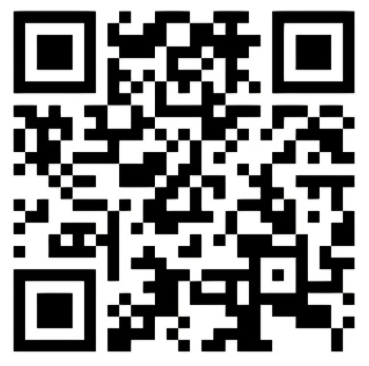
A song that I love, and speaks to me of a place, a new heaven and a new earth, where artificial, divisive labels—like those that categorize people by income or religion—do not exist.

To listen to U2’s “The Streets Have no Names” go to: https://youtu.be/_c79fnD7lPk?si=HYjBHPkVfIl1FRoH

Dear Friends—Forty-one Weeks Post Diagnosis
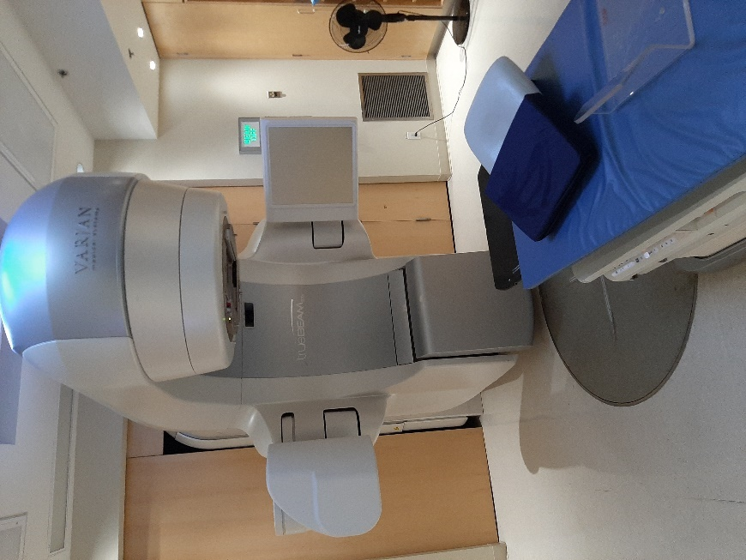
A picture is attached of the machine used for my first radiation treatment at the Juravinski Cancer Centre.
I was able to go in with him yesterday but was asked to not come inside for the next four treatments scheduled from Tuesday through Friday. The Centre wants to reduce the number of people who are inside the building as much as possible. I was thankful they made an exception for the first treatment. It was good for me to see where Grandpa will be treated in this next step in his journey, the treating of this recurring cancer. I’m praying that the prominent lesion in his T12 vertebra will be killed so that his spine will be protected.
His next appointment will be with a medical oncologist on Monday, May 17, to discuss the immunotherapy treatment which will follow soon after. I’m thankful to hear that much progress has been made even within the last five years in the treatment of renal cell carcinoma. You may recall that tests done following his cancerous kidney removal in September found minute aggressive variant cells present in his IVC vein.
Thank you for your love and support and for your continued prayers for the treatments to be effective.
With love, Grandma

Palliative Care: It Is Good—Forty-one Weeks Post Diagnosis
During the last few months, I have gradually adjusted my life to accommodate the increasing pain in my body—especially on my back. The radiation was begun expeditiously due to the apparent urgency of my situation (a vertebra break could cause paralysis). That pain was treated each day this past week with individualized and highly intense radiation, according to the radiation technician. I just completed my final treatment. Treatments were generally accompanied with a one-hour nap afterwards and some chills in the evening. Hopefully this very precise medical attack will kill those cancer cells and diminish the pain—we will find out how successful the treatment was through a CT scan or MRI in several weeks. Immunotherapy treatment plans are to be discussed this coming Monday.
While I was in the hospital the previous week, we met with the palliative team. My only previous connection with palliative care was at hospices. This team quickly corrected my misunderstanding of palliative care. A synonym at the hospital for the palliative team is the pain team—they help patients manage and reduce their pain. With their carefully thought out addition (particularly the pain-reducing and calming effect of morphine four times a day) and tweaking of some medications, I began to experience much less pain and delighted in refreshing nights of sleep.
The palliative team members encouraged us to think of them as people who try to improve the quality of life by reducing pain. They have found that often when people’s quality of life is improved, their length of life is also increased.
In terms of improving quality of my life, I have tried to create open space for God to engage more in my life, a kind of dating before a final wedding feast when God, the groom, calls all the world to feast in his presence in his marriage with all. In a letter written about 2,000 years ago, a man named Paul wrote to Christians in Ephesus, Greece, noting that God’s love is wide and long and high and deep (Ephesians 3:18). The wedding feast will be an amazing party. A significant push in enjoying my dating life with God is to help people (especially children) enjoy engaging in fun, purposeful, and physically active play. I think this kind of activity improves the overall health of children. I guess in that sense I’m also a palliative worker. One of the Bible authors, John, quoted Jesus saying he came to live with us for a while so we might experience abundant living (John 10:10). For me, God is love. God is also pained when love of all is not present and there is brokenness. Prayer, thoughts, and conversation with God are places where love and pain, humanity and divinity, connect.
Living forward, I need to remember the importance of celebrating, as we are able, how all people, this whole planet, and the entire universe are better understood, cared for, and enjoyed, through our small part in palliative caring.

DISCHARGE SUMMARY—May 8
ADMISSION DIAGNOSIS: Metastatic renal cell carcinoma.
DISCHARGE DIAGNOSIS: Metastatic renal cell carcinoma.
DISCHARGE MEDICATIONS:
The patient sent home with a script of medications from Palliative Care, which include morphine, amitriptyline, Senokot, PEG, as well as a separate script for dexamethasone for his radiation treatment.
DISCHARGE FOLLOWUP:
The patient to follow up with Radiation Oncology on Monday, May 10 for radiation treatment.
The patient to follow up with Medical Oncology for May 17, as per their instructions. The patient to follow up with Dr. Zareba from Urology, as per his office.
COURSE IN HOSPITAL:
Mr. John Byl is a 67-year-old gentleman who was admitted under the Urology Service for ongoing issues with pain due to significant progression of his metastatic renal cell carcinoma with evidence of new metastases to the liver, adrenal gland and surgical bed. He was admitted for pain control, as well as further workup and assessment. There is also a question of initially when he presented, whether there was some element of spinal cord compression from the malignancy. An urgent MRI was done, which showed some mild stenosis, but no concerning compression. Additionally, he did not demonstrate any signs of cauda equina clinically. The Spinal team was involved and we discussed the case with Dr. Oitment from Spine, who reviewed the images and said that there was no need for any surgery at this time, but did recommend a Radiation Oncology referral. We will arrange this and Radiation Oncology kindly saw Mr. Byl in hospital and discussed treatment options and have arranged treatment as an outpatient for him to start on May 10.
Additionally, Mr. Byl was already in contact with the Medical Oncology team, but we arranged a discussion with them as well in hospital and Dr. Lalani kindly had a visit and has set up a follow-up for him as well for consideration of additional therapy. We also had the Palliative Care Service see Mr. Byl while in hospital, who went over options for management of his pain, due to the fact that he has been significantly impaired due to his ongoing back pain from his spinal metastases. This was all arranged and a pain regimen was developed with new scripts for him to take in the outpatient setting.
Otherwise, we monitored him closely while in hospital and his laboratory investigations remained stable. His creatinine was mildly elevated at 130 on admission, but he continued to void well. His creatinine fluctuated in and around that number but stayed stable.
Otherwise, he had no signs of infection. Based on this, we had all plans sorted out and with good pain control and he was ready for discharge on May 7. Again, his follow ups are listed above. He is arranged to follow up with Medical Oncology, Radiation Oncology, as well as Urology. He knows to return to hospital if he develops any fevers, chills, worsening abdominal or flank pain, inability to void, inability to control pain at home, as well as if he develops any symptoms of cauda equina, including any saddle anesthesia, fecal incontinence, urinary retention or extreme pain.
It was a pleasure to be involved in Mr. Byl’s care.

Immunotherapy Consultation and Decision—Forty-two Weeks Post Diagnosis
I’m still sleeping quite a bit (two-three hours during the day), and feeling not well, a response to the radiation treatments I received last week. Today we met with a medical oncologist to discuss immunotherapy treatment plans.
We were presented with two effective newer therapies for me as a high risk, Stage Four cancer patient. One treatment required having an intravenous medication about once a month, as well as taking a pill orally twice each day. The other treatment involved two intravenous medications given on the same day three weeks apart, then one treatment every four weeks after that. Although there appeared to be more likelihood of some side effects with the intravenous treatment option, we decided in the end that it would be better to have occasional treatments instead of taking a pill each day for the rest of my life. The intravenous treatments involved Ipilimumab and Nivolumab. The goal was to supercharge the immune system so it would fight off the cancer cells—or at least contain them.
The treatment plan would likely begin in early June: four treatments, three weeks apart, followed by a CT scan to determine if the medications had restrained or even reduced the cancerous masses. Treatments would then proceed once a month with CT scans done every three months for a period of two years.
I’m thankful for the excellent care given to me, the short drive to the hospital for treatments, the options for new and improved treatments, and for fellow Canadians who are funding these treatments.
The median life expectancy of previous renal cell carcinoma treatments was about two years. The median life expectancy for the new treatment is four years—though that has not been totally clarified due to the newness of the drugs. Apparently in about 10% of the cases the cancer went into complete remission. Statistically, if all the patients were my age, 67, then half of them would die before they turned 72, and half would live longer. I must confess, that realization hit me harder than it has in the past. Grandma and I needed to discuss what this might mean for our life priorities in the next few years.

My First Immunotherapy Treatment: Providence, Humility, Thankfulness, and Hope—Eleven Months Post Diagnosis
I received my first immunotherapy treatment yesterday. It took about four hours under the caring and expert care of nurses. Although there were no side effects from the first treatment, the nurses warned me the side effects could start with the second. I was on a three-week schedule for the first three months, followed by a CT scan to check what was happening to the cancerous masses. After the first three months, I would be scheduled for once-a-month treatments for two years. It took some processing on my part to accept these very expensive drugs. By the time of the appointment, I was humbled and thankful, and, following the procedure, was hopeful of the drugs’ efficacy.
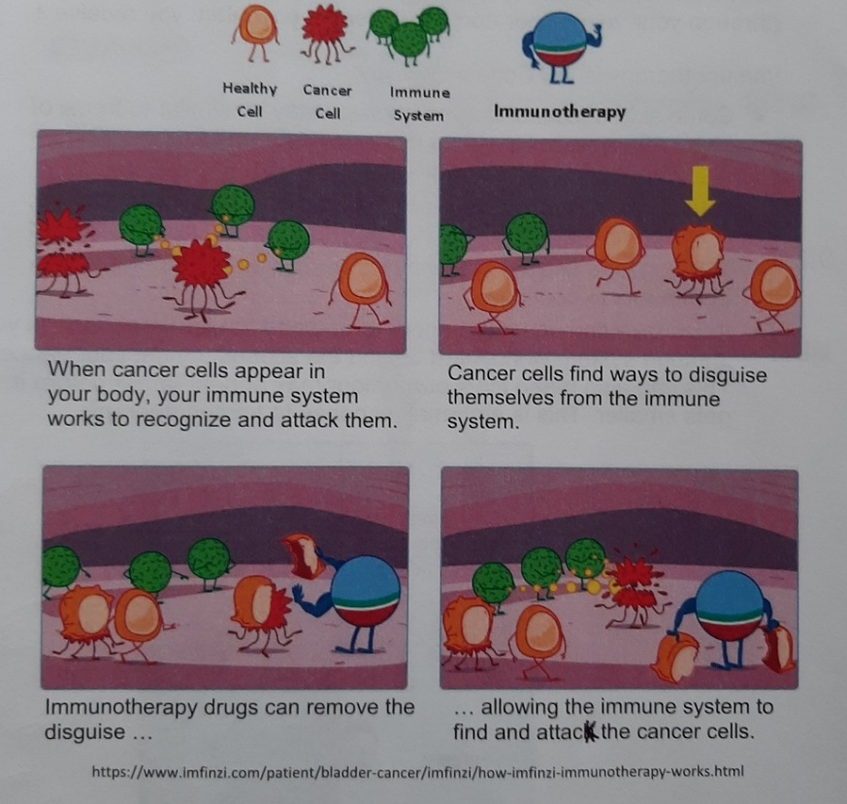
Immunotherapy is also called a checkpoint inhibitor. A document given to me at the hospital explained the procedure as follows: Cancer cells find ways to protect themselves from your immune system. Immunotherapy can:
- Mark or unhide cancer cells so the body knows they are harmful and should be attacked.
- Boost your immune system making it stronger to fight against the cancer cells (see attached photo).
If you are interested in reading my journey towards accepting the immunotherapy drugs, I will discuss that below. Without the drugs, or by delaying the drugs, the results would almost certainly have meant a premature death due to the cancer.
I believe that God so loved the world that God made it to be a place where all people and things could flourish. I believe that is God’s providing, God’s providence. However, people have made choices that put some people in better positions than others, put some in a more flourishing situation and others in a more despairing situation—think of the recent evidence that 215 Indigenous children may be buried in a mass grave in Canada. People have also made choices that help the earth to flourish and other choices that rob it of its glory.
A sociology professor once remarked in a class I attended that the biggest choice we can make for our economic well-being is to choose our parents. Well, I was born in the Netherlands and immigrated to Canada with parents who had opportunities to make a living and the capacity to immigrate. They certainly shared stories of difficult, non-flourishing times, living through WWII. But in some ways, I could equally have been born to parents in places of violence, of poverty and poor schooling, with inadequate hospitals. My life would certainly have been very different.
Was it providence that put me into a home with hard-working parents who had opportunities to live most of their life with peace, opportunity, and mobility? I don’t think so. Many people are born, just as I was, but in very different countries. For example, my life would have been different if I was born in one of these countries:
- Libya and Syria which are considered to be the most dangerous countries in the world 2020.
- The Republic of Sierra Leone which has the worst health care system in the world.
- Brazil or USA first and second on the list of countries with the most gun-related deaths in 2016.
- Where the median life expectancy is 53 for the Central Republic of Africa, and with a median life expectancy of 54 years in Chad (54 years). These are the lowest in the world in 2020. At age 67, I’m well past those median ages.
My parents moved me to Canada where the average life expectancy was 80 years for males and 84 years for females in mid-2020. According to the Global Wellness Index, “Canada is the best country in the world to live in based on a set of indicators that measure global health, wealth, and happiness. This new index is an attempt to change how a nation’s success is measured, rather than solely focussing on its GDP.”
I do not think it is providence that I’m receiving these opportunities, nor am I ungrateful, but I’m humbled and thankful that I live in a country where powerful drugs and excellent health care are provided for me at no cost. Thank you, fellow Canadians!
So, I try to bring together two thoughts from the Bible.
- Thought one: That “God so loved the world,” and
- Thought two: That Christ came that we (the world) will live in “abundance.”
My thinking on all of this made me feel more strongly that I need to give more thought and action to help the world flourish and, as I have breath, to do my part to ensure God’s providence is more equally distributed. I took the drugs to increase the quality and length of my life. I’m humbled, thankful, and hopeful of their efficacy.

Your Suffering is my Suffering—Forty-seven Weeks Post Diagnosis
I usually read a morning online devotion written by Henri Nouwen. This week I especially appreciated something he wrote, and my thoughts turned to many families and friends supporting us in our effort to live well with cancer. The excerpt below is from Nouwen’s book You are the Beloved (2002):
Compassion means to become close to the one who suffers. But we can come close to another person only when we are willing to become vulnerable ourselves. A compassionate person says: ‘I’m your brother; I’m your sister; I’m human, fragile, and mortal, just like you. I’m not scandalized by your tears, nor afraid of your pain. I, too, have wept. I, too, have felt pain.’ We can be with the other only when the other ceases to be ‘other’ and becomes like us.
Nouwen’s quote is perhaps the main reason we sometimes find it easier to show pity than compassion. The suffering person calls us to become aware of our own suffering. How can I respond to someone’s loneliness unless I’m in touch with my own experience of loneliness? How can I be close to handicapped people when I refuse to acknowledge my own handicaps? How can I be with the poor when I’m unwilling to confess my own poverty?”
Grandma and I are so appreciative of how you have blessed us with so much compassion.


We are reminded of a song about how, when we were down, God, through you, has raised us up.

200 Kids Sing A Cappella Style |
“You Raise Me Up” by Josh Groban,” Listen at:

https://Youtu.be/13_nXuJ6dX8

Don’t Let What’s Happening Around You Get Inside You and Weigh You Down—Forty-eight Weeks Post Diagnosis
A person I love deeply recently posted the following:
Ships don’t sink because of the water around them.
Ships sink because of the water that gets into them.
Don’t let what’s happening around you get inside you and weigh you down.
Then, quoting from one of the Bible writers, the writer continures:
“When you pass through the waters, I will be with you; and when you pass through the rivers, they will not sweep over you. When you walk through the fire, you will not be burned; the flames will not set you ablaze” (Isaiah 43:2).
Most sayings contain truth, and many sayings fall apart when pushed. This saying is no different.
The truth of most writing involves context. The biblical writer spoke to a group of captives taken to a land not of their choosing. The writer reminds them that God had helped them in the past, and though the present days were difficult, God was walking with them and, in the future would bring them back to their own country. In my own life I, like the Bible writer, feel it is good to remember that I’m loved by Creator God during days of plenty and in days of need.
Applying the saying in my life, I have watched very little news during the last 18 months. I found the news most often narrowly focussed on how the country I live in dealt with COVID. The news felt like negative tweaked reruns, and I tended to allow the news to have my lifeboat take on water. When our country’s Chief Public Health Officer spoke (as competent as she might be), I found the tone of her voice depressing. The solution for me? Stop watching the “news.”
But I think the saying breaks down in two significant ways.
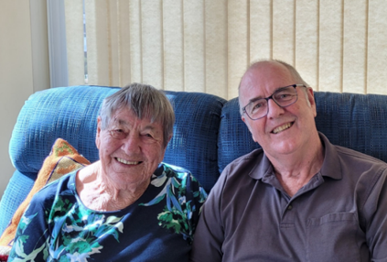
First, we are not machines, a lifelong piece of wisdom from Great Grandma. Let me explain. Nearly two decades ago I was in a collision. I suffered some disabilities on account of the collision. I sank into several years of clinical depression as I tried to unsuccessfully negotiate these disabilities—I was letting the water into the boat. It would have been helpful for me to be more objective, more machine-like, and not get as emotionally involved with my disabilities. For various reasons I could not do that. I sank into a clinical depression. Eventually Grandma fell into what was called depressive episode. She watched me be in dark places, she loved me, she was not a machine, and from time to time she entered those dark places with me. Sometimes the pains in our lives are like rotten porous boards on a ship. We can patch them for a while, but eventually we need skilled craftspeople to fix or replace these boards. In the long run I think it is those repaired boards that will keep our ship from sinking.
Second, we are not machines. As much as we want to sail on smooth waters in life, sometimes overpowering storms catch us unawares, and we are too far from a harbour to get to shore safely. There have been waves in my cancer journey that have threatened the buoyancy of my life-giving boat. Once again, to stand on deck, thinking only objectively about these waves, may be best. At times I find the news overwhelming, and I begin to take on water and begin to sink. Sometimes, my boat is too small, or life’s waves are too large, and, focus as I might, I do not have the ability on my own to avoid taking on water.
Despite the difficulties for Grandma and me, and not being more machine-like, we treasure our emotions. We also treasure the skilled help of professionals who help us repair porous boards or heal parts of ourselves that have begun to break. We treasure friends and family who join in our celebrating and help remove some of our cargo, assisting our boat to stay afloat when significant waves hit. We treasure a prodigal God who continues to pour out love on us, and on all that God has made.


A song that spoke to me about life’s storms is Lauren Daigle’s, “Peace Be Still.” The song is an intense eight-minute prayer that we are not going to fear the waves or the storm because God will set our feet on the waves and give us peace. I pray, oh Lord, let my faith and trust be strong as I journey with cancer. I pray that God will remove the cancer from me, and if not, that God will give me the strength and the peace to ride the waves and help me not be afraid. May peace be over us. Let me be still and know that God is God.

Listen at: https://Youtu.be/dUpKZz0Nm7c

You Don’t Always Know What You’ve Got Till It’s Gone—Forty-nine Weeks Post Diagnosis
I met a barista the other day while ordering 11 coffees for my family at a family reunion. After some small talk I asked her what had kept her busy before becoming a barista. She began to weep. She said she had been busy caring for her mother and son when their house burned down a few months ago, killing her mother and son. She required a lengthy hospital stay in ICU as she fought for her life because of smoke inhalation. All of this was still so raw that weeping seemed to me a most appropriate response.
I listened more as she explained how she had tried to make sense of what had happened and how she was beginning to move on with life. Her intimate and painful story reminded me that we are all on journeys. For some of us, life is amazing all the time. For some of us, life seems to toss one bad thing at us after another. For some of us, life is a mix of amazingly good things and very tragic things. For me, life is going relatively well, but cancer is certainly putting a strain on my life and on those I most love. Either way, let us not take life for granted, but treasure and share the good things we have at the time.


I was reminded of Joni Mitchell’s 1970 folksy environmental song “The Big Yellow Taxi.”

Listen to it at: https://Youtu.be/94bdMSC20dw

Bonding Through Sport—Forty-nine Weeks Post Diagnosis
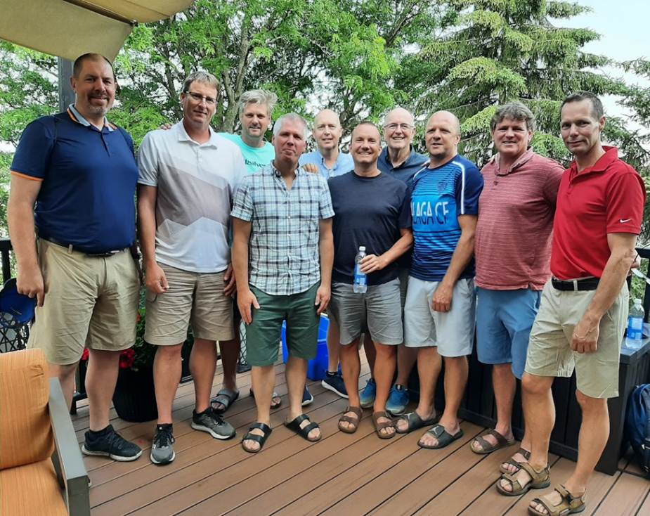
The next day I met (in-person and virtually) with a group of 13 men who I had been honoured to coach about three decades ago. What brought us together in the first place was a white ball, a volleyball, which we learned to gently and precisely set to teammates or knock down hard on the opponent’s side of the net. Our focus during those years together was how to best handle that little white ball as a team. As a coach, I tried to nurture the players to help them individually and as a team to get that white ball onto the opponent’s floor as efficiently as possible. During the hours of practicing, of taping players before practice and games, the driving to and from games, competing in actual contests, and debriefing afterwards, all of this grew into something much more significant than hitting a white ball; a strong and holy bond developed between these men under the fatherly care of a loving God. The second thing which brought us together was my having cancer. One of the players organized the reunion for us to celebrate what we had and have as a team. It became a holy four or five hours together.
Both experiences confirmed for me the importance of what we are doing today and celebrating the good that we were a part of. I hope we learn not to wait to celebrate something until it is too late.

A Toast to Crazy Good Wellness Numbers—Fifty Weeks Post Diagnosis
Lately I have been learning about the importance of GGT, ALT, and AST scores. It does not matter to me too much what those scores exactly represent, but essentially these numbers demonstrate to me my liver’s health. A healthy score for GGT is anything below 65; mine was 425 prior to my first immunotherapy treatment six weeks ago. A healthy score for ALT is between 0 and 49; prior to my first immunotherapy treatment, mine was 653. A healthy score for AST is 18 to 54; prior to my first immunotherapy, mine was 732. The two masses on my liver severely limited the health of my liver. The medical oncologist entered the consultation room and spoke soberly to me about their plan to heal a very compromised liver. The goal of the medical team was for me to have a quality of life and a lengthier life. They suggested that achieving this would require me to drink very little alcohol. Alcohol challenged my liver’s health, and diminished the effectiveness of the immunotherapy drugs. I made the decision to not drink alcohol for a several months.
Three weeks ago, the medical oncologist and I were amazed when the GGT score had dropped from 425 to 60 and was now in the healthy range. My ALT score dropped this week from 653 to 25 and was now in the healthy range. This week my AST score dropped from 732 to 34 and was also now in the healthy range. The medical oncologist took a double take at these scores and attributed this massive decrease in scores to the efficacy of the two immunotherapy treatments. We thanked God for the exceptional care extended to me and the effectiveness of the treatments thus far!
The two words I try to stay focussed on are “grateful” and “hopeful.” I found my recent blood work numbers unbelievably hopeful. The immunotherapy still gave me skin rashes, and the immunotherapy and previous blood clots in my lungs both made me very fatigued. I had a concerning pain on my left side. My third immunotherapy treatment was this Wednesday: a psychiatrist appointment was this Thursday; and a CT scan, unless needed earlier, was August 13—then I would have a clearer picture of what was going on inside my body.
I’m stunned and grateful that my liver numbers were already in the normal range. On July 19th, I will celebrate 46 years of marriage with the love of my life, Grandma. I think we will raise a toast then, with a small glass of wine, to our marriage, to our children, to their spouses, to each of you, to extended family, and to friends. We will also raise a toast to my health, the efficacy of the immunotherapy treatments, and to God who we feel walks with us. Please join us in a toast!

Why Pray for My Healing?—Fifty-one Weeks Post Diagnosis
I once heard a story of a family who went to church for Sunday morning and evening services. It was a rural church, it had been a dry summer, and during the morning service, the pastor had prayed for rain to nourish the crops. Getting ready to go to the evening service, a four-year-old child took an umbrella. The child’s parents asked why the umbrella, as it was sunny out. The child replied that the pastor had prayed for rain. The child expected prayer to be answered.
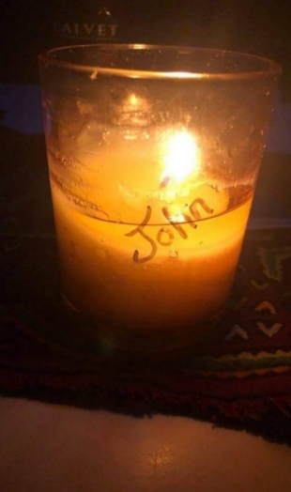
Recently, when my liver scores were high off the charts and then in a matter of a few weeks following immunotherapy returned to normal scores, some of you were not surprised: “Didn’t we pray for this?” I thought about this again as one of you created a paper prayer chain, kind of like a Catholic rosary, with praying for me as one of the links to his completed prayer. My brother made a prayer candle for me. Many friends were praying for me; I would use prayer interchangeably with blessing me with positive energy, positive thoughts…). I’m very grateful for the prayers of each of you, my children, Grandma, my extended family, and many friends from various traditions, prayerfully and thoughtfully loving me, and carrying me. Thanks! I feel carried. How does this all work?
As I reflect on the Christian tradition, I find that the Bible gives many examples of the power of prayer. A churchgoer may also have heard a message on these passages. One writer records Jesus as saying, “Ask and it will be given to you,” and, “Which of you, if your son asks for bread, will give him a stone?” (Matthew 7:7-11)? There is also Jesus’ story of a persistent widow who keeps nagging and eventually gets her way. The judge in the story says, “Yet because this widow keeps bothering me, I will see that she gets justice, so that she won’t eventually come and attack me” (Luke 18:1-5). Also, Moses engaged in an intercessory prayer for the Israelites, and God “relented and did not bring on his people the disaster he had threatened” (Exodus 32). It seems each of you have it right; God loves to answer prayer.
On the flip side, there are biblical texts used in fewer sermons. Some Bible writers found that their prayers were not heard. One Psalmist wrote, “My God, I cry out by day, but you do not answer, by night, but I find no rest” (Psalm 22:2). Another Psalmist said, “Do not hide your face from your servant; answer me quickly, for I’m in trouble” (Psalm 69:17).
I believe God listened to the cry for healing by many on my behalf. I’m thankful for the remarkable healing that seems to have occurred—I never expected this much healing to take place. I also believe God used researchers and other patients who went before me to develop medications that helped my immune system identify the cancer cells and attack them.
However, there are plenty of examples, in my life and in the stories of others, in which prayers have gone unanswered. We all die, regardless of how we might pray otherwise. Think also of those many patients with cancer whose life has been cut short. Yet God hears people’s cries and mine and walks with them and me—whether we realize it or not.
In the meantime, I know that a personal Creator God walks with me during each step of my journey. As much as my desire is to walk with God, I think the reality is that God walks with me and with all of us. God walks with us as we walk in “so loving the world” ways, or when we love in only myself ways. Therefore, for me, prayer is a 24-hour ongoing conversational walk with God through thoughts, words, and actions. This prayerful life does not necessarily need answers; it is about connecting with a divine life-partner who always feels our feelings, knows our deepest yearnings, enjoys our heartfelt joy, and, as Nouwen once wrote, “sees them in the light of unconditional love, [and] responds to them with divine compassion” (1979). God dwells in us and surrounds us. I believe God wants what is best for us, but God is not an insurance plan. God gives us individual and communal choices that impact our individual and communal health. We are not robots.
In addition to continuous prayer, Nouwen also noted the importance of prayerful times in solitude:
In solitude we can slowly unmask the illusion of our possessiveness and discover in the center of our own self that we are not what we can conquer, but what is given to us. In solitude we can listen to the voice of him who spoke to us before we could speak a word, who healed us before we could make any gesture to help, who set us free long before we could free others, and who loved us long before we could give love to anyone. It is in this solitude that we discover that being is more important than having, and that we are worth more than the results of our efforts. In solitude we discover that our life is not a possession to be defended, but a gift to be shared. It’s there we recognize that the healing words we speak are not just our own but are given to us; that the love we can express is part of a greater love; and the new life we bring forth is not a property to cling to, but a gift to be received (1975).
Nouwen added: “It is indeed a hard discipline to be useless in God’s presence and to let him speak in the silence of my heart. But whenever I become a little useless, I know that God is calling me to a new life beyond the boundaries of my usefulness” (1975).
In addition to spending time in places of solitude with God, I have found it helpful to take certain times of the day, often mealtimes, to express my and the world’s thankfulness and needs before a divine God. Grandma and I are essentially with each other 24 hours a day. However, we still find it important to sit down routinely and share meals together as much as possible, rather than just eating on our own.
A friend once told me that to pray for the sick is to go visit them. As I reflect on the above, I know I felt carried by your prayerful visits—in person, on the phone, with cards, and being nourished by your meals—but I also felt I was upheld by you carrying me before God. How does this work? I do not know. It is part of the mystery of life, and I’m okay with that mystery. A good friend once wrote: “We don’t know what ramifications come from prayer any more than we can predict the consequences of the flapping of the butterfly’s wings [some chaos theorists say that the flapping of butterfly’s wings in China can lead to a hurricane in the Caribbean]. It is not unreasonable, in my view, to posit that there are consequences we cannot fully predict that arise from the act of praying. Prayers can, I think, have multiple effects, certainly and obviously on the one who prays, but also, in usually untraceable ways, on the one prayed for.” Research supports this conclusion (Koenig, 2012). Please continue to hold me up with your prayers, thoughts, and energy.


In my morning music listening I appreciated the following song on prayer. Perhaps it will be helpful for you as well. “Talking to Jesus” focusses on personal prayer and on our relationship with Jesus.

You can find it on YouTube at: https://Youtu.be/OXsxw1fRHMA

My First Anniversary of Choosing Life—One Year Post Diagnosis
One year ago today, I was in the middle of making some work videos and then found myself confusedly laying on an ER bed with medical personnel hovering over me. I thought, “What in the world is going on with me?” One of doctors asked me, “If your heart stops, what are your instructions to us?” I carefully responded, “I’m choosing life.”
Facing death more imminently made me take more time to consider what living is about. I have shared some of those on CaringBridge and now in this book. Thanks for reading them and providing your instructive comments. Previously, I tried to think through what it means to live in a loving way with people and the world around me. I tried to contribute as I was able to help in small ways with some of the world’s hurts. Now I’m on the receiving end of a lot of love.
There are probably two significant life lessons I have learned from this journey.
- Though we feel we are in control of our lives, there are many significant parts of our lives we have absolutely no control over. Being attacked by cancer is certainly one of them for me.
- Fortunately, we do not travel this life alone. I’m very blessed to have a loving God walk with me, a loving family care for me, loving friends who support us, and a team of medical professionals in my journey who provided me with exceptional care!
This year has been a unique journey. I do not wish this journey on anyone. I think if there is something for us to learn from my journey, it is to be okay with not having everything under our control, and that it is good knowing that we are loved by a community. Thanks so much for loving me! Please choose life with me. Please choose abundant life for all and abundant life for the earth and universe we are a part of.

Just Completed Four Rounds of a Double Medication of Immunotherapy—Fifty-four Weeks Post Diagnosis
I just completed four rounds of a double medication of immunotherapy—now we continue with one medication once a month. My blood numbers are excellent, especially when compared to where they were at the beginning of June. It has been an emotional time. I’m not even sure which emotion I have. I will keep choosing life. Today is another gift. I hope to unwrap it well, and I’m trying to live with gratitude and hope.


This was one time when I felt I needed to ring the bell

View video at: https://Youtu.be/ZLUjz_bQFb0

Sunday School Answers to Life’s Challenges—Fifty-five Weeks Post Diagnosis
Let me share a brief story: “Little Johnny has been in Sunday school for several weeks and every time the answer to all questions is ‘Jesus!’ So, the teacher asks Johnny. What is black and has white spots and makes a moo sound? Johnny says, ‘Well it sounds a lot like a cow, but I’m going to say it’s Jesus!’”
More serious questions involve why good things happen to us, and why bad things happen to us? The answer for some people is always, “Jesus.” For some people, trying to sort out why I have cancer, the answer is simply Jesus, or the will of God. To help me in my journey of thinking through this question, I was given a book by a caring friend. The book was written by Kate Bowler, entitled, Everything Happens for a Reason and Other Lies I’ve Loved (2018).
The author begins her book by sharing her story of researching and writing her PhD dissertation on the Prosperity Gospel while she simultaneously began to personally struggle with a cancer journey. I found the author’s wisdom helpful. Let me share a little of what she wrote—much more can be mined from this wonderful personal story.
The author suggests that the Prosperity Gospel “looks at the world as it is and promises a solution. It guarantees that faith will always make a way.” There is an expectation that God is not simply fair, that we can “expect God to rain down blessings.” After all, Jesus said, “Which of you, if your son asks for bread, will give him a stone?” (Matthew 7:9). The author notes that for those in the Prosperity Gospel movement, followers of God are entitled to always receive bread. She explains that followers of the Prosperity Gospel “create a Newtonian universe in which the chaos of the world seems reducible to simple cause and effect.” If people follow certain rules or laws, they will be blessed. Two of these laws are:
- The Law of Agreement: Allowing “two or more people to harness their spirituality corporately to create an answer to prayer.”
- The Law of the Tithe: “Supernaturally multiplies an offering of 10% gross income…with a guaranteed tenfold or hundredfold return.”
The author points out how mean this approach is, because those who die young must then be “hypocrites or failures.” Someone who can no longer take the pain of medical treatments cannot stop the medications, fearing the disappointment of a miracle-expecting family.
The author then points out what she calls the lies of this self-rule approach. I added my thoughts after each “lie.” For example:
- Surrendering to a life challenge is to be defeated—I remember the wisdom of a friend a few days before he died saying, “John, learn to surrender.”
- There are no setbacks in life, just set-ups—Really? My cancer, and the growth of cancer cells, is just a set-up?
- Trials are just tests of character—Really? My cancer is just a test of my character?
- Tragedies are simply opportunities to claim a bigger and better miracle—Really? I have cancer so that a bigger miracle will be shown?
- “I can do all things through Christ who strengthens me”— All things?
- Everything is going to work out—Really? My friend died too young. I may die younger than I wish.
- Keep knocking because the door is about to open—Surrendering to a closed door might be best.
- “Favour” is a key word in the Prosperity Gospel—The well-known passage John 3:16 does not read, “For God so favoured a few,” but “For God so loved the world.”
- God will give us a long life—Can we really expect a long life, or should each day be more like a gift?
- God is a just God and will therefore allow a person to die young because of their sins—People said that to my father when he had a back injury from falling at a construction site in his 50s. If only he had enough faith, he would be healed. I believe back injuries are not just healed through prayer, but through prayerful surgery.
I felt agreement with Bowler in arguing that we are all ordinary people. She ends the book with a word of wisdom for today: “I will die, but not today.” Live life well, care for the needy, and learn to be blessed in the presence of God.


As I’m sure many Canadians have, I been thinking about the lives cut way too short in the Canadian Residential Schools. I’m not going to try and explain any of that with the Prosperity Gospel, but will only say we did wrong to many Indigenous children and families. I turned to Indigenous singer William Prince for wisdom. He noted that Jesus is often present and hidden in Fisher Bay, Manitoba, and I think in our lives as well. Prince reminisces about his Indigenous childhood dreams and salvation hopes on Peguis First Nation.

Listen to it at:

William Prince, Gospel First https://Youtu.be/VU2iejDT7eQ

Fearfully and Wonderfully Made: And a Brief Medical Update—Sixty Weeks Post Diagnosis
I find it amazing how the body knows how to heal itself. The body cannot replace a finger that is cut off, but it can replace skin that has been removed through an abrasion. The body can replace a missing fingernail, it can fight off diseases, it can grow, it can do so much. I have often viewed with amazement a video showing human development from conception to birth—I will attach the YouTube link if you are interested in viewing this 9-minute Ted Talk. Our lives begin with two cells fusing, and a complex person grows from this very minute connection. An Ojibway meditation reminded me, “The miracle is that we are here at all” (Wagamese 2016). With Henry David Thoreau, a 19th-century American naturalist, I can say “I stand in awe of my body.”


To view the Ted Talk, “From Conception to Birth,” go to:

https://Youtu.be/fKyljukBE70

However, sometimes the body needs help. In my case, a fully cancerous kidney needed to be surgically removed, and a cancerous vertebra needed radiation to reduce pressure on the spinal cord. My risk of getting sick or possibly dying from COVID had been significantly reduced by me two vaccine shots. My liver was severely compromised, and immunotherapy helped bring it back to full health. I think that if my cancerous kidney had not been removed, or the immunotherapy not begun and my liver restored to health, I might not be alive to write this.
Lately, I was tiring and gaining weight, and it turned out my thyroid now needed some medicinal assistance. The cancerous masses seemed, based on the last CT scan, to be gradually increasing in size. On October 13 there was another CT scan to see if this growth was continuing, or if the slightly increased cancer sizes were due to other reasons and the immunotherapy drugs were still keeping the cancer at bay. The medical oncologist reminded us that there is more in the toolbox than just the two immunotherapy drugs I’m on. I no longer need the immunotherapy drug Ipilimumab, which helped my immune system unmask the cancer, although I’ve gone on a stronger dosage of the other drug, Nivolumab, to help my immune system attack the cancerous cells. It was sobering for me to happen to read that Nivolumab will be continued “until disease progression or unacceptable toxicity.” In other words, the Nivolumab is keeping the cancer at bay, but it is unlikely to cure the cancer. I felt weighed down by some of this information.
Paul, who wrote a letter 2,000 years ago to Christians in the city of Corinth, demonstrated a profound appreciation for the diversity of the body. He wrote, metaphorically:
“Now the body is not a single part, but many. If a foot should say, ‘Because I’m not a hand I do not belong to the body,’ it does not for this reason belong any less to the body. Or if an ear should say, ‘Because I’m not an eye I do not belong to the body,’ it does not for this reason belong any less to the body. If the whole body were an eye, where would the hearing be? If the whole body were hearing, where would the sense of smell be? But as it is, God placed the parts, each one of them, in the body as he intended. If they were all one part, where would the body be?” (1 Corinthians 12:14-26).
I feel a kinship with a person who wrote this poem:
“For you created my inmost being;
You knit me together in my mother’s womb.
I praise you because I’m fearfully and wonderfully made” (Psalm 139: 13-14).
I find it awesome how well our bodies work. I find it amazing that people have discovered so much about how to treat the body. I read that the main drug that is being administered to me now, Nivolumab, is manufactured using Chinese hamster ovary cells. How did they figure that out? Crazy. I’m so appreciative of my physicalness and the very professional medical people who help me stay well, especially when my body is unable to heal itself. I was reminded in a recent Facebook post to be very thankful for hospital staff, the last-line people who are helping me stay healthy and alive. Thank you! Thank you! Thank you!

One Shining Day in a Sacred Journey—Fourteen Months Post Diagnosis
Some of what some of you have shared, and some of what I have read, encourages me to remember the importance of “now.” I’m not ignoring the importance of focussing on such things as my life situation, its joys and its challenges. It’s important for me to have a treatment plan for my cancer, to make holiday plans, to make financial plans, and to make dinner plans. It’s easy for me to get bogged down by these plans and not let them unfold, or as an Ojibway meditation said, in the now moment, “Dance, dang it! That’s what feet are for” (Wagamese 2016).
It is also easy to think about things in the past that did not go well. I know I need to let the negative pass through me, to not let it stay or cling to me; now is a place of ultimate forgiveness. That can be hard to do. I can also worry about a future that I anticipate going badly with my cancer. now I’m just sitting, writing, feeling your love as I sit and write. Right now is a good place. I’m going to try to extend that now feeling to the whole day and to contribute to feeling as well as I’m able, enjoying the good given to me. In a recent appointment a psychiatrist called this process “mindfulness.”
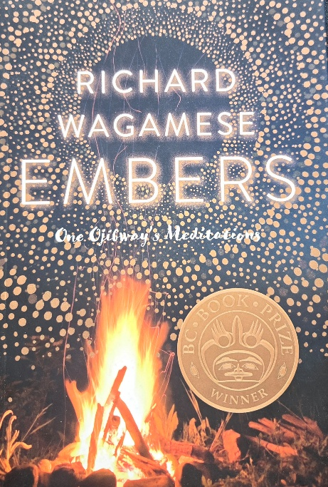
Recently, a caring friend suggested a book she found helpful in her cancer journey: Embers: One Ojibway’s Meditations. In one of the simple and powerful meditations, Richard Wagamese writes about living in the now: “I’m a traveler on a sacred journey through this one shining day” (2016).
Wagamese further encouraged me with these words: “I want awe to be the greatest ongoing relationship in my life. I want to move through my days floored by the magnificence and generosity of my Creator. The breaking of a day, the silence between words, the light emanating from a real conversation, and kindness, truth, love and the apparently random hand of grace: I want to remain gobsmacked by all of it. Rendered speechless by wonder” (2016).
Powerful reminders for me to live in awe, in the “right now.”


A couple of years ago I was blessed to have led some workshops in Iqaluit, Nunavut. At an evening social, they danced their feet off!

To view this dance, go to: https://Youtu.be/zwML__sScso

Dying and Death (1 of 2)—Sixty-two Weeks Post Diagnosis
I would like to share two weightier thoughts this week on dying and death. Last week, I attended a wake and celebration of life for a friend’s son, and then a few days later, another wake and celebration of life, this time for a cancer-fighting friend. It was an emotionally tiring few days. As Wagamese put it: “Missing someone is feeling a piece of your heart gone astray” (2016).
The second death made me especially aware of the cancer attacking me and the impact cancer may have on me if and when the cancer begins to win the fight. People try to minimize this thought by saying, “Any of us could die any day.” However true that statement is, I find it unhelpful because it dismisses the point that statistically I’m more likely to die younger than most Canadians. I was told that three more years is a statistical mean (mid-point) survival time for someone like me with Stage 4 Renal Cell Carcinoma. That puts me at 71 years. The Ontario average life-expectancy for someone my age is 20 more years, which would put me at 88 years. I hope to beat the 71 years, but I doubt I will reach 88 years. Eventually, though, we all succumb to death. The writings of Henri Nouwen were very helpful to me as I sorted out my thoughts on dying, death, and eternity. Working through these thoughts and feelings with a psychiatrist’s caring and effective questioning was also helpful for me. Here it goes.
Living and Dying Today:
I believe that each choice we make in daily living leads to abundant life or to death. I think there are choices that can lead to different levels of life’s well-being. Eating too much delicious cake brings us closer to death but eating an occasional sweet piece of cake as a celebration for a birthday, an anniversary, or another noteworthy event, is life-giving. I think it is good to celebrate life’s victories with others. An Ojibway meditation noted the importance of community in our lives: “Baseball is back. I love the central metaphor of the game—all of us helping each other to make it home. Funny how a game can teach us so much about life.” I think it’s very important for us to help all people live well. Wagamese also wrote: “When you reach out to the love of living, instead of the fear of dying, you create more life” (2016). As I said before, I’m trying to choose life in my decisions and actions today.
When We Know Death Is Close:
Nouwen wrote these important words on dying:
If I die with much anger and bitterness, I will leave my family and friends behind in confusion, guilt, shame, or weakness. When I felt my death approaching, I suddenly realized how much I could influence the hearts of those whom I would leave behind. If I could truly say that I was grateful for what I had lived, eager to forgive and be forgiven, full of hope that those who loved me would continue their lives of joy and peace, and confident that Jesus who calls me would guide all who somehow belonged to my life—if I could do that—I would, in the hour of my death, reveal more true spiritual freedom than I had been able to reveal during all the years of my life. I realize on a very deep level that dying is the most important act of living. It involves a choice to bind others with guilt or to set them free with gratitude (1994).

Nouwen adds:
The way we will die is unpredictable and our worries about it quite fruitless. Still, we need to be prepared. Preparing ourselves for our deaths is the most important task of life, at least when we believe that death is not the total dissolution of our identity but the way to its fullest revelation. Death, as Jesus speaks about it, is that moment in which total defeat and total victory are one. The cross on which Jesus died is the sign of this oneness of defeat and victory. Jesus speaks about his death as being “lifted up” (1994).
I’m not afraid of death, but I’m somewhat afraid of dying—and yet I still live in the hope that I have lots of years to live. However, I think it will be good for me to think about dying as a place of increasingly grateful and ultimate vulnerability, a place where I may be weakening, and a place where I can be increasingly grateful for the loving and professional care extended to me. As Wagamese writes in one of his meditations: “What defines me is not what I do but what I receive, and I have received in great measure” (2016).

Dying and Death (2 of 2)— Sixty-two Weeks Post Diagnosis
I believe in life after death. Then what is death about? For me, I see it as a transition from:
- A loved life to even more love.
- An illness to healing.
- Discouragement to celebration.
- An ending to a beginning.
- Defeat to victory.
- A wall to a gate.
- Fear to courage.
Nouwen put it this way:
To befriend death, we must claim that we are children of God, sisters and brothers of all people, and parents of generations yet to come. In so doing, we liberate our death from its absurdity and make it the gateway to a new life… “Death, where is your victory? Death, where is your sting?” (1 Corinthians 15:55). This is a choice, but a hard choice. The powers of darkness that surround us are strong and easily tempt us to let our fear of death rule our thoughts, words, and actions (1994).
What is my legacy? I think it’s helpful to think about the legacy of people who died before us, and for me to consider the legacy my current life may offer others. I was reminded by Nouwen that Francis of Assisi, who died in 1226, “is still very much alive! His death was a true gift, and today, nearly eight centuries later, he continues to fill his brothers and sisters, within and without the Franciscan orders, with great energy and life. He died but never died. His spirit keeps descending upon us. More than ever, I’m convinced that death can, indeed, be chosen as our final gift of life” (1994).
I thought of the changing seasons. My church friend Rob’s death was in autumn when the leaves shone but succumbed to less sunlight. The cool winter is the time of grieving. The upcoming spring is blossoming through the legacies of people who lived before us. During the summer the spring blossoms begin to bear fruit. At Rob’s memorial service, I was able to share words that acknowledged his autumn death, to mourn the winter bareness without him, to acknowledge a springtime relationship that continues, and to anticipate the summer fruit of Rob’s life to nourish me. At the memorial service I said what was one of Rob’s significant legacies to me: “His positive, thankful, and generous spirit will remain a constant encouragement to me throughout my cancer journey.” I think it’s helpful for me to consider what my legacy is to this world. I’ve often said to Grandma, if I’m buried and have a tombstone, it should read, “He tried.”
What is on the “other side?”
I believe that my only comfort in life and death is that I believe God is a God of love. I think of Jesus’ story of the prodigal father running to meet a long-lost son. On the “other side,” I imagine my loving Father and my hand-scarred brother running to meet me with open arms. I believe the story of the prodigal son illustrates God’s lavish love. I expect that love to be lavished upon all people. I believe that love is already poured out now. We can experience some of the “other side” already on “this side.”
Brian McFarlane explained the “other side” this way:
Imagine that you have just died and passed through the doorway of death. And you enter heaven. And it is a place of intense brightness, a place fragrant with goodness, a place alive with love. The presence of God seems to pervade everyone and everything… In this place, people are humble and genuinely interested in others. It is a place of true freedom, trust, and intimacy. And even though it is a place of great diversity, with people of all cultures and languages and times retaining all their uniqueness, it is a place where no one argues, no one fights, no one hates, and no one complains—not because they aren’t allowed to but because they don’t want to, because they accept and love one another completely. They are fully alive. Think about how you would feel entering that place.
How about we enter that loving place now? My challenge is to try to enjoy and contribute to the “other side” on “this side,” trying, as I’m able, to create heaven on earth today. A familiar Bible passage is John 3:16, “For God so loved the world….” I do, too.

Celebrating with some champagne tonight :)—Sixty-four Weeks Post Diagnosis
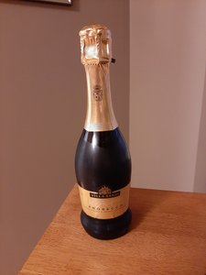
We met with the medical oncologist today to discuss last week’s CT scan. The 3 cm mass on my adrenal gland has seemingly disappeared. The two 2 cm masses on my liver have shrunk a little. The mass on my T-12 vertebra has remained the same but dormant. I anticipated the results being negative, and they ended up being very positive! We are very thankful and will celebrate by enjoying a glass of champagne this evening. Thankful for immunotherapy treatments, excellent caregivers, and the support of you all!

Trauma and Healing in Our Life—Fifteen Months Post Diagnosis
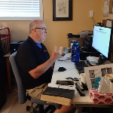
My collapse, subsequent life-saving surgery, radiation treatment, and life-saving immunotherapy have so far each begun with trauma and worry and ended with healing and life. I’m very grateful!
Prior to my last meeting in mid-October with the medical oncologist, I was assuming the news he would give me from my recent CT scan would show the cancer was winning, and that my life would be cut short. It turned out instead to be very good news. The cancerous masses were either gone or decreasing in size. This experience made me mindful of both the challenges of trauma and the joy of healing.
I know I’m not the only one with these experiences. Recently, Grandma and I had coffee with a happy woman who six months earlier was a man suffering from gender dysphoria for whom suicide was becoming an option. She had struggled most of her life trying to be a boy and a man and could no longer pretend she was something she was not. She needed to be who she really was. We are thankful she chose life. Also, recently I spoke with a mom whose adult child had threatened suicide and ended up pointing a gun at her. Thankfully, police came and diffused the situation capably. Thankfully, life was chosen. There are more of these traumas that we have experienced, and I’m sure you can add your own stories.
There are more examples I could reflect on. Some do not have happy endings. I just heard that a cousin of mine who was diagnosed just two weeks ago with cancer, was told that the cancer is inoperable. He was invited to return home and prepare to live out his shortened time surrounded by family.
There is also a world of trauma with famine, civil war, gangs, child soldiers, refugees, and climate change, a result of living on the earth rather than with it. I wish all these situations could be resolved in life-giving ways.
How do I live with both trauma and joy within myself and the world around me? When students would ask me what direction they should take with their lives, I often quoted Frederick Buechner, “The place God calls you to is the place where your deep gladness and the world’s deep hunger meet” (1973).
I found a sermon this past Sunday very helpful. The preacher spoke about trauma. She invited us to create safe places to be, safe places to reconnect, and safe places to share our stories, animating us to offer hope and peace and life within a traumatized world. This message reminded me of a recent quote I read by Pope Francis on the importance of leaders “smelling like the sheep” (Francis 2013).
How do I enjoy the good things in life? How do I line up my passions? How does my fight with cancer constrain me (just keeping appointments is like a part-time job), and how does this fight give me new opportunities? How do I enjoy food when my recent hypothyroidism stimulates me to eat too much? During the last eight days I feel blessed to have led seven virtual workshops for teachers—helping kids be physically active and emotionally and otherwise well. How many of these workshops can I do and should I do?
I think I need to heed the preacher’s advice and, as I’m able, help create safe places for others to be, safe places for this world to reconnect, and safe places where we can all share our important life stories. That invitation is probably a daily and life-long challenge how can I do my part to deal with some of the world’s trauma, and contribute to some of the world’s healing, and how can I cope with some of my trauma while also celebrating some of my healing.

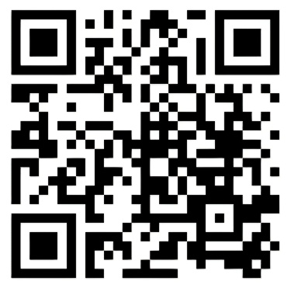
On Instagram,Michael Passons shared, “This has become an anthem for people who were told they didn’t belong in faith spaces. I hope that this is a reminder that there is room for all of us at the table of the divine.”

Watch TY HERNDON + MICHAEL PASSONS || “Testify To Love (feat. Melissa Greene)” on YouTube

https://youtu.be/9l7IPvr6b8s?si=-vmoEHQWuvAd9Tp5

Why Cancer, Why…?—Sixty-six Weeks Post Diagnosis
Previously, I referred to cancer as a random evil. I still think that, but a preacher’s message I heard this week got me thinking. She spoke about walking in cadence, walking in step, with Creator God. I began to wonder if cancer and other ailments are caused by us being out of step with Creator God and the good, created earth.
Wagamese offered the following important perspectives on living with the earth:
Walk gently on the earth and do each other no harm.

Earth. I will walk her skin today attuned to her heartbeat, the feel of her thrumming against the soles of my feet.

The moon, stars, rocks, trees, plants, water, insects, birds, mammals. Your whole family. Learn about that relationship. How you’re moving through time and space together. That’s why you’re alive (2016).

I will not document all the contributing reasons for cancer, but Dr. Google provides the following list: “tobacco, sun exposure, radiation exposure, chemicals, and other substances, some viruses and bacteria, certain hormones, family history of cancer, alcohol, poor diet, lack of physical activity, or being overweight.” Thinking about the preacher’s remarks, I wondered if maybe we are not living in a right(eous) way with the earth, and therefore people get cancer. I believe the cancer I’m fighting is not directly a fault of anything I have done, though perhaps my environment contributed. I was asked several times by medical folks if I had worked around chemicals, and I had worked with the manufacturing of paint 45 years ago. I think it’s more likely that the world I’m living in made me more vulnerable to cancer’s attack on me.
Individually and as a society, it is often difficult to understand how to live right(eous)ly, much less live. I hope our leaders at the current Glasgow Climate Change Conference will decide courageously and act right(eous)ly by making those difficult decisions about taking better care of the earth. As an individual, I ask myself, can I diligently engage in better creation care in smaller ways that will have an admittedly minuscule yet positive impact on the world?
All this reminded me of the saved starfish story:
A young girl was walking along a beach upon which thousands of starfish had been washed up during a terrible storm. When she came to each starfish, she would pick it up and throw it back into the ocean. People watched her with amusement. She had been doing this for some time when a man approached her and said, “Little girl, why are you doing this? Look at this beach! You can’t save all these starfish. You can’t begin to make a difference!” The girl seemed crushed, suddenly deflated. But after a few moments, she bent down, picked up another starfish, and hurled it as far as she could into the ocean. Then she looked up at the man and replied, “Well, I made a difference for that one!” The old man looked at the girl inquisitively and thought about what she had done and said. Inspired, he joined the little girl in throwing starfish back into the sea. Soon others joined, and all the starfish were saved (Eiseley 1969).
The starfish story reminded me of garbage-picking. Last year Grandma and I picked up 150 large bags of garbage and recyclables from our neighbourhood. This year there is no garbage because another family has been picking it up 😊.
Our important contributions are small compared to the heavy lifting Creator God does. God hears our cries and encourages us to choose right(eous) living in step with the Creator. In our fight against cancer, and many other ills, we are all in this together. Let’s try to get it right. Let’s do it right, even if it is only one starfish at a time.

Live Deeply—Sixty-seven Weeks Post Diagnosis
One year ago today, a friend held onto her son’s hands as the life-support machines were turned off after a week of no brain activity following a fentanyl overdose. She acknowledged that the 20 minutes that followed, till he breathed his last breath, were some of the longest minutes in her life. Then he breathed his last, when his organs were surgically removed, giving life to several people.
I miss my friend’s son. Our conversations were like those Wagamese spoke about:
I don’t want to touch you skin to skin. I want to touch you deeply, beneath the surface, where our real stories lie… I want to bump against you and feel the rush of contact and ask important questions and offer compelling answers, so that together we might learn to live beneath the surface, where the current bears us forward deeper into the great ocean of shared experience (2016).
I feel we did not do right with my friend while he was incarcerated. We could not touch skin-to-skin, and incarceration made those deeper conversations so much more challenging. We either sat across from each other divided by a glass wall, speaking into phones and limited to 30 minutes of conversation, or by written letters where it was difficult to share emotions.
For all of us, let’s be sure to make good use of our freedoms to ask important questions, offer compelling answers, learn to live beneath the surface, and live deeply into each other’s lives. I believe I have much more than 20 minutes to live, but let me not be complacent with this additional time. May I connect more deeply with people, especially those incarcerated, suffering from poverty, trying to stay warm on sidewalk vents, and those with a variety of ailments. As for me, as one of those suffering, thanks for coming beside me and asking, sharing, and listening to our important questions, our hopefully compelling answers, and learning to live more deeply with each other.

Deconstructing and Reconstructing my Thinking—Sixty-eight Weeks Post Diagnosis to Eighty-three Weeks Post Diagnosis
The other Sunday, a preacher spoke about deconstructing and reconstructing our lives. His message encouraged me to consider my own thinking and beliefs. I think that prior to collapsing on account of the pulmonary embolism, I often tried to live well, but I did not take much time to drill down and identify what was important for me and what was not.
With my cancer journey and while facing death more imminently, I’ve given myself increased liberty to deconstruct my thinking. I asked myself, what is core to what I believe, and what is not as important to me? What helped me sift through my thinking was Jesus’ story of the prodigal son. To summarize the story, the son of a wealthy man demands his inheritance and then goes off and squanders it. The son ultimately ends up in a pigsty before he decides to leave the pig poop of his life behind and surrender to his father to ask to be his servant. The father was prodigal, defined as wastefully extravagant, by giving the inheritance to the son before he had died. The father was also prodigal when he saw his son returning and without asking any questions ran to meet his son, celebrated the son’s return with an extravagant party, and loved on his son. For me, I believe a Creator of the universe is like this prodigal father, pouring extravagant love on all he has been made.
This week, a reading from Rohr reminded me that our view of God affects our view of ourselves. Rohr wrote, “Some believe in a God who makes traffic lights turn green and so become the children of magical coincidence. Some believe in a God of laws and crumble in spirit and psyche when they themselves break them or else become even more stern in demanding from other standards they themselves cannot keep” (Rohr 2011).
Through deconstructing and reconstructing, I see Creator God’s extravagant love as most central to my beliefs and thinking. I think this love was central for Jesus. He said: “Love the Lord your God with all your heart and with all your soul and with all your mind. This is the first and greatest commandment. And the second is like it: Love your neighbour as yourself. All the Law and the Prophets hang on these two commandments” (Matthew 22:37-40). As John, an apostle of Jesus, wrote: “See what great love the Father has lavished on us, that we should be called children of God! And that is what we are! My much-loved children, our love must not be empty words on our tongues but deeds done in truth” (1 John 3: 3 & 18).
I was also encouraged in Wagamese’s Ojibway Meditations, to see God’s love around me. He said: “I figure life is pretty simple: Creator is everywhere and divine light shines through everything and everyone all the time. My work is to look for that light. In those fleeting, glorious instances when I see it, I’m made more, right then, right there” (2016).
As I reconstruct my thinking, it is God’s extravagant love that I’m trying to use to shape my thinking, and, more challengingly, shape my living.
Experiencing 500 Tearful and Joy-filled Holy Days—500 Days Post Diagnosis
Last October, three months post diagnosis, I was told by the surgical oncologist who had saved my life by removing my cancerous kidney, that he was sad to tell me the pathology report indicated I still had a rare aggressive cancer variant. About a year ago, I began planning my funeral. I wept as I asked a friend to lead my funeral service. He wept with me and said he would.
I faced imminent death again at ten months post diagnosis when my liver was shutting down. Two immunotherapy treatments later, my liver health was restored. This time, joy. Interesting how joy and sorrow are very different emotions, but are both essential parts of what makes us human.
Grandma and I just returned from a one-week holiday. It was a real gift to be away from everything and be more focussed on enjoying each other’s company, relaxing, rejuvenating, and delighting in a beautiful creation. To be clear, this time away was not being vacant for a week (vacationing), but it was seven holy days (holidays). The word holiday comes from the Old English ‘haligdaeg,’ with ‘halig’ being holy and ‘daeg’ being day. Holy is defined as dedicated to God, to a God of love.
When we mentioned our holiday plans to the medical oncologist treating me and to our family doctor, they cheered our choice in living with quality of life—maybe even lengthening of life.
As I reflect on the last 500 days since I collapsed and began my medical care, my intention has been to try to continue to make all my days as holy days. I have tried to show love to people, including family members, golf buddies, some people with special needs, strangers, and friends by sharing a good joke, to the earth by walking, watching, listening, recycling., and to Creator God by living in God’s presence. I know that I have felt the love and holiness many have extended to me.
Several times during the past year and a half I anticipated my life being cut short. However, I’m at 500 holy days and counting :) Let me not get too far ahead of myself and remember that the present is a present which I have an opportunity to lovingly unwrap.

A Gift: “Determined to Live” in 1958—Seventy-one Weeks Post Diagnosis
My Dutch grandparents on my mother’s side of the family mailed a birthday gift to my parents in 1958—it was my parents’ first birthdays in Canada (I was five years old then). It was a book entitled Determined to Live. The book had been published in 1957. My Grandpa on my father’s side had died from cancer several years previous—and I always remember discussion about his death from cancer often being hush, hush, as if he had done something illicit.
The book chronicled the story of a man given a few days to live because of a colon cancer diagnosis. One surgeon “dared” operate, and the man continued to live many more years. According to the jacket cover, this book was written in an era when “from medical etiquette and from personal reluctance to discuss this disease, there is an almost impenetrable silence.” Thankfully, we are much freer today to discuss the fight against cancer.
Great Grandpa died during March, 2020, from old age. Recently, my sister discovered this book in my parents’ library. I wonder why my grandparents gave this book to my parents so long ago. Perhaps it was meant for me to read 63 years later, as a gift to me from my long-deceased grandparents. Though it was written by Brian Hession, I read it as if my grandparents were writing to me.
Below are a few bits of wisdom from Hession, with thanks to my Grandma and Grandpa:
- “You have just got to believe in the power of the human body to get well: but also, you have got to have… an utter determination to live.”
- “It is not having to face death that we mind: it is the dying that we do not like.”
- “There seems to be no real answer to pain.”
- “I have heard, since I was in America, so many people preach and speak as if God gives a special dispensation of favour and success to those who believe in him. They should know that there are millions who are in poverty who are deeply Christian, totally surrendered, who are praying for God’s help, but in this world, we may not always see the result of our prayers.”
- “Some try very hard to put up with suffering, as if God sends it, and what God sends must be borne with pious subjection. I’m absolutely convinced from the study of God that God, who is the perfect embodiment of love, does not send suffering.”
- “Trouble will sweeten or embitter you, and sufferings should be stepping-stones to fresh endeavour, not stumbling blocks.”
- “In pain the rich and poor are met together; God is the Father of them all and we are his stewards to bring them hope and courage.”
- “BE DETERMINED TO LIVE” (1957).

My Body Feels Like a War Zone With Cancer on One Hand and a Medical and Friend Community on the Other—Seventy-five Weeks Post Diagnosis
I began this week going to an appointment with a neuro-ophthalmologist. I still have vertical diplopia (double vision). Two decades earlier, due to the collision on my bicycle, my 4th cranial nerve was damaged. This nerve controls one of the small muscles on my eyes, and it being damaged causes the double vision. When I collapsed 18 months ago, I damaged this same nerve and aggravated the cycling injury. It looks like I will need to live with this diplopia.
During the next two weeks I will have nurses draw blood samples twice, have a bone scan, have a CT scan, see a dermatologist, visit with a medical oncologist, have an immunotherapy treatment, and, lastly, enjoy a massage. The bone scan and CT scan will give us a better picture how the battle is going. I feel like I’m doing well, but I’m apprehensive it isn’t.
I try to live healthy in order to give my body a fighting chance against cancer. Most of the heavy artillery comes from a medical community, a community I have come increasingly to appreciate. During the past 18 months, this community has saved my life on at least three occasions. This community enhances the quality of my present life and extends my life. I’m thankful for each of these professionals.
A meditation from Nouwen also helped me this week. “When we keep listening attentively to the voice [from Creator God] calling us the Beloved, it becomes possible to live our brokenness, not as a confirmation of our fear that we are worthless, but as an opportunity to purify and deepen the blessing that rests upon us” (1992). I’m also thankful for your prayerful help and positive energy!
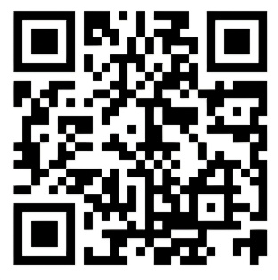
“Have you ever felt thrown away, used up, and left behind as if your heart was born to break? And you’ve given up the fight? Well, I’m here to say, He can take what’s beaten down, to make something beautiful. Even the song of a broken heart.”

Watch “Casting Crowns - Song of a Broken Heart (with lyrics) (2022).”

https://youtu.be/TyFO9IY13ao?si=HlT2K04qNRAi7xDQ

“Your Days are Like Grass.”— Seventy-five Weeks Post Diagnosis
Recently I attended a memorial service for a young person who died as a result of a physical assault. I heard a preacher’s message reflecting on how our lives are fleeting, like grass that thrives for a season and then dies. We are often reminded that life is short, too short to worry about it. For me, I believe my life will be shortened on account of the cancer in my body. The sermon also reminded the listeners of a beautiful heaven with a loving Creator God who awaits us for eternity. The preacher said that if we live forever, then life is too long to worry about the momentary pains or anxieties we experience from day to day. I agree with much of the above, I also think that the minutes of the here-and-now matter.
I believe Creator God, through Jesus, came into this world because the here and now matters. John was a disciple of Jesus and walked with Him for a few years. Reflecting on that time, John wrote, “The Word became flesh and made his dwelling among us. We have seen his glory, the glory of the one and only Son, who came from the Father, full of grace and truth” (John 1:14). He also wrote these well-known words, “For God so loved the world that he gave his one and only Son” (John 3:16).

I also love this world. I hope my presence in this world is one of some grace and truth. I think I have always felt that what I do today matters. One of the ways I use my current time is to create and share physically active games which help children be physically and mentally well (see www.canadago4sport.com). Because of cancer’s attack on me, I think I value each day a little
more deeply than I did before cancer. As fleeting as our lives are, the time, the relationships, and the moments of each day are rich opportunities to already begin to experience eternal and deep love growing like healthy grass in the here-and-now. I believe we are held now and forever in the everlasting and ever-loving embrace of God. The young man whose life was snatched too soon appeared to be the kind of healthy person who treasured the here-and-now and expected to enjoy that forever.


I find it important to be still often and know that Creator God is God. Jeremy Riddle sings a wonderful invitation to being still.

To listen to this song, go to: https://Youtu.be/A8TtOIMaKKA

Help Other Life-giving Dreams Come True?—Seventy-nine Weeks Post Diagnosis
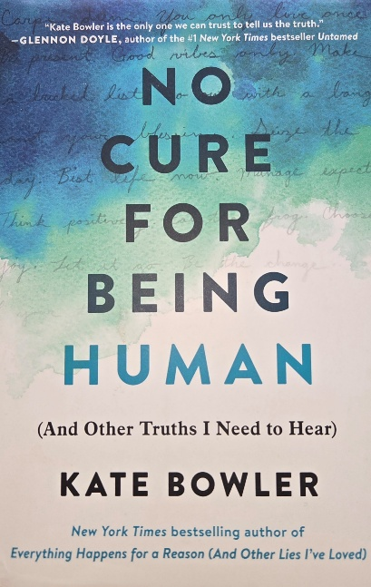
Close friends of ours read Kate Bowler’s book No Cure for Being Human (2018). They correctly thought Bowler’s situation was like mine and thoughtfully shared this book with me. The first half of the book is about discovering cancer and fighting it. I resonated with much of this story. Then, halfway through this book, she relates that the cancer she had been fighting seemed to have disappeared. The author asks,“Are these remaining lesions dead or dormant? This cancer could kill me or leave me alone. How afraid should I be?”
Eighteen months after discovering and being treated for cancer, I found myself in a similar place. I still had several cancerous masses, but other masses had disappeared, had diminished in size, or had been kept at bay. On January 30th, I wrote: “My mind says be jubilant, but I feel nervous and very afraid.” I felt as Bowler did. I also humbly realized, as Bowler did, “some of us responded to the immunity therapy drug and lived: and many did not respond and died.”
Her book was easy to read, and I found a lot of wisdom in its pages. I’ll share several insightful quotes with my own responses.
A personal and academic interest for Bowler is what she describes as the positive toxicity of the prosperity gospel movement. Bowler notes that North American “modernity is a fever dream promising infinite choices and unlimited progress…. Instead of helping us [through aspirational lists] grapple with our finitude, they have approximated infinity.” As she states in more sobering fashion: “We live and we are loved and we are gone.” Upon reflection, in the past, I have thought less much about my finitude and more about life possibilities. However, life on earth does have an end time for all of us. What does that mean for my thinking?
For me, a significant point Bowler makes is: “Time really is a circle; I can see that now. We are trapped between a past we can’t return to, and a future that is uncertain. And it takes guts to live here, in the hard space between anticipation and realization.” Looking back, I’ve found it easy to say would of, could of, and should of, about the past; but those thoughts do nothing to change the present. The past is the past. Also, we do not know what the future will bring. After dinner on July 30, I began taking videos of students engaged in purposeful play, and I ended that evening in a hospital with medical personnel asking me what they should do if my heart stopped. That day detoured my life into what is now an 18-month, and maybe a life-long, fight against cancer.
“It takes guts to live in the here.” For Bowler, “the terrible gift of a terrible illness is that it has, in fact, taught me to live in the moment. Nothing but this day matters. In my finite life, the mundane has begun to sparkle.” I’m still learning to live in the moment, and find the sparkle in my meals, my relationship with Grandma, my connections with family, my time with friends, and my creating on a computer.
Bowler further encouraged me with the following thought: “I have resurrected the old bucket list and have concluded that this will be the season of making other people’s dreams come true.” I think an important question for me to consider each day is, how can I calm any apprehension and use the moments I have been given today to help other people’s life-giving dreams come true?
What about God? Bowler suggests that: “If we are lucky, we see God in something mysterious, like a miracle. But mostly we see God in regular surprises like love and forgiveness.” I have seen God so often through family and friends who have so blessed me with their love and forgiveness. Thanks, all!
Bowler ends with a hopeful comment: “Someday we won’t need to hope. Someday we won’t need courage. Time itself will be wrapped up with a bow, and God will draw us all into the eternal moment where there will be no suffering, no disease, no email. In the meantime, we are stuck with our beautiful, terrible finitude.”
Kate Bowler and friends, thanks for sharing your timely and insightful thoughts with me and others!

The Mystery of Being Carried in Prayer—Eighty-one Weeks Post Diagnosis
Recently, close friends pointed us to the Bible story about a sick person being carried by friends. They reminded me that they continued to carry me in prayer and asked if I was well enough to carry friends of theirs in my prayers. I was! The Bible story was written by a doctor named Luke. The story is about Jesus, and, as translated by my Indigenous friends, it goes like this:
Several men came carrying a paralyzed man on a sleeping mat to bring him to Creator Sets Free (Jesus), but they could not get past the crowd. In their desperation, they climbed up to the rooftop and broke through the roof tiles. They lowered the paralyzed man down, sleeping mat and all, right in front of Creator Sets Free. When he saw their trust in him, he said to the paralyzed man, “Young man, you are released from your broken ways and wrongdoings” (Mark 2:1-12).
Some of the people who were in that house were offended that Creator Sets Free assumed God’s role as one who forgives. To those who took offence, Creator Sets Free asked the question, “Is it easier to tell a paralyzed man, ‘Get up and walk,’ or to say to him, ‘You are released from your wrongdoings?’” Then he turned to the paralyzed man and said, “‘Get up, and when you have rolled up your sleeping bundle, walk to your home.’ Right away the man stood up in front of them and did what he said, giving thanks to the Great Spirit for his healing” (Luke 5:17-26).
What my friends pointed out to me is that Creator Sets Free healed the man with paralysis because he “saw their trust in him.” The man was healed, less because of the paralyzed man’s trust, more because of the trust of his friends who carried him in front of Creator Sets Free.
I know people who fought cancer, who prayed, and were prayed for, but whose lives were snuffed out too soon. Though they were not healed, I know they were all carried in prayer by others, and I’m sure they were encouraged by those prayers.
There is much more that can be said about prayer. For example, Wagamese offers the following wisdom:
Me: What is the point of prayer and meditation?
Old Woman: To bring You closer to the Great Mystery.
Me: So, I can understand it?
Old Woman: No. So, you can participate in it (2016).

Rohr says this: Prayer is “more a way of being than an isolated act of doing” (1999).

But for today, thinking back on how I was carried during my recovery from my cycling collision, and the way I have been carried these last 18 months, I am so thankful for each of you, precious family and friends, for prayerfully holding onto the ropes, for carrying me with your outstretched arms. I find it a mystery to know how this works, but I feel your love and strength as you carry me.
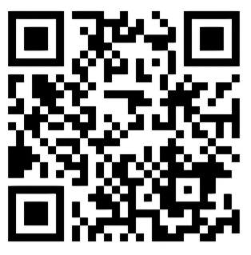
I listened to a helpful sermon on the passage about the paralyzed man carried by his four friends.

If you wish to listen to it, you can do so at (beginning at minute 23):

https://www.Youtube.com/watch?v=LSM9h22xbGU

Paused to Regroup—Eighty-two Weeks Post Diagnosis
I think about my fight against cancer as a war. The cancerous kidney was removed, and the cancer on my spine was held in check. The weapons were surgery and radiation. Furthermore, since I began monthly immunotherapy treatments this past June, the cancer cells are disappearing or diminishing. A strengthened mobilization of the immune system is doing its job. We are winning the war!
My last immunotherapy treatment was on December 22. My next treatment was scheduled for the end of January, but I developed colitis in my intestines as a cumulative side effect of the immunotherapy. Doctors decided I should take a break from the immunotherapy treatments to allow my body time to heal. Steroids and other medications were helpful, but they also had side effects. I could not continue to march forward but needed time to regroup. March 2, ten weeks after my last treatment, we would resume the treatments and attacks against the cancer cells. I was told we would start slowly, with half-treatments two weeks apart, so as not to overly stress my health.
My next CT scan would be in mid-April. I was a little concerned about whether or not this break in treatments had given the cancer cells time to regroup and strengthen. The medical team would know more in April, but we really had no choice but to regroup. We were beginning to march once again!
This pause to regroup was important for me as a cancer patient. Productive pauses in life are probably helpful for all of us. When I used to run marathons, slowing through periodic watering stations negatively affected my overall time; however, not hydrating myself would have meant I would not have completed the run. One cancer patient summarized it as follows: “Cancer life is a journey. There are many places to stop along the way and get nourishment—you must be willing and unafraid to take it.”

I Feel Saddened by People’s Decisions to Destroy. Let us Defend Life—Eighty-five Weeks Post Diagnosis
The treatments attacking the cancer seem to be working. I’m surrounded by a loving family (in fact, all 24 of our family members are sleeping over tonight 😊), caring friends, and excellent health practitioners who are all focussed on doing good. I should be happy, but, for the last couple of weeks, I often felt sad. Why?
In part, it may be that I have never before been sick for 19 months and still need treatment. In part, it may be my impatience with killing the cancer cells in my body. In part, it may be missing being outdoors to walk more or golf more. In part, it may be my tiring of winter. In part, it may be my weariness with COVID.
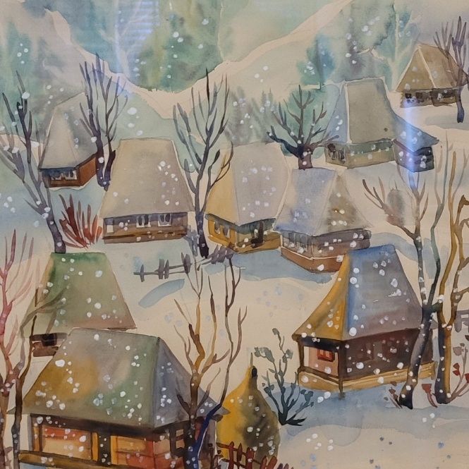
A lot of folks focus on doing good; however, I remember experiencing some of that goodness when I joined a team from Hamilton in 1991 to attend the International Children’s Games, wonderfully hosted by the people of Uzhhorod, Ukraine. While I was there, I purchased a watercolour painting which portrayed a peaceful scene in the Carpathian Mountains of Western Ukraine. I have attached a picture of this painting here.
I think the above list of possible reasons for feeling sad provides some reasons for my discouragement. As I think about it, the negative list made me more vulnerable to becoming most discouraged by Russia’s invasion of Ukraine, their killing of innocent people, and their indiscriminate destruction of buildings; last week, the Russians reportedly bombed a hospital and killed at least three people. For me, hospitals are havens in my cancer journey. I ask myself, why do some people focus on doing evil by killing civilians and killing hospitalized patients and their caregivers? Perhaps this is what confuses my emotions and makes me feel most sad. It confuses my emotions to know there is considerable destruction in the world, and then I’m saddened about people deliberately choosing to destroy even more.
I was encouraged by reading a recent post by Parker Palmer, a writer, speaker and activist who focusses on issues in education, community, leadership, spirituality, and social change. He wrote:
The opposite of loving life isn’t hating life—it’s fearing life. Authoritarians everywhere fear life’s diversity, complexity, exuberance, unpredictability, and creativity, the kind that challenges old orthodoxies. They feel safe only when they have the power to force the world into a form that meets their needs. What they love is death—the death that leaves the world as unchanging as the grave… Memo to Self: As you watch the news from Ukraine, go beyond your broken heart: learn and follow. Get in touch with your fierce love of life, everyone’s life, and if you find it missing, blow on the embers and rekindle it. Push back on the fearful who wants to tamp life down. Work hard to deny power to those who are in love with death. As Ukrainians will tell you, that’s a purpose worth living for (2004).
This week I sat in a chair in a hospital with a needle in my arm infusing me with Nivolumab to help my immune system fight the cancer in my body. I thought, cancer is worth defending against. As my mind turned to Ukraine, I thought about the invasion from an authoritarian leader, and I believe that is worth defending against. There is a cost to defending against cancer and against authoritarian leadership. They are both unfortunate realities that love death, but I believe we need to deny their power, and understand that denying power to authoritarians or cancer is a purpose worth living for.

Grateful to Lead Active Sessions and Receive an Encouraging Report on the Cancer Attacking Me—Ninety Weeks Post Diagnosis
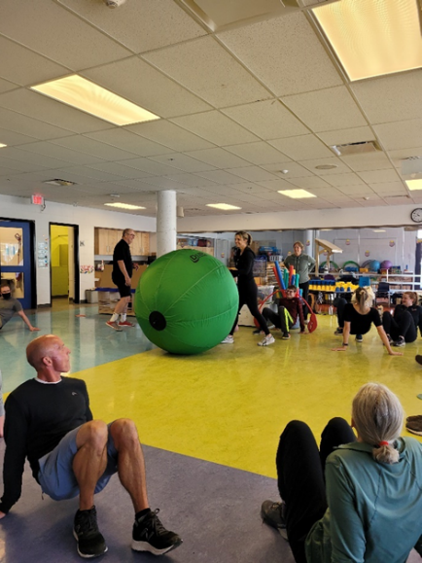
I just finished leading three active sessions at two conferences this past week in Alberta (one for the Calgary Board and one for EverActive in the beautiful Kananaskis area). These were my first major in-person sessions since COVID began and since it was discovered that I had cancer. I was super prepared for these, but I also had a few nightmares about the sessions not going well. However, they went very well. For the participants and for me the experience was exhilarating and tiring! I’m looking forward to autumn, when more conferences go in-person.
I shared a brief description of my cancer journey. It was emotional to tell, and it was emotional for participants to hear. The main theme was “Choosing life; it’s worth it!”
What motivates me? The opportunity to be a small part of the value Creator God places on “the city streets. filled with boys and girls playing there” (Zechariah 8:5).
We received positive news this week from the medical oncologist in charge of my care. She received the CT scan report. I do have some small nodules on my lungs that change from scan to scan and are probably reactions to immunotherapy. The cancer on my T12 vertebra is stable. The one kidney cancer nodule shrank from 1.6 cm to 1 cm. We are thankful for this positive news. The medical oncologist is scheduling another bone scan to look at my spine.

More to Life Than Just Choosing It—Ninety-two Weeks Post Diagnosis
There is more to life than just choosing it. I spoke with someone recently about my cancer journey and how I began this journey in the hospital by saying, “I’m choosing life, and since then I try to help others do the same.” This person’s father also had cancer and also chose life but he said, “Cancer can be cruel.” Recently he died.
During the last week, I’ve walked with three other people on their pain journey.
- I told my story to another person and she wept. She shared with me that a student she was in touch with could no longer choose life and had recently succumbed to suicide.
- I received an email from a person who was now giving care to a spouse. One day he was playing lively music in a pub and a week later was told he had inoperable cancer.
- We began a committee meeting the other day with the question, “What are you grateful for?” One colleague said she was grateful that her mom answered the phone each morning. This person’s mom was recently diagnosed with an aggressive cancer.
Grandma and I spoke with an older woman a few weeks ago. Her husband had died a few months earlier. Through tears, and in her native tongue, she said death is horrific.
Before I connected with these people, I did not know they were so pained. I was reminded this past week that there are many pained people who choose life but who find their life going badly.
I think there is a lot of pain in this world—and beyond individual pain, there is the unbelievable pain in places like Ukraine and Yemen. I was struck by the pain as I lived in my small world this past week. As I write this note, I feel a little overwhelmed. Though I believe in the comfort of a Creator who Sets Free (Jesus), this week’s encounters reminded me that in this life we will have trouble, and that death is a final enemy. I ask myself, “Can I do better at walking with people in pain? Can I do better at encouraging people to pursue their healing passions?”
I began to wonder about my own condition. When does my pain reappear? As I woke up in the morning, I did not know if today:
- I would find myself in the hospital again with cancer succeeding in its attack, although thankfully we are beating the cancer at this stage,
- I would be badly hurt by someone who chose to drink and drive, as happened to me on June 30, 2003, or,
- If I lived in Ukraine, would I be hurt or killed by one of Putin’s missiles or bullets (We are currently looking at more tangible ways we can help Ukrainians).
However, when I wake up in the morning, I think I ought not to worry about negative possibilities. Let me focus on choosing to open the gift of this day, to enjoy it for myself, and to share the gift of today with others so that we can all flourish, or at least feel carried by the love and care of others. I feel I have many companions who are walking with me in my pain and encouraging me in my passions. I’m grateful. I hope this can be true for everyone.
As a way of choosing life, I was drawn to the words of Creator Sets Free, who, in Matthew’s gospel, says, (in the words of the Indigenous New Testament):
Blessings of the Good Road (Beatitudes)
3 Creator’s blessing rests on the poor, the ones with broken spirits. The good road from above is theirs to walk.
4 Creator’s blessing rests on the ones who walk a trail of tears, for he will wipe away the tears from their eyes and comfort them.
5 Creator’s blessing rests on the ones who walk softly and in a humble manner. The earth, land, and sky will welcome them and always be their home.
6 Creator’s blessing rests on the ones who hunger and thirst for wrongs to be made right again. They will eat and drink until they are full.
7 Creator’s blessing rests on the ones who are merciful and kind to others. Their kindness will find its way back to them—full circle.
8 Creator’s blessing rests on the pure of heart. They are the ones who will see the Great Spirit.
9 Creator’s blessing rests on the ones who make peace. It will be said of them they are the children of the Great Spirit!
10 Creator’s blessing rests on the ones who are hunted down and mistreated for doing what is right for they are walking the good road from above (Matthew 5).

Don’t Carry the World Upon Your Shoulders—Ninety-three Weeks Post Diagnosis
I recently listened to the Beatles’ song “Hey Jude,” apparently written by Paul McCartney to comfort John Lennon’s young son Julian after Lennon had left his wife for the Japanese artist Yoko Ono. The part that struck me was:
And anytime you feel the pain, hey Jude, refrain,
Don’t carry the world upon your shoulders.

I was reminded of similar Biblical wisdom:
I do not concern myself with great matters,
or things that are too wonderful for me (Psalm 131:1)

I find it easy to get overwhelmed by Russia’s attack on Ukraine. I find it challenging listening to caring teachers share stories of stressed students. I feel less able to contribute on account of my cancer journey. I ask myself, how can I show concern for some of the world’s pains and make a difference? Part of my answer is to support our worshipping community’s refugee initiatives. Part of my answer came over the last few weeks when I was able to successfully lead several active presentations, assisting teachers who help students live physically and emotionally well.
I could just leave it all to God, but I know we all have responsibilities. A colleague once said, and I find it helpful, “Because of God nothing matters. Because of God everything matters.” Though I feel more fatigued due to the hypothyroidism caused by the cancer treatments and immunotherapy treatments, I can yet find a place in this world where I can balance “great matters” with what I can still do. I was reminded of the Serenity Prayer which directed me down a good path: “Father, give us courage to change what must be altered, serenity to accept what cannot be helped, and the insight to know the one from the other.” I’m grateful to still engage in this world without “carrying the world upon [my] shoulders” and having opportunities to heed the Beatles’ encouragement to take “a sad song and make it better.”
Recently a preacher reminded me to follow Creator Sets Free (Jesus) as I’m able:
- whose wounded feet remind me to walk with my wounded feet with those who are too wounded to walk well,
- whose wounded hands remind me to use my wounded hands to bring healing to the wounded, and
- whose wounded heart reminds me to open my wounded heart to the wounded hearts of others.
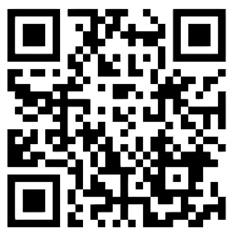
“Hey Jude” was written by Paul McCartney in 1968 to comfort John Lennon’s son, Julian, during the painful divorce of his parents, John and Cynthia Lennon.

To listen to “Hey Jude” go to the following and start at .58.

https://www.youtube.com/watch?v=A_MjCqQoLLA
We All Die: When we Die, Depends—Ninety-six Weeks Post Diagnosis
The cancerous masses inside me have been surgically removed, radiated to pieces, diminished or destroyed through immunotherapy treatments. The treatments have tired me. I have one less kidney, and my thyroid gland has stopped functioning, but I’m alive and living relatively well.
Results of a recent bone scan showed no new cancerous masses on my bones. A recent CT scan showed that cancerous masses in the rest of my body are diminishing or disappearing. The fight against the cancer in my body is going well.
I wish successful treatments were the case for all cancer patients. I feel confident that as we learn more, more people will conquer cancer. Death is a relationally painful and final enemy.
I began to think about what shapes life expectancy. In the Central African Republic (CAR), the average life expectancy is 53 years of age (among the lowest in the world)—I’m already 15 years past that age. In Canada, the average life expectancy is 83, among the highest in the world, and 30 years longer than in the CAR. These numbers reminded me that our lifestyle choices and at times the choices of others can significantly influence our life expectancy. Apparently, the genes we inherit also shape our life expectancy. I think more significant is the quality of health services available, our access to them, and whether the treatments are possible and efficacious. I think that even more significant than medical availability is accessibility to clean water and adequate nutrition, as well as less gun violence, decreased conflict, and reduced poverty.
My experience with the medical community as they treat me is that they try to reduce mourning or crying or pain, thus increasing quantity and quality of life—a taste of heaven on earth. Their efforts remind me to try to do the same with each day of my life, encouraging joy, laughter, and healing, regardless of how many days I have.

Love Mercy, Act Justly, and Walk Humbly—Ninety-seven Weeks Post Diagnosis
This past week, we enjoyed the in-person love of our family, some of whom live thousands of kilometres apart. We enjoyed playing games, eating together, watching family members engage in sport, appreciating their creativeness at painting, delighting in listening to them sing and play instruments like ukulele, flute, and keyboard, sharing favourite songs, praying, and loving them for the unique people they are.
There were times since I collapsed that I was not sure how much more time I would have to enjoy my family. Because of my cancer journey, I think I treasure my family more now, despite being slightly less able to be as actively engaged with them as I would like to. But I anticipate and look forward to the gift of more living along with each of them.
Nouwen encouraged me to think about the gift of dying:
When I felt my death approaching, I suddenly realized how much I could influence the hearts of those whom I would leave behind. If I could truly say that I was grateful for what I had lived, eager to forgive and be forgiven, full of hope that those who loved me would continue their lives of joy and peace, and confident that Jesus who calls me would guide all who somehow belonged to my life—if I could do that—I would, in the hour of my death, reveal more true spiritual freedom than I had been able to reveal during all the years of my life. I realize on a very deep level that dying is the most important act of living. It involves a choice to bind others with guilt or to set them free with gratitude (1994).
I began to think about what gift or legacy I will leave behind. Though I have written a lot of words in my life, I was reminded by the students’ singing at one of your schools to stay focussed on loving mercy, acting justly, and walking humbly. I hope that is how I live out each day and is the legacy I leave behind.
I appreciate living in a place with sufficient health supports that I have already been able to “live to see [my] children’s children” (Psalm 128:6) and experienced that “children’s children are a crown to the aged” (Proverbs 17:6).
I’m feeling blessed. I hope my children and each of you, my grandchildren, also feel blessed and are encouraged by my example to “love mercy, to act justly, and to walk humbly” (Micah 6:8).

Stability
“Faith, Hope, and Love”—102 Weeks Post Diagnosis
Because I was told 22 months ago that I have an aggressive cancer variant, I assume that, despite my faith or my hope, cancer will eventually take my life. For now, I’m pleased with the effective medical care given to me. I’m hopeful that immunotherapy treatments might be further paused in a few weeks when I receive a positive update on a CT scan. The doctors’ efficacious work gives me hope.
I was reminded by Wagamese that
We are all taken care of. We are all watched over, loved, and sheltered when we ask for it regardless of creed. It is what binds us and makes us a human family. It is our greatest human truth. Let our spirits rise collectively today in celebration and gratitude for the loving Creator/God we feel around us, in us, moving through us. Peace. Be blessed. Be the blessing (2016).
There is faith, hope, and love. But what happens when faith and hope do not heal my cancer? When cancer wins, and I have no faith or hope that I will be healed, I can continue having faith, hope, and love for Creator God and extending love to others. I remind myself that it is important to show love with my actions to give hope and faith to others. I also need to open myself to other people loving me as they in turn extend faith and hope to me. Love gives us a taste of eternity. Last Sunday I was reminded of the biblical passage which says, “Faith, hope, and love, and love is the greatest” (1 Corinthians 13:13).

Words Have Meaning and Context—123 Weeks Post Diagnosis
My cancer treatments have been going well. In the next couple of weeks I’m scheduled for a bone scan and a CT scan, and after that I will learn how I’m really doing. How do I speak of things when they are going relatively well?
I feel uncomfortable when I hear others say they are privileged or blessed. When I think of those words, my immediate question to is, “Why am I privileged or blessed, and not others?” For those for whom cancer’s attack seems to be winning, or for whom other life circumstances are very challenging (I think of Ukrainians in Eastern Ukraine whose homes have been destroyed and family members killed), I need to ask myself, “Why they’re not privileged or blessed?” I could go into a long explanation of why I’m in a time and place that is not at war and why people in Ukraine are currently under attack, but suffice it to say that privilege and blessing often have very complicated and sad explanations and usually have more to do with one place and time in history than with anything an individual deserves. My cancer treatment was approved by Health Canada just one month after I collapsed in 2020. If the cancer attacking me had happened several years earlier, this treatment would not have been available to me, and my prognosis now would likely be much worse.
I think some Bible readers often mistakenly take the Bible at its literal word. For example, I have heard believers in Creator God claim privilege for themselves through Creator God’s words: “For I know the plans I have for you, plans to prosper you and not to harm you, plans to give you hope and a future” (Jeremiah 29:11). These readers forget to read three verses further, where it is written: “I will bring you back from captivity” (Jeremiah 29:14). My copy of the Bible begins Jeremiah 29 with the words “A letter to the exiles.” Randolph Richards and Brandon O’Brien point out in their insightful book Misreading Scripture with Western Eyes that “this verse is about ancient Israel, not me” (2012). For those who read the Bible, it’s more important to try to understand the Bible’s meaning than to simply read the Bible without understanding context.
What words do I use to celebrate a six-month stalemate of cancer’s growth in me? For me the words I choose are grateful and thankful. If/when things get worse, I hope I can always be grateful and thankful for the life I still have, for the excellent care I’m given, fot the love that carries me, and for the love of Creator God that gives my life meaning.
Being grateful and thankful, however, does not mean that I’m fully pleased with my current situation. My thyroid has stopped functioning as a side effect of immunotherapy, my body is constantly itchy from the treatments, and walking up stairs and going for a vigorous walk finds me winded. I’m grateful and thankful for medicine to treat my thyroid, for medication and creams to deal with my itch, and for the ability to walk and climb stairs, but I often wish my life was different. At times I wish I had my old self back. Yet, despite life’s challenges, I remain grateful and thankful for much.

If Only…—Twenty-nine Months Post Diagnosis
As I look back, I see that it is unhelpful to reflect on my life using such words as could have, would have, or should have. Each of these words looks backwards and has me wanting to change the past. Of course, I can’t change the past, so it is best not to go there. It is better to live today with a vision of looking forward to an everlasting light.
Two weeks ago, I had four medical appointments. This past week, I had only one. Three of the appointments were related to my cancer. As I experience these appointments, I wonder what it would be like to not have all these appointments and reminders of cancer’s attack. I wonder what it would be like to not take any medications for thinning my blood, assisting with my barely functioning thyroid gland, and helping me deal with itchy skin. I think about taking a day off from taking my medications during the night, before breakfast, at dinner, and prior to going to bed. As appealing as that all sounded, even for one day, I think I will resist the urge to do that. The “would be” is really a cry that “if only” I did not have cancer attacking me. However, I think it’s important for me not to spend too much time in places I cannot change.
More recently I began to learn of another set of words I thought I needed to avoid: “If only.” If only I had not done this, or not done that, or did not get attacked by cancer. If I lived in Ukraine, I might say, “If only Russia had not attacked us.” These if only statements also have me look unhelpfully to a past I cannot change.
So, how do I live today?
- My bone scan two weeks ago showed: “No active bony metastatic disease identified.”
- This last week’s CT scan showed: “No local recurrence. Stable liver lesion. Stable lung nodules.” I sobbed gratefully when I read this note. I still have cancerous masses, but they are not increasing in size or spreading to other areas.
In my last update I shared that I’m trying to live thankfully and gratefully. My recent scans are a very good reason to be thankful. I think to be thankful and grateful may mean not looking back or thinking could have, would have, or should have. Instead, I think it means looking forward and being willing to make possible a flourishing life. Also, I think it’s helpful to use if only as a plea for a future better world. If I lived in Ukraine my prayer might be, “if only Russia would leave our country.” For me and my health journey, “if only the cancer remains at bay, or, if the cancers attack again, if only the medical team and my body have the skill and strength to combat it.” When I’m feeling weak, fatigued, and vulnerable, I long for a future that is better than the present. I hope to use if only not to consider where I have been, but to look forward to where I deeply wish to go.
I encourage myself that the best path forward is to be thankful and grateful for excellent medical care, for well-developed medications, and for a loving community supporting me. In this new year, I hope that in life’s challenges I may have the resilience to be continually thankful and grateful, especially if things are getting worse, and to hope and pray that if only things could get better. Also, I want to pursue, as I’m able, abundant living for all, today and into the future.
Happy New Year to all of you, as supporters of Grandma and me in our journey.

When Breath Becomes Air—129 Weeks Post Diagnosis
I just finished reading the story of Paul Kalanithi’s illuminating and personally heartbreaking journey, When Breath Becomes Air (2016). I was attracted to the book by its title. I began my cancer journey unconscious, having collapsed on asphalt and softly saying, as Grandma recalls, “I can’t breathe.” As I read the book, I found myself resonating with much more than the title.
Kalanithi found that the process of writing gave purposeful voice to his thoughts as he journeyed through a terminal cancer diagnosis. I think a lot about life and find writing therapeutic as I refine my thinking and express my thoughts. Reading Kalanithi’s book inspired me to keep writing.
About half of the book describes his passionate pursuit of his calling as a neurosurgeon. He’s reminded regularly of his wife’s statement, “You have to figure out what’s most important to you.” For me, I equally value my calling; it’s important for me to equip leaders to help children be physically and emotionally well.
When Kalanithi finally completed his last surgery, he recalls, “Tears welled up as I sat in the car... I drove home, walked through the front door, hung up my white coat, and took off my ID badge. I pulled the battery out of my pager... I called Victoria and told her I wouldn’t be in on Monday, or possibly ever again.” Similarly, I remember teaching my last class at Redeemer University. What would it be like to lead my last workshop? What would it be like to play a last game with each of you? When will I know?
I understood the physical weakness he felt at the beginning of his cancer treatments: “In physical therapy, I was not even lifting weights yet, just lifting my legs... My body was frail and weak.” I remember the first time I was in the hospital; it took all the energy I had to slide out of my bed onto a commode and then struggle to get back onto the bed again.
Kalanithi’s oncologist did not tell him for some time what his life expectancy was, despite him asking where he was on the Kaplan-Meier curve, which measures the number of patients surviving over time. At the beginning of my cancer journey I asked Dr. Google about life expectancy for someone with renal cell carcinoma. Google’s answer of “a few short months” was alarming. I asked my surgical oncologist, and he said the median life expectancy was four years. This means half of the people with renal cell carcinoma died before four years following their diagnosis, but this means that half the patients lived beyond four years. Also, a new immunotherapy treatment was just approved the month after I collapsed. Two and a half years after my collapse, immunotherapy treatments appear effective and I intend to exceed the four-year median life expectancy.
But, as Kalanithi states, “Death comes for all of us... Most lives are lived with passivity toward death.” Kalanithi’s cancer journey changed his earlier passive view of death. “I began to realize that coming in such close contact with my own mortality had changed both nothing and everything. Before my cancer was diagnosed, I knew that someday I would die, but I didn’t know when. After the diagnosis, I knew that someday I would die, but I didn’t know when. But now I knew it acutely. The problem wasn’t really a scientific one. The fact of death is unsettling. Yet there is no other way to live.” These words are true for me as well.
Kalanithi states that “science may provide the most useful way to organize empirical, reproducible data, but its power to do so is predicated on its inability to grasp the most central aspects of human life: hope, fear, love, hate, beauty, envy, honor, weakness, striving, suffering, virtue.” Furthermore, “human knowledge is never contained in one person. It grows from the relationships we create between each other and the world, and still, it is never complete. And truth comes somewhere above all of them.” I know that my treatments are added to a database to further scientifically informed treatment decisions. I’m very thankful to have family doctors, oncologists, other medical practitioners, family, and friends who continue to offer insight, hope, and love.
I resonated with Kalanithi’s belief in God. He writes: “If you believe that science provides no basis for God, then you are almost obligated to conclude that science provides no basis for meaning and, therefore, life itself doesn’t have any.” Creator God provides meaning for my life.
Furthermore, Kalanithi shares about a “frustrated Jesus whose metaphorical language receives literal interpretation from his followers.” He uses the example of Jesus when he said to his disciples, “‘I have food to eat of which you do not know.’ So, the disciples said to one another, ‘Could someone have brought him something to eat?’“ If I have a frustration with Christianity, I think it is that we are too quick to read what the Bible words say but are insufficiently prepared to dig more deeply into what the words might mean about the mystery of who God is and for the way we live.
Kalanithi understands Jesus’ main message to be “mercy trumps justice every time.” My life is also shaped by the thought of a prodigal Creator God who loved the son who stayed home, loved the son who left home, and loved the son who returned home.
The Epilogue in Kalanithi’s book, written posthumously by his loving wife, was tough reading. Grandma happened to sit by my side when I was halfway through the Epilogue. She asked, “Are you finished with the book?” Saying “no” was the easy part for me. I had to gather my emotions to say the tough part I had just read: “The author is dead now.
We attended a young friend’s wedding seven years ago. Instead of using the lines ”Till death do us part,” in their wedding vows, they said, more poignantly for me, “Till our last breath.” Tragically, this past summer we watched the funeral of this young man, husband, father, and colleague, as his last breath came way too soon.
I imagined my final days. How will that go? I thought of my friend Dave who, two days before succumbing to cancer, answered a question I had for him. “Dave, we’re on a similar journey. You’re going ahead of me. What advice can you give me?” I often remember his simple, yet profound statement: “Surrender.”
Finally, I often thought about two of Kalanithi’s statements:
“I can’t go on. I’ll go on.”

“Even if I’m dying, until I actually die, I’m still living.”

For me, I’m continuing to choose life in a perpetual present. “I’ll go on” if “I’m still living,” as long as I’m gifted with the ability to breathe in air.

Peeking into the Rearview Mirror and Gazing Through the Windshield—130 Weeks Post Diagnosis
I’ve heard it said a few times that we should live life like we drive a car. In other words, check the rear-view mirror now and then, but look mostly through the big windshield in front of you. I also think of George Santayana’s quote: “Those who cannot learn from history are doomed to repeat it.” I probably should not spend too much time in the past but learn enough from it to live wisely today.
Recently I did go back in time to read something I wrote on CaringBridge two-and-a-half years ago. I described the post-surgery pathology report as follows:
I knew I had renal cell carcinoma. We were told that the surgery was a more complicated surgery, but had gone well, and had healed well. They also cut away a seemingly healthy part of the inferior vena cava, and pathology determined there were cancer cells there. Pathology determined I have a very aggressive high-grade cancer variant with rapid differentiation. I will get a follow-up body scan in three months, and the current expectation is that the cancer may spread to the lungs and possibly my liver and bones. Treatment options will be considered as needed. Difficult news for Catherine and me to process. For me, once I get over my initial sadness, the gift of each day and each relationship has become even more valuable. We covet your continued support through your positive energy and prayers.
Then I read all the supportive comments from family and friends responding to my diagnosis and experienced their loving care. I wept a little as I reflected about my health then, and the tremendous outpouring of compassionate love from family and friends. I began to plan my funeral. Now, two and a half years later, I’m thankful for my present situation in which the radiation and immunotherapy treatments have been so effective that I’ve not needed treatment for the last nine months. I’m not currently planning my funeral. However, every time my body has an ache, or I have a CT scan, I do wonder when the aggressive cancer, still present in my body, will begin to attack again.
I have been driving my cancer-fighting journey for 130 weeks. When I recently looked in the rear-view mirror, I realized that I was in a tough place. I also realize that many people carried us through it. I wish I knew then how relatively well I would be today. I’m still aware that I have three small cancerous masses in my body. My body still itches continually from the treatments. My thyroid has been functionally destroyed. My lung capacity is limited, but still, so many family members, friends, and amazing health practioners are still traveling with us. I’m able to look through a large windshield of possibilities (sometimes moving quickly as I see through a fully clear windshield and sometimes moving slowly as I see through a mostly fogged-up windshield) to enjoy deep companionship with Grandma, to delight in engagement with my family, to appreciate meaningful moments with good friends, to be able to travel Canada and lead physically active workshops for enthused teachers, to walk or jog 3 km, to be alive, and to continue choosing life.

Letters to Myself on Dying by Mirth Vos (part 1)—Thirty-two Months Post Diagnosis
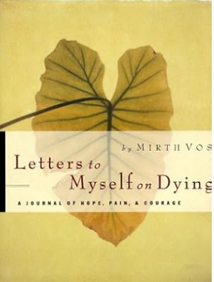
I reread this book published in 1988, a woman’s journal about fighting cancer a third time. I found her writing inspired, especially her view of this life, the next life, and the transition. Though her title is about dying, I thankfully do not feel death is any way imminent for me, but, as I read her story, and she more imminently considered passing from this life to the next, I was reflective about how her thinking was shaping my own.
Though the contents of her journals focus on coming to grips with dying, I think the focus of her journalling is about living in this world and the next, living in a well-known and valued present life and looking forward to an unknown but amazing eternal life. As she puts it, she is “…a developing human getting ready to be birthed into eternity.” These are some of her key phrases:
About this life:
- The beautiful things of this life, though passing away, are valuable as a foretaste.
- If I live another year, I will be able to read the whole Bible with concentration. If I do not, God will turn his eyes from his self-revelation in the Bible to his dazzling revelation of himself to me in heaven.
- As for man, his days are like grass, he flourishes like a flower in the field, the wind blows over it and it is gone, and its place remembers it no more (Psalm 103:15 16).
- How can I long for a heavenly country if I do not spend time meditating upon its existence… Perhaps I do not need to sacrifice the privileged place of my partner in my heart but instead shift it slightly and make room for THE PRIVILEGED ONE.
- We are “being transformed into his likeness” (2 Corinthians 3:18): “A transformation that starts now in time and gets completed in eternity.”
- “Now we see but in a poor reflection as in a mirror, then we shall see face to face. Now I know in part, then I shall see fully even as I’m fully known” (1 Corinthians 13:12).
About the next life:
- I believe that I will live on as a person, as myself after my death.
- God who created everything that exists out of nothing can certainly do what my mind cannot process.
- Jesus Christ said, I’m “not the God of the dead, but of the living” (Mark 12:27).
About the transition from this life to the next:
- For a few moments I hold the small view and the cosmic view in my mind at the same time. And it is very good.
- That cruel choice, life with Jack [her husband] or full communion with God, no longer seems cruel; the two concepts do not even present themselves as a choice. Now I expect the one will flow into the other.
- At the end…we will not be torn away from each other; we will willingly let each other go.
- God reminds me that dying is the biggest change I will ever make and that this “getting ready to pass over” time may be the richest in my entire life. He reminds me that earthly life is very important, and the perfect life with God following is beyond the grasping of it. I’m hanging between what is important and what is IMPORTANT, like a tightrope walker above the Niagara gorge.
As I, John, consider my life on earth, I find it to be a very short one—I was born, grew up, went to school, married, raised a family, did some work, enjoyed retired living, and then I will die. Even if I live to the age of Great Grandpa, who died when he was 96, that is only 27 more years. Time goes quickly. Cancer’s attack on me makes me more aware that my days are numbered.
For me, a belief in a Creator God who loves this world (John 3:16) is enough to give me a life purpose to also love this world. I know that the Bible teaches that “if our hope in the Chosen One is only for this life, then we should be pitied more than all other human beings” (1 Corinthians 15:19). Even if this life is all we have, for me a belief in Creator God gives me purpose for today.
As I consider this new heaven and new earth, I’m helped by U2’s song “The Streets Have No Names.” U2 look forward to an eternal place where there is no value in living on Bridle Path or near Jane and Finch, or on Manor Avenue or Donald Street, or Wilson’s Point Grey Road or East Hastings, or Riverside Drive or Kipps Lane. I imagine the names of streets in my city saying nothing about economic status because there is no economic status. A disciple of Jesus shared a vision of this new city and described it as a place where “death will be no more. There will be no sorrow, or weeping, or pain, because these former things have faded away” (Revelation 21:3). This gives me further purpose to try to make a difference where I’m today, to have me taste eternity. Today is a gift. The people and the world around me are a gift. I think the challenge for me is to open the gift of today, the people I’m with, and the opportunities presented to me in a way that enriches, enjoys, and loves the world.
I have no experience with the transition from this life to the next. I recall a story given to me when I was a young boy about my grandfather dying. I was told that he asked his adult children to sing a favourite hymn. They did. He said, “It sounds like angels.” Then he passed. I had to also think of the passing of my father. Probably the last physical act of his last day on earth, lying on a hospital bed, was to lift his hands as he received the blessing offered by his pastor. He then became unresponsive. He went to sleep that night, and I believe he woke up a few hours later in glory.
Just the other day I read a quote from Nouwen which also spoke to me: “…the real question for me as I consider my own death is not: how much can I still accomplish before I die, or will I be a burden to others? No, the real question is: how can I live so that my death will be fruitful for others? In other words, how can my death be a gift for my loved ones so that they can reap the fruits of my life after I have died? This question can be answered only if I’m first willing to admit Jesus’ vision of death, as a valid possibility for me” (1994).
I find it interesting that Mirth Vos passed a couple decades ago, yet she was able to speak to me the last few days through the pages of her journal. I then ask myself, “How can I make a difference today, and through my eventual passing, make this world a better place?”
Tremendous Medical Community—Mirth Vos (Part 2): What a Difference Twenty-four Years Make—140 Weeks Post Diagnosis
Mirth Vos was informed: “There are five spots of cancer on your lungs. The largest one is the size of a dime. This is incurable. But we will make you comfortable.” She felt the reassuring touch of the oncologist’s hand on her shoulders as she heard this news. The medical team reminded her to not focus on dying, but on “the months or years to live” (1988).
She had friends who apologized “for intruding, but pushed forward by concern, they offered books, videos, photocopied sheets, brochures, telephone numbers of homeopathic and naturopathic practitioners, addresses of clinics in Nevada and Mexico.” She tried various nutritional remedies, but ultimately, they made very little difference. However, her oncologist said that “taking any action is beneficial in that it gives the patient a sense of control.” When a person’s life is out of control, having a sense of control at least feels good.
For a time Mirth thought her cancer had disappeared—or had at least gone into remission. Mirth writes: “As someone said to my daughter, ‘There is no greater excitement than being in the middle of answered prayer.’” However, “I’ve been pulling lots of persons along on this roller-coaster ride. The recurrence of pain humiliates me before them.”
I’m not an oncologist, and I realize that cancer attacked Mirth three major times. She wrote about her third cancer journey. When I read her description of the “incurable cancer,” I wonder how she would have done if the cancer had appeared two decades later. From my limited knowledge, it seems my cancer is much worse than Mirth’s. However, the immunotherapy treatments I’m getting are very new and, thankfully, seem to be supercharging my immune system to successfully reduce cancer’s attack. If doctors had had immunotherapy treatments then, whether she might have survived longer. I very much appreciate that medical practitioners continually work at improving treatments. When I was apologetically told by a surgical oncologist that I “have an aggressive high-grade cancer variant with rapid differentiation,” I can still feel his reassuring hand on my shoulder—the same comfort Mirth’s oncologist offered her.
I have also had well-meaning family and friends make recommendations for cures or remedies that they felt would at least slow down cancer’s growth. Though I still have various cancerous masses in my body, they have been significantly reduced and held at bay by various medical treatments. Amusingly, I thought once, I eat a rusk with chocolate sprinkles at least once a week. There is probably a correlation between eating rusks sprinkled with chocolate and my lessening cancer. I doubt that a scientific peer-reviewed and replicated study, with a larger sample size than one, would substantiate a claim that a rusk with chocolate sprinkles in any way reduces cancer cells. I have learned, as I think Mirth did, to trust the experts. Nevertheless, I still enjoy an occasional rusk with chocolate sprinkles. 😊
Mirth experienced cancer returning three times. During the third episode she also thought for a while that she had been cured, or that the cancer was at least in remission. Recently, I have heard people share stories about being cancer-free. The oncologists working with me say that they never tell people the cancer is gone or in remission. They rather say that they do not see any cancerous masses right now. We can still see several cancerous masses in my body—larger than dimes. The oncologists regularly scan my body to know when cancer goes on the offensive again. I’m appreciative that cancer does not appear to be attacking me now. I continue to seek oncologist assistance in learning that if or when the cancer resumes its attack, I will follow their lead in determining the best ways to counter-attack.
My treatment options are much improved from what Mirth experienced 24 years ago. I’m thankful. I wonder what cancer treatments will look like 24 years from now.
I was back in the hospital today, but this time as a visitor. Great Oma suffered a hip fracture from falling this past Wednesday. By Thursday afternoon, she already had several screws in place holding her bone together. As I visited her, I was impressed again by the nurses, physiotherapists, cleaners, and food deliverers. What an amazing group of caring and capable people. I took a walk up one floor and passed three rooms that had been home for me for several weeks. It was good revisiting those rooms, but I’m happy about the care I have received that makes living well at home possible.

Hopefulness and Hopelessness—143 Weeks Post Diagnosis
Spring is a time when many of us put seeds or tender plants into the ground. We then care for these growing plants lest they be overcome by weeds. We also water them and otherwise protect them from the elements. We hope these plants bear fruit or at least bloom. This spring image reminded me of hopelessness and hopefulness.
Weeds and storms can snuff out hope in people’s lives. Two friends recently said that their lives were hard and they wanted life to end. I’m thankful they had the strength to live on. Other friends also struggled with the weeds in their lives. Some were able to negotiate a new path; or at times could not negotiate the weeds, and succumbed to suicide. There were times when the weeds began to almost snuff out my desire for life, but I was able to overcome the weeds with good counsel, helpful medications, a loving family, caring friends, Creator God, and followers on CaringBridge, all of which helped me to choose life.
With a prophet of millennia ago I echo that there is a time and season for everything (Ecclesiastes 3:1-8). I long for more hopefulness—for people and for the earth. As I considered hopefulness and hopelessness, I wrote the following:
A time to sow the seeds of hope,
and a time to gather its abundant harvest;
A time to uproot the roots of despair,
and a time to breathe new life into hope;
A time to tear down the walls of hopelessness,
and a time to build with the stones of hope;
A time to weep beside those lost in despair,
and a time to laugh with hearts awakening to hope;
A time to sit in silence with the broken,
and a time to dance with souls renewed by hope;
A time to cast away the worn-out burdens of despair,
and a time to fashion lives rich with hope;
A time to be centered in the hopes of God,
and a time to lovingly live those hopes;
A time to embrace with deep and hopeful affection,
and a time to walk together along hopeful paths;
A time to seek and treasure all that is good,
and a time to cast aside the chains of unforgiveness and the weeds of despair;
A time to tear away the yoke of oppression,
and a time to bind up hearts with threads of hope;
A time for solitude, to root the soul in hope,
and a time to speak words that kindle hope in others;
A time to love all that guides the world toward goodness,
and a time to reject all that leads it into darkness;
A time to stand against despair and injustice,
and a time to make peace with life's diversity and nurture hope;
A time for every heart to lose its way,
and a time for every heart to find hope again.

I’m choosing life, choosing to live hopefully and encouraging hopefulness for the world around me. I’m particularly hopeful that cancer will not get the upper hand. I hope you are also able to choose life, to choose to live in hope and share that hopefulness. If not, I’m hoping you are able to find support that can nurture hope within you.

Life’s Bookends—145 Weeks Post Diagnosis
Recently I had two satisfying experiences that felt like bookends in my life.
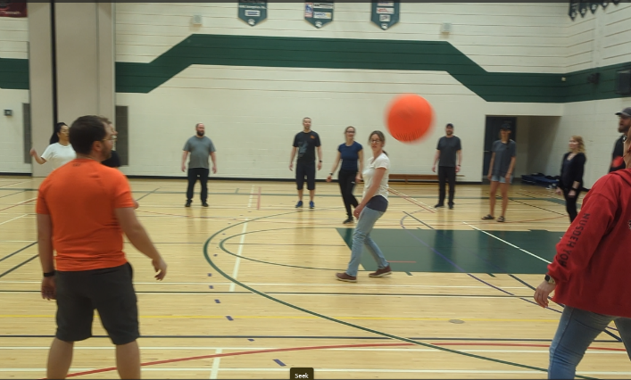
In 1977, I completed my final teaching practicum as a teacher candidate. I did that in Prince George, British Columbia. A few weeks ago, I taught in that same gymnasium, but this time to practicing teachers. Oddly, the school had not changed much during those 46 years. It felt as if I could just go back to the beginning of my 35 year full-time teaching career. It felt like these two experiences book-ended my teaching—though I continue leading workshops for teachers across Canada.

I also thought about how I began my childhood, living beside a playground and enjoying active, playful games. As a retired person I still enjoy creating, engaging in, and teaching active, playful games that enhance the physical, mental, and emotional health of participants—though I’m not sure when I will bookend my interest and involvement with play. If you want to see a website I created on active, playful games, go to: www.canadago4sport.com
Nearly three years ago, I began a cancer journey. At this point in the journey the cancer has diminished to a point where I seem to have several peanut-sized cancerous masses in my lungs. There is more going on, however. My fitness level is not yet where I would like it to be, my body itches from a super-charged immune system, and I’m on medication for a non-functioning thyroid gland. Still, I’m delighted with the excellent care I have had that has significantly decreased cancer’s presence in my body. I sometimes wonder how this story will bookend, but then I realize that thinking of what might happen is unhelpful. It’s better for me to focus on what I can do today to enjoy this world and to make it a better place given the opportunities and health I presently have.

Why the Pain of Cancer?—148 Weeks Post Diagnosis
This past Sunday, I led a worship service on pain. Below is the portion of the sermon about the pain of cancer.
When we are hurting, lying injured and alone on the road of life, I think it’s helpful to think of who God is. Luke, a physician who understood pain and who was a disciple of Jesus 2000 years ago, wrote that Jesus spoke about persistently connecting our needs for new life and protection from toxins to a loving Creator God. Jesus said: “Which of you fathers, if your son asks for a fish, will give him a snake instead? Or if he asks for an egg, will give him a scorpion? If you then, though you are evil, know how to give good gifts to your children, how much more will your Father in heaven give the Holy Spirit to those who ask him?” (Luke 11:11-13).
When I thought about forgiveness following my cycling collision, I wondered how I would feel if I experienced the pain of cancer. Three years ago, I began a cancer journey. I’ve been thinking about my cancer pains during these past three years, as I expect others in this congregation have been while processing their own cancer journeys. Was cancer God’s will in my life? No one person gave me cancer. For me, the person who gave me the most wisdom on this was a nurse in the emergency room in the Juravinski Hospital. He said, “Cancer is a random evil.”
Several months short of three years ago, I collapsed on asphalt. My lungs had filled with blood clots and I could not breathe. I agreed with the emergency room nurse and tried to unpack his thoughts a bit further. The first thing the ER doctor asked me when I regained consciousness was, “What do we do if your heart stops?” I said: “I’m choosing life, but if I’ve been dead for a while, just leave me be.” The second question was, “Did you work around chemicals?” Forty-five years ago, I worked in a paint factory, but I don’t think that caused my cancer. It made me think that the many chemicals that we breathe in our polluted air, in our homes, and in our workplaces, may have initiated this cancer. Who knows? I think there’s something random about who gets cancer, but I also think there is some communal responsibility for what we put in the air, in our foods, in our furniture, in our paints, and so on.
Paul, a Biblical writer from 2000 years ago, wrote: “We know that the whole creation has been groaning as in the pains of childbirth right up to the present time” (Romans 8:22). I need to ask myself, what is my part in a global community that pains the earth, and, by implication, other people? There is a study group that formed recently in a worshipping community I’m part of to try to develop healing responses to a groaning creation.
To sum up, I think pain is often a result not of one person harming us, but of communal actions and random evil, a kind of common curse.
To come back to the Good Samaritan story, I was not left lying on the street with people passing me by when I collapsed. In the years following my cancer diagnosis, paramedics carefully took me to hospitals where incredible care was again extended to me. My left kidney was surgically removed, a sacrifice of an organ so that I could live. As I recovered, family, friends, colleagues, and many others were neighbours to me. I’m blessed by so many Good Samaritans.

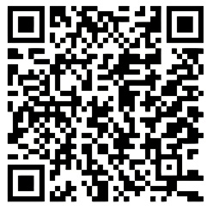

The Good Samaritan story can be viewed at:

https://docs.google.com/presentation/d/1Jwf2HpkK5zXcXjyWyosIqA5ZYDY7rlGKW5uQM5QmNrE/edit?usp=sharing

Tears—Thirty-five Months Post Diagnosis
This past Thursday, we left to go to the Grade 8 graduation of Anna in Sarnia but travelled to Oshawa on the way. First, in order to watch three of you compete in a multi-event track meet with 300 other young competitors.
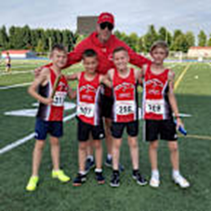
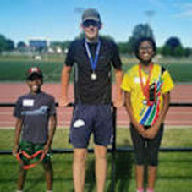
The track grandkids did very well; two of you came in first overall for your age group, and Daniel finished second (and smashed the shot-put record for his age group). There were some tears and smiles as I watched you strain to reach the best you could and smiles as I watched you begin to make new friends with your competitors. I experienced similar feelings as I saw a picture of Caleb in B.C. with his arms around his 4x100 Relay Team and read that his time was the seventh quickest in their club’s history. Well done, all!
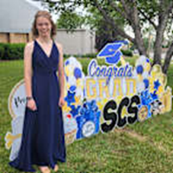
At noon, as we travelled to Sarnia at about 110 kmph in the express lane on Highway 401 in Toronto, the traffic in our lane came to a sudden stop. It turns out there was a large tread of a truck tire in our lane. We were able to stop quickly, but as soon as we came to a stop, a pick-up truck smacked into our back end and pushed us forward another five metres. Our vehicle is a little B200 Mercedes. Our neighbour, who used to sell Mercedes vehicles, said: “You and the other driver are fortunate that this car is manufactured to withstand this kind of collision.” Long story short, though I still find the collision emotionally challenging, nobody was seriously injured, the vehicles were drivable, and the collision did not cause a chain reaction, being limited to just the two vehicles. The person driving the truck that struck us has thankfully been most cooperative in resolving this situation. I shed some grateful tears as this accident could have been so much worse.
It was a delight to watch Anna graduate with an amazing class of students, and also to watch her receive the Academic Award for “excellent grades” and “deep thinking.” A congratulatory hug with tears in my eyes was all I could convey to her.
We returned home in time to watch a funeral of one of my sibling’s close friends. He was four years younger than I, and his cancer journey had lasted only six short months. There were tears as we watched family and friends celebrate this man’s life. I questioned myself, wondering why I was still living after having an aggressive rhabdoid variant of renal cell carcinoma metastasizing in three organs as well as on my adrenal gland and spine during the past three years. I’m thankful, humbled, and tearful.
This past weekend we watched a livestream of a wedding in which tears flowed for the bride, who had lost a sister to cancer some years ago, and for the groom, who had more recently lost his first wife to cancer. The bridal pair were surrounded by their three children and were encouraged to journey with God into more joyful days ahead. Kleenexes were a staple at this wedding service.
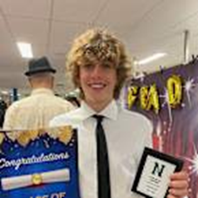
Last night we watched Eli graduate from Grade 8. He was taught by incredible teachers and travelled through years of elementary school with wonderful classmates. He was one of four in his grade to be awarded the Athletic Award. His teacher and coach spoke to me later and said, “I appreciated his athletic skill but valued more his great character.” More tears of gladness.
Five days with a lot of tears, tears of deep grief and tears of exuberant gladness. I think each day in this world, in most of our lives, we live with many of these conflicting tears. I wonder which tears will flow today.
I believe our tears are shared by Creator God who shared joy by turning water into wine at a wedding feast: I imagine the master of the banquet excitedly saying to the groom, with tears in his eyes, “You have saved the best till now.” Jesus cried tears of sadness at the death of a friend. Last week, I re-read Lewis Smedes’ Spiritual Memoir: My God and I. His wife Doris and he had lost a child on the first day of the child’s short life. Smedes wrote: “Doris and I cried a lot, and we knew in our tears that God was with us, paying attention to us, shedding ten thousand tears for every one of ours” (1981). I’m thankful to believe in and imagine a Creator God who sheds ten thousand tears for every one of ours.

Pain, Suffering, and Love?—153 Weeks Post Diagnosis
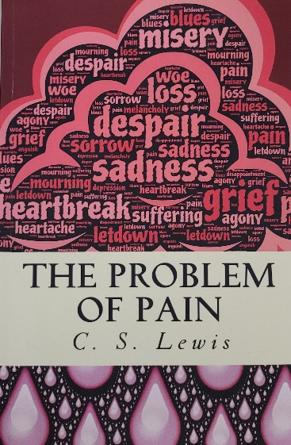
I delivered a message in a church recently on pain. Someone suggested I read C.S. Lewis’ book The Problem of Pain (1940). I read it but found it challenging, and I needed several readings before I think I understood his main points. About the same time, I read a piece by Richard Rohr on “Divine Solidarity with Suffering.”
Does God Love?
Lewis begins with the assumption that God is love, a biblical concept borrowed from much of the Biblical text, and certainly underscored by John, an disciple of Jesus, who wrote: “Whoever does not love does not know God, because God is love” (John 4:8 & 4:16). Lewis wrote, “God has paid us the intolerable compliment of loving us, in the deepest, most tragic, most inexorable sense.”
Did God Give Humans Free Will?
Lewis states that one of the keys to understanding pain is that God gives humans the ability to choose. “The freedom to choose… implies the existence of things to choose between.” Following in the love of Jesus is a choice. Rohr argues that “his life is an option, a choice, a call, a vocation for us, and we are totally free to say yes or no or maybe.”
Why do we Make Bad Choices?
Lewis makes the sobering point that human history “is largely a record of crime, war, disease, and terror, with just sufficient happiness interposed to give [humans], while it lasts, an agonized apprehension of losing it, and, when it is lost, the poignant misery of remembering. Every now and then [humans] improve their condition a little and what we call a civilization appears.” Lewis adds further, “We have used our free will to become very bad.”
Couldn’t God Prevent Us from Making Bad Choices?
Lewis answers this question by writing, “The permanent nature of wood which enables us to use it as a beam also enables us to use it for hitting our neighbour on the head. The permanent nature of matter in general means that when human beings fight, the victory ordinarily goes to those who have superior weapons, skill, and numbers, even if their cause is unjust.” Could God not have stepped in? Lewis asks, if we “conceive of a world in which God corrected the results of this abuse of free-will by his creatures at every moment: So that a wooden beam became soft as grass when it was used as a weapon, and the air refused to obey me if I attempted to setup in the sound waves that carry lies or insults. But such a world would be one in which wrong actions were impossible, and in which, therefore, freedom of the will would be void… Evil thoughts would be impossible, for the cerebral matter which we use in thinking would refuse its task when we attempted to frame them.”
I began to think of God making Russian and Ukrainian missiles simply fly in the air and produce an amazing fireworks display, while the bullets from their guns become refreshing sprays of water, but such a thought denies humanity the free will to make choices. Lewis adds, “Try to exclude the possibility of suffering which the order of nature and the existence of free wills involve, and you find that you have excluded life itself.”
I argued in the message I gave on pain that one reason we have pain is that we cause pain to each other. I used the example of a man who chose to drink too much alcohol and chose to drive. The result was that I was knocked off my bicycle and severely injured. I also argued that I think cancer comes from a groaning creation in which we have corporately done ill to the world and pained each other. Recently I heard Japanese artist Makoto Fujimara refer to this pain as being inflicted by a common curse.
What Is Pain and Suffering?
I found Rohr’s description helpful. He writes, “Pain is physical discomfort, but suffering comes from our resistance, denial, and sense of injustice or wrongness about that pain… Pain is the rent we pay of being human, it seems, but suffering is usually optional. The cross was Jesus’ voluntary acceptance of undeserved suffering as an act of total solidarity with the pain of the world.” An ancient prophet prophesized about Jesus with these words: “He was despised and rejected by mankind, a man of suffering, and familiar with pain” (Isaiah 53:3). Rohr adds: “God is always on the side of suffering wherever it is found, including the wounded and dying troops on both sides in every kind of war, and both the victims and the predators of this world” (2011).
Does God Use Our Pain?
Lewis notes, “Pain insists upon being attended to. God whispers to us in our pleasure, speaks in our conscience, but shouts in our pains.” Lewis states further that in pain, we may “begin to try to surrender self-will.”
This morning, I spoke with a friend whose close relative had died at too young an age. The spouse of the one who died ended up renewing a relationship with my friend. There is nothing good about a young life lost too soon, but a renewed relationship is a positive outcome. My cancer journey has been a painful challenge in my life; however, because of my cancer journey, I think I have lived more ably along with others as they travel on a cancer road. I also began to think about my life and began to write on CaringBridge, where I hope the thoughts I’ve shared have been helpful to others. Pain sometimes helps us become more, as Lewis writes, “God inourselves.”
What Is Our Free-Will Response?
I know I have experienced pain in my life, especially in the early days of my cancer diagnosis. I have experienced many of you being God’s hands, feet, and voice as you suffered with me. When you did that, as Rohr noted, you did not choose “a mere belonging system, [but] a transformational system that will change the world.” To have pain is to be human. May my pain help me to surrender more to Creator God, to suffer more with the hurting, and to love more as I’m able.

Meeting with an Oncologist Several Days After my Three-Year Cancer Diagnosis
Today I met with a medical oncologist who has extended to me life-saving care during the last two-and-a-half years. I knew, from viewing last week’s scan results, that the cancer attacking me has significantly diminished. The smiling oncologist meeting us today was also very pleased with how effective the treatments were. He compared the treatments to a campfire. It takes some work to get a fire going, which equates to the immunotherapy treatments, but then the embers give warmth for a long time, which equates to the sustaining power of these treatments. We are all very pleased by how well the treatments have controlled and diminished the cancer attacking me.
I ask myself, Why am I still alive? I’m not sure. I do believe the exceptional medical team deserves much praise. I also feel carried by the loving care and prayer of many.
I feel gifted with life to love Grandma, my family members, friends, others, and the earth I live on. I was recently reminded of Garth Brooks’ 1992 song “We Shall Be Free.” This song was an important reminder to me of what I can do with the gift of today while I’m gifted with breath: “To act justly and to love mercy and to walk humbly with [Creator] God” (Micah 6.8). As a friend encouraged his children before they left for school in the mornings, “Be good. Be kind. Be awesome. Be yourself.”
We celebrated this third-year anniversary during the past few days with some good friends and good food. We’ll enjoy a round of golf tomorrow and camping with the whole family (24 of us) next week. We are grateful!


To listen to Garth Brooks sing “We Shall Be Free,” go to:

https://youtu.be/wyPNe-7guyw

Why Worry?—173 Weeks Post Diagnosis
As I get closer to learning the results of a CT scan, my anxiety level increases, though I think it increases less than it used to as the cancer attacking me seems to be diminishing.
I know that excessive worrying can take a toll on my health. I read that, “Mentally, worry can lead to anxiety and depression, and physically, it can elevate our stress levels and weaken our immune systems. Above all, worrying too much can prevent us from living a happy and healthy life. When we think about everything that can go wrong in the future, we’re missing out on what’s right in front of us” (Vogel, 2022). Corrie Ten Boom knew about worry; she, along with other family members, helped many Jewish people escape from the Nazis during the Holocaust by hiding them in her home. She once said: “Worry does not empty tomorrow of its sorrow; it empties today of its strength” (1974). I take these suggestions as good advice.
How do I minimize my worry and unpack the gift of today as well as I can? I read that there are at least four ways to do so.
- Exercise: For the past few months, I faithfully walked 5 km a day. My body loves the movement, I enjoy seeing and hearing the environment around me, and I’m enriched by extending greetings to fellow walkers along the way.
- Meditate: I recently updated my phone plan, so I can play music as I do my one-hour walk. This has been an encouraging meditative time. I most often listen to songs I have chosen and have saved on my playlist at: https://www.youtube.com/playlist?list=PL0L46Lhc9pDVhrc8qHfhqw8ZDKc074cjD
- Journaling: Writing occasional CaringBridge posts and writing this book helped me express my anxieties. I have found that helpful.
- Build a support network. I feel fortunate to have had such a broad and deep network before I even began my cancer journey. Grandma and I are so grateful that you all have carried us during this time. Thank you for helping us choose love and life!
I also began to think that I need to put my life in perspective. Cancer is an insidious illness. For me, the treatments so far seemed to have worked well, but I think of my fellow humans being bombed, being held captive by an adversary, living a bleak future, or being catastrophically affected by natural disasters. I ask myself, why worry when so many people are dealing with more imminent, random, and catastrophic dangers?
This past week I had a dental appointment. The dentist suggested I get a new crown. I suggested we wait to see what my upcoming CT scan showed. The basic question I ask myself is, “Will I live long enough to warrant a new crown?” The CT scan will shed light on that decision.
Today I received the results of blood work and the CT scan. The blood work showed that all was normal. Unfortunately, the CT scan showed “New 0.9 x 0.8 cm pulmonary nodule in posterior segment right upper lobe (19:61]. Other pre-existing pulmonary nodules in bilateral upper, lower lobes and lingula remain stable [19:47, 68, 82, 84, 86, 107, 111, 160] largest in right lower lobe 0.5 cm.” The decision about my crown will need to wait till I can discuss these results with my oncologist next Thursday. I recall he once said, “If the cancer comes back, the medical community has a tool kit ready to get to work.” I’m guessing he might need to pull out his tool kit again.
It is just a new little mint-sized-tumour in my lung, but it makes me a little worried. I know from my past that there is a rejuvenating joy beyond sorrow. Let me be strong for today and look forward to an upcoming joy-filled weekend Christmas celebration with our family. We will wait to determine when I get the crown.
Recently I learned I also have access to all the actual scans, MRIs, and X-Rays I have had. I went through the November scan and found the mass that was to be biopsied. I will attach photos of this small (2 cm) mass from an overall view, to a more zeroed in view.
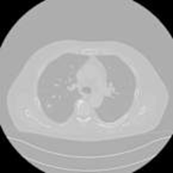
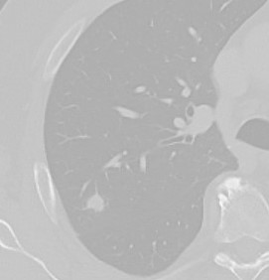
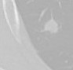

Getting a Crown—174 Weeks Post Diagnosis
I had an appointment with my oncologist this afternoon. He viewed the cancerous growth on my lung as small (about the size of a small Dutch peppermint) but sufficiently concerning, so that he ordered a biopsy and probably referring me to radiation and possibly surgery.
He was delighted that I completed a 5 km run a month ago and that I have continued to stay active.
He provided several options for moving forward, but we chose the above route as I generally feel compliant with the medical suggestions and prefer to plan a course of action rather than simply to wait and watch what the cancer does.
After the oncologist’s meeting, I met with the thrombosis team who regularly monitor my blood thinners. I feel grateful for the expeditious, attentive, thoughtful, and data-driven care given to me. I feel sobered and hopeful by our meetings.
Last Thursday, my main emotion was worry. Then the activities of the weekend included our wonderful family gathering for an early Christmas celebration, early as two of our sons-in-laws are pastors, the actual Christmas days are busy for them. I began to feel at ease with whatever the oncologist suggested.
On one of my recent morning walks I listened to a TED Talk on the healing influence of gratitude. Whether gratitude lengthens my days or not, the talk was a good reminder of the importance of being grateful. I was reminded to make sure to thank the oncologist and any other hospital people I saw today; they have all done wonderful work!
When I came home, several boxes of balls stood on our front steps. They encouragingly reminded me to look forward to the active workshops I have planned for the new year, helping teachers help students to also choose life. Then we enjoyed an engaging dinner with one of our grandsons who also helped me with this post. 😊
At last week’s dental appointment, we were still holding off on a crown for my teeth. I did have cavities filled but delayed one filling that was more preventative. I’m still choosing life, but possibly having fewer years to live can impact how preventative I need to be. After today’s medical appointments, I will book an appointment to crown one tooth.

During another morning walk, I listened to some music. One song that came up on my playlist was “Turn Me Tender.” As I thought about this song, and having listened to the Ted Talk on gratitude, I was reminded to be both tender and grateful—which was hard when I felt angry at the cancer (does it even make sense to be angry at cells?).

If you wish to listen to the song, you can do so at:
https://youtu.be/PIBx52eIyNg?si=09K74Yj4s-yfNLQ2

Still Affirming and Choosing Life—176 Weeks Post Diagnosis
Grandma and I are planning a one-week holiday, to the delight of the medical oncologist. Grandma and I enjoy living along with our children and their families, and despite living a good distance apart, attended recent sport and Christmas programs, as well as a college graduation. Today I was at the dentist getting a new crown.
After the dental appointment I had a consultation with a radiation oncologist, who, 30 months ago, successfully radiated and killed the cancer that had taken over my T12 vertebra. He was impressed that, even with no treatments for 18 months, my cancer had not come back until now. He was also pleased with how physically active I have been able to be. A biopsy is scheduled for January 4. Based on what they find, they will determine if the peppermint-sized mass in my right lung is cancer and what kind of cancer it is. Assuming it is cancer, we will next meet with the oncologist on February 20 and begin five bouts of stereotactic radiation treatment in early March. He was happy to hear that I’m helping teachers help children live healthy lives, but he reinforced that my health needs to be our main priority now.
Last week, I booked flights to attend five conferences in the new year, conferences where I will lead active workshops encouraging teachers to help their students choose, engage in, and celebrate life. Our planned holiday, the grandchildren’s engagements with life, a crown, the booked flights, and the consultation with the radiation oncologist gave me much hope for a longer future.
Last week I read about the middle-aged wife of a former colleague being moved to palliative care and breathing her last breath at home; we will attend her funeral following my oncologist appointment today. This morning, I visited with a fellow parishioner whose treatments are very challenging. For those at the end of a life-and-death battle, with fewer significant victories, may I know how to be present in their lives in a way that is helpful, as so many of you have been helpful for me.
I know that there will also come a time for me when hope for a longer future is not in the cards. When that time comes, may I have the courage to be at peace and have the hope that my colleague wrote about: “That my only hope in death is no different than my only hope in life—that I’m wholly yours, O Creator God.”
Recently I read an instructive post by Nouwen:
I’m increasingly impressed by the Christian possibility of celebrating not only moments of joy but also moments of pain, thus affirming God’s real presence in the thick of our lives. A true Christian always affirms life, because God is the God of life, a life stronger than death and destruction. In him we find no reason to despair. There is always reason to hope, even when our eyes are filled with tears (1997).
As my battle with cancer resumes, I continue to affirm life and choose life for myself and the world around me. I will try to do well at the few things I feel called to do. I look forward to a time when we all love each other enough so that there is no more damaging of people’s health or exploding of destructive bombs but flourishing times of joyful dance and of irrepressible life, a time when, out of the rubble, gladness and joy proclaim a healthy world.
Biopsy Results—Forty-two Months Post Diagnosis
I went to the hospital today for my biopsy. A doctor explained the biopsy procedure and possible side effects. I then lay on the scanning table. An intravenous line was connected to my arm. They had me all set to go, medical utensils were in place, and they ran me through the CT scanner one more time to confirm the mass. They come back a minute later and said, “The mass has shrunk to an insignificant size. No need to do the procedure.” We could not have asked for a better outcome. On the way home we needed to stop at a Dutch shop to buy some pastries and go to a friend’s home to celebrate. I’m still bewildered by what just happened.
Recently I read Dr. Paul Brand and Philip Yancey’s book, Fearfully and Wonderfully Made (1980). The authors reminded me that every cell of our body forms “and sustains the larger being.... If every cell accepts the needs of the whole body as their purpose, then the body will live in health.” However, “Some cells do enjoy the body’s benefits selfishly while maintaining complete independence—we call them parasites or cancer cells.” I know these survival parasites full-well. I stand amazed again how my body, through medication, friendship, positive energy, and prayers, has shrunk this mass.
A fully healthy person is a miracle. The complexity of the human body came home to me especially in the chapter on the human brain. Here are a few quotations.
- “A mere gram [the approximate weight of one unshelled peanut] of brain tissue may contain as many as four hundred billion synaptic junctions.”

- “My brain vibrates with activity, processing five trillion operations every second.”

- “Every other cell in the body expires and gets replaced but not the neurons... These maintain the continuity of selfhood.”

IR MINOR CONSULT—1 February
CLINICAL HISTORY:
Patient was referred for CT-guided biopsy of a right upper lobe nodule throughout metastasis.

COMPARISON:
Previous CT scan dated November 30.

PROCEDURE:
Consent was acquired from the patient.
Patient was positioned supine on the CT scanner and preliminary scan was acquired.
This demonstrated that the previously noted right upper lobe nodule has significantly reduced in size and density, previously measuring 9 x 7 mm and currently measuring 6 x 4 mm, which makes metastasis very unlikely.
The decision was not to proceed with the biopsy.
These findings were conveyed to the patient.
No intervention was done.
Why Do I Find it Important to Share my Pain and Feel the Pain of Others?—185 Weeks Post Diagnosis
Earlier I referred to Dr. Paul Brand and Philip Yancey’s book Fearfully and Wonderfully Made (1980). The authors take us through the discovery of primitive medical procedures in India, with a focus on leprosy. They also weave throughout the book parallels between the human body and the image of Creator God, the Christian life, the interaction of the Christian church in the world, and our relationship with the poor and needy. Though I found some of the details and comparisons less interesting, there were other parts that I found fascinating. Comparing our body to the body of humanity helped me answer the question of why share pain?
The challenge with leprosy is that people with leprosy do not feel pain. The authors related one story of a man with leprosy. They helped him identify causes of pain in his day-to-day life. This man returned to his village hut. He was doing well and went to sleep for the night. When he woke, he discovered that a rat had gnawed away the flesh on his hand. He did not wake from his sleep during the night because he could feel no pain. Had this man felt pain, he would still have his hand. Pain may not be a gift, but pain sensation is a gift. By analogy, if a person’s pain is not recognized, others cannot help with healing the pain.
A concern that runs through the book is how inadequately we care for the poor—the pained. For example, quoting from the Bible, “God gave this succinct summary of the life of King Josiah: ‘he defended the cause of the poor and needy, and so all went well,’ and then this poignant postscript: ‘is this not what it means to know me?’”(Jeremiah 22:16). They go on to say that although church potlucks serve a useful communal purpose, they may also give an illusion of church vibrancy; “the message of the Old Testament prophets, Jesus, and the Apostles. ‘Share your bread with the hungry and bring the homeless into your house’” (Isaiah 58:7). In other words, we need to pay attention to and remediate, as we are able, the pains of others. It’s what a healthy body does. A healthy body or community is sensitized to and carries the pains of the body or community.
I also recently read and felt a kinship with Yancey’s memoir, Where the Light Fell (2021). He compares churches to “family, as a dysfunctional cluster of needy people. Life is difficult, and we seek ways to cope.” Churches are not much different from other communities I’m a part of. In communities many are well, some have minor aches and bruises, and others suffer from a lot of pain. May we be able to share our lives with trusted friends and professional healers. Yancey was often discouraged by his church community. He wrote: “I wonder, what brings these people back week after week to hear about wickedness and failure?”
Yancey wished churches would lead more with what Augustine, an early Church Father, wrote: “The world is a smiling place, and God its lavisher of gifts.” He writes about connecting to creation which “awakens my desire to meet whoever is responsible for the monarch butterfly.” He wanted the church to show more love. Quoting Augustine, he wrote: “Show me a man in love; I’ll show you a man on the way to God.” He thought love might encourage us to be “asking God to somehow… give me the love of the Good Samaritan, who loved irrationally, with no reason.” How would our world be different if each cell, each person, did this? How great if our communities spent more effort celebrating acts of love. I think it’s so good when folks in hospitals facilitate healing and communities are hospitable to the hurting, spending less time pointing out what is wrong and more time embracing the hurting.
As I thought about the analogy of our human bodies with the body of humanity, I wished I was more present for the “well-being of the whole body”—the well-being of humanity and the earth we share. I might wonder why God does not heal so many of the world’s pains. As I meditated on 1 John 2, I saw that the writer focusses on “God is good,” then five times reminds me to be good like God, and to “follow in the steps” of Jesus. Particularly when it comes to human pain, Christ encourages us to choose a positive life of healing hurts: “For I was hungry and you gave me something to eat, I was thirsty and you gave me something to drink, I was a stranger and you invited me in, I needed clothes and you clothed me, I was sick and you looked after me, I was in prison and you came to visit me” (Matthew 25:35 36).
As I share my cancer journey, I’m very grateful for the many people who have followed in the steps of Jesus and lived out the words of Theresa of Avila, quoted in the author’s ending to their book:
Christ has no body but yours
No hands, no feet on earth but yours,
Yours are the eyes with which He looks
Compassion on this world,
Yours are the feet with which He walks to do good,
Yours are the hands, with which He blesses all the world.
Yours are the hands, yours are the feet,
Yours are the eyes, you are His body.
Christ has no body now but yours,
No hands, no feet on earth but yours,
Yours are the eyes with which he looks
compassion on this world.
Christ has no body now on earth but yours.

In My House There Are Many Rooms—203 Weeks Post Diagnosis
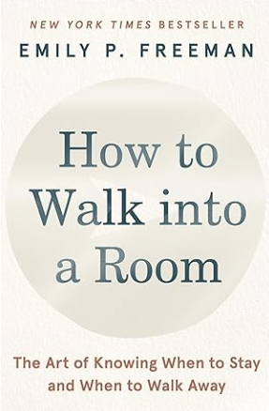
In her recent book, Walking into a Room: The Art of Knowing When to Stay and When to Walk Away (2021), Emily Freeman introduced me to the metaphor that our lives are lived in houses with many rooms. Some rooms, like new relationships, our helping place in this world, and accepting a job, are rooms we entered because they were available and we wished to walk into them. Other rooms, like a relationship break up, getting fired from a job, or getting cancer, are rooms we entered not by our own choice. Sometimes we go into hallways to deliberate which rooms we wish to enter, which we wish not to enter, and which we wish to exit. I found this book helpful as I consider how cancer’s attack on me has closed some rooms and opened others. Here is some of what Freeman wrote that I found important.
Life
Some of the “rooms” I most love in my life are:
- Walking on a beach with Grandma
- Enjoying our children and each of you
- Being on a golf course with good friends
- Leading teachers in action-packed, seamlessly flowing, active workshops
- Being the hands and feet for someone in need, and
- Receiving excellent care in hospital rooms
Freeman states, “We do well to be aware of how we are formed informs how we walk into a room. How we walk into rooms is informed by what was happening in the last room we left.” She quotes from a poem by Lynn Unger:
The path only unfolds behind us,
Our steps themselves laying down the road.
You can look back and see the sign posts—
The ones you followed and ones you missed—
But there are not markers for what lies ahead.

Freeman writes, “I’ve learned that the best indicator of future decisions are the decisions we’ve already made. That means that in order to move forward we have to look back. When it comes to our lives, we’re always only standing at the start.” She quotes from Parker Palmer: “Before I can tell my life what I intend to do with it, I must listen to my life telling me who I am.” I’m still me, and gratefully I can name and do the things I most love.

Hallway
The main thread of her book suggests how best to transition to entering a new room, or exiting an existing room, or negotiating an ellipsis in our lives. Recently, one room I’m in includes people who have made some decisions I find difficult to live with. Currently, I’m discerning a transition out of that room. To help me decide, and using Freeman’s metaphor, I enter a hallway.
Freeman states:
The hallway may be the space between two rooms, the place where you enter after you’ve already decided to leave. But it could also be a pause, a space where you’ve entered just for a time, to clear your head to take a beat, to weigh your options, to remember who you are. When your time in the hallway is past, you may re-enter the room you just left and discover it’s exactly right for you. Or at least right for now. Or the time in the hallway may be just what you need to get perspective and clarity on an inevitable ending.
In addition, she writes,
Imperfect closure is better than no closure at all.... Closure isn’t about everything working out; it’s about acknowledging the ending…. The lack of available closure can be the thing that keeps you stuck forever. Terrible endings are mostly just terrible. That terrible ending doesn’t get to have the whole say. God shifts our eyes from a plan we hope for to a person we can hope in. Don’t let the ending steal the narrative.
Freeman also states, “One useful practice to cultivate closure is to also take time to name the things you’re bringing with you. How can you walk out the door when doing so means you’ll also be leaving behind something that at one time seemed vital to your identity, maybe even your survival…. One thing no one can take from us is the person we have become and are becoming.”
It struck me that even though my lungs are compromised and I’m anxious sometimes about the cancer inside me, I can still meaningfully engage with life, and move on hoping in the divine.
How do we know it is time to move on?
Freeman suggests, “What we mostly hope is for readiness and timeliness to align. I’m ready but it isn’t time. How can I know if it’s time? The short answer is, you might not know for sure. But you can know for now. For now, is an arrow, pointing at the place where I now stand, keeping me in this present moment. My kids are struggling for now.” Or, I have cancer for now.
Finally, “For now can be a prayer, an acceptance of what is and a trust that we are not alone. Bringing all our finals to God can serve as both a confession and a relief: I don’t have any answers; I can’t control outcomes; I need a source outside of myself to accompany me in this interim place…. If the process of discernment has taught me anything, it’s that there is almost always no once and for all. There’s only for now.” Freeman says, “When you’re ready but it isn’t time, add for now. When it’s time but you’re not ready, add let go.” I had no choice when cancer struck me down, but I know it’s important to let go of what was, to appreciate what is, and to live courageously with what is to come.

Transition
Freeman quotes from Barbara Brown Taylor’s insightful book Learning to Walk in the Dark. She’s reminded that “new life starts in the dark. Whether it’s a seed in the ground, a baby in the womb, or Jesus in the tomb, it starts in the dark…When a plant grows, it goes through necessary change, but it never goes back to a seed. It becomes something new. Maybe there’s no normal to get back to... there’s only you, doing the next right thing you know to do, and releasing yourself from the hallway…. Honor what you have lost with space, compassion, and time.”
Freeman found these words running through her mind during one of her discerning times in a hallway: “Jesus—who knows what it is to wonder, watch, and wrestle in desert places—waits to meet us here and welcome us in, offering rest and renewal, solace and strength, for the journey still to come.” In the darkness of a cancer diagnosis, I can still find new life and opportunities to be me.
Arrows
Freeman invites the readers to “point and call. We call our subconscious to our consciousness and point to where we wish to go.” Freeman compares this to ”boarding a train based on our past and on the arrows pointing in the direction we wish to go.” She uses the metaphor of arrows developed from careful deliberation and considerations of our past and who we are, pointing us to where we wish to go, for now.
Freeman lists several sets of questions to ask when wondering about the room you are in. Cancer is not a room of my choosing, but the questions that were most helpful for me to consider were:
- What is good and beautiful in this room?
- What has the power in this room?
- If God is in this room, what is the action of the Divine?
- With whom can I safely entrust my feelings?
- Who is with me? The people who have loved you, the ancestors you have never met, the God who sees you. We never have to walk into rooms alone.
- What more do I need right now?
- What is the best thing that could happen here? Making a practice to also consider the best things that can happen in every room we enter allows us to move beneath the banner of a hopeful vision rather than the burden of potential catastrophe.
What do I have to offer? The person I am.
Freeman says, “The final movement in our discernment practice is to yield to the arrows. When we’re carrying questions about important rooms, it’s easy to get lost in our heads as we try to work out what to do. That’s why yielding to the arrows, rather than an obsessing over answers, can be a life-giving practice in times of uncertainty.”
When you walk into a room you have to know who you are, have rhythms in place to practice being who you are, and you need to learn to make peace with crises. This means developing patience to follow arrows when what you really want is an answer. Open to God, my heart receptive to Spirit, I’ll admit my mouth is shut more often than it used to be when it comes to my faith, a waiting listener in the presence of the Divine.
As I fight cancer, my hands are open to the Divine as I more thoughtfully discern old and new arrows pointing me towards my journey ahead.
Conclusion
What have I most learned from reading Freeman’s book? Even when I’m in a room not of my choice, like my cancer room, I can still make positive choices. These choices are largely based on the paths I have traveled and on knowing who I have become. I also found it helpful to be reminded that as I walk into a room, it’s important to be kind, to grow, and to be me. Perhaps the most liberating words were that I do not have to plan for the rest of my life, but instead, be engaged where I’m today, and following the direction where my life is pointing. That is good enough, “for now.”

Life Expectancy?—Four Years Post Diagnosis
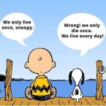
Though I was counting down to four years, a colleague who is also on a cancer journey reminded me, “It’s better to count up than down.” In other words, rather than counting down to certain dates or events, like a four-year anniversary of life, it’s better for me to consider each day as another time for me to add goodness to previous days. Or, as Freeman wrote, in How to Walk into a Room, “Now is the start of the rest of your life” (Freeman 2021). I think the Snoopy cartoon I attached gets at this idea in a lighthearted manner.
Nouwen puts my timeline into perspective: “Our clock-time is embedded in the timeless embrace of God” (1994).
I try to see today as an opportunity to add goodness to the nurturing and challenges of my yesterdays. I think of a young man learning to cope with autism and depression and a young woman fighting a cancerous attack much more challenging than mine.
At this moment in time, I stand at the beginning of the rest of my life. At this moment in time, I get to unpack today. I need to own my past, including the limitations caused by cancer. With the help of family, friends, and professionals, I live life trying to walk a good road in the timeless and loving embrace of Creator God.



To view a brief video celebrating life go to:

https://youtu.be/lRBFJ4BhIIk

Why Me?—218 Weeks Post Diagnosis
When we are struck by significant negative life-changing or life-ending circumstances, we might ask: “Why me?”
There are some easy answers to some “why me” questions. If we make some negative choices, negative consequences could be the result. For example, if we smoke cigarettes for a long time, we may get lung cancer; or if we eat too much and remain too inactive, we may get diabetes. There may also be a communal explanation for some illnesses. I think of malignant mesothelioma, whose major risk factor is asbestos exposure.
I’ve recently attended too many celebrations of life for people who died too young from a too-short battle with cancer. It broke my heart each time. Each time I asked myself, “I’m four years into a cancer journey. Two years of no treatment. No progression of cancer. I’m still actively living. Why me?” I think part of the explanation lies in the effective treatments for people like me who have a similar cancer attacking them. For others, there has still not been an effective treatment developed. That begs the question why treatments have been developed for the cancer attacking me and not for the cancer afflicting others? I don’t know. I do know the medical community continues to expand its knowledge and abilities.
I conclude, after wrestling through this question for the last several months, that it is probably fruitless for me to ask: “Why me?” or “Why not me?” I think it is better to bear fruit by living an answer to the following question: How can I choose wellness for myself and the world around me, as I unwrap the gift of today?
I found it helpful to read a recent post from Rohr about people at the end of life: “That’s why people in love—and often people at the end of life—have such an excess of energy for others. If God cannot be rested in, then it must not be much of a god. If God is not juice and joy, then who has created all these lilacs and lilies” (2011)?
I found a helpful blessing from Archbishop Desmond Tutu—who gave a blessing to and shared communion with Aunt Hannah and Uncle Ryan and their family:
Dear Child of God, you are loved with a love that nothing can shake, a love that loved you long before you were created, a love that will be there long after everything has disappeared. You are precious, with a preciousness that is totally quite immeasurable. And God wants you to be like God. Filled with life and goodness and laughter—and joy. God, who is forever pouring out God’s whole being from all eternity, wants you to flourish. God wants you to be filled with joy and excitement and ever longing to be able to find what is so beautiful in God’s creation: the compassion of so many, the caring, the sharing. And God says, “Please, my child, help me. Help me to spread love and laughter and joy and compassion. And you know what, my child? As you do this—hey, presto—you discover joy. Joy, which you had not sought, comes as the gift, as almost the reward for this non-self-regarding caring for others” (2023).

A Normal Life. A Rich Life. An Unknown life—A Scheduled CT Scan—Fifty-nine Months Post Diagnosis
We are all human. We all need to eat, drink, rest, love, and be loved
We all make plans. Sometimes they come to fruition. Sometimes only in part. And sometimes, we get stuck, derailed by life.
We all have plans made for us. Someone hires us, someone lets us go, someone causes us significant injury.
I have been cleaning up my office and found some letters from a friend. His mother attends the same worshipping community I do. I brought the letters to church with me and gave them to her. The last time the mother, son, and I were together was when he was being kept alive in a hospital so that the medical team could harvest his organs. He died from a fentanyl overdose while incarcerated. (I often wonder if taking the fentanyl was his choice or someone else’s.) All our lives changed at the moment he died.
Many of us encounter crossroads in our journey. This week I had a CT scan. I know worry serves no real purpose. During the days leading up to the scan, however, I wondered and worried: will my life continue the way it has?
I find myself asking:
- Will I need new medical options to face this renewed attack from cancer?
- Will I have to change how I contribute to PE?
- Will my health take a sharp decline, and will I need to get my house in order?
In recent weeks, Grandma and I have often said to each other how fortunate we are to be relatively healthy and deeply rich in relationships. We’ve had the joy of watching each of you shine in school events and other activities, the gift of connecting with friends and loved ones, and the privilege of finding ways to give back.
A negative CT scan won’t change the richness of our lives, but it might change how we live them.
I found encouragement in these words from the Indigenous Translation of the New Testament:
Do not worry about tomorrow’s troubles. It is enough to trust Creator to give you the strength you need to face today (Matthew 6:34).

The Great Spirit cares deeply about you, so gather all your worries into a blanket and throw them on his shoulders. He will carry them for you (1 Peter 5:7).
The oncologist and I agreed it would be wise to involve a gastroenterologist. We are asking for a deep endoscopy to take a better look at this growth. We’ve also decided to move my next CT scan up—three months instead of four. I’m writing a very long piece.
I was anxious for the last week leading up to the CT scan, viewing the scans, then waiting for the results, and then finally reading them. Now, I feel quite relieved.
Grandma asked the oncologist how he thought I was doing. His response? “John is doing amazing.” He reminded us that with the diagnosis that I had five years ago—a very aggressive high-grade cancer variant with rapid differentiation that required the removal of my kidney. Within one year it had metastasized to my spinal cord, lungs, liver, and adrenal gland which meant that my survival rate was four years. He’s delighted, as are Grandma and I, that I’m living past that four-year milestone and living very well.
I’m deeply grateful for my life. We are both profoundly grateful for the medical professionals who have supported us on this journey. The oncologist also expressed his appreciation for the way that Grandma and I have been able to contribute and give back.
This afternoon I have an appointment with the Hamilton Health Sciences Foundation. They’ve asked me to serve as their Patient Ambassador for a major fundraising campaign this fall. I’m honoured, but, more than anything, I’m delighted that I’m still here, to enjoy each of our amazing kids and each of you, to spend time with our good friends, and to continue to be a part of the broader PE community.
I look forward to so much: graduation festivities, a grandson’s wedding, our 50th wedding anniversary, our family reunion, completing more articles, leading engaging workshops, and sharing life with all of you. I was reminded, as I thought about all the above, not to get too far ahead of myself. Today is a gift: I hope I can unwrap it well.
Yesterday, I submitted three small articles to a PE journal and finalized a conference presentation in New Brunswick at the end of August. We celebrated Indwell’s 51st anniversary—an organization we support that provides hope-filled housing for the homeless. Today we took a walk with friends. Tomorrow, we celebrate the wedding of Grandma’s brother. The next day we will attend a bridal shower for our grandson’s fiancé. Life is rich.
Love you all very much!

Seeing the Light—258 Weeks Post Diagnosis
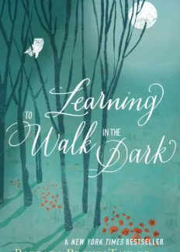
Recently I read Barbara Brown Taylor’s book Learning to Walk in the Dark (2014). She reminds us, that “new life starts in the dark. When a plant grows, it goes through necessary change, but it never goes back to a seed. It becomes something new. Maybe there’s no normal to get back to... there’s only you, doing the next right thing you know to do, and releasing yourself from the hallway…. Honor what you have lost with space, compassion, and time.”
The author recalls her mother calling out in the evening, “‘Come inside now, it’s getting dark.’ That is my mother speaking, saying the same thing she said every night when she looked out the kitchen window and saw that the sun was going down.” In other words, darkness is to be avoided; we need to come into the safety of the light.
The author also recalls times when she sensed monsters and witches as she tried to get to sleep at night. She was simply told: “There are no monsters under your bed. Just go to sleep.” But she wondered, “There is no telling what I might have said if they had asked me what color the monster’s eyes were, or what the witches were planning to do to me. If they had, I might have learned to become more curious about what the darkness inside me was dishing up. I might have learned to look more deeply instead of looking away, but one thing my parents and I shared was the wish for a quick fix.”
Barbara Brown Taylor began to explore being in places of darkness and feeling comfortable there. She understood that “darkness turns out to be as essential to our physical well-being as light. We not only need plenty of darkness to sleep well; I also needed it to be well.” When I ran a lot, I really enjoyed cool early morning summer runs with a headlight illuminating my path in the darkness and occasionally meeting a small herd of deer walking in the conservation area I ran through.
When I finished reading this book, I felt a little confused. I know that darkness is helpful for sleep and the recovery that sleep brings into my life. I agreed with Brown that it is important to not ignore or find quick fixes to darkness. I have grown by working my way through emotionally dark places. However, I do not choose emotionally dark places or wish them on anyone.
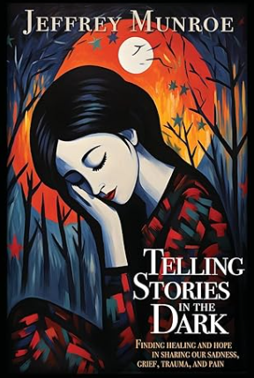
Then I read Jeffrey Munroe’s Telling Stories in the Dark (2024). The book builds on deeply life-shattering stories with instructive reflections on how some people dealt with significant traumas in their lives, for example, the murder of a family member, the death of a family member through medical malpractice, a fight with cancer, and the death of a son through a climbing accident. Each story is supported by the comments of competent individuals who help shine light on ways to survive these dark experiences.

This week I have an appointment with a gastroenterologist to explore the dark recesses of my colon to check a 7-mm suspicious growth. I’m hoping this person can shed light on what this growth is.

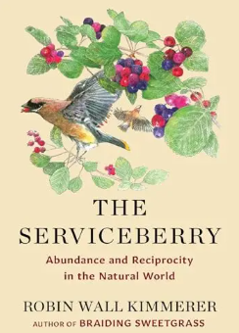
Finally, I read Kimmerer’s The Serviceberry (2024). As I read this book, I found I could not tarnish its pages by writing notes on the margins or highlighting keywords. The book felt holy to me, full of light. Her major theme in the book is the power of a gift economy. I think that is what Jesus offered the world as He came to live among us, and what medical practioners and so many of you committed yourselves to when you’ve been Jesus’ hands, feet, body, beacons of light, to Grandma and me as we travel the traumas of my collision and cancer journey.

We are also very grateful that I survived the cycling collision and am surviving cancer as Grandma and I celebrate 50 years of marriage this Saturday (married July 19, 1975).

Hope—Five Years Post Diagnosis
How does one live with hope in life, or, more specifically for me, live with hope in a cancer journey? I found a recent post by Debra Rienstra very helpful. She described five different types of hope I’ve experienced or that I’ve been directed to. They are:
- Pollyanna Hope: This kind of hope says, “Everything’s gonna be fine! I don’t have to do anything about [this problem]!”
- Active or Heroic Hope: Active Hope says, “It’s gonna be fine, but I’m going to have to fight to make it happen.”
- Stoic Hope: “I’m not sure about the outcome, but I’ll take whatever comes. I’ll ride the wave and be OK.”
- Grounded Hope: Here, “a person is realistically informed about the state of affairs, and thus skeptical of a positive outlook, but chooses to do whatever she or he can to bring about the best possible outcome, because standing by is an unacceptable and unethical option.”
- Radical Hope: In this form of hope, a good outcome is not guaranteed, nor are the means to get there clear (Rienstra, 2025).
As I thought about my cancer journey, I think I mostly relied on Stoic Hope and Radical Hope. Recently I had a colonoscopy, and doctors removed a 1 cm sessile polyp. I have not heard if they sent it to pathology or not, or, if it was sent to pathology, what they determined. A 2-3 cm lump has formed on my abdomen, and I’m scheduled for an ultrasound, but not until August 20. I will not know what the growing 7 mm mass in my abdomen is doing until a CT scan mid-September. How do I live with hope during these unknowns?
Rienstra provided a wonderful illustration of Radical Hope. Imagine a crew of rowers in a racing scull. “They’re working together, pulling hard, but sitting backwards in the shell, moving toward a goal they can imagine but cannot see.”
I feel like one of those crew members. I can see what is behind me. In my wake there is a lot of love and care given to me that has been amazing and effective. I row hard by making phone calls to the hospital, taking daily walks, celebrating life’s successes, enjoying good friendships, promoting purposeful and inclusive active play for children, and helping a needy friend. I do not know the future, but I’m alive, living well, and okay with the mystery of an unknown future.
I grab the oars and row on. Thanks for rowing with me or cheering me on from the shoreline. Live hopefully.

“Don’t Just Make Money, Make a difference.”—270 Weeks Post Diagnosis
I recently saw this phrase, “Don’t just make money, make a difference.” During the last few weeks I had two opportunities to make money and make a difference.
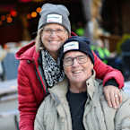
Last week, as the Patient Ambassador, I attended the Illuminight fundraising event for Hamilton Health Sciences Foundation. I used the following script but modified it when I spoke: “Five years ago, I was attacked by cancer cells that were killing me. Fortunately, the caring staff at Juravinski helped me fight this cancer. Today I’m alive due to their tools and skill, and as a success story I accepted their invitation to be this year’s Patient Ambassador. Not all people are as fortunate as I am, as some cancers evade the tools we currently have. Tonight, we celebrate monies raised to combat more cancers so that more people can live longer and healthier lives.” Thanks to many of you, I was able to donate and raise just over $4,000. For me this is a token of thanks for the hospitals which have saved my life. We made money so hospitals can make more of a difference. That night reminded me of the goodness of people. My default is to see the good in others.
When the hospital staff did a CT scan of my abdomen to look at my bowel obstruction, they wrote lots of notes about my intestines and noted, along with another recent scan of my chest, that there were “Unchanged Stable nodules.” No changes are like money to me and permit me to continue to try to enjoy life and make a positive difference in this world.



To view my Illuminight one-minute talk go to:

https://youtu.be/E6BZCZgnMzA?si=SMHTt2QQ8VLYPrs_

Counting Our Days—2000 Days Post Diagnosis
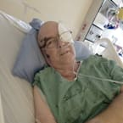
Two thousand days ago, around 6:30 pm, I collapsed due to a pulmonary embolism caused by a cancerous left kidney. That fall began two years of amazing medical care, which continues . My next CT scan will be March 16. My last immunotherapy treatment was 1329 days ago. The cancer remained unchanged till 547 days later when a 2 cm mass showed on my right lung. A biopsy was scheduled for 63 days later and was not done because a CT scan showed the mass had remarkably disappeared. It has been 1084 days since that scan, and I’ve remained stable since.
Recently I read Eugene Peterson’s paraphrase of Psalm 43:3-4:
Give me your lantern and compass,
give me a map,
So I can find my way to the sacred mountain,
to the place of your presence,
To enter the place of worship,
meet my exuberant God.
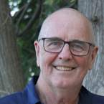
Each day adds one more dot to a line of life, one more page to my story. Though the days form a straight timeline, I have needed a lantern and compass to navigate a life that has been anything but straight. I’m grateful to enjoy living and giving today, enjoying and making this day count, serving and observing as I’m able, and travelling and meandering my life route to a good destination.

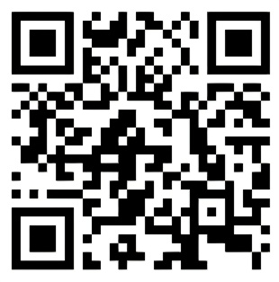
Join with me in praising God who walks with us in our life journey.

Watch “Cheryl Bear - Drum Doxology.”
https://youtu.be/W_AAMwpOfbg?si=UcDLaWWwVqKevteM

How do we Forgive
When There is No One to Forgive?

You either get bitter or you get better. It’s that simple.
You either take what has been dealt to you and allow it to make you a better person,
or you allow it to tear you down.
Josh Shipp
When I described my recovery from the cycling collision, I wrote about forgiveness. I discussed how forgiveness can be a tool for healing, allowing us to release the anger we hold toward someone who has wronged us, but when it comes to cancer, who am I supposed to forgive?
Unlike a person who intentionally causes harm, cancer doesn’t stem from a singular wrongdoer. It’s a disease that brings real pain and suffering. While Smedes argues that forgiveness must be honest, natural, fair, and essential for personal growth, I’m left with the question, Who do I forgive? The truth is, I can’t pinpoint a person to forgive.
Smedes also lays out a process for forgiveness: acknowledging our pain, taking ownership, and allowing time for healing. This process doesn’t help when I don’t know who to forgive in the first place. Also, the traumatic event of cancer isn’t a one-time incident like my bike collision—it’s an ongoing presence in my life. It’s as if I’m being repeatedly abused, and though I might want to forgive the abuser, the continuous assault renders forgiveness ineffective. Cancer may be an injustice against my body, but even if I forgave it every time it reappeared, I still wouldn’t have resolved the deeper issue: the absence of a clear person to forgive. Smedes’ framework, which centers on forgiving another person, doesn’t seem to apply here. How do I move forward?

Is Humanity Collectively to Blame?
When I collapsed and was first hospitalized, the doctors asked, “Have you worked around chemicals?” The question made me think about the chemicals and carcinogens present in everyday household items—paint, rugs, furniture, and even food. I also considered the air I breathe by living in an industrial city. Could all these factors have played a role in the disease that now inhabits my body?
The International Agency for Research on Cancer (IARC), a part of the World Health Organization (WHO), classifies over 1,000 substances as carcinogens. These are categorized into four groups: “carcinogenic to humans” (Group 1), “probably carcinogenic to humans” (Group 2A), “possibly carcinogenic to humans” (Group 2B), and “not classifiable as to its carcinogenicity to humans” (Group 3).
Some common Group 1 carcinogens include excessive alcohol consumption, leather dust, tobacco smoke, and wood dust. Reflecting on my own past, I realize I was exposed to significant amounts of cedar dust and second-hand smoke as a child, although that exposure occurred over 50 years ago.
Some common Group 2A carcinogens include fried foods, consumption of excessive red meat, and various hair products. We do watch our food intake, and although we enjoy some occasional fried or barbequed meat, including red meat, I do not think we do so excessively.
Some common Group 2B carcinogens include gasoline, engine exhaust, and even pickled vegetables. Sure, I have been exposed to all these items but so have most people.
Some common Group 3 carcinogens include acrylic fibers, chlorinated drinking water, electric fields, fluorescent lighting, lumber and sawmill products, and insulation wool. I have been exposed to all of these, some of these when I worked at a sawmill and some at another job in which I inhaleded copious amounts of cedar dust, but this was all about 50 years ago.
There seems to be a pattern in my experience. As a child, I was exposed to various carcinogens, but could it really have taken over 50 years for cancer to develop and strike? Perhaps. Then, of course, there are countless other chemicals and products that nearly all of us in industrialized countries encounter daily. In the end, I can’t blame a single person for my cancer, but I do hold our collective humanity responsible for exposing all of us to these carcinogens.
The WHO’s carcinogen list reminds me to be more careful of how I might inadvertently hurt myself or cause injury to others. It is a good reminder to be cautiously vigilant in our lives.

Is This World Simply a Cause-and-Effect World?
We humans strive to understand the world to make life simpler and more predictable. However, our understanding must be tempered with the recognition that we may never fully comprehend the complexities of life and need to continually refine our views.
In my cause-and-effect way of thinking, I found myself asking, “Where did my cancer come from?” Some might blame an all-powerful God for giving me cancer for some unknown reason, but I don’t subscribe to that view. Perhaps there was something I did that negatively affected my health. The answer is probably more complex, with multiple factors contributing to cancer’s development. Maybe the cancer attacking me was a random event in a broken world. If one does not believe in a Creator God, such as Richard Dawkins, one might conclude, “In a universe of electrons and selfish genes, blind physical forces and genetic replication, some people are going to get hurt, other people are going to get lucky, and you won't find any rhyme or reason in it, nor any justice. The universe that we observe has precisely the properties we should expect if there is, at bottom, no design, no purpose, no evil, no good, nothing but pitiless indifference” (Dawkins 1995).
I hope you are okay with living in a complex and often unpredictable world, a place blessed by a common grace and challenged by a common curse. You may find your life taking very different turns, as mine did when I was struck off my bike and attacked by cancer. I hope your life is not as severely challenged as mine. Whatever your challenges, I hope you will have a community that helps you, the personal strength to flourish as you are able, and faith in Creator God to sustain you.

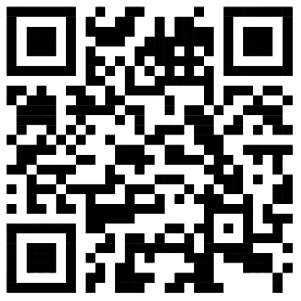
For a song about a thousand miracles in our lives listen to “Million Little Miracles” from Elevation Worship & Maverick City at:

https://Youtu.be/Viiw6tGimHo?si=FKywXdmsZo1LeF42

Cancer:
Walking Through My Healing Journey

Walking is a man’s best medicine
Hippocrates
In the spring of 2020, I started to get back into running. However, my 3 km training session times felt hopelessly slow. At times I even felt I might faint. When I had those feelings, I ran on the grass boulevards. I thought I was just out-of-shape, and kept training. Then, at a place when I was not training, I collapsed due to a pulmonary bilateral embolism and began my current cancer journey. Research shows that pulmonary embolism leads to sudden death in 25% of cases. Not only did I survive pulmonary embolism, but I’m alive and walking.
Physical activity has always been an important part of my life. The activity strengthened my bodily health, and the time alone was good for my emotional and spiritual health. When I engaged in games with friends, I loved the added benefits of camaraderie and joy in the game.
When I was first in the hospital, it took all the strength I had to get off my bed, to sit on a commode, and then to climb back into bed. Four days after I arrived at the hospital, I was able to stand up and walk up and down the hallway. I was gaining my strength back very slowly, was still very weak, and tired easily.
Eight days following my hospital arrival, I had enough strength to walk to the hospital room’s toilet. Then I tried walking down the hallway a little. Then, with the help of a physiotherapist, I began to walk up and down a few steps. Running a marathon seemed like a very long way away. I suspected my next priority was running for my life. The start of this race involved a lot more thoughtful consideration about what life is about, why bad things happen, how to overcome obstacles, what God has to do with any of this, the role of a community, what death is about, who I trust, and how I would get in shape again. Ten days after I collapsed, I returned home. By the time I returned home, I was able to walk around our home and do small walks to and from our car.
One week before surgery and four weeks after first going to the hospital, I walked a flight of stairs from our basement to the main floor; I was winded. I needed to lie down for a few minutes. Not good, but I did it. There were still too many blood clots in my lungs. I wrote: “A week tomorrow the plan is to remove the clot-producing cancer, which I’m told is a difficult procedure. It will be so good to begin climbing stairs, walking, and maybe even doing a bit of running as the clots stop being produced and existing clots diminish. As I watch people walk, bike, work, drive, garden, dance, and move freely I yearn for the ability to do those beautiful things again. Please do not take these activities for granted.”
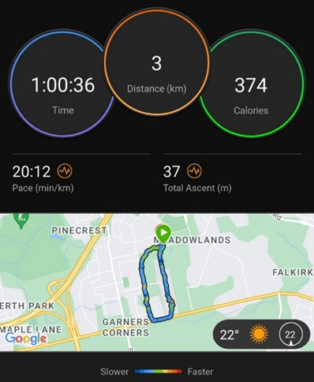
Following the surgical removal of my kidney, I began small walks with a walker so I could take a break and sit when I tired. Eventually, I was able to walk a 3 km route. That distance took me one hour, 20 minutes per km. I found it difficult to breathe. The pulmonary embolism still made getting air through my lungs a challenge. Going up the stairs from the basement to the main floor still required a few minutes of rest for me to recover. My heart rate was higher as my heart worked harder to get oxygen to fuel my resting body. I wondered:
- When can I exercise my body more freely?
- When can I walk as others can?
I told myself, “Be patient, John. Perhaps the striving for breath can remind you to strive similarly for the sacred.”
Several weeks after I returned from the hospital, I did my 3 km route assisted by a pair of walking poles. My time was about 42 minutes, about fourteen minutes per km. While I walked, I dreamt of signing up for the late-March, 30 km Around the Bay Race in Hamilton. I knew that such a race would be just against my own hoped-for time. I imagined myself wearing a shirt that said, “Cancer Survivor.” I told myself not to get ahead of myself. I had not received the pathology report yet, and I could not even run 10 metres.
On one of those walks, I felt wonderful! I walked quickly enough to push my compromised heart and lungs a little, but it was not so hard that I needed a break. I thought about my body. My gall bladder had been removed previously, and now one of my cancer-riddled kidneys. As I walked, I marveled at our bodies’ ability to heal and do the things we can. A previous week’s blood work showed that my kidney function was slightly compromised, due me having only one kidney now. I expect that future blood work will not indicate any compromise. Amazingly, my body heals and adjusts.
Three weeks post-surgery I wrote: “I’m healing well but I wish I felt less tired on account of my clot-filled lungs. I have slowly walked 3 km in our flat neighbourhood, I’m breathless when I walk up our stairs or do any activity. Even getting dressed requires a rest at the end. I find being seated as a passenger in a car quite tiring. Tiredness gives me lots of times when I just do not feel like doing anything.”
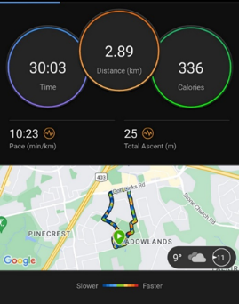
I kept living in hope. Two months post-surgery I did the same 3 km route in 30 minutes on my own minimal strength by doing a jog/walk—I still had lots of clots in my lungs. I went from 20 minutes per km to 10 minutes per km :). The “run” was a celebration of sorts, even though I used to be able to do a 3 km distance in about 15 minutes.

Increasing My Walks—One Year Post Diagnosis
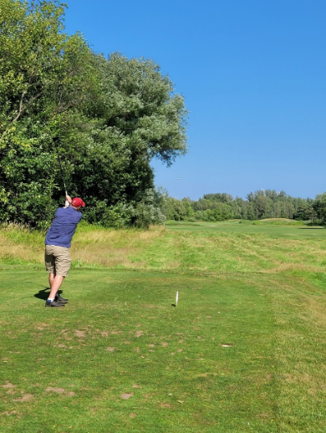
One year post collapse I enjoyed golf with my buddies. I typically used a cart, as walking up hills continued to be challenging due to my scarred lungs. One year following the radiation treatments on my back, I wrote, “Today I played my first round of golf this season. The temperature was just above freezing :). I love this game. I love outdoor walks. I love the men I play with. Though my breathing is difficult still, golf works out perfectly. I hit a ball and wait for my partners to hit. I walk about 100-200 yards, wait till we all hit a ball, and then walk another 100-200 yards and then wait again as we take turns hitting our ball. When we get on the green, we wait for each other to putt. It’s a perfect game. It’s a good walk enjoyed. I love it!”
About the same time, as part of the healing, I decided to extend my 3 km walks to a brisk 5 km daily walk at just under one hour—I even began thinking I might run again sometime in the future. “I’m using a pair of recently acquired walking poles from my father, who died in March 2020. I feel as though I walk hand in hand with my deceased father, and I’m opening myself to the living Creator Father to shape my thoughts in our solitude as we walk together. The improvements of my health have been considerable over the last two years.”
The emotional stress of cancer and medications increased my weight. On the one hand, it seemed that going on a diet as I fought cancer was unwise. On the other hand, letting my weight increase was not helpful. Running regularly was something I needed to let go of. Goals seem to be meant to be broken, so no goal-setting was advised. I asked myself, “What do I want to give myself to?”
My thoughts then? Somehow, I think I need to give myself more to regular activity. I love golfing with friends, rowing in our basement, and Grandma would love us to go on more walks together. I need to eat healthy amounts of nourishing foods, enjoy positive emotional spaces, care for others as I’m able, and appreciate the unwrapping of the gift of today. I feel it is not enough to be alive; I want to thrive. Got to give myself what I can!
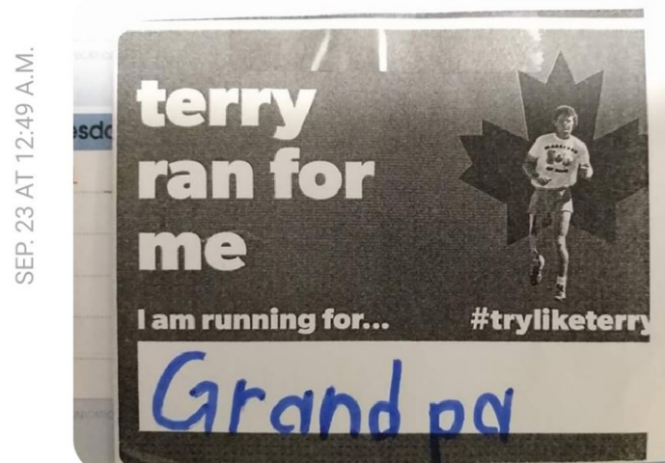
I was reminded by Wagamese that “we are all taken care of. We are all watched over, loved, and sheltered when we ask for it regardless of creed. It is what binds us and makes us a human family. It is our greatest human truth. Let our spirits rise collectively today in celebration and gratitude for the loving Creator/God we feel around us, in us, moving through us. Peace. Be blessed. Be the blessing” (2016).
It was emotional when after two years post-surgery, a couple of you ran the Terry Fox run and ran it for me.

“Faith, Hope, and Love”—102 Weeks Post Diagnosis
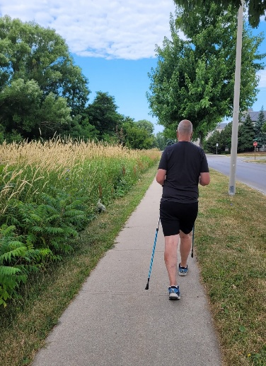
Recently I became a more faithful walker. I walked 3 km, 5 km. 8 km, and 10 km. As I walked, I reflected on a lot of things. One of my reflections was how, 22-months earlier, after the surgical removal of my left kidney, it took me considerable effort to complete a 3 km route with the help of a walker. The improvements in my health have been considerable.
Walking makes me feel hopeful and loved. I feel the warmth of morning sunshine, the cool of shade, and the gentle brush of low-lying leaves on my head. I feel the slope of the ground beneath my feet. I feel pulled up hills with the use of Great Grandpa’s walking poles. I feel enticed to quicken my pace going down hills. Walking also gives me opportunity to greet and occasionally have a conversation with others traveling the same path.
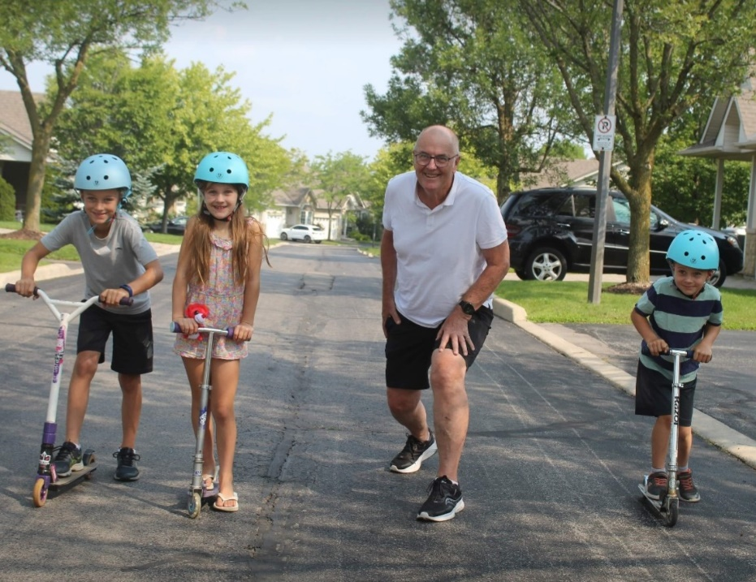

My journey fighting cancer has been different from that of many others. For the two years after my cancer diagnosis I gained 20 kg. During the last year I have shed about 8 kg. I’m slowly getting back to a healthier weight.

Challenging Cancer: Running Life’s Race One Step at a Time—104 Weeks Post Diagnosis
I tried to live a physically active, fit lifestyle that helped me enjoy my present life and help me stave off future illnesses. The US National Cancer Institute shares these numbers in support of physical activity as an antidote against cancer:
- Kidney Cancer—[this is what I have] individuals who were the most physically active had a 12% lower risk of renal cancer than those who were the least active. A pooled analysis of over one million individuals found that leisure-time physical activity was linked to a 23% reduced risk of kidney cancer.
- Bladder Cancer—15% lower risk for individuals with the highest level of recreational or occupational physical activity than in those with the lowest level.
- Breast Cancer—the most physically active women had a 12–21% lower risk of developing breast cancer than those who were least physically active.
- Colon Cancer— individuals who engaged in the highest level of physical activity had a 19% lower risk of colon cancer than those who were the least physically active.
- Cancer of the Uterus—highly physically active women had a 20% lower risk of endometrial cancer than women with low levels of physical activity. There is some evidence that the association is indirect, in that physical activity would have to reduce obesity for the benefits to be observed. Obesity is a strong risk factor for endometrial cancer.
- Esophageal Cancer—individuals who were the most physically active had a 21% lower risk of esophageal adenocarcinoma than those who were the least physically active.
- Stomach Cancer—individuals who were the most physically active had a 19% lower risk of stomach cancer than those who were the least active.
When running longer distances, I found significant support from spectators along the way. Towards the end they might shout out encouragingly, “You’re almost there!” “Just a little further!” On my cancer journey I’m grateful for a cloud of witnesses that follow and encourage me.
I knew when I ran a race that there was a definite finish line. After the finish line I would rest, eat some nourishing food, go home, continue life, and begin training for the next race. I know that challenging cancer is a different kind of race. Oncologists tell me they no longer talk about being “cancer free” or having “cancer that is in remission,” but that I’m stable. I think that challenging cancer is ultimately a life-long fight for my life. To that end I will walk/jog around our 3 km neighbourhood loop or row or bike downstairs when it is too slippery outside, look forward to breaks with exceptionally competent and caring medical practioners, and take encouragement from family and friends who walk with me. Got to stop writing now. Got to go out for a walk.

A Five-Kilometre Race—Thirty-nine Months Post Diagnosis
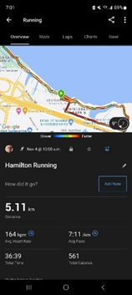
Some of you entered a 5 km race. I had been thinking that I needed to fight cancer one step at a time, and maybe now was the time to metaphorically put that into practice by joining my family members in this 5 km run.
This 5 km run helped me to understand my body better. People supported this run financially, and $635 was raised towards building two classrooms in Zambia. I completed my 5 km run today with a personal best during my cancer journey. On top of this, 12 other family members also ran today, several with personal bests.
“Fighting Cancer One Step at a Time.” This statement has been my motto during my cancer journey and in my recent commitment to try running again. The run helped me understand my body better.

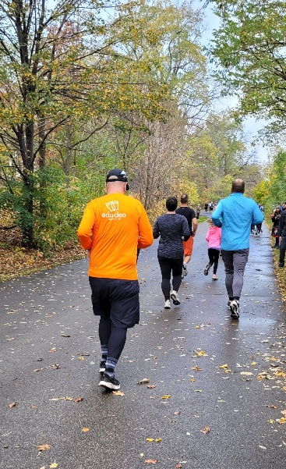
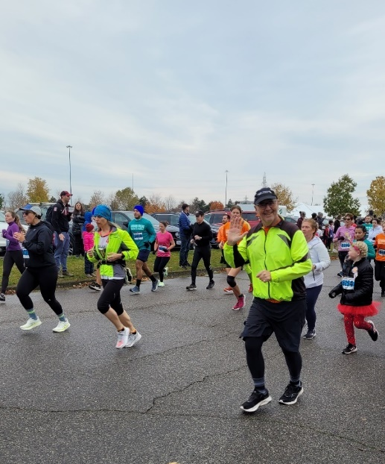

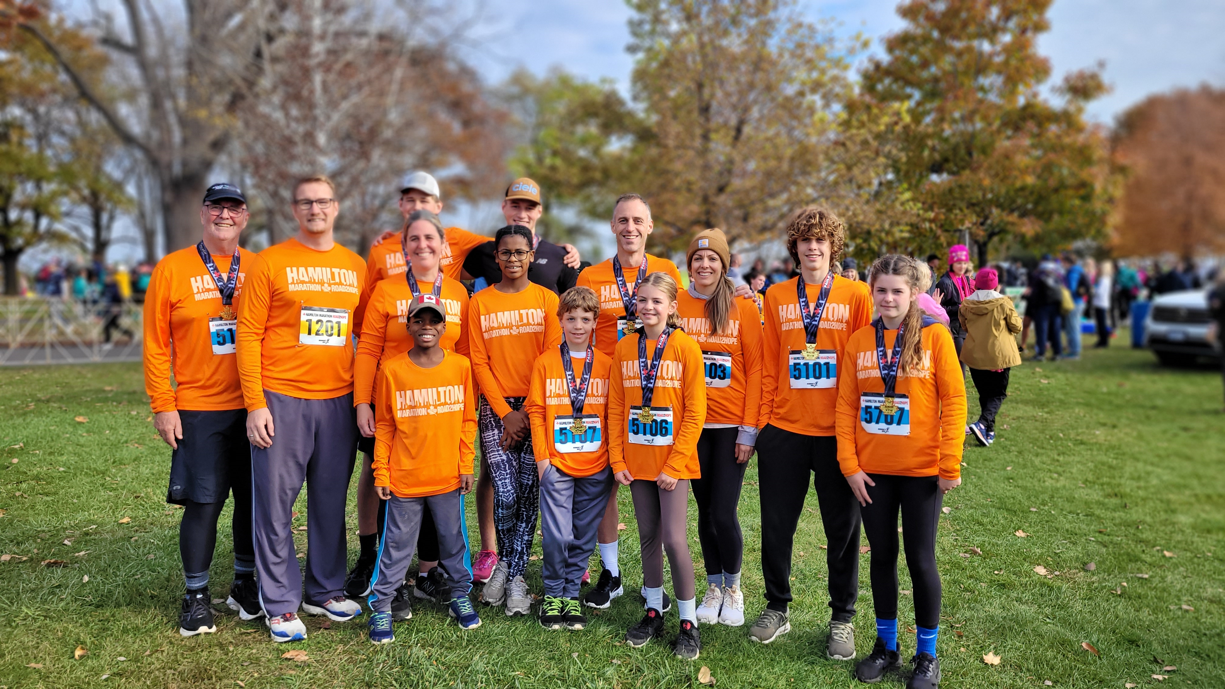

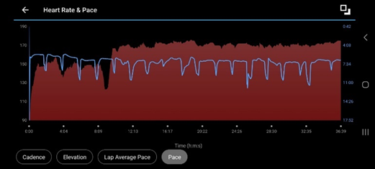
My heart rate jumped at around nine minutes and stayed high till the end of the race, but I did it! Part of completing a personal-cancer-journey best run, are the witnesses on the sides of the course and you who help me fight cancer one step at a time. What an amazing encouragement each of you are. Thanks!

Experimenting with My Walking
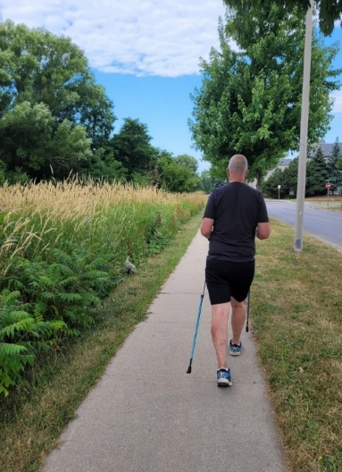
I tried walking 7,500 steps a day and managed to complete this number for 205 consecutive days. Once the routine was broken, I decided to take a break and just see what happened with my steps. I found out that I enjoyed the freedom, but that it would be better for me to reestablish the accountability of a smartwatch and see if I could establish a new record for myself in the number of consecutive days walking at least 7,500 steps. Recently, I learned I also have increasing arthritis, and my family doctor encouraged me to keep moving.
Sometimes I experimented with increasing my walking intensity. Other times I wore a weighted vest which adds resistance, boosts calorie burn and activates more muscles. This type of activity is also called rucking. New evidence shows that weighted walking could increase our energy burn by over 40%. Other times I Nordic walked. Nordic walking is a full-body walking workout using poles to engage the upper body. The benefits of Nordic walking are that it boosts heart health, strengthens arms, shoulders and core, and burns more calories than regular walking.

Research: Benefits of Physical Activity
I’m also a researcher, so I wanted to look at research that showed the benefits of the activity I was doing.
In a recent study of 889 patients with resected colon cancer who had completed adjuvant chemotherapy, half were randomly selected for an exercise group. The results suggested that the risk of dying, cancer coming back, or developing a new cancer was 28% lower in the exercise group (Engeroff et al., 2023).
Walking also increases your lungs’ ability to take in oxygen and improves lung fitness. When you are physically active, your heart and lungs work harder to supply the additional oxygen your muscles demand. Walking improves heart health, strengthens muscles and bones, enhances mood, improves digestion, supports better sleep, and boosts energy levels.
Walking also reduces risks of chronic diseases such as diabetes, strokes, and some cancers. A recent study in the UK found the following: “After a mean follow-up of 5.8 years, 2,633 participants had been diagnosed with one of the 13 cancer types. Individuals with the highest total amount of daily physical activity had a 26% lower risk of developing cancer than individuals who had the lowest amount of daily physical activity” (National Institutes of Health, 2025).
Walking for longer can help increase high-density lipoprotein (HDL) cholesterol, or “good” cholesterol. Researchers from the Duke University Medical Center found that exercise improved the number and size of the particles carrying cholesterol through the body. People who exercised had larger, fluffier particles that were less likely to clog arteries. Studies showed that people with diabetes who walked at least two hours a week were less likely to die of heart disease than those who remained sedentary. Those who exercised three to four hours a week reduced their risk even more. Studies have also shown that walking decreases the likelihood of heart attack, stroke, Alzheimer’s, cancer, Parkinson’s, and neurodegeneration, and may add seven to 10 years to your life. Dr. Milica McDowell, a Certified Exercise Physiologist and Vice President of Operations at Gait Happens, said walking is the most effective form of preventative physical activity you can do. Taking at least 3,800 steps per day is linked to a lower risk of dementia, according to a recent study published online (Engeroff et al., 2023, Buffey et al., 2022).
Walking also improves emotional and mental health. Walking aids in release of the happy hormones endorphin, dopamine, serotonin, and oxytocin, which can make you feel good about life and curb depressive tendencies. Walking, especially outdoors, improves creative thinking (Oppezzo et al., 2014, Rominger et al., 2024).

10,000 Steps a Day: Five Years Post Diagnosis
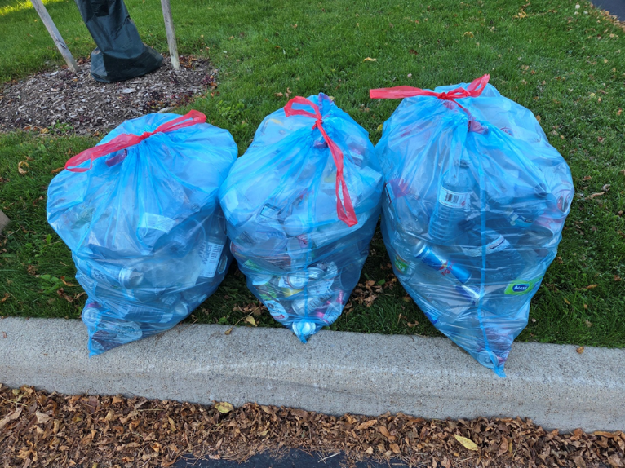
During one period I walked over 10,000 steps each day. I managed 104 consecutive days of 10,000+ steps, but that came to a halt with a colon obstruction. The obstruction resolved itself in two days, and I was back to walking. As I walk, I take a long-handled grabber and two shopping bags with me. With the grabber, I pick up garbage to put in one bag and recyclables in the other. That one week I collected three bags of recycling—and even more garbage. Our neighbourhood is a cleaner place. Some fellow walkers thank me, and I feel the earth thanking me. When I pick up trash, unfortunately I’m reminded that not all people seek what is best for this world. This week I picked up $2.60 in beer containers—disconcerting were the number of beer cans I found on an access ramp to a highway.
I recalled a story as I walked of someone who had been mauled and left to die at the edge of a road. Good people walked by the mauled person, but one person stopped, picked the injured person off the edge of the road, and showed care to him. When I travel this world and see ubiquitous trash, I feel the earth has been mauled and left to fend for itself. As I walk my daily 10,000 steps, I think the least I can do is to show care for a mauled earth by picking up some trash from the edge of the roads. When I walk without a grabber, or drive, or when winter snow comes, I will not be picking up trash—just apologizing to the earth for not picking up the trash at that time.
When the hospital staff did a CT scan of my abdomen to look at my bowel obstruction, they wrote lots of notes about my intestines and noted, along with another recent scan of my chest, that there were “Unchanged Stable nodules.” No changes is “money” to me and permits me to continue to try to enjoy and make a positive difference in this world. Gotta keep walking.

Choosing Life
Continuous monitoring of my health allows my medical teams to be ready to reach their toolbox whenever another defense against cancer might be needed.
Thankfully, for the last three-and-a-half years, my health has remained stable.
Grandma and I were generously supported in many ways by family, friends, and our worshipping and work communities. We were carried on the shoulders of a lot of people. We will always be grateful for the love, encouragement, prayers, practical help, and companionship that surrounded us.
We are also grateful to Creator God for walking with us through this journey. We have felt God’s presence. What role God played in my healing remains a mystery to me. I don’t pretend to understand it. But whatever that role was, we are very grateful. I’m still here. I still have breath.
Cancer has left its marks. I live with a damaged lung, a compromised back, and other physical and life challenges. Even with those limitations, I have continued to have opportunities each day to choose life.
I doubt I will ever run a marathon again. I may never even run 10 km. However, I can walk. I can sometimes run shorter distances. I can pay attention to my health. I can spend time with people I love. I can appreciate the ordinary gift of another day.
Through many conference workshops, I also encourage teachers to help their students enjoy life and make choices that support life. Perhaps that is another way I can choose life: by encouraging others, especially young people, to recognize and embrace the opportunities they have to live well.
For you, my grandchildren, I hope you will always make choices that contribute to your health, to the health of others, and to the health of the Earth we share.
I expect you will experience setbacks in your lives—some small and some much larger. Some will be of your own making, others will arrive without warning or invitation. You may face illness, disappointment, loss, failure, fear, or circumstances you cannot control.
Whatever challenges come your way, I hope you will keep looking for ways to choose abundant life—for yourselves, for the people around you, and for the world we love and share.
- Choose life when you can.
- Choose hope when you can.
- Choose love.
And whenever possible, choose to use the life you have been given to help make life better for all.
I hope you feel God’s presence in your journey, even when you cannot explain it. And I hope you can be comfortable with the mystery of God’s love.
That is what I hope for you.
Love you very much!
Grandpa

Afterword

“What Do We Do If Your heart stops?”
Several times I was given the opportunity to share a talk about choosing life. I used my life-story to demonstrate how key people helped me choose life. I encouraged the listeners to help others choose life.

Imagine yourself sitting here listening to me, and then your next memory is waking on a hospital bed, and the first thing you are asked by a medical professional is, “What do we do if your heart stops?”
Not likely? That was me, nearly four years ago. I was taking videos of two students engaged in physically active games, and the next thing I knew, I was waking up on a hospital bed. I realized I was in trouble, and the medical professional needed an answer.
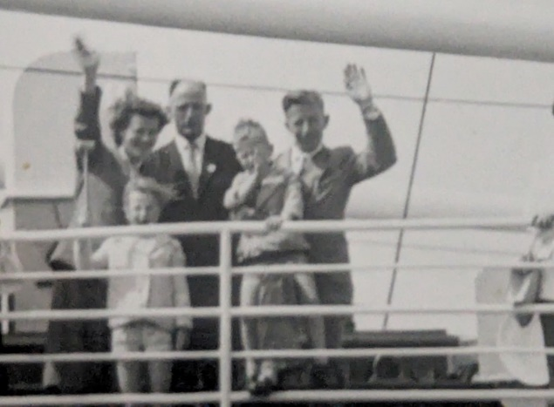
The answer to that question has different answers for different reasons in different stages of my life. Let me explain.
I do not recall much of my life as a young person. I was born in the Netherlands and immigrated when I was four years old to Vancouver, Canada, as a settler in a place which I later learned was part of Turtle Island. We immigrated to Canada as it was a land of opportunity and mountains and wilderness. My childhood days were enriched with games at a neighbourhood park beside our home.
During my elementary school days, I did poorly in my classes, but I was the first one to arrive at school so that I would then be the first up for the before-school baseball game. I loved recess and lunch breaks, but I did not much like the rest of the school day. I felt like a loser most of the day. A humiliating experience that still hurts a little today is when, in a Grade 7 Art class, but some of my fellow students laughed at my painting. I had painted the people green. I did not understand then that I’m colour blind. Ridicule deepened my feeling of being a loser. I did graduate from Grade 7, but only on the condition that in Grade 9 I enroll in the General Program in high school. Physically active games gave my life purpose and joy. If you asked me then what to do if my heart stopped, I would have said, “I want to play and I want to live; please revive my failing heart.”
When the time came in Grade 8 for my parents to sign the papers for me to enroll in the General Program in Grade 9, my immigrant parents, neither of whom had gone past Grade 6, signed the papers. My older sister objected and told them that I should stay in the Academic Program and that I needed to get my butt in gear. I agreed. The impact of my sister, one person, changed the rest of my life that evening. I often reflect on that evening and the power of one person in changing the life of another for good.
Great Grandpa took on several extra jobs to provide for our family. These jobs often meant that I, as a young teenager, had to stand behind a table saw all day Saturday, stacking cedar planks with its ubiquitous dust. I coughed up cedar dust for days. I recall never being fast enough for Great Grandpa as he pushed boards through a table saw. I got scolded or punished for not keeping up with him. I learned to work hard and efficiently, but during some of those Saturdays, if you would have asked me what to do if my heart stopped, I would have said, “Just let me die.” A senior high school guidance counsellor helped me deal with my “just let me die” emotions. Once again, the power of one person changed my life for good.

“I keep fighting voices in my mind that say I’m not enough. Every single lie that tells me I will never measure up. Am I more than just the sum of every high and every low? Remind me once again just who I’m because I need to know. Taking all I have, and now I’m laying it at your feet. You have every failure, God, you have every victory. You say I’m loved when I can’t feel a thing. You say I’m strong when I think I’m weak. You say I’m held when I’m falling short. When I don’t belong, you say I’m yours and I believe.”

Watch "Lauren Daigle - You Say (Official Music Video)."
https://youtu.be/sIaT8Jl2zpI?si=6XnAxAj9pxhsC5m0

Sometime after my high-school graduation, a break-up with a girlfriend brought me into a closer relationship with Creator God. A recreation leader encouraged me and helped me to apply for a community college Recreation program. I was accepted into this program and enjoyed 10 years of further academic studies, including Teachers’ College after my academic high school graduation. These studies all started for me with the encouragement of one person, a recreation leader.
In 1992 I finished a PhD dissertation on the Margaret Eaton School (1992). A recent book noted that “the school’s notable teachers, and many of its students, had a far-reaching impact upon the structure and gender dynamics of Canadian physical education, sport and recreation.” As an example, every physical education director from the Canadian YMCAs in the 1930s were graduates of MES. Physical Health Education Canada had its founding meeting with MES faculty at MES in 1933. One person, Emma Scott Raff, began this school on her own. One person made a huge difference. Furthermore, her great-grandson, Bob Young, paid to digitize the MES archives and launch a women’s leadership grant with PHE Canada. Again, one person made a big difference.
When I taught high school for eight years and university for twenty-seven years, my focus was often on purposeful and inclusive play. Grandma and I also received four children, and eventually fifteen grandchildren. As we share our lives with our children and grandchildren, we try to encourage them to choose life as well.
I also coached University Varsity Volleyball. I coached men, several of whom did not have a father figure in their lives. Unintentionally, I became a father figure for several of them and helped them to choose life. One of these athletes experienced the death of his mother about 10 years after graduation. When I came to the wake, this athlete wrapped his arms around me and wept. He said it was the first time he had been able to cry. He was finally in a place where he could safely let his emotions flow.
Grandma and I once took in a young woman who suffered with an eating disorder and suicidal ideation. Each morning, we hoped she was still alive. Grandma helped her get a job and connected her with a positive group of young people. She married one of those folks, had five children, and 25 years later is still choosing life.
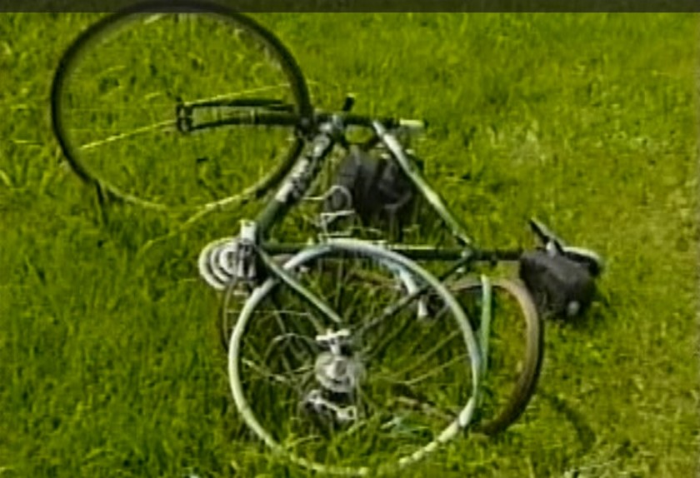
In 2003, and several years before that, I did a lot of road cycling. Riding 150 km on a Saturday morning was normal. But on June 30, I had ridden only about 2 km before waking up on an X-ray table at a local hospital. I had no idea what had happened. I told the attending medical technician: “I’m cycling. Is this for real?” Then I felt the pain in my body, and I knew it was real. What I learned later was that a 70-year-old man had medicated his life’s problems with alcohol. He had drunk 13 ounces of vodka one night and then the following morning chose to drive his pick-up truck. His blood alcohol level was nearly three times the legal limit. One person was going to hit something or someone that morning. He hit me!
The result of the collision was that I had a broken leg, double vision for half a year, lots of abrasions, and a dangling ear. It took me two months before I could walk somewhat unassisted. What turned out to be the most complicated part of my recovery was a head injury–even though I wore a helmet which saved me from even more complicated damage.
I had written six editions of books before this time, mostly through Human Kinetics, but now I could not write.
My memory did not last past two paragraphs. I also had headaches 24/7. About one-year following this collision, I sank into clinical depression. It was a place where darkness was my closest friend. If you asked me then, “What do we do if your heart stops,” I would have said, “Just leave me be.” I was not suicidal, but in my darkness, I preferred death to life. The constant headaches led me to retire early at the age of 60.
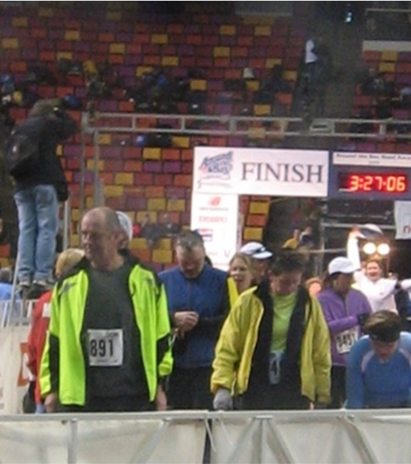
Probably 100 counselling sessions dealing with the depression and unpacking the trauma of my youth brought me closer to choosing life. One day, in 2007, my daughter asked our family members if anyone wanted to run the 30 km Around the Bay Race in Hamilton. I said, “I’m in!” I began four months of incremental training, and eventually I ran this race in 3 hours and 23 minutes. I had completed it! One person’s encouragement helped me move forward. This run renewed my zest for life, and I kept on running half marathons, full marathons, and once, even a 50 km run. I loved running! Running was a meditative time, and the left-right leg-and-arm movements in the outdoors renewed my spirit to a place where once again, I would have answered the heart question affirmatively, “I’m choosing life. Please revive me if you can.”
Since then, I have been able to write again, and Human Kinetics has published 11 more editions of books I authored or coauthored, with one translated into Chinese, one into Spanish, and three into German. Each book was an opportunity to positively impact the lives of its readers. Over 117,000 copies have positively impacted many people.
From 1996 till 2018 I served on the board of CIRA Ontario. I was privileged to be its president for the last 15 years of my tenure on this board. I co-authored 12 of CIRA Ontario’s popular and engaging books. CIRA Ontario’s motto was: “Promoting fun physical activity for all.” This organization helps children choose life through the recesses I so valued as a child.
In 2014, I ran another half-marathon. When I approached the finish line, there was a bit of a log jam because paramedics were working on someone. It turns out it was a running friend of mine. Sadly, he died just before the finish line. I then lost my desire to run races. My friend would not have wanted me to make that choice, but I lost my zest for running.
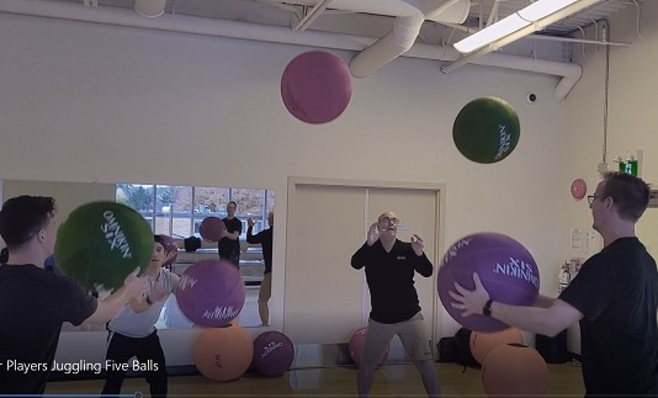
In 2017, I began leading active sessions at physical education conferences for Gopher Sport across Canada. It’s a company with innovative and high-quality equipment and great service. It was my pleasure to continue to promote choosing life for students.
I prepared a website with over 1200 games, prepared Pinterest and YouTube accounts with over 900 videos, and every Tuesday and Thursday I post on various social media platforms. All this to encourage teachers to help students choose life. Recently I wanted to determine how many people read posts on each of these sites. For that one month it was over 100,000 visits. I thought, if each reader impacted 10 students, that equals an impact of one million people during this past November. I’m one person trying to make a positive impact on the lives of students.
In the summer of 2020, I decided I needed to begin running again. I was desperately slow and ran only a 3 km distance. I thought I was out of shape and just needed to keep running. After about one month of these 3 km runs, I went to our family doctor. She prescribed some blood tests. Tests indicated that I was losing blood. She ordered an endoscopy and a colonoscopy.
Three days following my blood tests, and before I was to have the two scopes done, I was videoing two students playing some games, and once again I woke up in a hospital.
Oxygen was flowing into my nose, an IV needle was in my arm, and several medical people were standing around me. One of them asked me the question, “What do we do if your heart stops?” With a question like that, I knew I was in deep trouble. My knee-jerk response was, “I’m choosing life. But if I have been dead for a while, just leave me be.” I’m okay with dying. But I choose life!
Turns out the reason I collapsed was that my lungs were full of blood clots caused by a fully cancerous left kidney. I collapsed because I could not breathe. A month after my collapse, my left kidney was surgically removed in six hours of surgery during which I gratefully received six units of blood. The pathology report indicated that I had an Aggressive Stage IV Renal Cell Carcinoma. I began to prepare my funeral. I asked my oncologist about life expectancy; he replied, “The medium life expectancy is four years.” I passed that mark nearly four years ago, but then nothing happened. I should add that recently I was encouraged to not count down to four years, but count up. In other words, so far in my life, I have been gifted with 26,636 (From August 3, 2026) days and counting. I’m trying not to count down to the end of this talk, to the end of this work week, to my retirement from Gopher, and so on. Rather, I want to consider how I can unpack the gift of today and add it to the rich gifts of yesterdays. May we always live each day as one more gift to unwrap well.
Nine months after my surgery the medical team radiated a cancerous vertebra for five days. By then, I also had five golf-ball-sized masses on my lungs, liver, and adrenal gland. They began me on immunotherapy treatments. Following one year of immunotherapy treatments, I could no longer tolerate the infusions. By then the masses had amazingly shrunk to the size of peas. Miraculous! Life expectancy following immunotherapy is also four years, and recently I passed that milestone.
The motto throughout my cancer treatments has been, “I’m choosing life!” More time with Grandma, my kids, each of you, and amazing teachers. Our students are our most important guests. They are gifted into our classes, ask for careful attention, stay for a while, and then leave to follow their own way. I hope we can each be one person in the life of many children, encouraging them to choose life through sacred, fun, purposeful, physically active play. Through physical education classes and intramurals we can gift students with powerful experiences as they get lost in the motivating experience of participating in joyful activity, the excitement of competently mastering new skills, and the feeling of confidence in life. Through our work we can hopefully help students choose for healthy and active lifestyles: Help them choose life!

Still Able to Contribute to Our World
Since my collision I have been able to write again, and Human Kinetics has published 11 more editions of books I authored or coauthored, with one translated into Chinese, one into Spanish, and three into German. Each book was an opportunity to positively impact the lives of its readers. Over 120,000 copies have positively impacted many people.
Human Kinetics (HK) published my first book, Organizing Successful Tournaments, in 1992. Drawing on the principles of this book, I created the professional Women’s United Soccer Association competition schedule in 2003, and the schedules for Ontario University Athletics’ five major sports from 2009-2020.
I have also published 13 academic research articles, more than 100 professional articles, and over 100 popular articles. I authored six chapters in physical education textbooks and written numerous book reviews. In addition, I contributed to the PHE Canada Journal, including one research article, two professional articles, and 10 activity-based articles.
I was privileged to serve on the CIRA Ontario board for 21 years, including the final 14 years as its president. I was mentored by former president Pat Doyle, who instilled the importance of financial sustainability while always keeping the well-being of children as the foremost priority. During my tenure with CIRA Ontario, I coauthored 12 books with outstanding colleagues and successfully secured $120,000 in grants to develop and deliver workshops for the Daily Physical Activity (DPA) resource Everybody Move, in both English and French. This multimedia resource was later published by Human Kinetics (2010).
While working at Redeemer University, I devoted significant effort to developing college-level intramural programming. In recognition of this work, the Ontario Colleges Athletic Association inducted me into the OCAA Hall of Fame as a Builder in 2007.
I was an active participant in the Christian Society for Kinesiology and Leisure Studies (CSKLS), which awarded me The Literary Award in 2006, The Presidential Award in 2006, and The Distinguished Service Award in 2013.
I was also actively involved in promoting recreation and sport within the City of Hamilton. In recognition of my contributions, the City of Hamilton honoured me by adding a banner in my name to its Sport Hero Banner Series in 2011.
I was awarded the Queen Elizabeth II Diamond Jubilee Medal for outstanding contributions to promoting physical activity in my community and across Canada, as well as the Ontario Syl Apps Ontario Volunteer Achievement Award in 2013.
My PhD dissertation examined the Margaret Eaton School (MES), a formative Canadian women’s normal school for physical education. In 1942, MES amalgamated with the University of Toronto, a partnership that led to the launch of its Bachelor of Physical Education degree. The Margaret Eaton School was also the founding location of PHE Canada in 1933.
I acquired funds to digitize the collection of Canadian women’s physical education from 1901 to 1942.
https://share.google/MWpMZOv8Cb2vd3Ape
In 2024, I worked with donor Bob Young to contribute $20,000 to PHE Canada in support of the Margaret Eaton School Legacy Fund. This fund provides financial support for women’s leadership opportunities through physical education.
https://share.google/tY0q2DAvXI6r1qRCF
I retired from Redeemer University at age 60 after experiencing persistent headaches resulting from a serious bicycle collision in 2003 involving a truck driven by an intoxicated driver.
In 2017, during my retirement, I began representing Gopher Sport as its Educational Consultant, leading workshops featuring the company’s high-quality equipment and outstanding service. To complement this work, I created my personal website, www.canadago4sport.com, which offers teachers access to over 1,200 games. Since 2017, I shared innovative game ideas twice weekly across various social media platforms. In recent years, I expanded my outreach by offering occasional inclusive sessions featuring Omnikin and You.Fo.

I’m looking forward to lots more dances with my lovely lifelong partner and wife, and your Grandma. Our friends the Condells encouraged us with suggesting a song they appreciated in their relationship.

Watch it at:
https://youtu.be/MjgXGDs6dMI?si=DR4KIdQo4tBMk47S

Personal Bibliography

- Le Masurier, G., Corbin, C., Baker, K., & Byl, J. (2017). Fitness for life Canada. Human Kinetics.
- Byl, J., & VanGils Kloet, B. (2014). Small groups, big games. Human Kinetics.
- Byl, J. (2013). Organizing successful tournaments (4th ed.). Human Kinetics.
  - Translated into Spanish: John Byl. Como Organizar Competiciones Deportivas. Badalona, Spain: Paidotribo, 2016.
- Walters, P., & Byl, J. (2013). Christian paths to health and wellness (2nd ed.). Human Kinetics.
- Byl, J., Burland, M., Dyck, M., Lass, M., Schwass, K., & Trojanovic, M. (2010). Everybody move: Daily vigorous physical activity. Human Kinetics.
- Byl, J. (2008). Having a ball: Stability ball games. Human Kinetics.
- Translated into German: John Byl. Riesen balle–Riesen spaB: Gymnastikball–Spiele by Verlag an der Ruhr: Mulheim an der Ruhr 2009.
- Walters, P., & Byl, J. (2008). Christian paths to health and wellness. Human Kinetics.
- Byl, J., Raithby, A., Bauldauf, H., & Doyle, P. (2007). Chicken and noodle games. Human Kinetics.
- Byl, J. (2006). Organizing successful tournaments (3rd ed.). Human Kinetics.
  - For a review of this book see: Jan Miller. Book Reviews. Joint Forces Journal. (May 2006): 7-8.
- Byl, J. (2004). 101 fun warm-up and cool-down games. Human Kinetics.
  - Translated into German: John Byl. Aug- und Abwarmen ohne Trott by TibiaPress: Mulheim an der Ruhr, 2005; and by Verlag an der Ruhr: Mulheim an der Ruhr 2005.
- Byl, J. (2002). Intramural recreation: Step-by-step guide to creating an effective program. Human Kinetics.
- For a review of this book see: http://www.pelinks4u.org/bookreviews/intramuralrecreation.htm
- Byl, J. (2002). Co-ed recreational games. Human Kinetics.
  - For reviews of this book see: Palaestra, 19(2), 52; and KAHPERD Spring 2003, 6.
- Byl, J. (1999). Organizing successful tournaments (2nd ed.). Human Kinetics.
  - Translated into Chinese: John Byl. Organizing Successful Tournaments. People’s Sports Publishing House, 2000.
- For reviews on the second edition see: Erin Peterson, Athletic Business, May 1999, 16; and Athletics Administration, June 1999, 58.
- Byl, J., & Visker, T. (Eds.). (1999). Physical education, sport and wellness: Looking to God as we look at ourselves. Dordt College Press.
- Byl, J. (1990). Organizing successful tournaments. Human Kinetics.
- Byl, J. (1990). Organizing successful YMCA tournaments. YMCA of the USA.
  - For reviews on this book see: The British Journal of Physical Education, 23, 2 (Summer 1992); John Foley, Interscholastic Athletic Administration, (Summer 1992): 27; The British Journal of Physical Education, 21, 2 (Summer 1990); and John Elwin, The ACHPER National Journal, (June 1990): 34.

Books I coauthored and published through CIRA Ontario
- Byl, J., & Matheson, R. (2016). Great balls of fun. CIRA Ontario.
- Stone, T., Munro, G., & Byl, J. (2014). Bats and balls: Striking and fielding games. CIRA Ontario.
- Byl, J., & Kawamoto, J. (2014). Net and wall games: Teaching games for understanding. CIRA Ontario.
- Baldauf, H., Byl, J., Grigg, A., Raithby, A., Schwass, K., & Wilson, C. (2011). Follow the leader. CIRA Ontario.
- Baldauf, H., Bevaart, D., Byl, J., Grigg, A., Raithby, A., Schwass, K., Thomas, B., & Wilson, C. (2010). Replay: Safe & fun environmentally friendly games & activities. CIRA Ontario.
- Doyle, P., & Byl, J. (2010). Tag, tag, and more tag. CIRA Ontario.
- Byl, J., Burland, M., Dyck, M., Lass, M., Schwass, K., Stephen, M., & Trojanovic, M. (2005). Everybody move: Daily vigorous physical activity. CIRA Ontario.
- Byl, J., Byl, J., & Raithby, A. (2005). Everything but the kitchen sink. CIRA Ontario.
- Byl, J., DeCoste, K., Housdon, F., Raithby, A., & Baldauf, H. (2004). Dollar store games. CIRA Ontario.
- Byl, J., Raithby, A., Baldauf, H., & Schwass, K. (2004). Oodles of noodles. CIRA Ontario.
- Byl, J., Baldauf, H., Doyle, P., Dyment, R., Raithby, A., & Stephen, M. (2003). Why paper & scissors rock. CIRA Ontario.
- Byl, J., Baldauf, H., Doyle, P., Raithby, A., & Stephen, M. (2003). 50 games with 50 tennis balls. Canadian Intramural Recreation Association of Ontario.

References

Albom, M. (1997). Tuesdays with Morrie: An old man, a young man, and life’s greatest lesson. Doubleday.

Alves, F., Cruz, S., Ribeiro, A., Bastos Silva, A., Martins, J., & Cunha, I. (2020). Walkability

Bowler, K. (2018). Everything happens for a reason and other lies I’ve loved. Random House.

Bowler, K. (2018). No cure for being human: And other truths I need to hear. Riverhead Books.

Brand, P. W., & Yancey, P. (1980). Fearfully and wonderfully made: A surgeon looks at the human and spiritual body. Zondervan.

Brooks, D. (2015). The Road to Character. Random House.

Brooks, D. (2019). The Second Mountain: The quest for a moral life. Random House.

Buechner, F. (1973). Wishful thinking: A theological ABC. Harper & Row.

Buffey, A. J., Herring, M. P., & Langley, C. K. (2022). The acute effects of interrupting prolonged sitting time in adults with standing and light-intensity walking on biomarkers of cardiometabolic health in adults: A systematic review and meta-analysis. Sports Medicine, 52(9), 1765–1787. https://doi.org/10.1007/s40279-022-01649-4

Byl, J. (1992). The Margaret Eaton School, 1901–1942: Women’s education in elocution, drama and physical education (Doctoral dissertation, State University of New York at Buffalo). University Microfilms International.

Chanda, M. L., & Levitin, D. J. (2013). The neurochemistry of music. Trends in Cognitive Sciences, 17(4), 179–193. https://doi.org/10.1016/j.tics.2013.02.007

Chittister, J. (2019). The time is now: A call to uncommon courage. Convergent Books.

Dawkins, Richard. River Out of Eden: A Darwinian Life. New York: Basic Books, 1995, Chapter 4, “God’s Utility Function.”

Dillard, A. (1989). The writing life. Harper & Row.

Eiseley, L. (1969). The unexpected universe. Harcourt Brace.

Engeroff, T., Groneberg, D. A., & Wilke, J. (2023). After dinner rest a while, after supper walk a mile? A systematic review with meta-analysis on the acute postprandial glycemic response to exercise before and after meal ingestion in healthy subjects and patients with impaired glucose tolerance. Sports Medicine, 53(3), 849–869. https://doi.org/10.1007/s40279-022-01808-7

Francis. (2013, March 28). Chrism Mass homily [Homily]. Cathedral of Buenos Aires, Argentina.
Freeman, E. (2021). Walking into a room: The art of knowing when to stay and when to walk away. WaterBrook.

Hession, B. (1957). Determined to live. Peter Davies.

Holmes, B. A. (2017). Joy unspeakable: Contemplative practices of the Black church. Fortress Press.

Kalanithi, P. (2016). When breath becomes air. Random House.

Kaur, V. (2020). See no stranger: A memoir and manifesto of revolutionary love. One World.

Kimmerer, R. W. (2024). The Serviceberry. In Braiding Sweetgrass: Indigenous wisdom, scientific knowledge, and the teachings of plants. Milkweed Editions.

Lewis, C. S. (1940). The problem of pain. HarperOne.

Merton, T. (1956). Thoughts in solitude. Farrar, Straus and Giroux.

Metcalfe, A. (1987). Canada learns to play: The emergence of organized sport, 1807–1914. McClelland & Stewart.

Munroe, J. (2024). Telling stories in the dark: Finding healing and hope in sharing our sadness, grief, trauma, and pain. Reformed Journal Books & Front Edge Publishing.

National Institutes of Health. (2025, March 26). Daily physical activity, even at light intensities, linked to lower cancer risk. https://www.nih.gov/news-events/news-releases/daily-physical-activity-even-light-intensities-linked-lower-cancer-risk

Nouwen, H. J. M. (1972). The wounded healer: Ministry in contemporary society. Doubleday.

Nouwen, H. J. M. (1975). Reaching out: The three movements of the spiritual life. Doubleday.

Nouwen, H. J. M. (1979). Clowning in Rome: Reflections on solitude, celibacy, prayer, and contemplation. Doubleday.

Nouwen, H. J. M. (1992). Life of the beloved: Spiritual living in a secular world. Crossroad.

Nouwen, H. J. M. (1994). Our greatest gift: A meditation on dying and caring. HarperSanFrancisco.

Nouwen, H. J. M. (1994). Here and now: Living in the Spirit. Crossroad.

Nouwen, H. J. M. (1996). The inner voice of love: A journey through anguish to freedom. Doubleday.

Nouwen, H. J. M. (1997). Bread for the journey: A daybook of wisdom and faith. HarperCollins.

Nouwen, H. J. M. (2002). You are the beloved: Living God’s word of love. Crossroad.

Oppezzo, M., & Schwartz, D. L. (2014). Give your ideas some legs: The positive effect of walking on creative thinking. Journal of Experimental Psychology: Learning, Memory, and Cognition, 40(4), 1142–1152. https://doi.org/10.1037/a0036577

Palmer, P. J. (2004). A hidden wholeness: The journey toward an undivided life. Jossey-Bass.

Richards, E., & O’Brien, J. (2012). Misreading Scripture with Western eyes: Removing cultural blind spots. IVP Academic.

Rienstra, D. (2025, August 2). What is mature hope? Reformed Journal.
https://reformedjournal.com/2025/08/02/what-is-mature-hope/

Rohr, R. (2011). Falling upward: A spirituality for the two halves of life. Jossey-Bass.

Rohr, R. (1999). Everything belongs: The gift of contemplative prayer. Crossroad.

Rohr, R. (2019). The universal Christ: How a forgotten reality can change everything we see, hope for, and believe. Convergent Books.

Rominger, C., Fink, A., Weber, B., Benedek, M., Perchtold-Stefan, C., & Schwerdtfeger, A. (2024). Step-by-step to more creativity: The number of steps in everyday life is related to creative ideation performance. American Psychologist, 79(6), 863–875.

Russell, B. (1912). The problems of philosophy. Williams & Norgate.

Silva, A., da Cunha, J., & Silva, J. (2014). Estimation of pedestrian walking speeds on footways. Proceedings of the Institution of Civil Engineers: Municipal Engineer, 167(1), 32–43.
Smedes, L. B. (1981). My God and I. William B. Eerdmans Publishing Company.
Smedes, L. B. (1997). The art of forgiving: When you need to forgive and don’t know how. Ballantine Books.
Smedes, L. B. (2003). My God and I: A spiritual memoir. Wm. B. Eerdmans Publishing Co.
Statistics Canada. (2026, January 13). Deaths, 2024. Government of Canada. https://www150.statcan.gc.ca/n1/daily-quotidien/260113/dq260113b-eng.htm
Taylor, B. B. (2014). Learning to walk in the dark. HarperOne.
Ten Boom, C. (1974). Clippings from my notebook. Fleming H. Revell.
Tutu, D. (2023). Blessing. https://graceupongrace.org.uk/a-blessing-from-desmond-tutu/
Vogel, K. (2022, May 6). Why do we worry so much? 3 key reasons and how to cope. Psych Central.
Vos, D. (1988). Letters to myself on dying. Harper & Row.
Wagamese, R. (2016). Embers: One Ojibway’s meditations. Douglas & McIntyre.
Wagamese, R. (2021). What comes from spirit. Douglas & McIntyre.
Yancey, P. (2021). Where the light fell: A memoir. Convergent Books.

