6 Ladder With Feet Challenges

By Dr. John Byl

Follow/Subscribe with John on Twitter, Instagram, Pinterest, YouTube, or on his website

For 45+ Ladder Challenges
For innovative Ladder Options

- Every Other Rung Run
https://www.canadago4sport.com/Ladders/Every-Other-Rung-Run

Objective:
- Running with one-foot landing in every other rung.

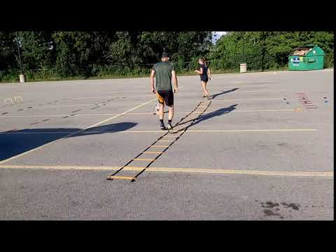

Fundamental Movement Skills:
- Locomotor
  - Running

Equipment List:
- Agility Ladder

Setting Up:
- Player stands at the beginning of the ladder.

Instructions:
- Player must run quickly through the ladder with each foot landing in every second rung.

- Three Jumps and Three Runs…
https://www.canadago4sport.com/Ladders/Three-Jumps-and-Three-Runs

Objective:
- Powerfully jump in three rungs in a row, then run three rungs, then jump three rungs…

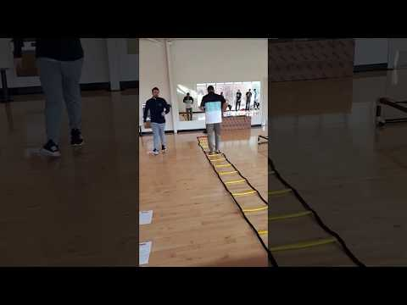

Fundamental Movement Skills:
- Locomotor
  - Hop
  - Run

Equipment List:
- Agility Ladder

Setting Up:
- Player stands at the beginning of the ladder.

Instructions:
- Player must jump powerfully and quickly through three rungs in a row, then run three rungs, then jump three rungs…

- Tap In
https://www.canadago4sport.com/Ladders/Tap-In

Objective:
- Running with left foot outside the ladder and right foot tapping off inside each rung.

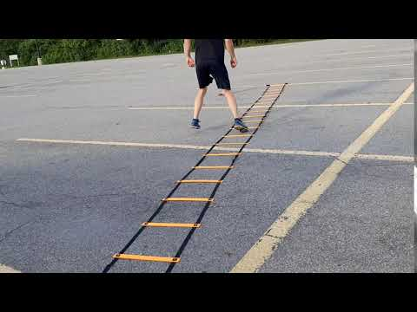

Fundamental Movement Skills:
- Locomotor
  - Running

Equipment List:
- Agility Ladder

Setting Up:
- Player stands at the beginning of the ladder.

Instructions:
- Player must run quickly through the ladder left foot outside the ladder and right foot tapping off inside each rung.
- Then alternate with other foot in and out

- Jump Forward In and Hop Out

https://www.canadago4sport.com/Ladders/Jump-Forward-and-In%2C-Hop-Out

Objective:
- Hop out of rung to two feet outside, then jump forward into next rung landing on one foot.

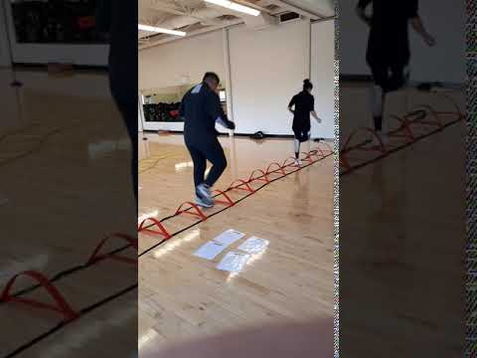

Fundamental Movement Skills:
- Locomotor
  - Hop

Equipment List:
- Agility Ladder

Setting Up:
- Player stands in the first rung of the ladder on one foot.

Instructions:
- Hop out of rung to two feet outside, then jump forward into next rung landing on one foot....

- Slalom Skiing
https://www.canadago4sport.com/Ladders/Slalom-Skiing

Objective:
- Two-foot jump from one side to the next rung and the other side...

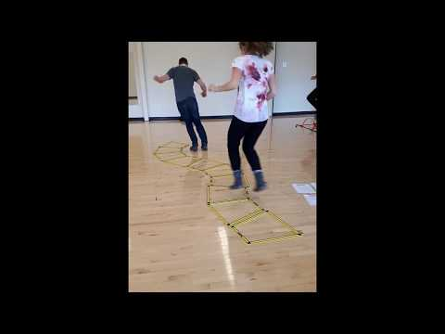

Fundamental Movement Skills:
- Locomotor
  - Jump

Equipment List:
- Agility Ladder

Setting Up:
- Player stands with one foot in and the other out of the first rung.

Instructions:
- The player jumps to the other side and up one rung with one foot in and one foot out, then jump to the other side and up with one foot in and one foot out….

- 180s
https://www.canadago4sport.com/Ladders/180s

Objective:
- Complete a series of 180-degree jump turns.

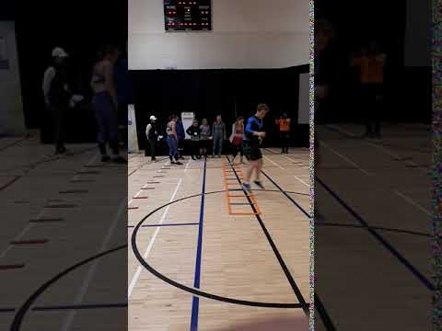

Fundamental Movement Skills:
- Locomotor
  - Jump

Equipment List:
- Agility Ladder

Setting Up:
- Player straddle the side of the ladder with one foot inside and one foot outside first rung facing backwards to planned direction.

Instructions:
- Players jump and do a 180-degree left turn and land in the same square facing forward.
- Then jump and do a 180-degree right turn and land in the starting position but one rung up…

