Executive Functioning Through Physically Active Play
Dr. John Byl

Want More?
JOHNBYL50@gmail.com
www.canadago4sport.com
www.gophersport.com
Twitter => @canadago4sport (for weekly posting of a new game)

- Workshop Description: Engage in safe, active, and playful games to build self-regulation (waiting for signals or turns), working memory (remembering sequences), and cognitive flexibility (requiring quick changes). Be prepared to participate in these games with some innovative equipment you can use on Monday.

- Define ( https://www.understood.org/en/learning-attention-issues/child-learning-disabilities/executive-functioning-issues/3-areas-of-executive-function )
  - Executive Functioning = The ability to organize cognitive processes. This includes the ability to plan ahead, prioritize, stop and start activities, shift from one activity to another activity and monitor one’s own behavior.
  - Inhibitory Control = Being able to ignore distractions and resist temptation. A child might use this skill to keep from blurting out an answer in class. It helps kids regulate their emotions, and keep from acting impulsively.
  - Working Memory = Being able to keep information in mind and then use it in some way. A child might use this skill to read a passage on an English test, hold on to the information, and use it to answer questions.
  - Cognitive Flexibility = Being able to think about something in more than one way. A child might use this skill to answer a math problem in two ways or to find relationships between different concepts.
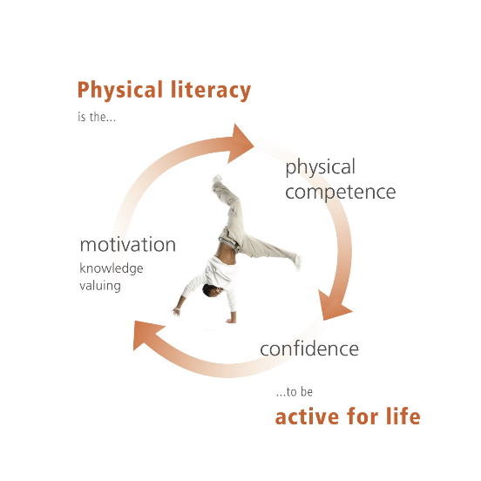
- Research
  - Socially acceptable behaviour
  - Frontal Cortex
  - Neurons firing together wire together
- Goldilocks story
- Chart from Physical Literacy
- Examples
  - Self Regulation: Baseball cannot hold a player’s shirt on first base.
  - Memory: Run on a fly ball with two out.
  - Flexibility: When to steal a base.

Agenda

- Head and Shoulders
  - Self Regulation: Follow the prescribed pattern—Head & Shoulders, Knees & Toes; Eyes Ears, Mouth & Nose
    - https://www.canadago4sport.com/Leadership/Head-and-Shoulders-Slow
  - Memory: Do it more quickly
    - https://www.canadago4sport.com/Leadership/Head-and-Shoulders-Fast
  - Flexibility: Different pattern—Knees & Shoulders, Toes & Knees; Mouth, Ears, Eyes & Nose
    - https://www.canadago4sport.com/Leadership/Head-and-Shoulders-Reverse
- Beach, Bridge, and Boats (Gopher 18 poly spots, six hula hoops, four foam balls)
  - Self Regulation: Move through beach and bridge and boat
    - https://www.canadago4sport.com/Locomotor/Beach%2C-Bridge%2C-and-Boats
  - Memory: Move with taggers
    - https://www.canadago4sport.com/Locomotor/Beach%2C-Bridge%2C-and-Boats-with-Tag
  - Flexibility: Move with taggers with a ball
    - https://www.canadago4sport.com/Locomotor/Beach%2C-Bridge%2C-and-Boats-2-Player-Tag
- Simon Says—with two sides for those who mess up
  - Self Regulation: Do it with “Simon Says”
    - https://www.canadago4sport.com/Leadership/Simon-Says
  - Memory: Do with previous “Simon Says”
    - https://www.canadago4sport.com/Leadership/Simon-Says-Do-Previous
  - Flexibility: Nomis
    - https://www.canadago4sport.com/Leadership/Simon-Says-Do-Opposite
- Smashing Volleyball (Gopher 18 poly spots, 3 bouncy foam balls, for 3 games of 36+ players)
  - Self Regulation: Two-square love
    - https://www.canadago4sport.com/Net/Team-Two-Square-Cooperative-Instructions
    - https://www.canadago4sport.com/Net/Team-Two-Square-Cooperative
  - Memory: Two-square money
    - https://www.canadago4sport.com/Net/Team-Two-Square-Competitive
  - Flexibility: Smash volleyball (spike ball on own side then run to back of court, and back on rotating one spot)
    - https://www.canadago4sport.com/Net/Smashing-Volleyball-Instructions
    - https://www.canadago4sport.com/Net/Smashing-Volleyball

- 21 Pilots
  - Self Regulation: Count to 21
    - https://www.canadago4sport.com/Numeracy/21-Pilots
  - Memory: Activity with specific number—5 or….
  - Flexibility: Carry over number from last game
- Ying Yang You
  - Self Regulation: Slow
    - https://www.canadago4sport.com/Leadership/Ying-Yang-You-Instructions
    - https://www.canadago4sport.com/Leadership/Ying-Yang-You-Slow
  - Memory: Quicker
    - https://www.canadago4sport.com/Leadership/Ying-Yang-You-Faster
  - Flexibility: Back
    - https://www.canadago4sport.com/Leadership/Ying-Yang-You-Back
- Square Out (Gopher SquaredOFF)
  - Self Regulation: Begin with square in the middle and build on
    - https://www.canadago4sport.com/Numeracy/Squared-Off-Instructions
    - https://www.canadago4sport.com/Numeracy/Squared-Out
  - Memory: Begin with random pieces
  - Flexibility: Bean bag toss and flip one piece
    - https://www.canadago4sport.com/Target1/Squared-Out-Toss-Instructions
    - https://www.canadago4sport.com/Target1/Squared-Out
- Tic Tock Three in a Row (two sets of different coloured bean bags per groups of 6-8 players)
  - Take turns in one spot
    - https://www.canadago4sport.com/Numeracy/Tic-Tac-Toe--No-Grid-Instructions
    - https://www.canadago4sport.com/Numeracy/Tic-Tac-Toe%E2%80%94No-Grid-
  - Relay with three per team on a grid
  - Relay with three per team on a floating grid
    - https://www.canadago4sport.com/Numeracy/Tic-Tac-Toe%E2%80%94No-Grid-Relay
- Robin’s Nest (Gopher 12 Hula Hoops and three decks of cards)
  - Self Regulation: Wait to run
  - Memory: Cards in order
  - Flexibility: Cards in order but of same suit (return non-suited cards)
- Twin Ball (Gopher Stryke and one foam ball per groups of 5-10 players)
  - Self Regulation: Take turns knocking over pin from outside circle with own team—how many pins can the team knock down in set time limit.
    - https://www.canadago4sport.com/Target1/StrykeN-the-Pins
  - Memory: Score highest in team playing set time limit.
    - https://www.canadago4sport.com/Target1/StrykeN-the-Pins-to-Over-50
  - Flexibility: Count points to 35 points exactly.
    - https://www.canadago4sport.com/Target1/StrykeN-the-Pins-to-Exactly-40

Item |  | Details | Quantity | Subtotal
Rainbow TopSpot Vinyl Spots - Rainbow Set, 5" dia  Item No: 93-022  Availability: In Stock | Price:  Unit: | C$25.00  Set of 6 | 4 | C$100.00
DuraHoop™ Skinny - Set of 12, 30" dia  Item No: 43-511  Availability: In Stock | Price:  Unit: | C$65.00  Set of 12 | 1 | C$65.00
ClassicCoat™ Bounce™ Coated-Foam Balls - Screamin' Rainbow Set, 7" dia  Item No: 72-078  Availability: In Stock | Price:  Unit: | C$219.00  Set of 6 | 1 | C$219.00
ACTION! SquaredOff Set - ACTION! SquaredOff Set  Item No: 58-473  Availability: In Stock | Price:  Unit: | C$315.00  Set | 1 | C$315.00
Gopher Oversized Foam Tennis Balls - Gopher Oversized Foam Tennis Balls  Item No: 41-718  Availability: In Stock | Price:  Unit: | C$18.00  Set of 3 | 4 | C$72.00
Large-Face Playing Cards - Large-Face Playing Cards  Item No: 58-099  Availability: In Stock | Price:  Unit: | C$5.00  Ea | 3 | C$15.00
Stryke'N Score™ Bowling Set - Stryke'N Score™ Bowling Set  Item No: 45-572  Availability: In Stock | Price:  Unit: | C$175.00  Set | 1 | C$175.00

