Everybody Move Workshop
Dr. John Byl

Want More?

JOHNBYL50@gmail.com
www.canadago4sport.com
www.gophersport.com

Twitter & Instagram => @canadago4sport (Tuesday posting of a new game)

Description: Come and experience Daily Physical Activity (DPA), with ideas for getting all students moving and loving it every day. Enjoy trying out games, "funky moves", simple routines to music that can be done by dancers and non-dancers alike, and activity ideas to "try on Monday". Everything you need to get you started or to supplement your DPA.

Helpful resources:
- Everybody Move
  - https://www.ciraontario.com/product-page/everybody-move
  - https://canada.humankinetics.com/collections/schoolwide-physical-activity/products/everybody-move-2nd-edition?_pos=1&_sid=ea461899b&_ss=r
  - https://www.gophersport.com/pe/movement/everybody-move
- Teaching Groove
  - https://www.ciraontario.com/product-page/teaching-groove-for-understanding

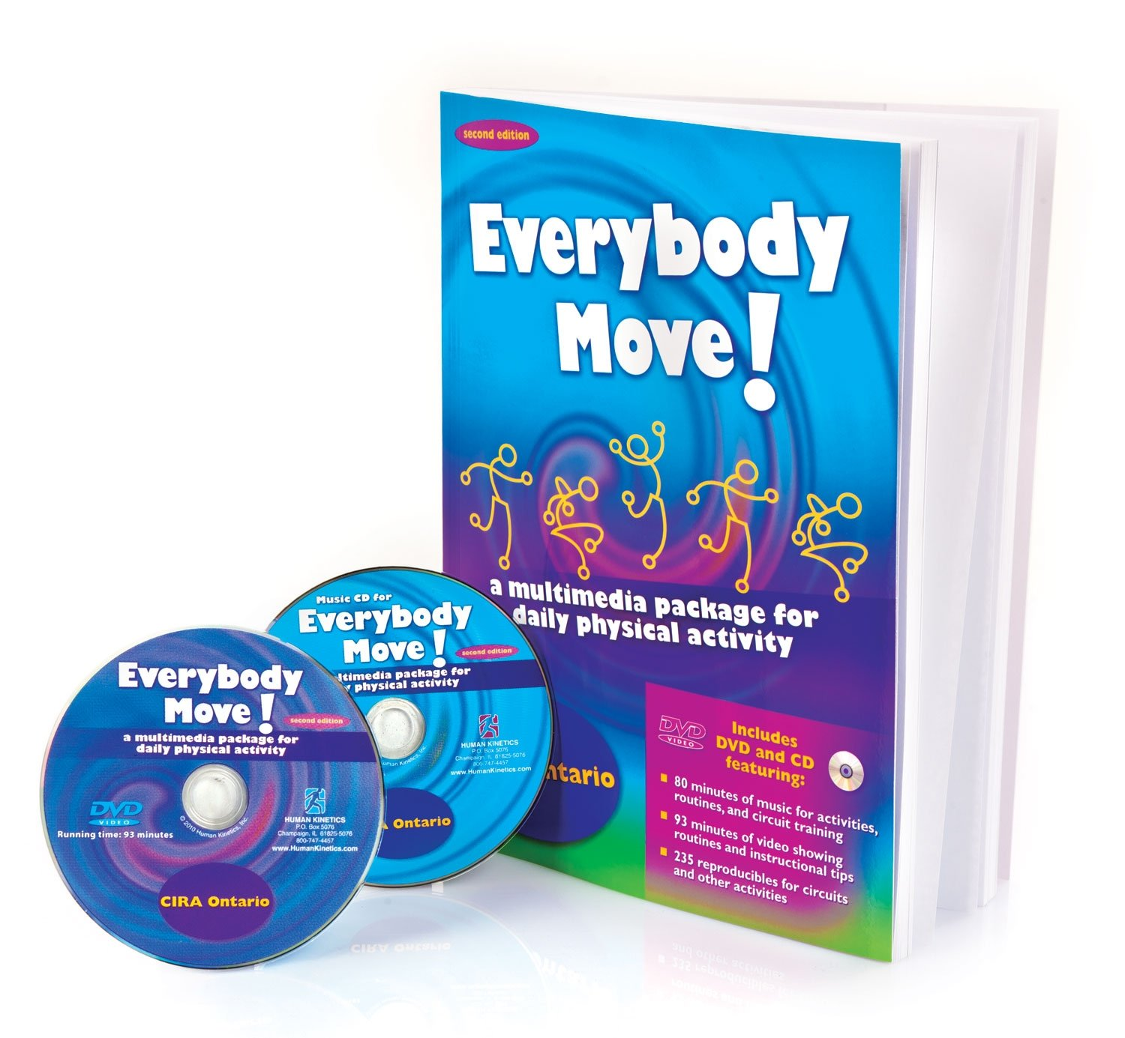

Making Daily Vigorous Physical Activity in small spaces fun and easy to implement.

- Getting started
  - Word Jacks—select one
  - RPS Ha Ha
  - RPS High knees
  - RPS Stretch
  - Fitness Eggs (with activity inside when dropped) **Fitness Eggs
  - Varied Ball Pass (have group create other variations) **One ball per group of six
    - Over and Under with turn both ways
      - https://www.canadago4sport.com/Warmups/-Over-Under
    - Over both ways
    - Under both ways
    - Left then right then left… hip
    - Roll length and back
  - Exeropoly
    - https://www.canadago4sport.com/Warmups/Exeropoly
  - Over-Under-Around
    - https://www.canadago4sport.com/Warmups/-Over-under-around
  - Copy Cat activities x 4
  - 7-minute workout app
  - 4 x 20 second workout
    - Run on spot
    - Pushups
    - McGill Crunches
    - Should taps
  - Four-Square Fitness
  - Pushup Hockey

- Move to music--short (18-24)
  - Grab bag **A few toy animals
  - Move to animal picture **Six different animal pictures
  - Copy Cat Dance—for 8 beats…
  - Just Dance Kids on YouTube
    - https://www.youtube.com/results?search_query=just+dance+kids

- Move to music--longer
  - Circuits **Circuit charts
  - Learn a dance:
    - Marching Circus **Dance charts
  - Line jump (12/17)
  - Cards **Dance cards
  - Groove (three-to four basic dances and add to it)
    - Escape to Egypt
  - Groove interpretation (create one with some music—animal movement, Cinderella…)
    - Moping
      - Body-Mop in one area
      - Brain-Mop a tough spot
      - Being-Mop the whole room
    - Ride the carriage
      - Body-Riding in a carriage
      - Brain-Over rougher terrain
      - Being-With speed
    - Dance at the ball
      - Body-Dancing self-consciously by your self
      - Brain-Dancing with the Prince
      - Being-Dancing while in love with the Prince
    - Running home
      - Body-Running from the dance
      - Brain-Running with one shoe
      - Being-Running with fatique and disappointment the last 100 metres to the cottage

- Games Getting started
  - Groove
    - Night in the Museum (Egypt) p.19
    - Play the Drums (Marching Circus)
    - It’s a Jungle out There--Tag with Gliderz **Gliderz and hoops
  - Circle delight (2-4 circles?) **One ball per eight players

- Everybody Move
  - Bass the bass **Six rubber fish
  - Simon Says
  - Mission possible (16) **Mission possible sheets
  - Fit Roll **One dice and one instruction sheet per groups of four
  - Climbers and Sliders *One board, one dice, one marker per groups of four

Equipment List:

Ready to Purchase? Order items in this cart or send this order to Customer Service.
Item |  | Details | Quantity | Subtotal
PEmoji Coated-Foam Balls - PEmoji Coated-Foam Balls  Item No: 72-094  Availability: In Stock | Price:  Unit: | C$115.00  Set of 6 | 2 | C$230.00
GoGliderz Floor Skaters - GoGliderz Floor Skaters  Item No: 58-698  Availability: In Stock | Price:  Unit: | C$10.00  Pr | 24 | C$240.00
FitDotz Fitness Spots - FitDotz Fitness Spots  Item No: 93-085  Availability: In Stock | Price:  Unit: | C$85.00  Set of 10 | 1 | C$85.00
Rainbow Rubber Critters - Fish, 14"L (36 cm)  Item No: 12-659  Availability: In Stock | Price:  Unit: | C$89.00  Set of 6 | 1 | C$89.00

Bring from home:

- One dance chart for Marching Circus
- Dance cards
- One Climbers and Sliders photocopy per groups of four
- Mission impossible sheets
- Roll sheets
- Fitness Eggs
- iPad
- Extreme Sound
- Popsicle sticks

